Plus 54

Portfolio Development Requirements

**General Document**



Plus 54, LLC.

August 12, 2014

**Contact:**

**Andres Baldessari – Business Analyst**

**216 282 2111**

**abaldessari@gmail.com**

|  |  |  |
| --- | --- | --- |
| New York 210 East 47th Street 6 H, New York,  NY 10017, USA.  +1 (216) 282 2100  info@plus54.com | Cleveland 4781 Richmond Rd – Cleveland  OH 44128, USA.  +1 (216) 282 2100  info@plus54.com | Buenos Aires Av. Corrientes 2554, 6to. Floor. C1046AQ  Buenos Aires, Argentina.  +54 11 5238 1026  info@plus54.com |

© 2014 Plus 54 LLC. All plans, preliminary outlines, sketches, photographs, graphics, texts, ideas, notes, memoranda, data, reports, musical themes, slogans, copy and any other creative products and materials presented by Plus 54 LLC are and shall remain the exclusive property of Plus 54 LLC. The use of any product without the express prior written consent of Plus 54 LLC is prohibited including, but not limited to, the reproduction, copying or publishing of any of the same.

Table of Contents

Document History 3

Main Section 4

Subsection 1 4

Subsection 2 4

# Document History

The following revisions were made to this document:

|  |  |  |  |
| --- | --- | --- | --- |
| **Version** | **Describe Changes** | **Author** | **Date** |
| V0 | Original Draft | Andres Baldessari | 08/12/14 |
|  |  |  |  |
|  |  |  |  |
|  |  |  |  |
|  |  |  |  |
|  |  |  |  |
|  |  |  |  |
|  |  |  |  |
|  |  |  |  |
|  |  |  |  |

# CONTENT MANAGEMENT SYSTEM REQUIREMENTS

## Project creation

**Functional Specification:**

***New Project Creation***

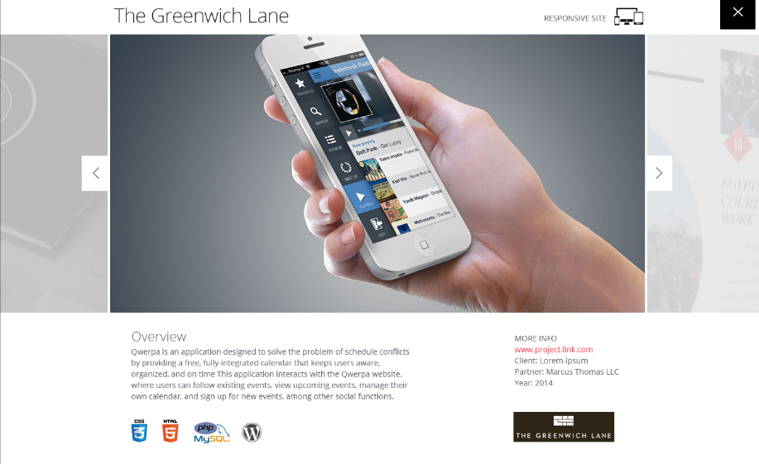

* As an admin I should be able to create a new project
* As an admin I should be able to write Project Name
* As an admin I should be able to write Project Description
* As an admin I should be able to select Type of Project #1 (Designs Type Responsive, Phones App, Tablet Apps, Landscape Apps, Portrait Apps, ETC)
* As an admin I should be able to select Type of Project #2 (E-commerce, Corporative, Sweepstakes, Mobile App, etc.
* As an admin I should be able to select Technology (.NET, PHP, Mobile Apps, Java)
* As an admin I should be able to write URL
* As an admin I should be able to write Client
* As an admin I should be able to write partner
* As an admin I should be able to write year
* As an admin I should be able to upload LOGO IMAGE
* As an admin I should be able to upload PROJECT IMAGE
* As an admin I should be able to upload LIST PAGE IMAGE

***Type of Project ABM***

* As an admin I should be able to create TYPE OF PROJECT#1 category
  + As an admin is should be able to write a name for it
  + As an admin I should be able to upload a thumbnail image for it
* As an admin I should be able to create TYPE OF PROJECT #2 category
  + As an admin I should be able to write a name for it
* As an admin I should be able to create TECHNOLOGY category
  + As an admin I should be able to write a name for it
  + As an admin I should be able to upload a thumbnail image for it

## data base impact in website

This section is meant to display how the CMS information impact in different website screens

***Portfolio List View - Sorting***



Portfolio will include two different sorting criteria I order to display results as quick as possible to the clients.

**Sorting #1 – Type of Project #2**

We will display the field Type of Project #2 in which we are going to specify the category or type of project from a business perspective. This is going to be created by the admin and should display dynamically all the information created. The admin will have to bear in mind that there is a certain amount of space so the content will have to fit the space.

**Sorting #2 – Technology**

We will display the field Technology in which we are going to specify the technology used for projects. This is going to be created by the admin and should display dynamically all the information created. The admin will have to bear in mind that there is a certain amount of space so the content will have to fit the space created for it.

***Project List view***

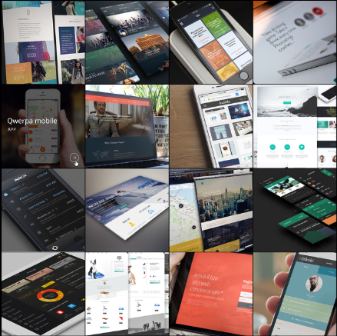 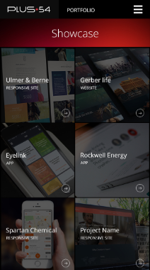

The project list view is going to be created using the information created for the PROJECT Detail. This screen will include

* LIST PAGE IMAGE
* PROJECT NAME
* Type of Project #2

***Project Details view***

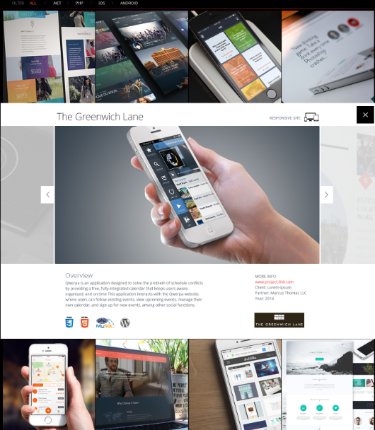

We will decompose this screen in multiple pieces so is easier to understand where each data base field goes

***Project Name (Always Text)***



***Project Type #1 (Always Image)***



***Project Photo Display (Manual sliding with touch sliding functionality for mobile devices)***

**Note:** *Nice to have* sliding with mouse sliding functionality)

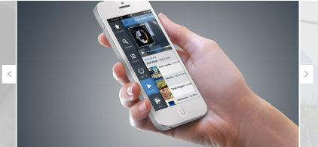

***Project Description (Always Text, no bullets, Title Overview (Static).***



***Technology (Always images, each technology will have a logo)***



***Social Media Integration (Always Images below Technology not displayed in Mockups)***

***More Info (Title More Info (Static), Project URL, Client Name, Partner Name, Year all coming from project creation data base.***



***Site Logo (Always Image)***



## site look and feel details

**Look and Feel Animations and Styles for List View boxes**

The site must be create using ISOTOPE in order to display in a neat way the sorting. The sorting will make disappear the options that not fit the criteria created for those projects and will reorganize the images.

The boxes when on hover for desktop each box will display Project Name and Type

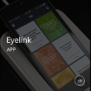

The boxes without hover will display the image

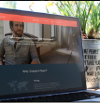

Mobile devices will always display the image as on hover since there is no hover functionality and we want to avoid the double tap in order to get into details.

Users in desktop will select one item by clicking on them and the Detail view will appear between lines, in example if the user clicks a project that is part of the first line then the detail box will appear above it between the sorting and the first line of boxes but if the user selects a project that is in the subsequent lines the details box will open in middle of them pushing the content below down.

**Note Desktop UX –** Users will select a box in desktop version, that box, will remain ACTIVE but the rest will not be active, we will have to blur them or add opacity to them alerting that those are inactive till the details box is closed. When the Details close then all the rest of images will be back to normal state.

Desktop will display lines of 4 boxes.

**Note Tablet UX –** Portrait Tablet Orientation will have the same behavior changing the hover status.

Portrait Tablet will display lines of 3 boxes.

**Note Phone UX –** Phones is different since the size of screen is smaller, the Details pop up will fill the entire screen and the rest of the boxes are not going to be visually available because of that.

Smallest resolutions will display lines of 2 boxes.

**Detail View Look and Feel Details**

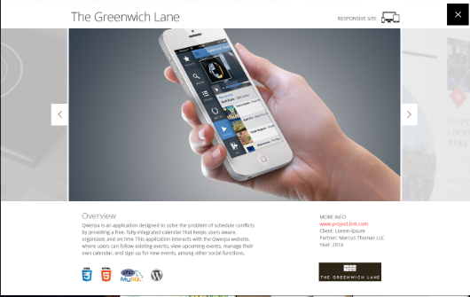

Desktop UX – As described on image the layout will remain like that. The background image of the slider will be a static image assigned for that purpose

Portrait Tablet UX – the information will be displayed in the same way but the images are going to be smaller to fit the differences between resolutions.

Portrait Phone UX – The information will accommodate one after the other depending on the screen size.

Title and Type #1 image if not fit will go one title and above image, slider will remain equal above will go description, above technology (this one will maybe form multiple lines since some projects may include up to 10 logos), above of it social media, above of social media more info and lastly project logo.

## portfolio landing page details

This is a list of the components that are outside of the functional portfolio behavior.

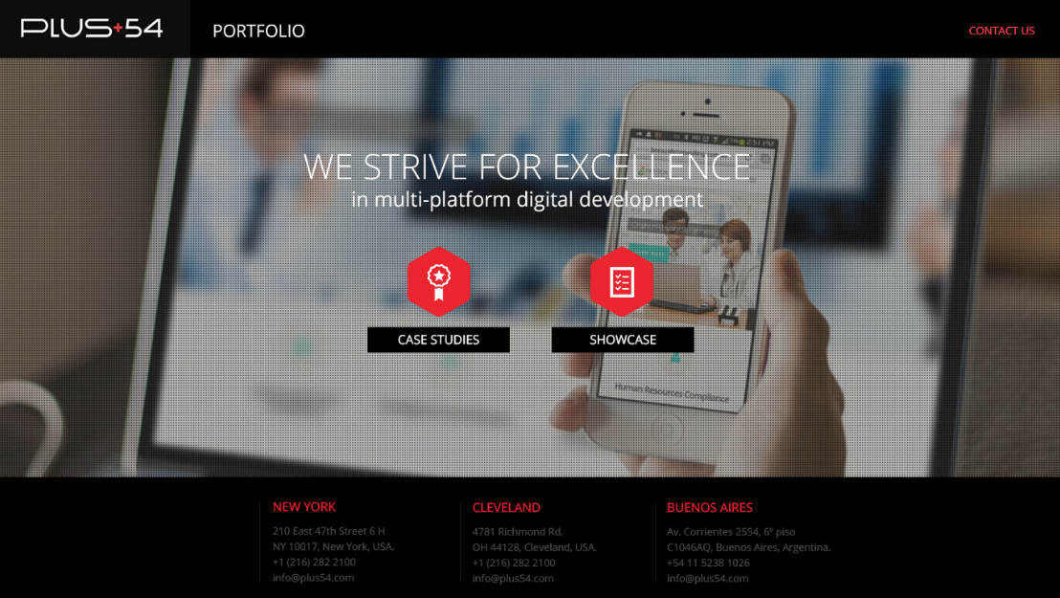

**Portfolio Landing Page -** The log in screen will hold what is displayed in the image above show case will take the user to showcase page (List view) and case studies will take the user to case studies page (not part of this FSD)

Footer will display address (content already created for the site plus54.com

Header contact us will take the user to the plus54.com contact us area.

The entire page is static, there is no interaction with the CMS for anything.

## log in page details

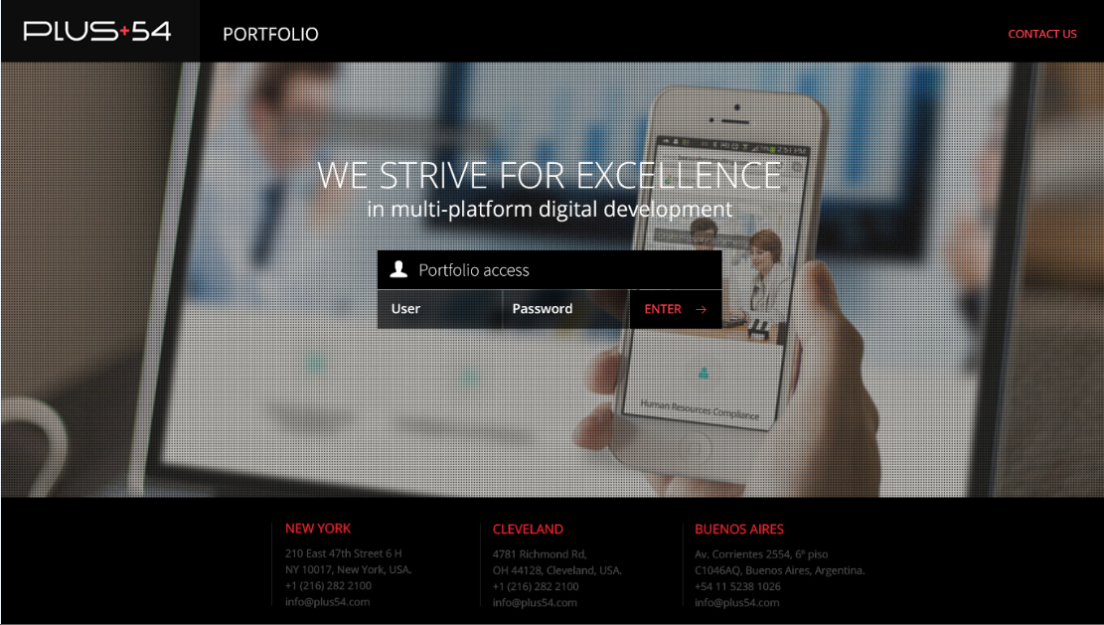

**Log in Screen –** Users comes from the landing page to this screen from Show Case. The log in and password is going to be static without necessary CMS (At least for now).

When users touch or click USER the word USER will disappear to allow writing same behavior for password.

The error handling will be a highlight on the fields, one of them or both in order to alert that there is an error, both fields are mandatory and validated properly.

When clicking or touching enter the user will go to the list view of projects.

## show case other components details

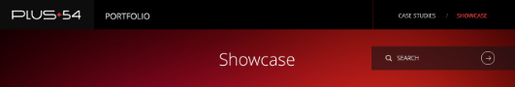

**Header**

The portfolio will have a header in which the user will be able to change from case studies to showcase.

There is going to be a title below the header so users knows where they are.

We included a search fields in which users will have the ability to search by keywords. The logic for the search should be search the XXXXXX content across every word in data base. The results should be displayed in the same way as they are displayed when there is no search except that the title will change for SHOW CASE SEACH RESULTS.

If no results are displayed then a background image with a text in front of it will be displayed alerting that there are no results with a button to go back to the main list of projects.

**Show More**

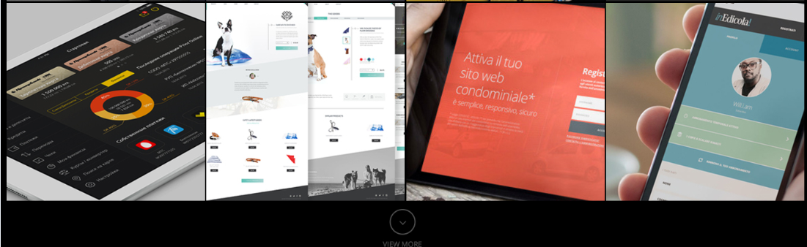

The portfolio in order to display more data will have a SHOW more functionality. The show more will add a new set of 3 lines of content to the list.

The show more will appear if

1. There are more items to display that does not fit inside the area to display

The show more will NOT appear if

1. There are no more items to display

**Footer**



Footer will include a Contact Us link that will take the users to the contact us form of plus54.com site.

**Mobile Menu**

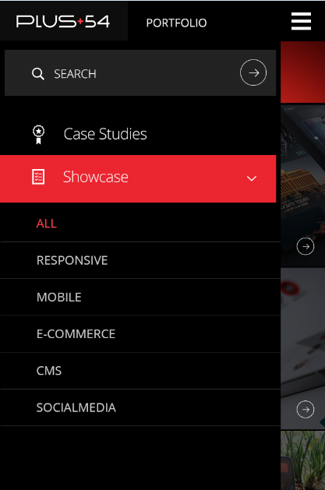

Smaller screen resolutions will include this left side menu. When activated the menu will appear at the left and the content will be pushed to the right completely.

The menu will include all the options that appear in the header

* Search – When users touch that option the search will allow them to write the criteria and the button will trigger the functionality.
* Case Studies – When users touch that option they are going to be linked to another page
* Show Case – Show case will include two collapsible panels one for Sorting #1 and another one for Sorting #2 and a button to execute the sorting.

Execution buttons will close the panel and display the action in the main screen. Users are not going to be able to interact with the website while the menu panel is open.