Plus 54

Portfolio Redesign 2014

**General Document**



Plus 54, LLC.

August 12, 2014

**Andres Baldessari – Business Analyst**

**216 282 2111**

**abaldessari@plus54.com**

**Leonardo Pautasio – Project Manager  
216 282 2128**

**lpautasio@plus54.com**

|  |  |  |
| --- | --- | --- |
| New York 210 East 47th Street 6 H, New York,  NY 10017, USA.  +1 (216) 282 2100  info@plus54.com | Cleveland 4781 Richmond Rd – Cleveland  OH 44128, USA.  +1 (216) 282 2100  info@plus54.com | Buenos Aires Av. Corrientes 2554, 6to. Floor. C1046AQ  Buenos Aires, Argentina.  +54 11 5238 1026  info@plus54.com |

© 2014 Plus 54 LLC. All plans, preliminary outlines, sketches, photographs, graphics, texts, ideas, notes, memoranda, data, reports, musical themes, slogans, copy and any other creative products and materials presented by Plus 54 LLC are and shall remain the exclusive property of Plus 54 LLC. The use of any product without the express prior written consent of Plus 54 LLC is prohibited including, but not limited to, the reproduction, copying or publishing of any of the same.

Table of Contents

Document History 3

Browsers Support 4

Content Management System 5

Foundation 5

Login and Logout 5

Categories, Types of Projects, Technologies and Social Media Items Administration Pages 7

Projects Administration Page 13

Site Content 17

Login and Logout 17

Home Page 19

Showcase Landing Page 21

# Document History

The following revisions were made to this document:

|  |  |  |  |
| --- | --- | --- | --- |
| **Version** | **Describe Changes** | **Author** | **Date** |
| V0 | Original Draft | Andres Baldessari | 08/12/14 |
| V1 | Second Draft | Leonardo Pautasio | 08/25/14 |
|  |  |  |  |
|  |  |  |  |
|  |  |  |  |
|  |  |  |  |
|  |  |  |  |
|  |  |  |  |
|  |  |  |  |
|  |  |  |  |

# Browsers Support

**Browser Compatibility**

* Internet Explorer 9
* Internet Explorer 10
* Internet Explorer 11
* Firefox (latest Windows version – 24.0)
* Chrome (latest Windows version – 30.0.1)
* Safari (latest Mac version – 7.0)

**Mobile Operating System Compatibility**

* Apple iOS 7 or greater
* Android
  + Ice Cream Sandwich
  + Jellybean
  + Gingerbread

**Targeted Mobile Devices**

* Apple devices
  + iPhone 4s, 5c and 5s
  + iPad 3, 4 and mini
* Android devices (by resolution, includes phones and tablet)
  + 480 x 800
  + 960 x 540
  + 1280 x 720
  + 800 x 1280
  + 1024 x 600

**Note**: for the CMS, only supported browser is Chrome latest version. Desktop only.

# Content Management System

## Foundation

**User Story 0 – Basic Structure**

As an administrator, I want to see the basic structure of the page (header, menu, content, footer), so that I can navigate through the CMS.

* Description:
  + Header must include the Plus54 logo.
  + Menu must display the following items:
    - Projects: links to the projects lists admin page.
    - Properties: opens submenu.
      * Categories: links to the Categories list admin page.
      * Types of Projects: links to the Types of Projects list admin page.
      * Technologies: links to the technologies list admin page.
      * Social Media: links to the social media items list admin page.
    - Sign Out: logs the user out.
  + Footer must display “© Copyright 2014 – Plus 54”.
* Pre-conditions:
  + User must be logged in.

## Login and Logout

**User Story 1.1 - CMS Login**

As an administrator, I want to login to the CMS so that I can administrate the portfolio’s content.

* Description
  + When the user goes to the CMS section of the site, if they are not logged in, they will be asked to log in by submitting a form.
  + Nice to have: user will login using their domain credentials.
* Pre-conditions
  + User must not be logged in.
* Login Page
  + Form elements
    - Username: alphanumeric text field. 40 characters long.   
      Placeholder: “Username”. Mandatory.
    - Password: alphanumeric password field. 25 characters long.   
      Placeholder: “Password”. Mandatory.
    - Sign in: button. Submits the form.
  + Validations
    - Before form submission, validate that mandatory fields are not empty. Error message: “Please, complete the fields marked with an asterisk”.
    - After form submission, check for existing combination of username and password.
      * If the combination was found, the user will be taken to the CMS home page, or to the page that was originally requested.
      * If the combination was not found, indicate the error through the following message: “The username or password you entered is incorrect.”
* Post-conditions
  + User logged in, if credentials are correct.

**User Story 1.2 - CMS Logout**

As an administrator, I want to logout from the CMS so that no other can use my account when I finished using the CMS.

* Description
  + Session will expire after 20 minutes of inactivity. User will have to login again.
  + The user will be able to sign out from the CMS at any moment, through a link with the text “Sign out”. User will be taken to the Sign In page after they are logged out.
* Pre-conditions
  + User must be logged in.
* Post-conditions
  + User logged out.

## Categories, Types of Projects, Technologies and Social Media Items Administration Pages

**User Story 2 - CMS Categories CRUD**

As an administrator, I want to create, edit, delete, list and search Categories, so they can be assigned to projects from the Projects CRUD.

* Description
  + When the user goes to the Categories Administration page of the CMS, a list of categories will be displayed. User will be able to delete or edit any of the existing items, or add a new one.
* Pre-conditions
  + User must be logged in.
* Create/Edit Page
  + Form elements
    - Name: alphanumeric text field. 20 characters long.   
      Placeholder: “Name”. Mandatory. Unique.
    - Thumbnail: image file input field. Types: JPG or PNG. Size: 340px max height. Mandatory.
    - Save: button. Submits the form.
    - Cancel: returns to the listing page.
  + Validations
    - Validate that mandatory fields are not empty. Error message: “Please, complete the fields marked with an asterisk.”
    - Validate unique fields. Error message: “A category with that [field name] already exists. Please, enter a new one.”
    - Validate thumbnail image types. Error message: “The selected image file type is not allowed. Please, choose a JPG or PNG file.”
    - Resize thumbnail image to the corresponding size.
  + Post-conditions
    - If form is correct, element is created / updated. Otherwise, show error messages.
      * Success message: “The category has been created.”
      * Error message: “There was an error: [show error]”
* Listing Page elements
  + Search form
    - Search: alphanumeric input. Once the user starts typing, searches and filters all elements on the fly by name.
    - Show: combo box. Label: “Show [combo box] entries”. Displays the selected number of elements in the list. On change, refreshes the list. Options: 20, 50, 100. Default: 20.
  + List columns (clicking on the column’s name must order the list by that column)
    - Name: text. Links to the edit page.
    - Thumbnail: image.
  + Edit, Delete and Add buttons (or links). (Edit can be accomplished by clicking on the element’s name).
    - Delete confirmation message: “The selected categories will be deleted. Any projects associated to these categories will be unassociated. Would you like to continue?”
  + Pagination
    - Text: “Showing [x] to [y] of [z] entries”.
    - Buttons: First | Previous | 1 | 2 | 3 | (…) | Next | Last

**User Story 3 - CMS Types of Projects CRUD**

As an administrator, I want to create, edit, delete and list Types of Projects, so they can be assigned to projects from the Projects CRUD.

* Description
  + When the user goes to the Types of Projects Administration page of the CMS, a list of types of projects will be displayed. User will be able to delete or edit any of the existing items, or add a new one.
* Pre-conditions
  + User must be logged in.
* Create/Edit Page
  + Form elements
    - Name: alphanumeric text field. 20 characters long.   
      Placeholder: “Name”. Mandatory. Unique.
    - Save: button. Submits the form.
    - Cancel: returns to the listing page.
  + Validations
    - Validate that mandatory fields are not empty. Error message: “Please, complete the fields marked with an asterisk”.
    - Validate unique fields. Error message: “A type of project with that [field name] already exists. Please, enter a new one.”
  + Post-conditions
    - If form is correct, element is created / updated. Otherwise, show error messages.
      * Success message: “The type of project has been created.”
      * Error message: “There was an error: [show error]”
* Listing Page elements
  + Search form
    - Search: alphanumeric input. Once the user starts typing, searches and filters all elements on the fly by name.
    - Show: combo box. Label: “Show [combo box] entries”. Displays the selected number of elements in the list. On change, refreshes the list. Options: 20, 50, 100. Default: 20.
  + List columns (clicking on the column’s name must order the list by that column)
    - Name: text. Links to the edit page.
  + Edit, Delete, Add buttons (or links). (Edit can be accomplished by clicking on the element’s name).
    - Delete confirmation message: “The selected types of projects will be deleted. Any projects associated to these types of projects will be unassociated. Would you like to continue?”
  + Pagination
    - Text: “Showing [x] to [y] of [z] entries”.
    - Buttons: First | Previous | 1 | 2 | 3 | (…) | Next | Last

**User Story 4 - CMS Technologies CRUD**

As an administrator, I want to create, edit, delete and list technologies, so they can be assigned to projects from the Projects CRUD.

* Description
  + When the user goes to the Technologies Administration page of the CMS, a list of technologies will be displayed. User will be able to delete or edit any of the existing items, or add a new one.
* Pre-conditions
  + User must be logged in.
* Create/Edit Page
  + Form elements
    - Name: alphanumeric text field. 20 characters long.   
      Placeholder: “Name”. Mandatory. Unique.
    - Thumbnail: image file input field. Types: JPG or PNG. Size: variable width, 40px height. Mandatory.
    - Save: button. Submits the form.
    - Cancel: returns to the listing page.
  + Validations
    - Validate that mandatory fields are not empty. Error message: “Please, complete the fields marked with an asterisk”.
    - Validate unique fields. Error message: “A technology with that [field name] already exists. Please, enter a new one.”
    - Validate thumbnail image types. Error message: “The selected image file type is not allowed. Please, choose a JPG or PNG file.”
    - Resize thumbnail image to the corresponding size.
  + Post-conditions
    - If form is correct, element is created / updated. Otherwise, show error messages.
      * Success message: “The technology has been created.”
      * Error message: “There was an error: [show error]”
* Listing Page elements
  + Search form
    - Search: alphanumeric input. Once the user starts typing, searches and filters all elements on the fly by name.
    - Show: combo box. Label: “Show [combo box] entries”. Displays the selected number of elements in the list. On change, refreshes the list. Options: 20, 50, 100. Default: 20.
  + List columns (clicking on the column’s name must order the list by that column)
    - Name: text. Links to the edit page.
    - Thumbnail: image.
  + Edit, Delete, Add buttons (or links). (Edit can be accomplished by clicking on the element’s name).
    - Delete confirmation message: “The selected technologies will be deleted. Any projects associated to these technologies will be unassociated. Would you like to continue?”
  + Pagination.
    - Text: “Showing [x] to [y] of [z] entries”.
    - Buttons: First | Previous | 1 | 2 | 3 | (…) | Next | Last

**User Story 5 - CMS Social Media CRUD**

As an administrator, I want to create, edit, delete and list social media items, so they can be assigned to projects from the Projects CRUD.

* Description
  + When the user goes to the Social Media Administration page of the CMS, a list of social media items will be displayed. User will be able to delete or edit any of the existing items, or add a new one.
* Pre-conditions
  + User must be logged in.
* Create/Edit Page
  + Form elements
    - Name: alphanumeric text field. 20 characters long.   
      Placeholder: “Name”. Mandatory. Unique.
    - Thumbnail: image file input field. Types: JPG or PNG. Size: 40x40px. Mandatory.
    - Save: button. Submits the form.
    - Cancel: returns to the listing page.
  + Validations
    - Validate that mandatory fields are not empty. Error message: “Please, complete the fields marked with an asterisk”.
    - Validate unique fields. Error message: “A social media itema with that [field name] already exists. Please, enter a new one.”
    - Validate thumbnail image types. Error message: “The selected image file type is not allowed. Please, choose a JPG or PNG file.”
    - Resize thumbnail image to the corresponding size.
  + Post-conditions
    - If form is correct, element is created / updated. Otherwise, show error messages.
      * Success message: “The social media item has been created.”
      * Error message: “There was an error: [show error]”
* Listing Page elements
  + Search form
    - Search: alphanumeric input. Once the user starts typing, searches and filters all elements on the fly by name.
    - Show: combo box. Label: “Show [combo box] entries”. Displays the selected number of elements in the list. On change, refreshes the list. Options: 20, 50, 100. Default: 20.
  + List columns (clicking on the column’s name must order the list by that column)
    - Name: text. Links to the edit page.
    - Thumbnail: image.
  + Edit, Delete, Add buttons (or links). (Edit can be accomplished by clicking on the element’s name).
    - Delete confirmation message: “The selected social media items will be deleted. Any projects associated to these social media items will be unassociated. Would you like to continue?”
  + Pagination
    - Text: “Showing [x] to [y] of [z] entries”.
    - Buttons: First | Previous | 1 | 2 | 3 | (…) | Next | Last

## Projects Administration Page

**User Story 6 - CMS Projects CRUD**

As an administrator, I want to create, edit, delete and list projects, so they are displayed in the showcase landing page and their information is shown in the projects details.

* Description
  + When the user goes to the Projects Administration page of the CMS, a list of projects will be displayed. User will be able to delete or edit any of the existing items, or add a new one.
* Pre-conditions
  + User must be logged in.
* Create/Edit
  + Form elements
    - Project Name: alphanumeric text field. 50 characters long.   
      Placeholder: “Project Name”. Mandatory. Unique.
    - Overview: alphanumeric text field. 400 characters long.   
      Placeholder: “Overview”. Mandatory.
    - Category: multiple selects. List is pulled from the database. At least one item must be selected. Placeholder: “Category”.
    - Type of Project: multiple selects. List is pulled from the database. At least one item must be selected. Placeholder: “Type of Project”.
    - Technologies: multiple selects. List is pulled from the database. At least one item must be selected. Placeholder: “Technologies”.
    - URL: alphanumeric text field. 100 characters long.   
      Placeholder: “URL”. Optional.
    - Client: alphanumeric text field. 50 characters long.   
      Placeholder: “Client”. Mandatory.  
      Nice to have: save client name into a different table. Use autocomplete to pull clients’ names. If the client already exists in the table, use its ID. If not, create a new client and get the new ID.
    - Partner: alphanumeric text field. 50 characters long.   
      Placeholder: “Partner”. Mandatory.   
      Nice to have: save partner name into a different table. Use autocomplete to pull partners’ names. If the partner already exists in the table, use its ID. If not, create a new client and get the new ID.
    - Year: numeric field. 4 digits. Mandatory.
    - Site Logo: image file input field. Types: JPG or PNG. Size: 180x180px. Mandatory.
    - Project Images: multiple image file input field (must allow to add all necessary amount of images, and remove them as well). Types: JPG or PNG. Size: 1366x712px. Mandatory.
    - Project Thumbnail: image file input field. Types: JPG or PNG. Size: 340x340px. Mandatory.
    - Save: button. Submits the form.
    - Cancel: returns to the listing page.
  + Validations
    - Validate that mandatory fields are not empty.
    - Validate unique fields. Error message: “A project with that [field name] already exists. Please, enter a new one.”
    - Validate URL format. Error message: “The entered URL is not valid. Please, enter a new one.”
    - Validate numeric fields. Error message: “The entered value in [field name] is not a number. Please, enter a number.”
    - Validate image types. Error message: “The selected image file type in [field name] is not allowed. Please, choose a JPG or PNG file.”
    - Resize images to the corresponding sizes.
  + Post-conditions
    - If form is correct, element is created / updated. Otherwise, show error messages.
      * Success message: “The project has been created.”
      * Error message: “There was an error: [show error]”
* Listing page elements
  + Search form
    - Search: alphanumeric input. Once the user starts typing, searches and filters all elements on the fly by all fields, except images fields.
    - Filters for columns:
      * Categories
        + “All categories”. Default value. Shows projects of any category, including not associated ones.
        + “Unassociated”. On select, shows projects that has no categories associated.
        + Rest of the categories. On select, shows the projects associated to the selected category.
      * Types of Projects
        + “All types of projects”. Default value. Shows projects of any type of project, including not associated ones.
        + “Unassociated”. On select, shows projects that has no types of projects associated.
        + Rest of the types of projects. On select, shows the projects associated to the selected type of project.
      * Technologies
        + “All technologies”. Default value. Shows projects of any technology, including not associated ones.
        + “Unassociated”. On select, shows projects that has no technologies associated.
        + Rest of the technologies. On select, shows the projects associated to the technology.
      * Social Media
        + “All social media”. Default value. Shows projects of any social media, including not associated ones.
        + “Unassociated”. On select, shows projects that has no social media items associated.
        + Rest of the social media items. On select, shows the projects associated to the selected social media item.
    - Show: combo box. Label: “Show [combo box] entries”. Displays the selected number of elements in the list. On change, refreshes the list. Options: 20, 50, 100. Default: 20.
  + List columns (clicking on the column’s name must order the list by that column)
    - Project Name: text. Links to the edit page.
    - Client: text.
    - Partner: text.
    - Categories: comma separated list.
    - Types of Projects: comma separated list.
    - Technologies: comma separated list.
    - Social Media: comma separated list.
  + Edit, Delete, Add buttons (or links). (Edit can be accomplished by clicking on the element’s name).
    - Delete confirmation message: “The selected projects will be deleted. Would you like to continue?”
  + Pagination
    - Text: “Showing [x] to [y] of [z] entries”.
    - Buttons: First | Previous | 1 | 2 | 3 | (…) | Next | Last

# Site Content

## Login and Logout

**User Story 7.1 – Site Login**

As a user, I want to login to the site so that I can access the restricted content (all site).

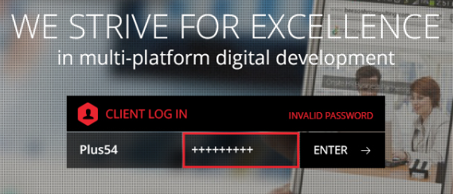

* Description:
  + When the user enters the site, if they are not logged in, they will be taken to the login page.
  + A video will be displayed in the background of this page.
* Pre-conditions:
  + User must not be logged in.
* Login Page
  + Form elements
    - Username: alphanumeric text field. 40 characters long.   
      Placeholder: “Username”. Mandatory.
    - Password: alphanumeric password field. 25 characters long.   
      Placeholder: “Password”. Mandatory.
    - Enter: button. Submits the form.
  + Validations
    - Before form submission, validate that mandatory fields are not empty. Error message: “Please, enter your username and password”.
    - After form submission, check for existing combination of username and password.
      * If the combination was found, the user will be taken to the CMS home page, or to the page that was originally requested.
      * If the combination was not found, indicate the error through the following message: “Invalid username or password”.
* Post-conditions
  + User logged in, if credentials are correct.

**User Story 7.2 - Site Logout**

**Logout link was not included in the design**

As a user, I want to logout from the site so that no other can access the restricted content with my account.

* Description
  + Session will expire after 20 minutes of inactivity. User will have to login again.
  + Nice to have: user will be able to sign out from the site at any moment, through a link with the text “Sign out”. User will be taken to the Sign In page after they are logged out.
* Pre-conditions
  + User must be logged in.
* Post-conditions
  + User logged out.

## Home Page

**User Story 8.1 – Home Page – Basic Structure**

As a user, I want to see the basic structure of the home page of the site, so that I can see the header and footer links.





* Description:
  + After the user logins into the site, they will be taken to this page. ***Note: since Case Studies page is out of the scope of this first phase, the user will be taken directly to the Showcase Landing Page. This Home Page will be created anyway, and must be tested.***
* Sections
  + Header
    - Plus 54 logo: links to this Home Page.
  + Footer
    - Contact Us: links to the Contact Us page of the main site. Opens in a new tab.
* Pre-conditions:
  + User must be logged in.

**User Story 8.2 – Home Page – Content**

As a user, I want to see the content of the home page of the site, so that I can access the different contents.



* Description:
  + After the user logins into the site, they will be taken to this page. ***Note: since Case Studies page is out of the scope of this first phase, the user will be taken directly to the Showcase Landing Page. This page will be created anyway, and must be tested.***
  + User will be presented with two buttons:
    - Case Studies: takes the user to the Case Studies Landing Page.
    - Showcase: takes the user to the Showcase Landing Page.
* Pre-conditions:
  + User must be logged in.
* Post-conditions:
  + User is taken to the chosen page.

## Showcase Landing Page

**User Story 9.1 – Showcase – Basic Structure**

As a user, I want to see the basic structure of the Showcase Landing Page, so that I can see the header, content and footer.

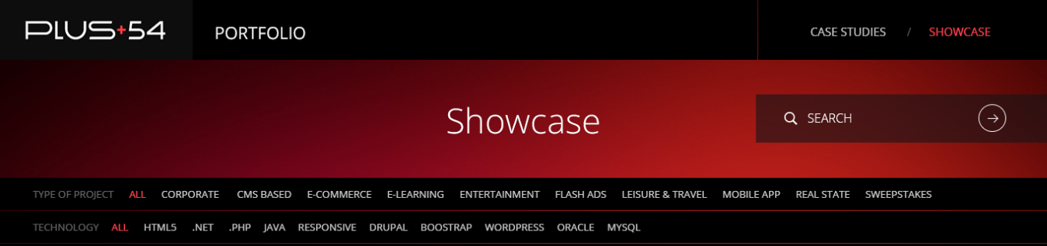



* Description:
  + After the user logins into the site, they will be taken to this page. ***Note: since Case Studies page is out of the scope of this first phase, the user will be taken directly to this page instead of the Home Page.***
* Sections:
  + Header
    - Plus 54 logo: links to the Home Page.
    - Case Studies: links to the Case Studies Landing Page.
    - Showcase: links to the Showcase Landing Page.

***Note:*** ***since Case Studies page is out of the scope of this first phase, Case Studies and Showcase links should not be included.***

* + Footer
    - Contact Us: links to the Contact Us page of the main site. Opens in a new tab/window.
* Pre-conditions:
  + User must be logged in.

**User Story 9.2 – Showcase – Initial Content**

As a user, I want to see all the projects, so that I can select any of them and see its details.

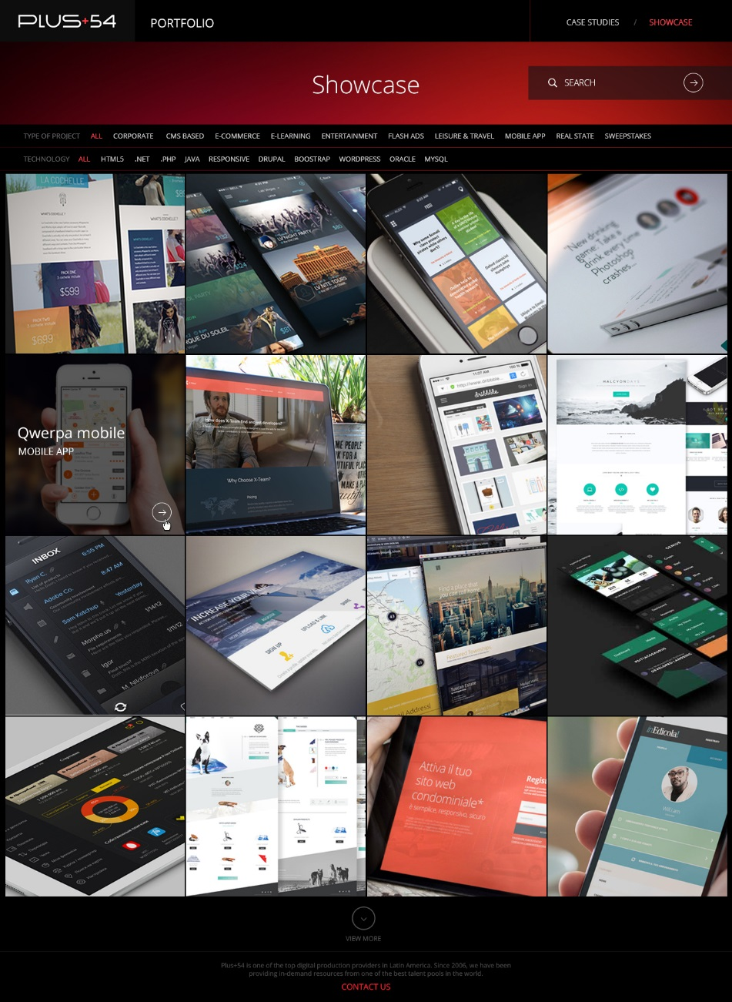 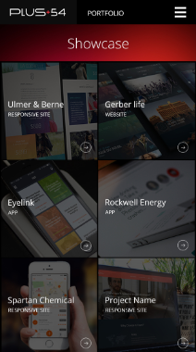

* Description:
  + Desktop:
    - Rows of thumbnails will be displayed.
    - On mouse hover, each thumbnail will display a dark overlay on top of it with:
      * Project Name
      * Type of Project
      * Arrow button: on click, opens the project details.
  + Tablet/Mobile:
    - Rows of 3 thumbnails will be displayed for tablet, and 2 thumbnails for mobile.
    - Each thumbnail will always display a dark overlay on top of it (there’s no hover on tablet/mobile) with:
      * Project Name
      * Type of Project
      * Arrow button: on tap, opens the project details.
  + View More button:  
     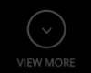
    - This button will be shown only if there are more projects to display.
    - It will add 3 rows to the list.
* Pre-conditions:
  + User must be logged in.

**User Story 9.3 – Showcase – Search**

As a user, I want to search projects by keywords, so that I can find the ones related to the words I entered.

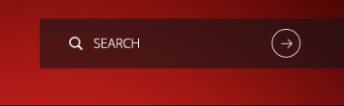

* Description:
  + User can enter any number of keywords, and press on the arrow button. Then, the user will be taken to the Search Results Page.
* Form elements:
  + Search: alphanumeric text field. Placeholder: “Search”.
  + Arrow button: on click/tap, submits the form.

**User Story 9.4 – Showcase – Filters**

As a user, I want to apply filters by type of project and technologies, so that I can find the ones that meets the criteria.



* Description:
  + User will be able to select different filters that will trigger a search and will bring all projects that meet the selected items.
  + User can select one or more items from the different filters.
  + Selected items that are from the same filter will use and OR logic, meaning that all projects that have any of the selected items will be shown. Example: Technology: HTML5, PHP, .NET, then all projects that used HTML5 and were developed in PHP or .NET will be shown.
  + When selected items are from different filters, the AND logic will be applied, meaning that projects that have items from the first filter AND from the second will be shown. A project must have items from both filters to be shown. Example: Type of project “E-commerce” and Technology “PHP”, then only E-commerce projects developed in PHP will be shown. E-commerce projects developed in .Net will not be shown, for example.
* Filters
  + Type of Project: These items correspond to the ones created in the Type of Project CRUD.
  + Technology: These items correspond to the ones created in the Technologies CRUD.
  + Apply button: For desktop, there will be one button that will apply both filters. For mobile, there will be two buttons for each filter, but on tap they will apply both.

**User Story 9.5 – Showcase – Mobile Menu**

As a user, I want to see the mobile menu while using small screens, so that I can easily access the different options.

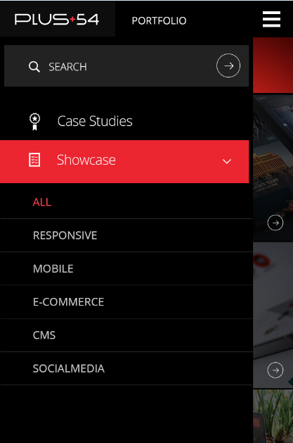

* Description:
  + User will be able to enter keywords on the search input, and tap on the arrow button to trigger the search functionality, and the menu will close.
  + User will be able to select any filters they want. There will be two collapsible panels for each filters, user will select the ones they want, and tap on a button to apply them. Menu will close.

**User Story 10 – Showcase Projects Details**

As a user, I want to see the project details, so that I can learn more about the project I selected.

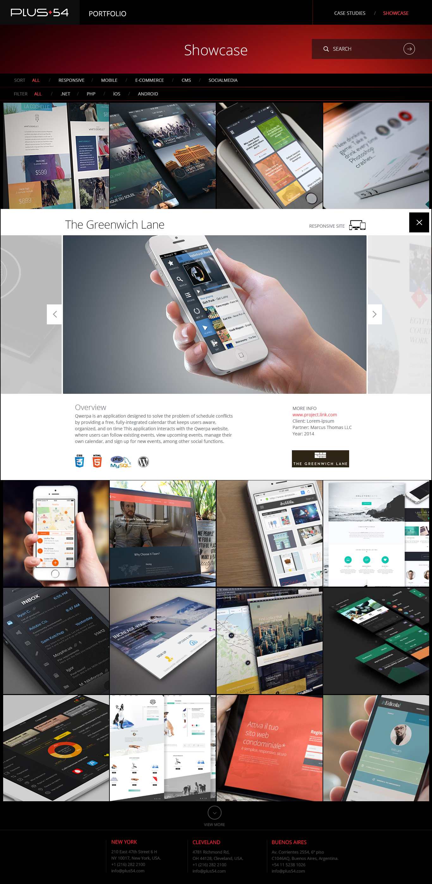

* Description:
  + When the user clicks or taps on a thumbnail, the detail view of the selected project will be displayed.
  + Project details will include:
    - Project Name: text. 50 characters long max. For e.g., “The Greenwich Lane”.
    - Categories: images, one for each category. Types: JPG or PNG. Size: 100x100px. On hover, shows name. For e.g., “Responsive Site”.
    - Project Images: slider. Image types: JPG or PNG. Max size: 1366x712px.
    - Overview: text. 400 characters long max.
    - More Info:
      * URL: text (if available).
      * Client Name: text.
      * Partner: text.
      * Year: 4 digits number.
    - Technologies: images, one for each technology associated to the project. Types: JPG or PNG. Size: variable width, 40px height. On hover, shows name. For e.g., “CSS”, “HTML5”, “MySql”, etc.
    - Social Media: images, one for each social media item associated to the project. Types: JPG or PNG. Size: variable width, 40px height. On hover, shows name. For e.g., “Integration with Facebook”, “Integration with Twitter”, etc.
    - Site Logo: image. Types: JPG or PNG. Size: 180x180px. For e.g.: “The Greenwich Lane”.
  + Desktop/Tablet:
    - When the user selects a thumbnail, it will remain in an active status, while the rest of the thumbnails will be in an inactive status. Inactive thumbnails will have a higher opacity.
    - Project details will be displayed between rows, below the selected thumbnail. For e.g., if the thumbnails belongs to the first row, the detail box will be displayed the first and the second row.
  + Mobile:
    - Projects details will be displayed into an overlay that will fit the entire screen.
  + Click/tap on opacity:
    - If any “inactive” thumbnail is clicked or tapped, it will become active and its details will be shown.

**User Story 11 – Showcase Search Results**

As a user, I want to see the results of the search I did by entering the keywords, so I can find the ones I’m interested in.

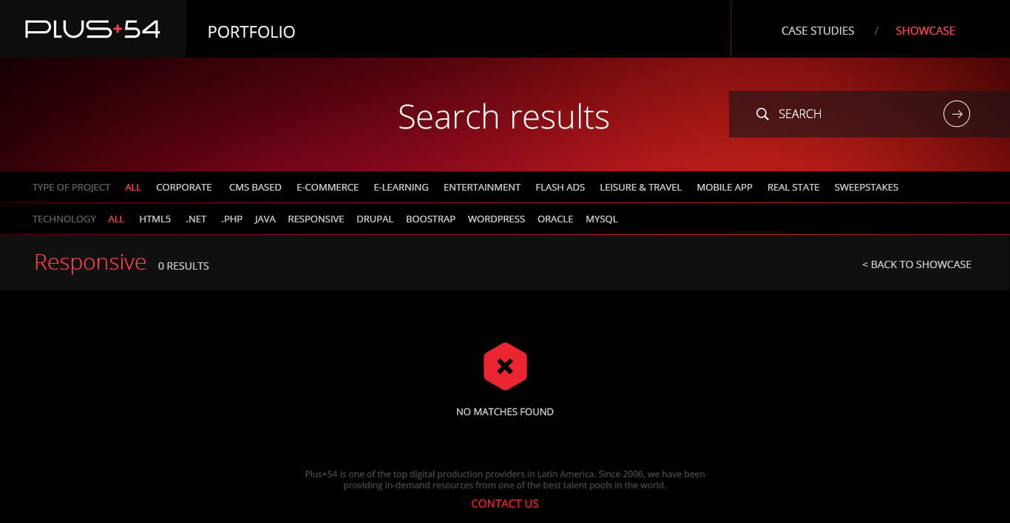

* Description:
  + When the user searches for any keywords, a page displaying the results will be shown.
  + This page will be similar to the Initial Content only that projects displayed will have any of the keywords in any of their details fields.
  + If there are no results, the message “no matches found” will be displayed.
  + At the top, the number of results will be shown, and next to it, a link to go back to the Initial Content (Back to Showcase).
  + Search & Filters: filters will be cleared when a search is performed. Filters can be applied after a search was performed.