RESET PASSWORD
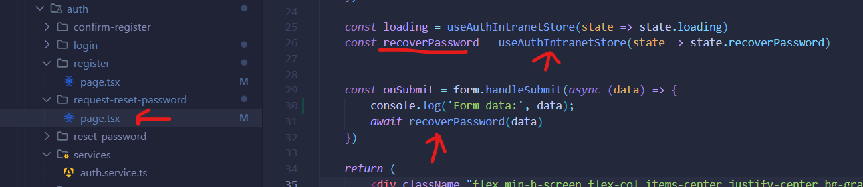
C:\xampp\htdocs\forotis\app\src\modules\intranet\auth\request-reset-password

C:\xampp\htdocs\forotis\app\src\modules\intranet\auth\store
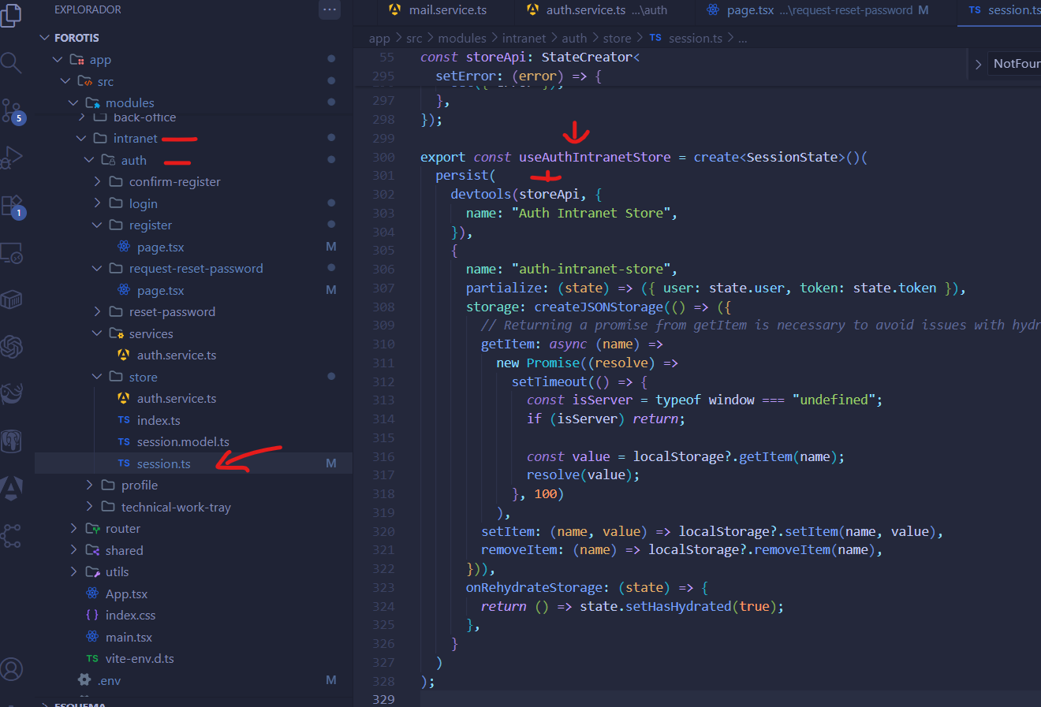

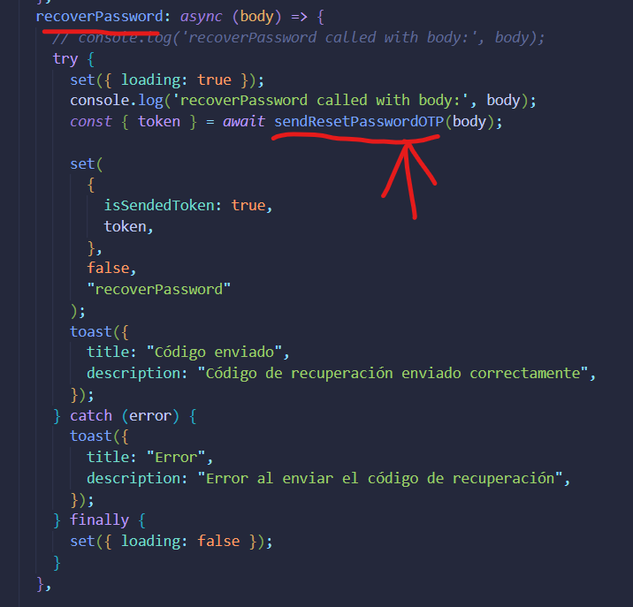
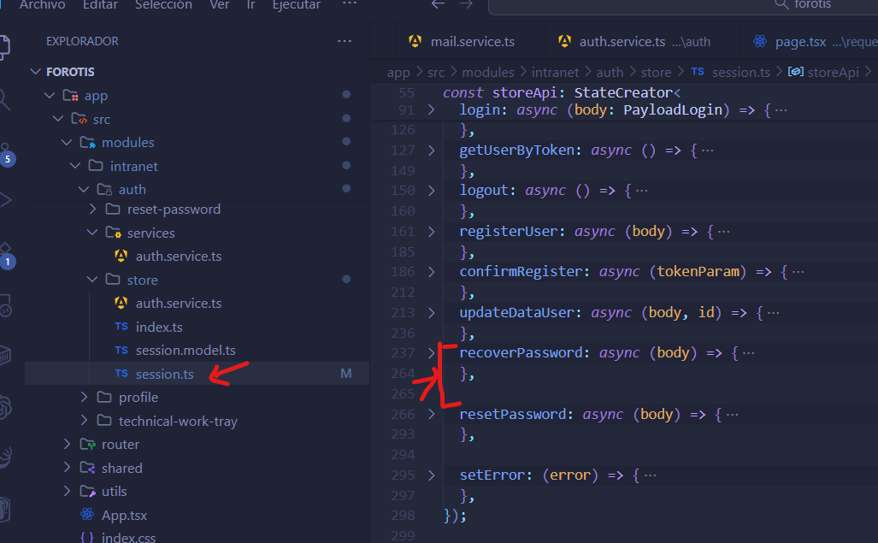
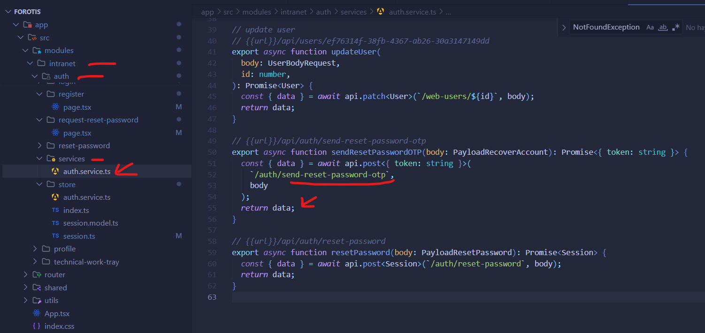
C:\xampp\htdocs\forotis\app\src\modules\intranet\auth\services

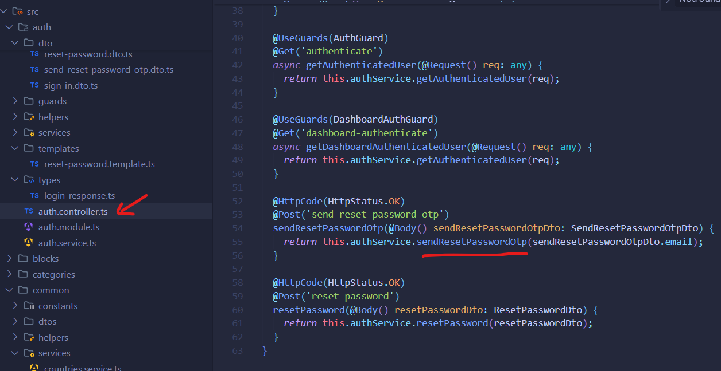
C:\xampp\htdocs\forotis\backend\src\auth

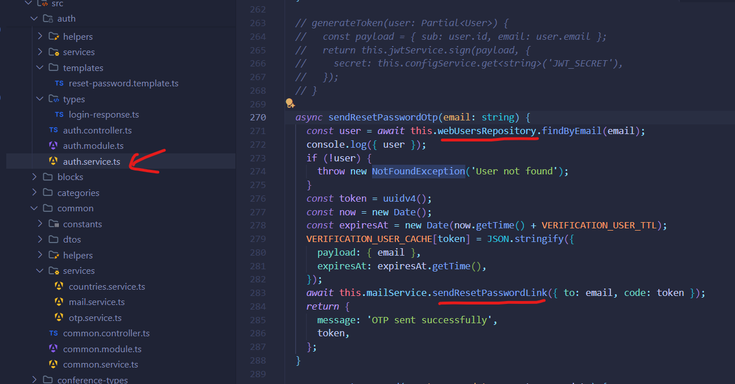
C:\xampp\htdocs\forotis\backend\src\auth

C:\xampp\htdocs\forotis\backend\src\domain\repositories
