SMART VIBRATION SENSORS TO IMPROVE HAUL TRUCK OPERATIONS: REAL-TIME INSIGHTS FOR MAINTENANCE, ROAD CONDITION AND OVERSIZE DETECTION
(Mining Operations and Asset Management – Maintenance Management)

MacDonald Mandaza¹, Kanishka Jayasinghe², Hayden Marcollo³ and Alejandro Postigo⁴

¹ Author: AMOG, Australia (macdonald.mandaza@amog.consulting +613 9542 3700)
² Coauthor 1: AMOG, Australia (kanishka.jayasinghe@amog.consulting +613 9542 3700)
³ Coauthor 2: AMOG,Australia (hayden.marcollo@amog.consulting +613 9542 3700)
⁴ Coauthor 3: RDR, Peru (proyectos_soporte@rdr.com.pe +51 992 744 537)

____________________________________________________________________________________

Abstract

Mining operations face significant challenges across the entire value chain, from extraction through haulage to processing. Undetected oversized rocks, poor road conditions, and excessive equipment wear impact haul truck operations and cause substantial processing plant downtime through crusher blockages. These issues directly affect operational efficiency, equipment lifespan, and ultimately mine profitability.
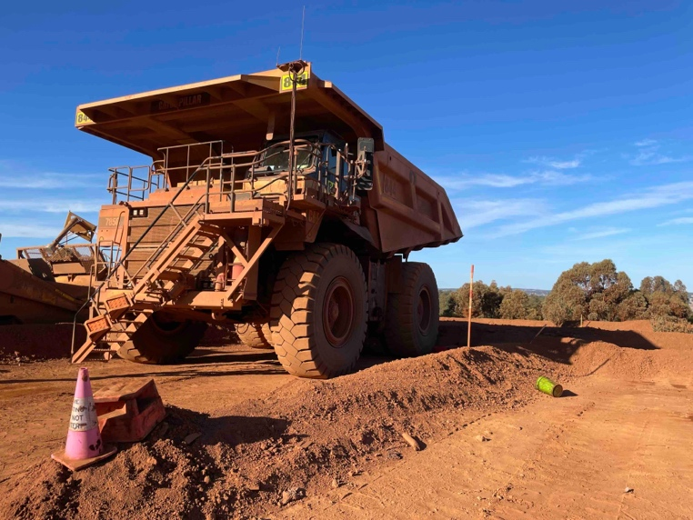
The objective of this paper is to present a vibration and GNSS based monitoring system that addresses these challenges through real-time data collection and analysis. The system aims to improve haul truck maintenance regimes, monitor road conditions, detect oversized rocks during loading, and enhance overall operational efficiency through data-driven insights.

The methodology employs ruggedised, battery-powered wireless sensors specifically designed for mining environments. These sensors are rapidly deployable on haul truck trays using magnetic mounting to minimise installation and maintenance overhead. The system continuously monitors vibration and shock events throughout the load and haul cycle, processing data both at the edge and in the cloud depending on operational requirements and connectivity availability.

Results from field implementations demonstrate multiple critical applications including: maintenance optimisation through detection of wear-causing shock events; road condition assessment based on vibration patterns during truck movement; and oversized rock detection during loading based on the vibration response of the tray. Field testing at iron ore operations has validated these capabilities, showing potential to significantly reduce unplanned stoppages at ore processing facilities.

This paper concludes that smart vibration and GNSS integrated monitoring technology represents a practical application of Mining 4.0 principles that can be effectively incorporated into existing operations with minimal disruption. The paper discusses implementation approaches and operational integration pathways that leverage existing fleet management systems and operational workflows, creating a sustainable framework for continuous improvement in haul truck operations.

Figure 1. A haul truck on an operating mine.

1. Introduction

In recent years there has been a clear trend in the emergence of commonly observed challenges across the mining sector. Growing energy and capital costs, along with decreasing ore grades are among the increasing headwinds that the industry is contending with.

The decline in the quality of ore grades necessitates that operators extract and process larger ore quantities to achieve the same product yield. To remain economically viable, operators must do this while minimising capital expenditure on the infrastructure, equipment and machinery required to meet increasing through-put targets. In effect mines are now being required to operate cheaper, run harder and achieve better uptimes.

Running assets at these new demand levels alone introduces higher production expenses, however, allowing any significant deterioration in asset health and integrity inevitably results in unplanned downtime leading to poor production outcomes. On average, an hour of downtime can cost a mine site up to USD$350 thousand. Oxford Economics affirmed that the cost of downtime from a sample of 2000 global companies was a reported USD$400 billion in a single year [1].

To put the scale of these challenges into perspective, in the years spanning 2019 – 2023, global top mining companies on average missed between 1 to 11 percent of production forecasts across commodities such as copper, gold and zinc. In the zinc market, the maximum forecast production miss in this same period was observed to be 95%. The effect of these misses across the sector was a missed production valuation of USD$59 billion between the years of 2020 – 2023 [2].

Strategic adoption of technology across the sector along with effective utilisation of data, holds the potential of solving several significant industry challenges simultaneously.

The advent of technology in the mining sector is one not to be ignored as a solution for the challenges presented. Simple and novel solutions are demonstrating in today’s landscape that they have the potential to invoke significant impact that improves:

- Asset health, integrity and reliability management
- Process optimisation and operational efficiency
- Cost reduction and operational decision making

In above ground load and haul operations, running load and haul assets such as haul trucks and excavators accounts for a significant portion of a site’s operational costs. These mining assets are also on the critical path of an open-pit operations’ value chain as they directly influence mine through-put.

Understanding how effectively these assets are being used highlights where business value can be fully captured. Increasingly the application of technology to fulfil this function is being acknowledged and exploited. The high-level objective was therefore determined to be the implementation of a haul truck-based accelerometer and GNSS solution that tackles the larger scale industry challenges of decreasing ore grades and growing capital costs.

2. Objectives

The primary objectives of the solution explained in this paper are to:

- Collect haul truck and excavator loading and movement data to generate actionable insights that can be demonstrated to counter-act the impact of decreasing ore grades by improving mining asset utilisation and productivity rates.
- Collect haul truck accelerometer-based chassis wear data for use in improving decision making in the areas of haul-truck health and integrity management. The insights generated are to be demonstrated to have the potential to reduce capital costs.
- Collect site haul road condition data to enable haul trucks and haul truck components to achieve greater longevity and better health outcomes or present a more cost-effective methodology of maintaining haul roads.
- Implement a solution with a low to medium implementation and operation cost allowing the solution to be scalable. The cost achieved must enable the solution to be leveraged by mine operators of all tier levels and accommodate multiple commodities.

3. Solution methodology and data collection

3.1 Field implementation strategy
The implemented solution aims to achieve the outlined objectives by influencing the high significance input mechanisms that lead to poor haul truck maintenance outcomes and compromised load and haul asset productivity and utilisation. The key mechanisms targeted include:

- Haul truck chassis wear from shock, rack and bias events
- Haul road degradation
- Haul truck and excavator cycle times (including queueing time tracking)
- Run-of-Mine (ROM) bin uptime and utilisation

For each selected mechanism, data was collected in a field implementation pilot to understand general performance or conditions and identify the occurrence of adverse events. Accelerometer and GNSS technologies were leveraged to collect the data required to infer the desired information. These technologies typically have application in the realms of asset tracking and condition monitoring.
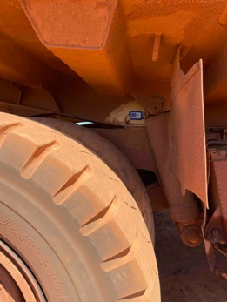
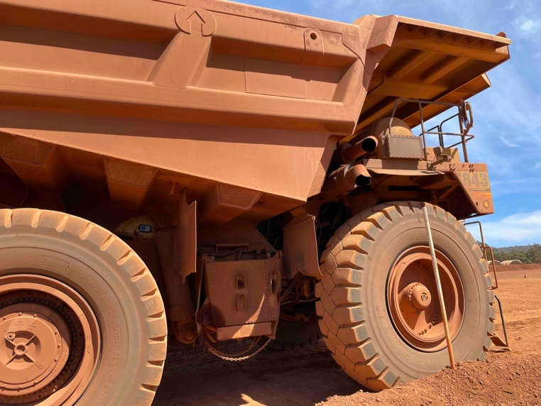
Figure 2. Sensor installed on haul truck tray.

The field implementation pilots were conducted on active mine sites in Western Australia. A standardised approach was utilised to conduct the pilots as per the following steps:
- Request of site operation logs to establish productivity rates & present prevalence of challenges that can be addressed by the proposed solution
- Liaise with site to determine objectives, key performance criteria, the pilot duration and the number of haul trucks in the fleet to instrument
- Installation of hardware on haul trucks and commissioning of the solution for pilot operation
- Monitoring of the solution accompanied by periodic review of insights being captured and communicated by the solution.
- Summary and review of collected data to generate pilot results and assess benefit potential.
- Collaboration with site to implement an integrated solution based of existing site infrastructure, processes and desired solution functionality.

3.3 Implemented solution description

For the field implementation pilots used as examples in this paper, up to two trucks were instrumented concurrently. The solution consisted of:
- A ruggedised, batter-powered wireless sensor installed on the haul truck tray. The install location is optimised to maximise capture of target vibration content.
- A GNSS and 4G/LTE enabled gateway device used for aggregating sensor data and integrating data to an on-line dashboard.

The solution is designed to operate independently of any other systems or solutions. This allows the system to be retrofitted to any haul truck, at any point in the life cycle of a mine’s operation.

3.3.1 Measuring and quantifying chassis wear & haul road degradation

Haul truck chassis shock is collected using the sensor installed on the tray. Basic capture of acceleration and GNSS data immediately provides information relevant to mechanisms such as chassis wear and haul road condition. Further processing of the data is required to normalise against factors such as vehicle speed. Smart algorithms used in data processing are typically employed on the edge to alleviate network utilisation pressures that arise from transmitting raw data.

3.3.2 Tracking haul truck and excavator utilisation & productivity through cycle times

GNSS and accelerometer data are utilised to track where haul trucks are and infer the cycle activity being performed. The use of accelerometers is pivotal in differentiating the different phases within a single haulage cycle. Additionally, the use of an accelerometer on the haul trucks provides a method of inferring cycle information of the excavators without directly instrumenting the excavators themselves.

3.3.3 Implementation of Oversized Rock Detection

Oversized rocks are defined as fragments that exceed the capacity of standard loading, hauling, or crushing equipment. They typically occur:

- At the edge of the blast pattern.
- When local hard pockets are not individually targeted for increased blasting
- When there are restrictions on drill and blast practices.

These fragments are difficult to process and cause reduced production, wear to equipment and site safety concerns.

The oversize detection solution implemented employs accelerometer sensors installed on the haul truck trays to capture tray vibrations during loading. These vibrations are analysed using advanced signal processing techniques to estimate rock sizes within the load to try and detect the presence of oversized rocks.

Leveraging an initial tuning and calibration phase is beneficial to account for common confounding factors that influence accurate interpretation of loading vibrations. This process includes direct validation using visual confirmation methods, controlled loading and correlation of crusher blockage records with loading instances collected.

Detection at the instance of occurrence and implementation of the solution as a real-time system are crucial to the effectiveness of an oversize rock detection solution. This is to allow thorough consideration of decisions and ensures the chosen actions are communicated and actioned in a timely fashion. In comparison to gantry-mounted cameras that detect oversized rocks only once the haul truck travels underneath them on the return journey. This methodology accounts for the fact that notifications must have sufficient time to enable appropriate action.

4. Presentation and discussion of results

4.1 Improving site throughput via optimised haul truck cycle times

In surface mines, smooth operation of haul trucks is the foundation of a productive and efficient operation. Haul truck movements establish the through-put rate that affects all other downstream processes. Cycle times between loading sites and the primary crusher are key in determining a site’s overall throughput rate.

In a single cycle, a haul truck transitions through several phases as illustrated in Figure 3. Combining accelerometer data with GNSS data enables accurate tracking of haul truck movement and precise evaluation of the transition through the various cycle phases. Leveraging data on cycle times enables operators to optimise productivity rates and increase through-put.

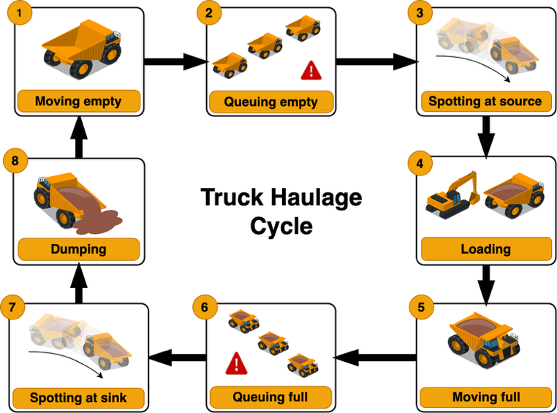

Figure 3. A typical truck haulage cycle.

Queueing phases for example are unproductive and should typically be minimised or eliminated. Using data collected from a single shift during the pilot, it was observed that the median cycle time of one of the instrumented haul trucks was 1211s. Figure 4 summarises the performance of the haul truck over a single shift. In this operation, a single shift has approximately 10 hours available for productive operation of haul trucks. Using the median cycle time observed, a single truck on this route should typically achieve 29 cycles per shift.
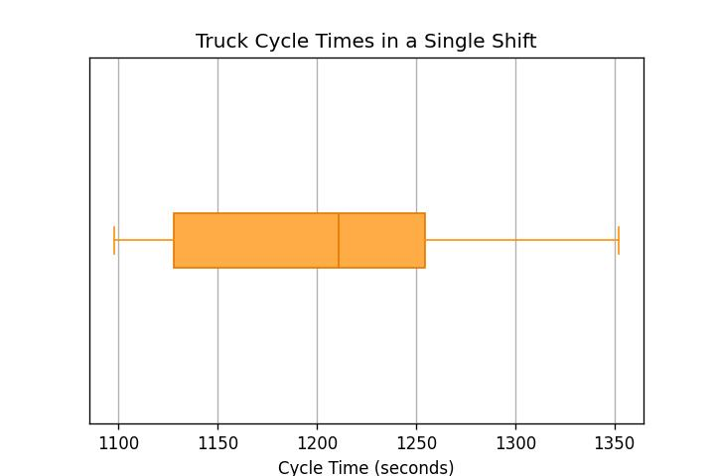
Figure 4. Box-plot showing the haul truck cycle times achieved in a single shift.

Analysis of the cycle phase data collected indicates that more cycles can be achieved. There are several instances where time spent queueing to begin loading was observed to be ~5% of the median haulage cycle time. These insights generated by the system are reported in real-time to operators. Understanding the severity and prevalence of queueing helps planning and dispatching functions to know where further haulage optimisation can be realised.

4.2 Improving site throughput via optimised excavator cycle times

Excavator operation is a critical task in the process of ore extraction. Excavators initiate the transportation of ore from the dig site to the mine's processing facilities by loading the haul trucks. The rate of truck loading sets a throughput limit on the feed to the ROM-bin for a given loading circuit. As shown in Figure 5, a single excavator cycle is comprised of all actions between two dig actions. The rate-of-loading is therefore governed by this excavator cycle time.

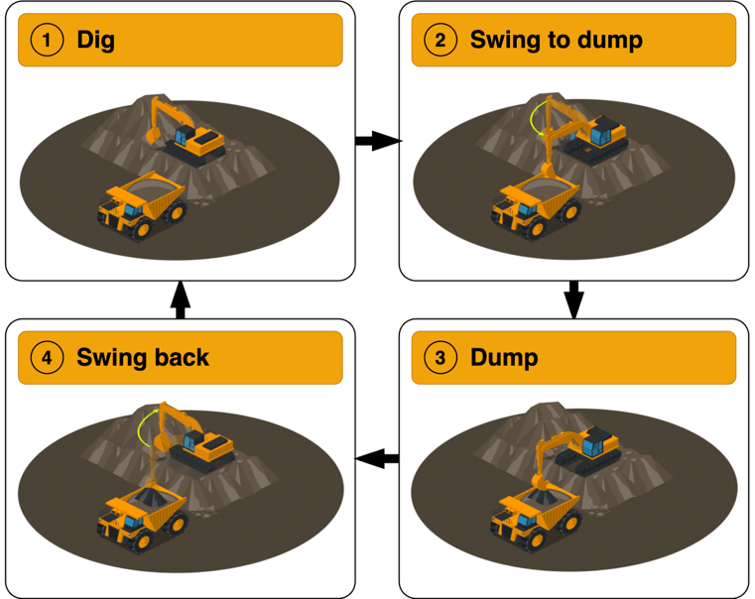

Figure 5. A typical excavator loading cycle.

For the duration of the field implementation pilot, the majority of excavator loading sequences performed on instrumented haul trucks were identified and the cycle time calculated. Figure 6 shows that the spread of excavator cycle times from sample shifts at a selected dig site ranged from 15.8s to 59.7s.
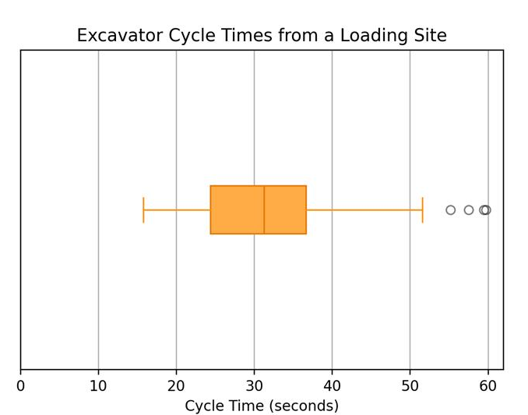

Figure 6. Box-plot showing the excavator cycle times achieved at a single dig site.

Based on the cycle times achieved during the pilot, an assumed bucket capacity of 21.6 tonnes and no wait time on trucks or flitch changes. The indicated maximum loading rate for the shifts in this circuit were ~3.8 buckets per minute or a throughput of 4921.5 tonnes/hr. The median performance for this circuit however was observed to be 2484.3 tonnes/hr. This represents approximately 50% of the indicated capability.

From the data collected, it can be deduced that one underlying reason for this under-performance can be attributed to excavator operator performance. Figure 7 shows a loading cycle where an operator’s worst cycle under-performed the median cycle rate by 35.6%. Using these insights in conjunction with operator assignment records, consistently under-performing operators can be identified and trained adequately to help improve their cycle time KPIs.

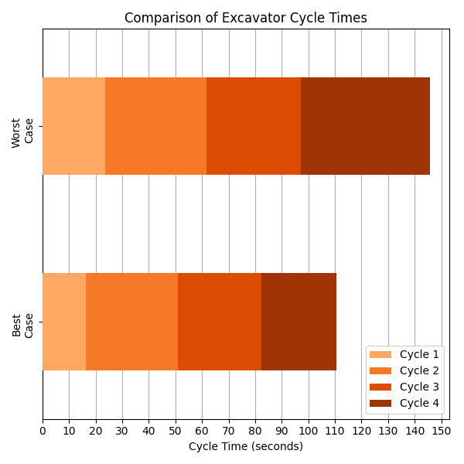
Figure 7. Plot of the best and worst cases of excavator loading cycle performance.

4.3 Improving haul truck maintenance outcomes by tracking wear inducing incidents

Understanding the payload history of haul trucks is critical in accurately determining the causes of chassis problems and excessive tray wear in haul trucks. The root causes of these wear inducing incidents range from poor site conditions to equipment overload and operator abuse. Common practices of assessing the root causes of poor maintenance outcomes are typically time consuming and can be significantly complex.

The conducted pilot demonstrated that the system accelerates root cause assessments. Collected data quickly indicated that significant instances of chassis shock occurred during truck loading. Figure 8 illustrates the range of peak accelerations recorded over a 24-hour period, during each loading instance for one of the monitored trucks. The majority of loading events exist in a range that is reasonable to accept however, there are instances of loads that induce significantly high shocks (greater that 5g).

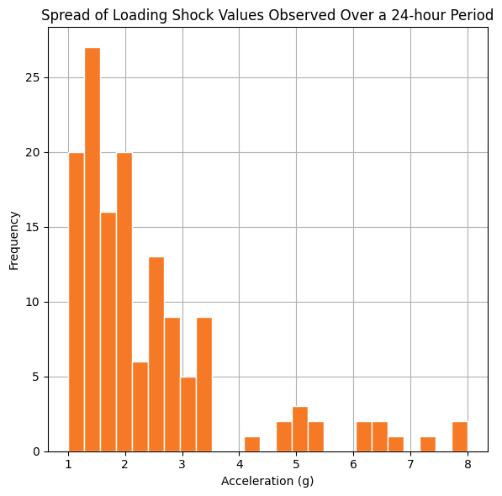
Figure 8. Spread of shock values observed when performing excavator bucket passes.

The data also identifies that shock events are interconnected with excavator loading procedures. Correlating instances of poor loading practice with operator records enables sites to identify opportunities for training and reducing the prevalence of wear inducing events. Systemic issues also have the potential of being quickly identified. Observing high accelerations universally, for example, is a strong indication that an endorsed loading practice is unsuitable. Operators can subsequently implement changes such as adjusting the recommended material drop height or material lay speed during passes.

Aside from loading, shock events were also prevalent while haul trucks travelled between site locations. Figure 9 shows that shock events observed while travelling are concentrated at a higher shock value than those observed during loading. The pervasiveness of extreme shock values, however, is lower during travelling in comparison to loading. These observations immediate highlight the impact of road condition on haul truck wear. This provides insights that can be used for road condition management which is the topic of discussion in section 4.4.

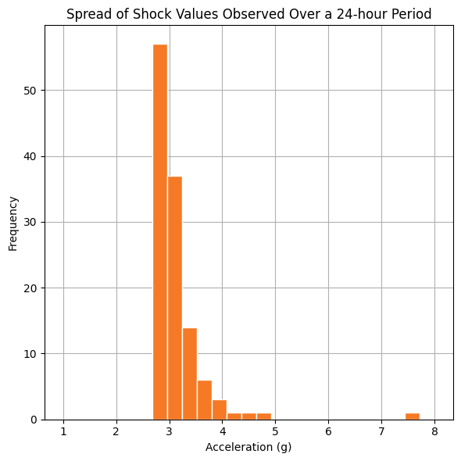
Figure 9. Spread of shock values observed from haul truck driving on haul roads.

4.4 Improving haul truck maintenance and productivity outcomes by improving haul road maintenance

Haul roads are a critical piece in the efficient operation of a mine and are typically affected by jarring and directional stability. Jarring refers to poor road quality caused by permanent deformation in the underlying or in-place materials, along with surface layer damage. Directional stability on the other hand, refers to the propensity of a haul road to form potholes and slip cracks that typically result in the use of evasive action by a haul truck [3]. These phenomena influence both the maintenance outcomes (e.g. accelerated tire wear) and operational efficiency of haul trucks.

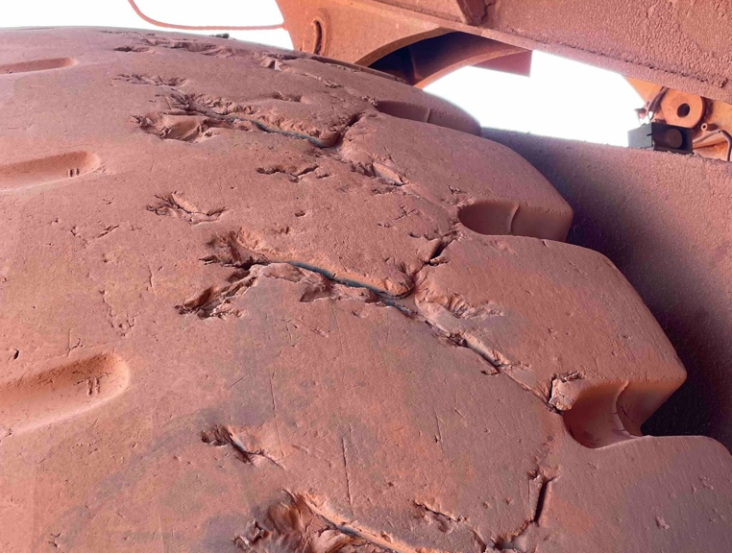

Figure 10. Haul truck tire with evidence of wear.

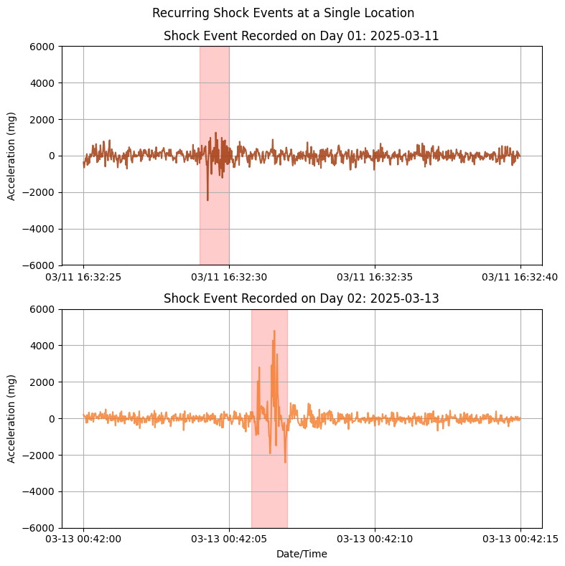
Figure 11. Plots showing an identified road defect.

Assessing the energy content of the vibration profile provides an indication into the destructive potential of the vibration generated due to the degree of jarring. As summarised in Figure 9, jarring and directional instability are a significant cause of shock events that lead to haul truck wear. In the case of directional stability, it was observed that failure to take evasive action resulted in a significant shock event. Figure 11 illustrates how repeated travel along one specific road segment revealed a potential pothole. The road deformity was noted to have induced a shock event that had a severity in the upper percentile range.
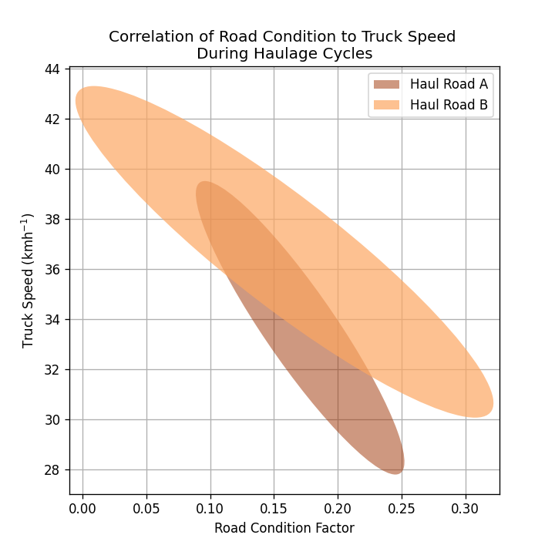
Figure 12. Plot illustrating the effect of road condition on cycle efficiency.

To avoid excessive wear and discomfort due to vibration, haul truck operator also modulate their speed to suit road conditions. Figure 12 shows how collected data provides a correlation between the measured road condition and the achieved haul truck speed. It was observed that on average a 7.8% decline in road condition resulted in a 8.3% decline in the average speed achieved for an unladen haul truck. Reduced truck speeds were noted to result in higher cycle times leading to reduced throughput.

Using this data, road maintenance crew can implement a cost-effective corrective action plan to achieve a specified road condition. This style of prescriptive maintenance is advantageous because it:

- Is actioned only when necessary
- Is directly tailored to achieve desired productivity targets
- Implements the appropriate level of effort to achieve the required gains

4.5 Reducing unplanned stoppages at ore processing facilities through oversized rock detection

Oversized rocks from blasting can disrupt production cycles, requiring secondary breakage thus slowing down material handling and resulting in longer production cycles.

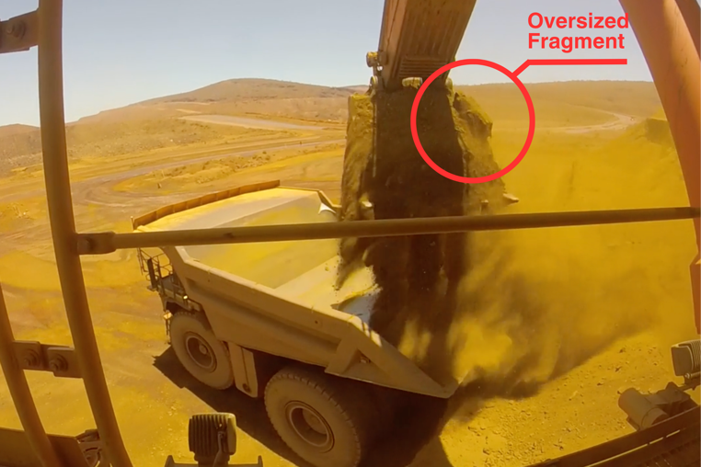

Figure 13. Instance of an oversized rock being loaded onto a haul truck.

 |  | Oversize presence validated |  | Total
 |  | Yes | No | Total
Oversize detected on sensor? | Yes | 15% | 14% | 29%
Oversize detected on sensor? | No | 5% | 66% | 71%
Total |  | 20% | 80% | 100%
Sensitivity = TP / ( TP + FN ) = 15/20 = 75%
Specificity = TN / (TN + FP) > 66/80 > 83%

Figure 14. Table showing the achieved oversized rock detection accuracy of the solution

In the pilot, the accelerometer data demonstrated two key solution parameters:

- The capability to detect buckets being loaded onto the haul truck tray
- The capability to assess each detected bucket for the presence of oversized rocks

A bucket load is first identified and subsequently presented to the oversize detection algorithm for assessment. Figure 13 shows an instance of a bucket load with a visible oversized rock. The solution most effectively detects buckets in the early stages of loading due to the reduced influence of signal damping caused by material build up in the tray. Despite the damped response, it was shown that most bucket loads are detectable. Though it was confirmed that efficacy of detecting oversized rocks in a bucket load decreases as signal damping increases. As per Figure 14, the solution was still validated to have a sensitivity of 75% in detecting oversized rocks.

Solutions for oversized rock detection broadly fall into three main categories:

- Manual methods
- Camera-based solutions
- Vibration-based solutions

Most mine sites rely on excavator operators calling out oversized rocks as they see them, however, this is ineffective in solving the oversize issue. Dust obscures the operators’ view, resulting in missed manual assessments. Dust and debris also affect camera sensor performance, significantly reducing their detection potential. Camera solutions are typically installed on gantry fixtures which is costly and limited to surface layer detection.

Accelerometer systems are advantageous because they excel in harsh mining conditions, ensuring longevity. They are highly proficient at detecting buckets providing greater opportunity to at least try at assessment. In future testing, application of different and more complex signal processing techniques will be applied to investigate the potential for improving the assessment efficacy for oversized rocks in later buckets.



Figure 15. Accelerometer sensors are suited to operating in harsh mining conditions.

When an oversized rock is detected, an alert is issued to either the haul truck operator, or dispatch team, to prompt diversion of the haul truck from the ROM bin. This completely prevents oversize rocks from entering the primary crusher, improving crusher uptime. Reporting of each oversize assessment is also provided as an “oversize factor”. Operators use this factor as an indicator of the likelihood of a blockage occurring. This allows the solution to be tuned to achieve detection rates that are adjusted to match specific ore characteristics and production goals unique to a site. Additionally, reporting a likelihood enables operators to prompt different types of actions for different likelihood levels. For example, sufficiently high likelihoods that are lower than a diversion threshold can prompt early preparation of a rock-breaker. Pre-emptive preparation of a rock-breaker can reduce the time taken to clear a blockage reducing overall downtime.
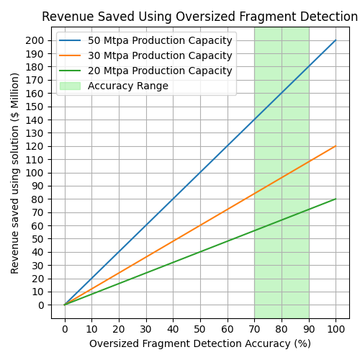
Figure 16. Revenue saved potential of oversize detection system.

The pilot, which aimed to address a production loss of 2 Mtpa due to blockages from oversized rocks, confirmed that the solution can achieve an oversize detection accuracy between 70% and 90%. These results were validated using camera footage and site operation records to demonstrate that between USD$140 million and USD$180 million of lost revenue, annually, could potentially be recovered for the 50Mtpa iron ore site.

5. Conclusions

This paper shows that technology solutions can indeed be a viable solution to the key challenges experienced in the mining sector.

A solution comprised of an accelerometer sensor and GNSS sensor were shown to capture load and haul asset data that provided insight into:

- The cycle time data of excavator operations
- The movement and cycle time data of haul trucks

This data was demonstrated to highlight both the potential operations hold and operation areas where gains in productivity can be made. This was achieved through:

- Identifying opportunities to train load and haul asset operator
- Identifying the prevalence of production hindering conditions such as haul trucks entering queueing states

Furthermore, the solution was also demonstrated to capture data that could be used to improve asset health outcomes. Data captured from haul trucks was shown to inform operators on the root causes of wear inducing shock. In the pilot implementation, the role of shock events from material loading and travel were noted to have a significant influence in the wear accumulation of haul trucks.

The ability to track and quickly understand the root causes of wear was a maintenance benefit highlighted by the solution discussed in this paper. These maintenance benefits directly influence capital costs of mining operations by enabling cost effective maintenance strategies and improving the asset life.

Lastly, the solution was demonstrated to have application in improving haul road maintenance management. Collected data was able to quantify the quality of haul roads and show the degree to which reduced haul road quality affects haul truck cycle time leading to reduced material throughput. Demonstrating the quantification of road quality also shows how targeted road maintenance can be employed. This enables mine sites to efficiently perform road maintenance works.

The simplicity of the solution basis also highlights how low-cost solutions can be strategically implemented to provide high business value. A key innovation of the solution is its ability to operate independently of any other existing site solutions. This enables the following key benefits:

- The solution can be retrofit onto any load and haul truck, broadening its application base
- The independent nature of the solution enables quick implementation due to its low integration complexity and low cyber-security risk

Overall it can be confirmed that challenges around decreasing ore grades and increasing capital costs can be mitigated using technology solutions that are targeted to increase mine throughput and facilitate the employment of cost-reducing maintenance strategies.

6. Annexes

7. References

[1] Prometheus Group., (2025). The future of asset management in mining – connected, integrated and enhanced by AI. Future of Mining Australia 2025 Conference.
[2] Elser B., Gilbertson, B., (2024). Webinar: The Billion-Dollar Blindspot. Austmine webinar.
[3] Thompson, R., (2010). Mine Haul Road Design and Management: A Current Practice Review. Western Australian School of Mines, Curtin University, Kalgoorlie WA, Australia.

