From waste to value: agricultural input production from zinc industry residues

(4. ESG - Waste management and circular economy)

Isabela Correia Costa¹, Saulo Luiz Sales Parreiras de Rezende² y Henrique Hipólito Costa³

¹ Isabela Correia Costa; Nexa Resources; Innovation Engineer; Sergipe Street, 1440, 8° floor - Savassi, Belo Horizonte, Minas Gerais, Brazil; Zip code 30130-174 (ext.isabela.costa.ic1@nexaresources.com; +55 31 99832-0500).

² Saulo Luiz Sales Parreiras de Rezende, Nexa Resources, Innovation Engineer; Sergipe Street, 1440, 8° floor - Savassi, Belo Horizonte, Minas Gerais, Brazil; Zip code 30130-174 (ext.saulo.rezende@nexaresources.com, +55 31 99876-2819).

³ Henrique Hipólito Costa, Nexa Resources, Innovation Engineer; BR 267 KM 119, S/N – Igrejinha, Juiz de Fora, Minas Gerais; Zip code 36.091-970 (ext.henrique.costa@nexaresources.com, +55 31 99141-5230).
____________________________________________________________________________________

ABSTRACT

This study evaluates the technical and financial feasibility of producing a calcined agricultural input by reusing two industrial residues generated during the processing and smelting of zinc ore. The residues used in the formulation include a dolomitic tailing originating from the mineral beneficiation stage and a calcium sulfate-rich waste derived from the treatment of industrial effluents. These materials were mixed in predetermined proportions and subjected to thermal processing in a pilot-scale rotary kiln, simulating industrial calcination conditions. The resulting product, after calcination, exhibited significant concentrations of essential nutrients, namely calcium (Ca), magnesium (Mg), sulfur (S), and zinc (Zn). Furthermore, toxic elements such as cadmium (Cd) and lead (Pb) were found in concentrations below the maximum limits established by the Normative Instruction No. 27 of the Brazilian Ministry of Agriculture and Livestock (MAPA) for mineral fertilizers containing secondary macronutrients and micronutrients — with average levels of 20 ppm Cd and 1162.5 ppm Pb, respectively, confirming the product’s compliance with national regulatory standards. X-ray diffraction analysis revealed the formation of various crystalline phases in the calcined material. Among them were periclase (MgO), zincite (ZnO), and anhydrite (CaSO₄), which are beneficial for nutrient availability in soils. However, the presence of mineral phases such as brownmillerite and larnite, known for their lower solubility, indicates reduced reactivity of the product as a liming agent. These phases are likely a result of the high-temperature conditions (approximately 24 hours at elevated temperatures) employed during calcination, which may have favored the formation of stable, less reactive compounds. As such, future process improvements, particularly in optimizing the residence time and operational temperature within the kiln, are recommended to enhance the formation of more reactive oxides and increase the agronomic efficiency of the final product. Furthermore, the financial and commercial feasibility tests demonstrated the economic viability of scaling up this production process to an industrial level. In summary, the research demonstrates a promising alternative for the sustainable management of industrial residues associated with the zinc production chain. By diverting waste from traditional disposal routes — such as tailings storage facilities — and converting it into a value-added product, the project aligns with circular economy principles. The calcined material presents potential applications not only as a mineral fertilizer enriched in secondary macronutrients and micronutrients but also as a soil conditioner and acidity corrector. Its multi-nutrient profile, containing Ca, Mg, S, and Zn, contributes to soil health and agricultural productivity, offering a dual benefit of environmental responsibility and economic opportunity.

1. Introduction

Mining activity, which comprises a wide range of operations — from geological prospecting and exploration to extraction, beneficiation, and mineral processing — plays a fundamental role in the functioning and development of several productive sectors. In Brazil, the importance of this sector is evidenced by data from the Brazilian Mining Institute (IBRAM), which reported that, in 2024, the mineral trade balance accounted for approximately 47% of the country’s total trade balance (IBRAM, 2024). Despite its relevance, the mining production chain is also associated with significant environmental and social challenges, particularly due to the large volumes of waste it generates throughout its stages. These residues are produced in different forms, including tailings, waste rock, slag, and process residues, and require appropriate management to avoid long-term environmental impacts. This issue is especially critical in regions with a high concentration of mining operations, such as the state of Minas Gerais. According to the Mining Solid Waste Inventory, published by the State Environmental Foundation (Feam), over 562 million tons of mining waste were documented in Minas Gerais between January and December 2017 (FEAM, 2018). This volume reflects the intensity and scale of mining operations in the region and highlights the need for more sustainable waste management strategies

To address this issue, the adoption of circular economy (CE) principles in the mining sector aims to convert waste streams into valuable secondary raw materials, thereby reducing environmental liabilities and enabling the recovery of critical metals and mineral fractions (Kinnunen et al, 2022). CE implementation in mining supports the development of alternative processes that promote resource regeneration and value creation from the substantial volumes of waste generated. These strategies include waste stream recycling, advanced sorting techniques to minimize disposal, and the reintegration of recovered metals into products, extending their lifecycle and improving material efficiency within the industry (Osei et al., 2023).

In this context, Nexa Resources, the fifth largest zinc producers in the world, stated in its Annual Report that 25% of the waste and tailings generated by the company in Brazil and Peru are disposed of in tailings dams, while 38% are deposited in dry-stacked piles (NEXA, 2024). One example of the first type of disposal method refers to a specific residue generated during the treatment of industrial effluents at a zinc smelting facility. This residue, commonly referred to as “gypsum” due to its high calcium sulfate content, results from a chemical process in which limewater (calcium hydroxide solution) and sodium sulfide are introduced into the wastewater stream. The purpose of this treatment is to increase the pH of the effluent and promote the precipitation of dissolved heavy metals, particularly cadmium (Cd) and lead (Pb), which are commonly present in this type of industrial wastewater. As a result of this process, a solid waste is formed. The annual volume of this gypsum-like residue reaches approximately 13,000 tonnes when measured on a dry basis. A visual representation of this calcium sulfate-rich waste, obtained from the wastewater treatment process, is provided in Figure 1.

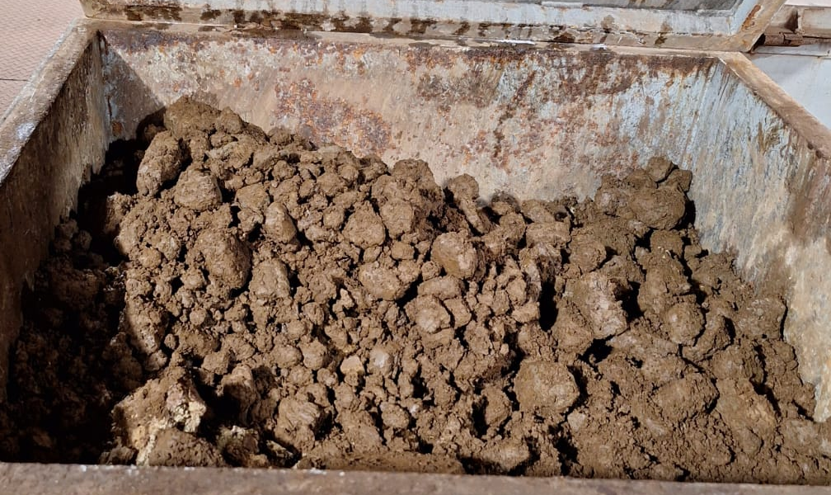

Figure 1. Calcium sulfate-rich waste from wastewater treatment. Source: authors.

In relation to the dry-stacked piles disposal method, a representative example is the dolomitic tailing generated during the beneficiation of zinc ore. This material, shown in Figure 2, is produced as a result of a sequence of unit operations commonly employed in mineral processing plants. The process begins with comminution, which consists of crushing and grinding the run-of-mine ore to reduce particle size. Subsequently, flotation is applied to separate valuable sulfide minerals from the gangue, followed by a thickening stage, where solids are concentrated and excess water is removed. These operations are illustrated schematically in Figure 3. As an outcome of this sequence, a large volume of tailings with high dolomite content is produced, reaching an estimated annual generation of approximately 1 million tonnes. It is important to note that both the dolomitic tailing and the gypsum-like residue mentioned previously are generated at industrial units located in the state of Minas Gerais, Brazi

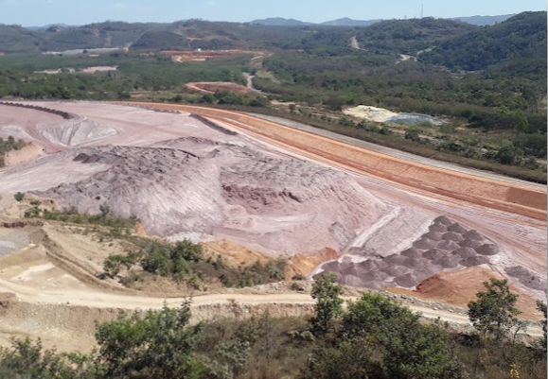

Figure 2. Deposit of dolomitic tailing in dry-stacked piles. Source: Nexa Resources.
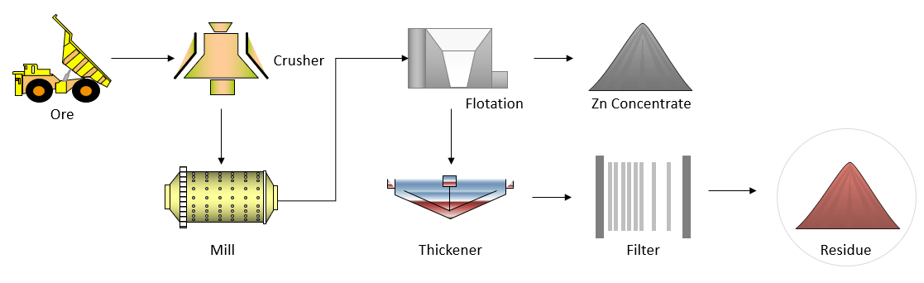

Figure 3. Generation process of the dolomitic tailing. Source: authors.

From a geochemical and mineralogical perspective, previous studies have shown that these residues contain potentially toxic elements (PTEs), such as lead (Pb), cadmium (Cd), and manganese (Mn), primarily due to the mineralogical composition of the original zinc ore. Chen et al. (2022) demonstrated that these elements are predominantly associated with carbonate minerals, for example dolomite, while Pb may also be found in sulfide minerals such as galena (PbS). Furthermore, during wastewater treatment at the zinc smelter, sodium sulfide is commonly added to precipitate heavy metals, resulting in the formation of compounds such as PbS and CdS. As a result, both types of residues evaluated in this study - the mining tailings and the sludge from wastewater treatment - contain measurable levels of Pb and Cd, which are relevant in assessing their environmental risk and feasibility for reuse.

Alongside the mining sector, the agribusiness sector plays a crucial role in Brazil's economy, accounting for approximately 24% of the country's wealth generation and exerting a significant influence on the Gross Domestic Product (GDP), as reported by the Brazilian Agricultural Research Corporation (EMBRAPA, 2023). Despite its importance, this sector faces the challenge of balancing rapid population growth, which increases food demand and, consequently, the pressure to expand agricultural production, with the preservation of ecosystems. In response, countries have been adopting sustainable intensification strategies aimed at increasing agricultural productivity on existing farmland without the need for further expansion (EMBRAPA, 2023).

This trend is illustrated in Figure 4, which shows the increase in productivity of grain-producing areas in Brazil between 1994 and 2023. According to data from the Agricultural Information System (CONAB), during this period, production rose by over 400%, while the planted area increased by only 60% (CONAB, 2024). This disparity highlights significant gains in yield per hectare, reflecting improved management practices and technology adoption. The productivity gains can be attributed to several factors, including the use of precision agriculture technologies and the appropriate use of agricultural inputs.

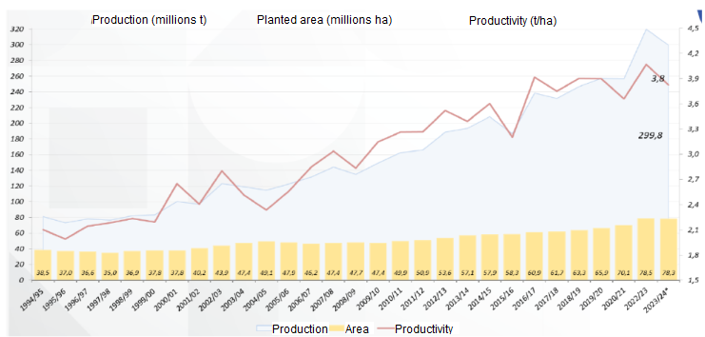

Figure 4. Trends in Grain Production and Cultivated Area in Brazil (1994–2023). Source: CONAB, 2024.

In Brazil, Decree No. 4954 of January 14, 2004, establishes the definitions of fertilizers and soil amendments for agricultural use. According to this regulation, fertilizers are defined as mineral or organic substances, natural or synthetic, that supply one or more nutrients to plants, including micronutrients (e.g., Zn, Fe, Mn, Si) and macronutrients (N, P, K). Soil amendments, in turn, are products of inorganic and/or organic origin intended to improve the physical, chemical, and biological properties of soils, either individually or in combination. These include materials used to correct soil acidity or to enhance physicochemical conditions (i.e., soil conditioners) (BRASIL, 2004).

To be commercialized, both fertilizers and amendments must meet the specifications of Normative Instruction No. 27/2006 of the Ministry of Agriculture and Livestock (MAPA), with regards to the maximum concentrations allowed for toxic heavy metals and other substances. For mineral fertilizers containing secondary macronutrients and micronutrients, Annex I of the Normative Instruction specifies that the maximum permissible concentrations of cadmium (Cd) and lead (Pb) are calculated by multiplying the sum of guaranteed micronutrient contents (expressed as percentages) by 15 and 750, respectively. The resulting values represent the limits in mg/kg of product. For acidity correctives, however, Annex II establishes the maximum concentrations in 20 ppm for Cd and 1000 ppm for Pb (BRASIL, 2006).

Another important parameter to be assessed is the solubility of the declared nutrients, as established in Normative Instruction No. 39/2018 of August 8, 2018. Both micronutrients and secondary macronutrients (Ca, Mg, S) must have their solubility expressed as total mass percentage in the fertilizer. Additionally, for certain micronutrients, including Zn and Fe, it is necessary to declare the content soluble in 2% citric acid (BRASIL, 2018). To be specifically classified as a soil acidity corrector, Normative Instruction No. 35/2006 of MAPA defines that the product must contain available forms of calcium and magnesium, typically as free CaO and MgO, capable of neutralizing soil acidity and enhancing base saturation. Table 1 shows that the sum of these oxides (%CaO + %MgO) must be at least 38% (w/w) (BRASIL, 2006).

Table 1. Reference parameters for soil acidity corrective materials. Source: Adapted from MAPA Normative Instruction No. 35/2006 (BRASIL, 2006).

Soil acidity corrective material | Sum of oxides (%CaO + %MgO)
Agricultural limestone | 38
Agricultural calcined limestone | 43
Agricultural hydrated lime | 50
Agricultural quicklime | 68
Reference parameters for other correctives | 38

Considering the context described above and aligned with its ESG (Environmental, Social, and Corporate Governance) strategy, Nexa began exploring technological solutions to valorize both the dolomitic and gypsum residues, applying the principles of Circular Economy. The focus is on the agricultural sector, aiming to reduce environmental liabilities associated with residue disposal while generating economic value through the sustainable reuse of mining by-products.

2. Objectives

This study aims to present the technological development process and results of exploratory trials designed to assess the feasibility of applying a dolomitic tailing generated in the beneficiation of zinc ore and another residue generated in the wastewater treatment of a zinc smelter as agricultural inputs. The agricultural input to be produced consists of a combination of limestone and gypsum, with the potential to correct soil acidity, supply essential secondary macronutrients, such as calcium, magnesium, and sulfur, and improve soil structure. The product generated also has the potential to provide zinc, an essential micronutrient for plant growth and development.

In addition to the agronomic benefits, the project provides strategic advantages for the company by enabling the reuse of industrial residues, reducing environmental liabilities associated with tailings disposal, and potentially generating economic value through the commercialization of a marketable agricultural product. Additionally, the recovery of zinc, cadmium, and lead concentrates is intended, aiming to reintroduce these materials into the company's production process.

3. Methodology and data collection

3.1 Residues

Table 2 presents the chemical characteristics by a preliminary atomic absorption analysis of each residue. The evaluation of regulatory compliance was based on the limits established for mineral fertilizers containing secondary macronutrients and micronutrients. As the materials described below contain cadmium and lead concentrations exceeding the limits established by current legislation, a treatment process is required to ensure compliance with market standards. This treatment involves calcination in a rotary kiln, which promotes the thermal decomposition of the matrix and facilitates the reduction and volatilization of certain heavy metals.

Table 2. Characterization of the materials under study. Source: authors.

Elements | Dolomitic tailing | Gypsum residue
Zn content (%w/w) | 3.25 | 19.25
Cd content (ppm) | 400 | 3,000
Cd Limit (ppm)* | 50 | 290
Pb content (ppm) | 3,000 | 4,900
Pb Limit (ppm)* | 2,400 | 10,000
*According to the limits defined in Annex I of MAPA Normative Instruction No. 27/2006.

The reactions involved in the calcination process are described below. Sulfide minerals (PbS, CdS) were considered, as they represent the predominant form of contaminants in the material analyzed. The temperature must be maintained at 990 °C to exceed the decomposition point of the dolomite matrix, which occurs around 900 °C (Olszak-Humienik, 2015). Under these conditions, cadmium is effectively removed due to its relatively low boiling point (767 °C), which allows its volatilization during calcination. As a result, the reaction represented by Equation (2) occurs, enabling the release of Cd from the solid matrix. In contrast, lead has a much higher boiling point (1725 °C), and therefore the reaction represented by Equation (4) does not take place under the same thermal conditions. To enable its removal, calcium chloride is added to the mixture, promoting the formation of volatile lead chlorides and facilitating its release from the solid phase.

CdS + O₂ à CdO + SO₂ + heat​ (1)
CdO + CO(g) à Cd(g) + CO₂(g)​ (2)

PbS + O₂ à PbO + SO₂ + heat​ (3)
PbO + CO(g) à Pb(g) + CO₂(g)​ – does not occur(4)

PbO +CaCl₂ + heat à PbCl₂(g) + CaO(g)​ (5)

Zinc is recovered through a similar carbothermic reduction process as cadmium. The reaction leads to the formation of zinc oxide (ZnO), which is collected as a fine particulate or dust in the gas phase, due to the metal’s relatively low boiling point and high volatility under these conditions.

3.3 Tests on pilot scale

The evaluation of the proposed technology was carried out through tests conducted in a pilot-scale rotary kiln with a feed capacity of 10 kg/h, a length of 4 m, a rotation speed of 5.6 x 10⁻³ Hz, and an inclination of 2°. Figure 5 shows a two-dimensional schematic of the pilot-scale rotary kiln system, including auxiliary components, such as the fabric filter and the collection point for the agricultural input. It is important to highlight that this pilot kiln represents an industrial kiln that Nexa already has in one of its units, which is shown in Figure 6. Therefore, the idea is to use the industrial kiln during idle periods in the unit’s regular operation, which is dedicated to the calcination of secondary raw materials containing zinc.

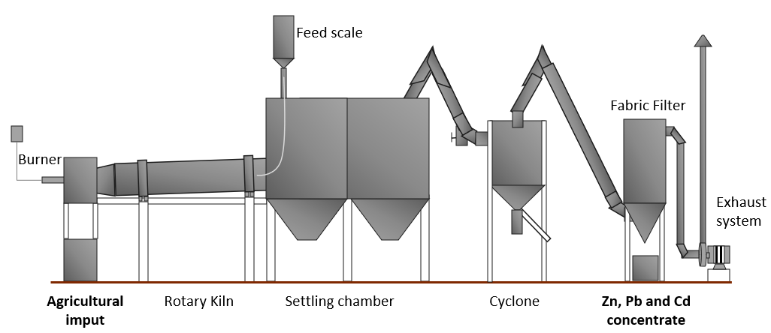

Figure 5. 2D schematic of the Pilot-scale rotary kiln. Source: authors.
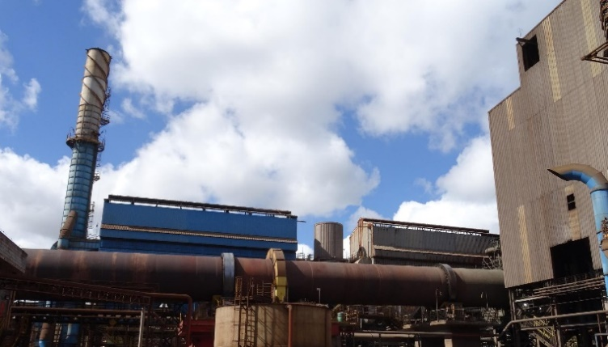

Figure 6. Industrial rotary kiln. Source: authors.

Two tests were performed in duplicate, as detailed in Table 3. The mass flow rate of the gypsum residue introduced into the kiln was defined based on a set of operational and logistical parameters, including the estimated annual generation of this residue at the industrial unit, the available idle periods of the rotary kiln, its nominal processing capacity, and the average utilization rate during regular operations. Considering these constraints, it was determined that the gypsum residue could represent approximately 43% of the total processing capacity of the kiln under the test conditions.

The feed rate of metallurgical coke, used as the reducing agent in the calcination process, was varied between two conditions. The first condition, 27%, reflects the current proportion typically used in the industrial kiln under standard operating conditions. The second, 10%, was established based on a preliminary financial feasibility analysis, which indicated the potential for reducing fuel consumption to lower operational costs while maintaining process efficiency. The calcium chloride addition rate was fixed at 2% of the total mass flow, based on prior internal studies and past experimental results, which had shown this concentration to be effective in promoting Pb removal during calcination. Finally, the feed rate of the dolomitic residue was calculated indirectly, by subtracting the combined mass contributions of the other reagents (gypsum residue, coke, and calcium chloride) from the total processing capacity of the kiln (10 kg/h).

Table 3. Conditions of the tests conducted in a pilot-scale rotary kiln. Source: authors.

Condition | Dolomitic tailing (kg/h) | Gypsum residue (kg/h) | CaCl₂ (kg/h) | Coke (kg/h)
1 | 2.8 | 4.3 | 0.2 | 2.7
2 | 4.5 | 4.3 | 0.2 | 1.0
Each experiment had a residence time of 24 hours, and the average kiln temperature was maintained at 990°C, which exceeds the decomposition temperature of the dolomite matrix. The agricultural input and the Zn, Cd/Pb-rich concentrate obtained after each test were collected and subjected to atomic absorption spectroscopy for analysis. Figure 7 provides a flowchart summarizing the process steps evaluated during the tests, offering a visual representation of the sequence and conditions applied throughout the study.

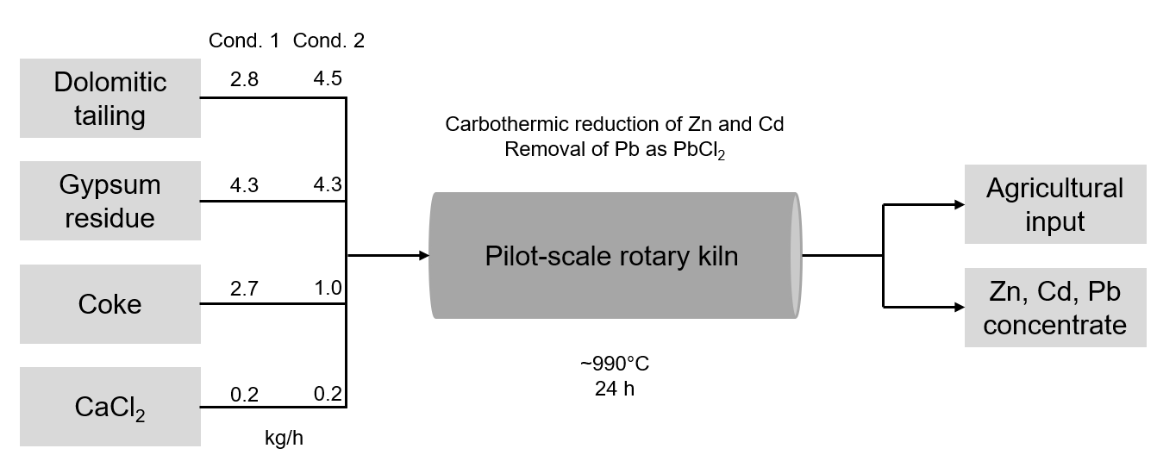

Figure 7. Schematic representation of the tested process.

3.4 Financial feasibility study

Following the technical validation of the proposed process, a financial and commercial feasibility study was conducted to evaluate the economic viability of implementing the proposed production process on an industrial scale. The analysis included market-related assumptions, such as regional demand for agricultural inputs, transportation logistics, and distribution capacity. Technological factors were also considered, including the required quantities of raw materials, specifications of the equipment involved in each processing step and labor requirements for continuous operation. Product pricing was estimated based on the current market value of a mixture of agricultural limestone and gypsum — materials that the proposed input aims to replace — considering the similar functions they perform in soil amendment and nutrient supply.

The economic assessment also included estimates of capital expenditures (CAPEX), covering equipment and infrastructure investment, and operational expenditures (OPEX), including raw materials, utilities, maintenance, and labor costs. To assess project profitability, key financial indicators were calculated, including Net Present Value (NPV), Internal Rate of Return (IRR), Earnings Before Interest, Taxes, Depreciation, and Amortization (EBITDA), and Payback period. These metrics provided a quantitative basis for evaluating the potential return on investment and supporting decision-making regarding industrial-scale implementation.

4. Presentation and discussion of results

4.1 Tests on pilot scale

The resulting agricultural input is shown in Figure 8. The observed changes in color and hardness between the feed mixture, shown in Figure 9, and the final product suggest that the calcination process was effective. Figure 10, in turn, presents the Zn, Cd/Pb-rich concentrate, which has a light gray color, visually similar to zinc oxide.

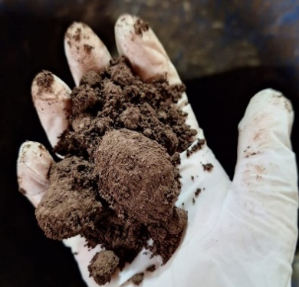

Figure 8. Mixture (gypsum residue, dolomitic tailing, coke, and calcium chloride) feed to the pilot-scale rotary kiln. Source: authors.

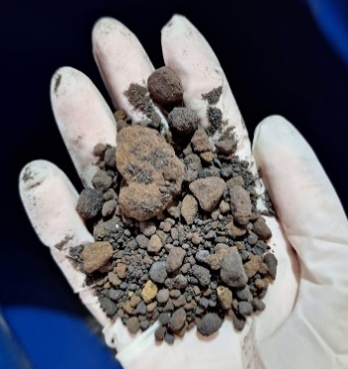

Figure 9. Product obtained after calcination for 24h under approximately 990°C. Source: authors.

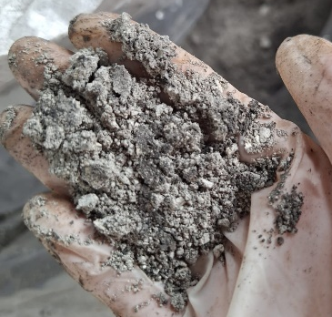

Figure 10. Zn, Cd/Pb concentrate obtained. Source: authors.

Tables 4 and 5 present the atomic absorption results for the feed mixture, the agricultural input (product) and the Zn/Pb/Cd concentrate. The values represent the average of duplicate analyses performed for each condition.

Table 4. Chemical characterization of the material generated under Condition 1. Source: authors.

Parameter (% w/w) | Feed mixture | Agricultural input | Zn/Pb/Cd concentrate
Zn | 7.34 | 14.88 | 47.95
Pb | 0.26 | 0.13 | 3.00
Cd | 0.10 | 0.0015 | 0.95
CaO | 13.82 | 37.60 | 0.93
MgO | 6.49 | 12.80 | 0.24
Al₂O₃ | 0.61 | 1.43 | 0.05
SiO₂ | 2.55 | 6.99 | 0.00
Carbono | 35.10 | 5.31 | 2.72
Fe | 6.30 | 16.20 | 1.77

Table 5. Chemical characterization of the material generated under Condition 2. Source: authors.

Parameter (% w/w) | Feed mixture | Agricultural input | Zn, Pb/Cd concentrate
Zn | 8.13 | 11.35 | 34.2
Pb | 0.32 | 0.1025 | 2.91
Cd | 0.11 | 0.0025 | 0.924
CaO | 19.37 | 37.4 | 0.53
MgO | 10.32 | 15.35 | 0.20
Al₂O₃ | 0.83 | 1.76 | 0.04
SiO₂ | 3.45 | 5.98 | 0.00
Carbono | 17.28 | 2.54 | 3.06
Fe | 8.82 | 17.00 | 1.59

Based on the zinc content and in the limits established for mineral fertilizers containing secondary macronutrients and micronutrients (Annex I of MAPA Normative Instruction No. 27/2006), it is observed that both conditions produced an agricultural input with cadmium and lead levels below the limits established by current legislation, as shown in Table 6. The results indicated a 98% reduction in cadmium (Cd) content and approximately 55% reduction in lead (Pb) content in both analyzed conditions, when compared to the respective feed mixture. Although differences were observed between the two conditions, since both remained within the established limits, condition 2 was considered preferable due to its preliminary financial feasibility.

Table 6. Content of Cd and Pb in each agricultural input and the respective limit according to Annex I of MAPA Normative Instruction No. 27/2006. Source: authors.

Parameter | Agricultural input – Condition 1 | Agricultural input – Condition 2
Zn (%w/w) | 14.88 | 11.35
Pb content (ppm) | 1,300 | 1,025
Pb limit (ppm) | 10,000 | 8,500
Cd content (ppm) | 15 | 25
Cd limit (ppm) | 220 | 170

In addition, the sum of calcium oxide and magnesium oxide contents reached approximately 50%, which is in accordance with the specifications and minimum requirements for acidity correctives established by MAPA’s Normative Instruction Nº. 35. Based on this normative, the material can be classified as a calcined agricultural soil amendment (BRASIL, 2006). However, to be considered a soil acidity corrector, the product must contain available forms of calcium and magnesium.

An X-ray diffraction (XRD) analysis was also conducted on the calcined product to verify the mineralogical phases. The analysis revealed the presence of periclase (MgO), brownmillerite (Ca₂(Al,Fe)₂O₅), anhydrite (CaSO₄), larnite (Ca₂SiO₄), magnetite (Fe₃O₄), and zincite (ZnO). The detection of periclase and zincite indicates the availability of magnesium and zinc in reactive forms, which are beneficial as secondary nutrients for plant development. Anhydrite contributes with soluble calcium and sulfur, which can enhance soil structure and nutrient uptake. The presence of magnetite may serve as a supplementary slow-release source of iron, supporting micronutrient supply in intensively managed or nutrient-depleted soils (SUN et al., 2023).

However, the presence of brownmillerite and larnite suggests that part of the calcium is bound in low-solubility crystalline phases, reducing the material's reactivity and, consequently, its effectiveness as a liming agent. To improve the reactivity and agronomic efficiency of the product, the calcination conditions should be optimized, especially by reducing the residence time and carefully controlling the maximum temperature, preserving free CaO and MgO in the final product.

The Zn, Cd, and Pb-rich concentrate generated during the process can be further investigated for reintegration into the company's own zinc production chain, potentially as a secondary raw material. This approach could reduce the need for primary raw materials, minimize external disposal, and support internal circularity by recovering valuable metals from previously discarded residues.

4.2 Financial feasibility study

The financial feasibility study was based on the results obtained under condition 2, considering an estimated annual production of 15,080 tons of final product and 1,260 tons of zinc concentrate. Revenue projections included the sales of the agricultural input as well as the zinc recovered from the produced concentrate. The OPEX calculation included only the cost of inputs (coke, calcium chloride, and natural gas) and the transportation cost of the tailing to the production unit. Additional costs, such as labor, were not considered, since, as previously mentioned, the objective is to use an existing furnace that is already in operation. Also because of that, CAPEX (Capital Expenditure) was considered zero.

The results of the financial feasibility study are shown in Table 7. The financial indicators confirm the project's economic viability. The high internal rate of return, positive net present value, and a relatively short payback period demonstrate strong profitability with low financial risk. In addition, the positive EBITDA reflects consistent operational performance. These results are especially favorable considering the project makes use of existing infrastructure, requiring no additional capital investment.

Table 7. Financial feasibility study of the project. Source: authors.

Indicators | Value | Unit
IRR | 108.6% | % per year
NPV | 17.7 | Million BRL
Payback period | 4.1 | years
EBITDA | 2.1 | Million BRL

5. Conclusions

The pilot-scale tests conducted in a rotary kiln demonstrated the technical feasibility of producing a calcined agricultural input rich in zinc, sulfur, and calcium, using a mixture of two residues from the zinc mining and metallurgy industry. The final product presented cadmium and lead concentrations below the legal limits established by current Brazilian legislation to mineral fertilizer containing secondary macronutrients and micronutrients, with average values of 20 ppm for Cd and 1162.5 ppm for Pb.

The process can be optimized to enhance agronomic performance and increase availability of calcium. This includes reducing residence time and carefully controlling calcination temperature to prevent the formation of low-solubility phases and to favor the retention of free CaO and MgO. In this study, a residence time of 24 hours was adopted, which may have contributed to phase stabilization.

In addition, the financial evaluation confirmed the economic feasibility of the proposed route, with indicators demonstrating high profitability and low investment risk. The results are particularly favorable given the use of existing infrastructure, reinforcing the potential for implementing the solution in an efficient and cost-effective manner.

For future stages of this research, additional tests will be conducted with a modified formulation that excludes the use of calcium chloride. This adjustment aims to minimize the potential formation and release of chlorinated compounds during the calcination process, which may pose environmental and regulatory concerns due to their potential contribution to atmospheric pollution. To complement this approach, atmospheric monitoring is planned at the chimney of the pilot-scale rotary kiln. The objective is to quantify the emissions of key atmospheric pollutants, including particulate matter (PM), sulfur oxides (SOx), nitrogen oxides (NOx), fluorides, and persistent organic pollutants such as dioxins and furans.

In parallel, agronomic value tests will be carried out to evaluate the effectiveness of the calcined material as an agricultural input. These tests will be conducted under field conditions using selected crop species, with a planned duration of six months. The results will support the evaluation of the product’s performance compared to conventional fertilizers or soil amendments.

Based on the outcomes of the agronomic trials and environmental monitoring, the material will be assessed for classification according to the criteria established by the Normative Instruction No. 27 of the Brazilian Ministry of Agriculture and Livestock (MAPA). This classification will determine the regulatory framework for commercialization and define whether the product can be officially recognized as a mineral fertilizer containing secondary macronutrients and micronutrients, soil conditioner, or acidity corrector.

The implementation of this project represents a strategic opportunity for the company to reduce environmental liabilities associated with the disposal of industrial residues, while creating value through the development of a marketable agricultural input. By converting two residue streams into a product with agronomic potential, the company not only decreases disposal costs and dependence on tailings storage facilities but also contributes to circular economy practices and regulatory compliance. Additionally, the reuse of these materials aligns with growing industry and government expectations for sustainable waste management and resource efficiency. The potential recovery of metallic concentrates, such as zinc, cadmium, and lead, further enhances the economic viability of the process by allowing the reintegration of these elements into the production chain. Overall, the initiative strengthens the company’s environmental performance, supports innovation in waste valorization, and opens new possibilities for diversification in the fertilizer market.

7. References

Brasil. Decreto nº 4.954, de 14 de janeiro de 2004. Regulamenta a Lei nº 6.894, de 16 de dezembro de 1980. Diário Oficial da União, 15 jan. 2004.

Brasil. Ministério da Agricultura, Pecuária e Abastecimento. “Instrução Normativa nº 27, de 5 de junho de 2006. Aprova os métodos analíticos oficiais para análise de corretivos de solo”. 2006.

Brasil. Ministério da Agricultura, Pecuária e Abastecimento. “Instrução Normativa nº 35, de 12 de julho de 2006. Aprova as especificações e garantias, tolerâncias, registro, embalagem e rotulagem dos corretivos de acidez, de alcalinidade e de sodicidade e dos condicionadores de solos”. 2006.

Brasil. Ministério da Agricultura, Pecuária e Abastecimento. “Instrução Normativa nº 39, de 08 de agosto de 2018. Aprova as regras sobre definições, exigências, especificações, garantias, registro de produto, autorizações, embalagem, rotulagem, documentos fiscais, propaganda e tolerâncias dos fertilizantes minerais destinados à agricultura”. 2018.

Chen, T., Wen, X., Zhang, L., Tu, S., Zhang, J., Sun, R., & Yan, B. (2022). The geochemical and mineralogical controls on the release characteristics of potentially toxic elements from lead/zinc (Pb/Zn) mine tailings. Environmental pollution, 120328. https://doi.org/10.1016/j.envpol.2022.120328.

CONAB. “5° Levantamento de Safra de Grãos”. https://www.conab.gov.br/info-agro/safras/graos/boletim-da-safra-de-graos. 2024.

Empresa Brasileira de Pesquisa Agropecuária (Embrapa). “Plano Diretor da Embrapa: 2024-2030”. 2023. https://www.embrapa.br/busca-de-publicacoes/-/publicacao/1163372/plano-diretor-da-embrapa-2024-2030.

Fundação Estadual do Meio Ambiente (Feam). “Inventário de resíduos sólidos da mineração: ano base 2017”. 2018. https://feam.br/w/inventario-de-residuos-solidos-minerarios.

Instituto Brasileiro de Mineração (IBRAM). “Panorama do Setor Mineral Brasileiro 2024”. 2024. https://panoramamineracao.com.br/pmb2024/.

Kinnunen, P., Mäkinen, J., Yli-Rantala, E., Kivikytö-Reponen, P., & Karhu, M. (2022). A review of circular economy strategies for mine tailings. Cleaner Engineering and Technology. https://doi.org/10.1016/j.clet.2022.100499.

Nexa. Annual Report. 2024. https://www.nexaresources.com/wp-content/uploads/2025/04/RA_Nexa_2024.pdf.

Olszak-Humienik, M., Jablonski, M. Thermal behavior of natural dolomite. J Therm Anal Calorim 119, 2239–2248 (2015). https://doi.org/10.1007/s10973-014-4301-6.

Osei, V., Bai, C., Asante-Darko, D., & Quayson, M. (2023). Evaluating the barriers and drivers of adopting circular economy for improving sustainability in the mining industry. Resources Policy. https://doi.org/10.1016/j.resourpol.2023.104168.

Sun, X. D., Ma, J. Y., Feng, L. J., Duan, J. L., Xie, X. M., Zhang, X. H., ... & Yuan, X. Z. (2023). Magnetite nanoparticle coating chemistry regulates root uptake pathways and iron chlorosis in plants. Proceedings of the National Academy of Sciences, 120(27), e2304306120.

8. Professional Summary

Isabela Correia Costa
Chemical Engineer with experience in sustainability and environmental management.

Saulo Luiz Sales Parreiras de Rezende
Metallurgical Engineer with experience as an innovation project manager in the mining and metallurgical sector.

Henrique Hipólito Costa
Chemical Engineer with experience in decarbonization projects.

