Application of Sublevel Caving in Mining Projects: Feasibility and Comparison with Traditional Methods
(Mining Operations and Asset Management - Mine Planning)

Mateo Rolando Villanueva Panocca¹

¹ Author: REDCO Mining Consultants, St. Coronel Andrés Reyes 338, San Isidro, Lima Perú, Email: mvillanueva@redcoglobal.com Cel.: 977101085

____________________________________________________________________________________

Summary

This paper examines the application of Sublevel Caving (SLC) as an advanced underground mining method, comparing its viability with traditional methods such as Sublevel Stoping. The study is based on a case study of a mineral deposit located in Central USA. The deposit contains significant quantities of base metals, such as copper and nickel, along with valuable precious metals including palladium, platinum, gold, silver, and cobalt. These are hosted in lithologies like troctolite, melatroctolite, and norites.

The geotechnical data indicates that the rock mass quality ranges from good to very good, with high RMR values, Q', and RQD, all exhibiting low variability. These values align with those observed in other projects within the same district.

The mineral resource estimate reveals a total geological potential of several hundred million tonnes (Mt), including both indicated and inferred categories. A tonnage-grade curve was constructed to assess the geological potential, highlighting the favorable economic outlook of the deposit.

In evaluating the mining methods, economic assessments confirmed that Sublevel Caving, with its high Net Present Value, provides the most cost-effective solution for resource extraction. The method’s efficiency is attributed to its reduced operating costs, high productivity, and suitability for automation.

The findings underscore the economic and technical advantages of Sublevel Caving for large-scale mining projects, particularly those involving complex ore bodies and geological structures. This method is recommended for implementation in future mining operations seeking optimal recovery rates and improved profitability.
1. Introduction

The mining industry continues to evolve, driven by the demand for more efficient, cost-effective, and safer extraction techniques. Among the various underground mining methods, Sublevel Caving (SLC) has emerged as a promising alternative to traditional methods like Sublevel Stoping, offering higher resource recovery and lower operational costs. This method is particularly effective for a range of small to large deep ore bodies.

This paper explores the application of Sublevel Caving in a modern mining project, assessing its feasibility and comparing it to more traditional mining methods. The analysis is based on a case study of a mineral deposit in Central USA, which contains rich mineralization of base metals like copper and nickel, as well as valuable precious metals, including PGM (platinum group metals), distributed across various lithologies. Located beneath a lake, the site is located at an emplacement characterized by low to very-low temperatures during half of the year. Situated in a region with a long history of open-pit mining operations, the area also houses a closed underground mine nearby. Furthermore, it is noteworthy that Original Equipment Manufacturers (OEMs) are present in nearby cities within a 100 km radius of the deposit.

The paper will first describe the geological setting, lithological and structural models used to evaluate the deposit, highlighting key factors such as fault zones, rock quality, and mineralization characteristics. These models are critical for understanding the challenges posed by the deposit's geology and determining the optimal mining method.

Additionally, the study will compare mining methods in economic terms and demonstrate why Sublevel Caving, particularly when paired with hydrofracturing, is a suitable and cost-effective method for mid-scale mining operations. The study demonstrate SLC’s ability of maximizing resource recovery while minimizing operational risks and costs.

2. Objectives

- Compare mining methods by assessing their economic and technical effectiveness to identify the most appropriate method for this deposit type.

- Assess the feasibility of applying the Sublevel Caving (SLC) method in a mineral deposit in located in Central USA, highlighting its advantages over traditional methods.

3. Data Compilation and Work Development
3.1. Geosciences
Lithological Model
The mineralization at the deposit located in Central USA. This ore zone is characterized by a continuous, sheet-like body dipping east-southeast (25°-30°), with thicknesses ranging from 25 to 50 meters. The mineralization includes base metals such as copper (Cu) and nickel (Ni), as well as precious metals including palladium (Pd), platinum (Pt), gold (Au), silver (Ag), and cobalt (Co). These minerals are hosted in lithologies such as troctolite, melatroctolite, gabbros, and norites, with textures ranging from very fine-grained to pegmatitic.
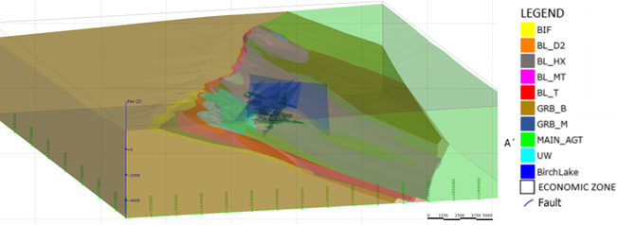
Figure 1 : Lithological model

Structural Model
The structural model developed for the deposit identifies six main faults. Four of these have a northeast orientation and dip northwest. Faults are associated with the main family of discontinuities characterized in the rock mass through Acoustic Televiewer (ATV) logging. Further analysis has shown that intervals with very low Rock Quality Designation (RQD) values (<20) coincide with or are near the faults, which preliminarily validates the consistency of the structural model.
A geotechnical model is developed based on detailed characterization data, including systematic geomechanical logs with RMR and Q' classifications, structural information from Acoustic Television (ATV) surveys, and laboratory test results such as UCS, PLT, and triaxial tests. This model provides a solid technical foundation for assessing the spacing of extraction points and cave geometry.
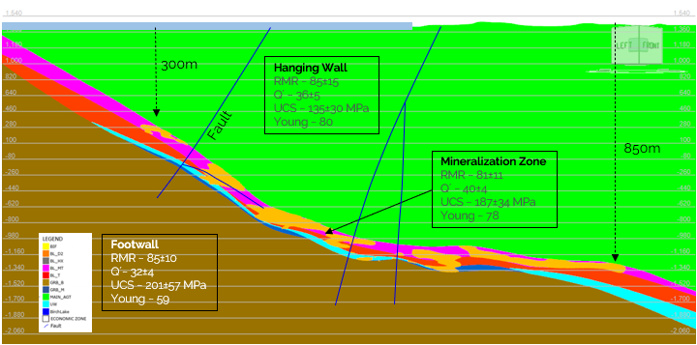
Figure 2: Vertical Section of Geotechnical Model
Table 1: Characteristics of Geotechnical Model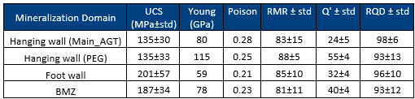
3.2. Mineral Resource Estimate
The block resource model for this project is as follows.
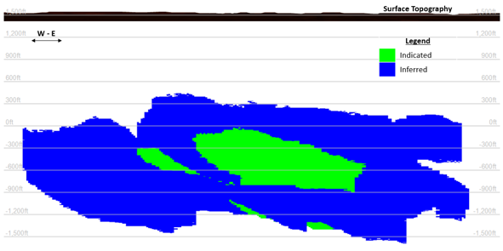
Figure 3: Longitudinal View of the Block Model
After incorporating prices, recovery rates, concentrate grades, selling parameters, and royalty adjustments, the tonnage-grade curve of the block model reveals a geological potential of several hundred million tonnes (Mt) of resources, including both indicated and inferred categories.
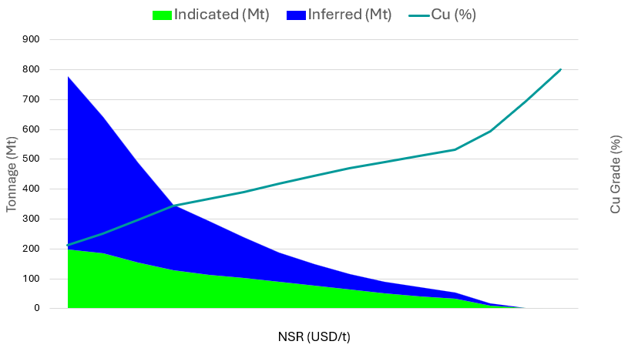
Figure 4: Tonnage-Grade Curve
3.3. Mining Method Selection
Selecting the appropriate mining method requires careful consideration of several factors. These include the location, shape, size, surface conditions, depth of mineralization, ore type, consistency of mineralization, and the quality of the rock mass, among other features. To evaluate the orebody effectively, the deposit was subdivided into 14 distinct zones. Each of these zones was assigned a score based on its characteristics, and the results are as follows:

Table 2: UBC Results

Among the methods evaluated, Sublevel Caving (SLC) and Sublevel Stoping (SLS) received the highest scores.

Geotechnical models call for the backfilling of stopes. Because of the complexity in logistics and costs of cemented backfill, SLS method was discarded, and preference was given to SLC.

A key consideration in the preference for SLC was the possibility to force the caving of the hanging wall (HW) in a controlled manner by including an induced fracturing process. The progress in hydro-fracturing in caving methods is a technique that has gained knowledge and momentum over the past 20 years approximately.

Further analysis revealed that Sublevel Caving achieved 8% higher resource recovery rate compared to Sublevel Stoping.

Description of Method

The objective is to develop a cost-efficient mining method that eliminates the need for backfilling. This approach is especially crucial due to the project's location in a region with an extremely cold climate, which complicates the logistics involved in backfilling. These challenges lead to increased operational costs, as backfill transportation would require rail systems, further escalating expenses. As a result, the aim is to develop a mining method that reduces supplementary costs and enhances operational efficiency.

This Sublevel Caving (SLC) variant with hydrofracturing considers a traditional top-down extraction sequence, complemented by an initiation with hydro-fracturing from the extraction and slot drives. Drilling into the hanging wall will ensure controlled cave propagation and will mitigate air blast risks.
Because of the strong competent rock, the excessive stability of the hanging wall is the major concern of this option as SLC extraction will create large void volumes under it. As extraction grows and the void span extends, the hanging wall may suddenly collapse and create an air blast. To control this risk, induced fracturing of the hanging wall prior to SLC extraction will be conducted. Fractured zones will go up to a height that will ensure swelling over the extracted volume, creating a controlled collapse. The induced fractures will be created using hydro-fracturing techniques commonly applied today in caving mining projects.
Besides the benefit of controlling air-blast risk, the use of the HW swelled rock also provides an inexpensive way of backfilling the stopes.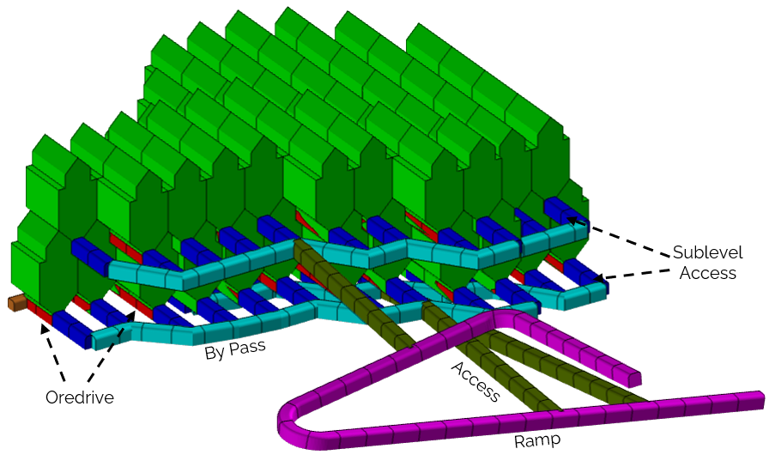
Figure 5: Schematic of SLC with Hydrofracturing (Isometric view)

Hydro-fracturing will be conducted by drilling 100-150m high holes from production drifts. The drilling pattern will depend on the size of the fracturing pump used, but for the analysis fractures with 50m radius were considered. Two sets of different fracture patterns are considered: a coarse fracture (fractures every 3m or more) at and above the hanging wall to ensure breakage and caveability, and a finer fraction within the orebody (fractures every 1.5m). The hydro fracture must be completed before extraction starts.

Following preconditioning, traditional SLC sequence will follow, applying a differential draw strategy: stopes in contact with the hanging wall and lacking overlying mined zones are limited to 40% of planned ore extraction to preserve stability, while extraction points below mined levels recover up to 120% of the planned tonnage to maximize recovery and maintain controlled draw rates.

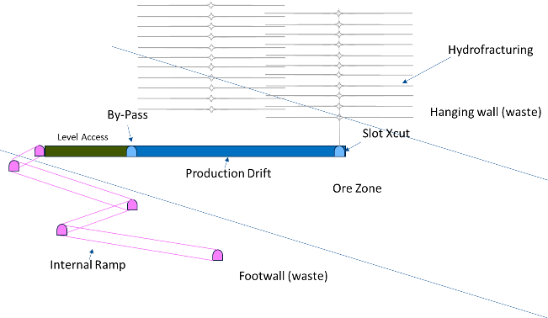
Figure 6: Schematic of Hydrofracturing (Section view)

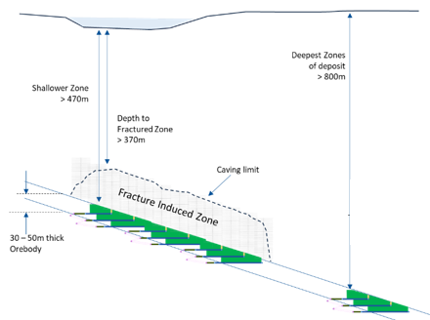
Figure 7: Schematic with Fracture Induced Zone
The method is expected to consider a minimum of two levels to ensure proper mine recovery: the first to fracture and induce the caving of the HW with the SLC extraction, and the following levels below to fully extract to economic volume.
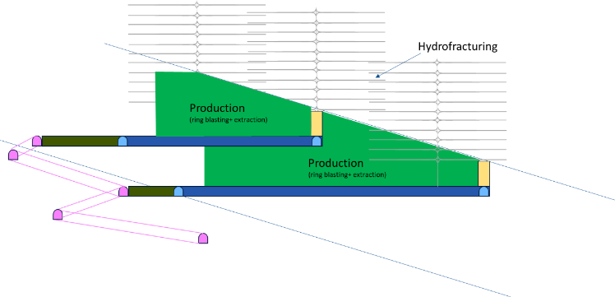
Figure 8: SLC Cross Section with Two levels
To manage the inherent risks associated with cave propagation, the system will rely on continuous seismic monitoring and geotechnical instrumentation. These tools provide real-time data on ground conditions, enabling proactive decision-making and ensuring the safety and efficiency of the operation.

SWOT Analysis

Strengths

- Low operational costs compared to conventional stope mining methods.
- High productivity method with low development density ratios (m of development per Mt of ore) compared to other stoping methods.
- Non reliance on backfilling and curing times due to the induced and continuous collapse of the hanging wall.
- High automation potential in operations such as drilling, loading, and induced fracturing, which leads to increased operational safety by reducing the direct exposure of personnel in extraction zones.

Weaknesses

- SLC with hydrofracturing variant lacks comparable industrial reference cases.
- Critical dependence on accurate geomechanical modeling to design effective fracturing.
- Need for specialized drilling and monitoring equipment to induce and control fractures.
- Operational and technical learning curve, particularly in pilot stages.

Opportunities

- Applicability of the method in mineralized bodies with significant vertical thickness.
- Scalability of the method, allowing easy adaptation to increasing production rates.
- Investor interest in mass mining methods offering higher recovery rates in complex zones where other methods have limitations.

Threats

- Negative perception from communities and stakeholders due to the method involving caving mining beneath water bodies.
- Potential future restrictions from changes in environmental regulations or more stringent licensing requirements.
- Difficulties in obtaining permits in environmentally sensitive areas due to opposition from environmental groups.

3.3. Sublevel Caving Design
Stope Design Parameters

The evaluation of the Sublevel Caving method is carried out using the empirical Laubscher Caving Methodology, which is widely recognized in underground geomechanics for assessing drawpoint spacing and cave geometry. This methodology employs various empirical tools and formulas to determine optimal extraction parameters, thereby ensuring both efficient resource recovery and effective ground control.

A key element of this methodology is the Laubscher Drawpoint Spacing Chart, which allows for the estimation of the ideal spacing between drawpoints based on rock mass rating and caving conditions. This spacing is essential for achieving controlled ore flow and reducing the risk of isolated draw zones or premature dilution.

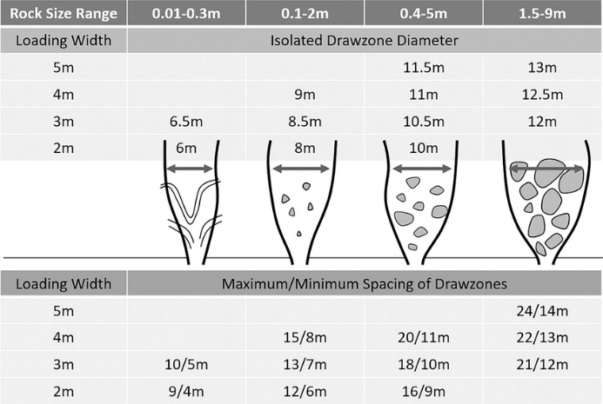
Figure 9 : Laubscher chart for determining spacing between drawpoints
The methodology also includes the Kvapil Curve which establishes a relationship between the effective diameter of the draw ellipsoid and the interaction height, also known as caving height. The draw ellipsoid defines the area around each drawpoint from which broken ore can be mobilized during the caving process. To ensure efficient coverage of the draw area, the Kvapil formula is applied to calculate the actual diameter of the ellipsoid based on factors such as the height of interaction, drawpoint spacing, and characteristics of the fragmentation.

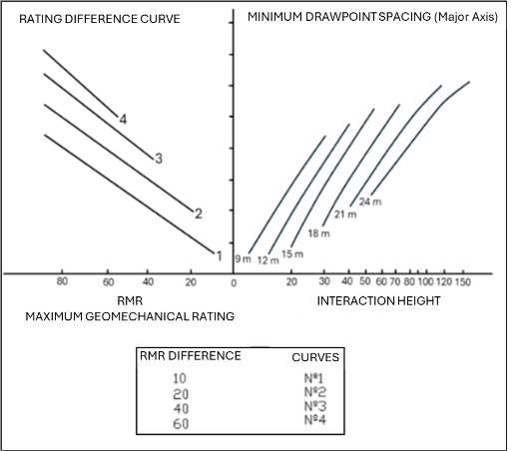
Figure 10: Laubscher Interaction Height Curve
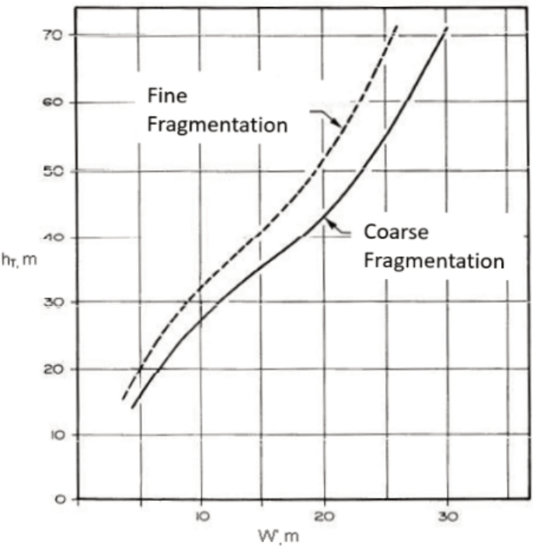
Figure 11: Kvapil curve relating extraction ellipsoid diameter to draw height (interaction height)
The Laubscher Interaction Height Curve is used to determine the vertical range within which material from adjacent drawpoints interacts. This interaction height depends on the quality of the rock mass and the desired fragmentation size, playing a crucial role in ensuring that material caves uniformly without hang-ups or excessive dilution.

From a design standpoint, the sublevel drift height (Ht) should be set at the level where the extraction ellipsoid reaches its maximum width. This positioning enhances draw zone efficiency, promotes even cave propagation, and reduces unsupported spans in the back area. Proper alignment of the sublevel drifts with the geometry of the draw ellipsoid is essential for maximizing resource recovery.
This methodology is particularly applicable in weak to moderately competent rock masses where controlled caving is necessary. The approach has been validated through numerous case studies and remains a fundamental aspect of the geotechnical design for sublevel caving operations.
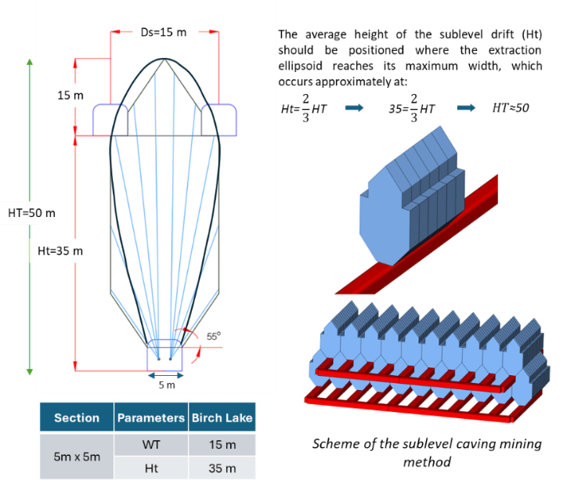
Figure 12 : Sublevel Caving Design

Table 3 Sublevel Caving Stope Size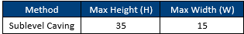
This empirical estimate serves to define the upper limits for stope design dimensions. Nevertheless, it is strongly recommended to adhere to the stope dimensions that are currently employed in active mining operations globally, as these dimensions have been rigorously validated through extensive operational experience. Maintaining these established dimensions not only ensures safety and efficiency but also leverages proven practices that have been optimized over time in various geological conditions.

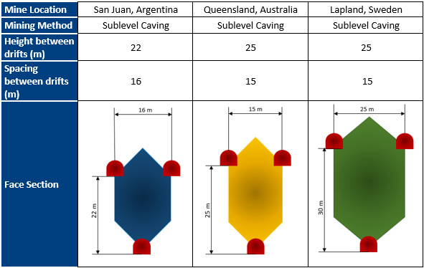
Figure 13: Stope sizing benchmark in Sublevel Caving mines.
Consequently, it is determined that the optimal dimensions for the vertical spacing between drifts should be set at 25 meters, with a horizontal separation of 15 meters between them. In situations where the development of a minimum of two levels of stopes is not feasible, an alternative approach involves adjusting the vertical spacing to 15 meters and the horizontal spacing to 12 meters. This adjustment aims to maximize accessibility and efficiency in the mining operation while ensuring safety and structural integrity are maintained. These considerations play a crucial role in the overall design and planning of the underground workings, influencing both the resource recovery and the operational viability of the project.

4. Results
To confirm the potential profitability, a 3D pilot model was developed in more detail in a section of the deposit. The pilot was fully designed and scheduled to confirm the applicability of the proposed method within the geometry of the deposit. In this pilot 25m meters vertical separation was considered in the design of SLC stopes. Ramp accesses were designed in the footwall. The material handling system was considering trucks to crusher and conveyor.
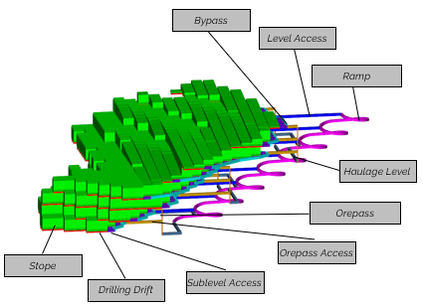Figure 14: 3D Design of Sublevel Caving Method

A preliminary cashflow model was also prepared to analyzed the economic benefit.
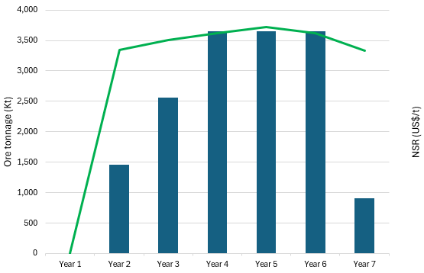Figure 15: Mine Plan of Sublevel Caving Method
The resulting plan showed that the Sublevel Caving variant with Hydro-fracturing fits adequately in the geometry of the deposit and allows a good recovery of resources. The productivity of the SLC allows to reach the steady state capacity after a three-year ramp-up period in consideration of development capacities.
The drilling up to 100m above the hanging wall contact and hydrofracturing is expected to create volume large enough to swell into the cavity left by the extraction without further propagating to surface. This would ensure no impact on surface will be noticeable. A crown pillar in excess of 300m will remain between surface and the top of the caved zone.
An economic trade-off also revealed the capacity of this method of delivering a Net Present Value that is 13% higher than other Sublevel Stoping options analyzed.
Based on this, Sublevel Caving (SLC) is the selected mining method for this case study. This option was chosen due to its high productivity, suitability for automation, low development intensity, and lower operating expenses allowing for a low marginal cut-off grade.

5. Conclusions

Application of an Innovative Sublevel Caving Variant
The introduction of a novel variant of Sublevel Caving (SLC) incorporating hydrofracturing presents a significant advancement in underground mining. This method improves resource recovery by ensuring controlled cave propagation and minimizing the risks associated with air blasts. The strategic use of induced fracturing in the hanging wall combined with the highly automated capacity of the method enhances both safety and efficiency, providing a robust solution for complex ore bodies in challenging geological conditions.

Cost-Effectiveness of Sublevel Caving
Sublevel Caving stands out as a cost-effective mining method, particularly when compared to traditional techniques such as Sublevel Stoping. The method's lower operating costs, high productivity, and potential for automation contribute to its economic superiority. Moreover, the removal of backfilling requirements further reduces logistical costs, making it an attractive option for large-scale mining projects with complex ore bodies, especially in cold climates where backfilling logistics can be particularly challenging.

Perceived Risks and Community Perception
While Sublevel Caving offers substantial economic benefits and operational efficiencies, its implementation may face resistance from communities and stakeholders, particularly due to the expected footprint impact of surface of a traditional “caving” method. Therefore, it is essential to address these concerns through clear communication, regulatory compliance, and proactive environmental management to ensure the method's social acceptability and long-term sustainability.

6. Bibliographic References

Hustrulid, W., & Kvapil, R. (2008). Sublevel caving – past and future. Proceedings of the 5th International Conference and Exhibition on Mass Mining. Retrieved from https://www.geokniga.org/bookfiles/geokniga-hustrulidkvapilslcpastandfuture.pdfgeokniga.org

Laubscher, D. H. (1990). A Geomechanics Classification System for the Rating of Rock Mass in Mine Design. Journal of the South African Institute of Mining and Metallurgy.

Miller, L. (1995). UBC Mining Method Selection. University of British Columbia, Vancouver, Canada.

Pennsylvania State University. (n.d.). 9.4.2b Sublevel Caving. MNG 230. e-education.psu.edu

Shekhar, G. (2018). Draw Control Strategy for Sublevel Caving Mines. Luleå University of Technology. Retrieved from https://www.diva-portal.org/smash/get/diva2%3A1167252/FULLTEXT01.pdfDiva Portal

Full Name of the Author:

Mateo Rolando Villanueva Panocca

Brief Professional Profile:
Mateo Villanueva is a mining engineer with more than three years of experience in mining planning and evaluation of underground mining projects. He has participated in technical-economic studies for world-class projects in the United States, specializing in mine design, LOM plan construction, prefeasibility studies, and economic analysis. He is currently working as a Project Planning Engineer at REDCO Mining Consultants, designing solutions focused on maximizing profitability and operational efficiency.

AUTORIZACIÓN DE PARTICIPACIÓN

Yo (Nombre completo), (cargo), (Nombre de la empresa o institución educativa); autorizo que el trabajo
titulado “____________________” presentado por el autor (nombre completo) y coautores (nombres completos) sea presentado en el concurso del Premio Nacional de Minería del evento PERUMIN 37 Convención Minera en las fechas del 22 al 26 de setiembre del 2025 en la ciudad de Arequipa.

___________
Firma
DNI/Pasaporte
Fecha

Nota:
Esta autorización se entrega solo en el caso de que el participante se presente de manera independiente y
el trabajo implique el desarrollo en el marco de una empresa o institución. La indicada autorización deberá
ser entregada en hoja membretada.

