DETECTION OF PRECURSORS TO MINING SLOPE FAILURES VIA MACHINE LEARNING

Hayden Marcollo¹, Kanishka Jayasinghe², Richard Shedlock³, Macdonald Mandaza⁴, Amjad Karim⁵, Cristian SlivaPerez⁶, Alejandro Postigo⁷

¹ Hayden Marcollo: AMOG (hayden.marcollo@amog.consulting +613 9542 3700)
² Kanishka Jayasinghe: AMOG, Australia (kanishka.jayasinghe@amog.consulting +613 9542 3700)
³ Richard Shedlock: AMOG, Australia richard.shedlock@amog.consulting +618 9212 1800)
⁴ Macdonald Mandaza: AMOG, Australia (macdonald.mandaza@amog.consultin(g +613 9542 3700)
⁵ Amjad Karim: Keen AI, UK (ak@keen-ai.com +44.1212503535)
⁶ Cristian Silva-Perez: Keen AI, UK (csp@keen-ai.com +44.1212503535)
⁷ Alejandro Postigo: RDR, Peru (proyectos_soporte@rdr.com.pe +51 992 744 537)

____________________________________________________________________________________

____________________________________________________________________________________
Abstract

Open-pit mine slope failures pose significant safety risks and operational disruptions in mining operations globally. Traditional slope monitoring methods often involve costly equipment and limited coverage, with many systems failing to detect early precursors to instability, providing minimal warning time for response. This paper explores a novel approach using drone-captured aerial imagery and AI analysis to automatically detect early warning signs of slope instability. The technology has broad applications for open pit mining operations worldwide, with specific potential for adaptation to glacial lake flood risk monitoring in countries like Peru where such threats are increasing due to climate change.

The research aims to demonstrate a proof-of-concept system for automated detection of mine slope instability markers using drone imagery and evaluate the effectiveness of deep learning algorithms in identifying visual indicators preceding slope failures. The paper also explores practical operational integration pathways and workflow changes needed to implement this technology effectively within existing mine safety protocols and monitoring systems.

Our methodology employs computer vision and machine learning techniques to process aerial imagery of mine slopes. Using a limited dataset of known pre-failure conditions, the system was trained to identify visual patterns including tension cracks, surface deformation, and drainage changes that typically precede failure events. The approach includes collection and preprocessing of drone survey imagery, application of convolutional neural networks for feature extraction, and validation against known slope failure events.

Initial proof-of-concept testing demonstrates the system's ability to identify key visual precursors to slope instability. The technology recognizes visual patterns including tension cracks, surface deformation, and drainage anomalies from drone imagery that traditional monitoring methods often miss. This capability provides mining operations with critical early warnings, substantially extending the response window for safety teams to implement preventative measures before potential failure events occur.

This technology represents a cost-effective complement to traditional monitoring methods, potentially expanding coverage and providing earlier warning of slope instability risks in mining operations. The paper will outline practical integration strategies for incorporating this system into existing operational workflows. While the primary application focuses on mining safety globally, the technology framework could be adapted to serve as an additional early warning mechanism for specific environmental risks such as glacial lake outburst floods, demonstrating the versatility of AI-powered visual analysis systems in multiple geotechnical applications.

Introduction
Mining disasters, including slope failures, are often rooted in human fallibility, particularly in the context of engineering design, assumptions, and maintenance practices. Quinlan (2014) identified human error as the dominant cause of catastrophic failures in his review of industrial disasters. Shedlock (2018) supported this, citing systemic flaws in design validation and unverified engineering assumptions as key contributors to failure.

This vulnerability is especially pronounced in slope design and construction, where engineers must contend with the inherent variability of soil and weathered rock, fluctuating moisture conditions, and other geotechnical uncertainties. Validating every assumption across an entire mine site is often logistically and financially impractical. As a result, slope reliability remains inconsistent. These challenges are compounded by cost pressures and operational constraints, which can further degrade risk margins (Quinlan 2014).

Large-scale slope failures in surface mining operations pose significant risks to workforce safety, critical equipment, and operational continuity. While such failures are relatively infrequent, early-stage indicators (such as crack propagation, bench deformation, and subtle ground movement) can manifest well in advance. The challenge lies in detecting these reliably and at scale, without placing unsustainable demands on personnel or equipment. Badola (2023) provides an overview of environmental factors that can affect slope stability. Tsachouridis (2025) presents a review of UAV (Unmanned Aerial Vehicle) applications in open-pit mining.

Existing Technologies
Survey Networks and Automated Total Stations form the backbone of traditional surface monitoring. These systems use target prisms and control points to provide relative displacement measurements . Automated total stations have enhanced this approach by enabling high-precision, automated monitoring over large open pit areas (Brown et al., 2007). While these systems offer high precision and are well-established methods, they are limited by labor-intensive installation and maintenance requirements, and need clear line-of-sight to operate effectively.

Subsurface monitoring systems include several specialized technologies. Inclinometers measure lateral displacement profiles within the slope, while Time Domain Reflectometry detects subsurface deformation through reflected electronic pulses . Borehole extensometers measure displacement at various depths, and piezometers monitor pore water pressure to track water-related instability. These technologies provide critical data on subsurface processes and failure mechanisms but are typically limited to point measurements and require complex installation procedures, especially in unstable areas (Jirard et. al).

Slope Stability Radar (ground-based radar interferometry) represents a significant advancement in slope monitoring. This technology provides sub-millimetre precision and continuous real-time monitoring with broad area coverage (Harries et al., 2006). While it is particularly effective for active slope monitoring and early warning systems, it does face limitations from line-of-sight requirements and atmospheric effects.

Satellite Interferometric Synthetic Aperture Radar (InSAR) technology, including Differential InSAR and Sentinel-1 platforms, offers large spatial coverage without requiring on-site installation. These systems can detect movements of 10-20 mm/day and provide early detection of instability (Tripolitsiotis et al., 2014). However, they are limited by revisit times (6-35 days) and can suffer from coherence loss in disturbed areas.

Global Navigation Satellite System (GNSS) systems provide high-precision, automated, and scalable monitoring suitable for large pits (Brown et al., 2007). These systems excel in continuous deformation monitoring and can be effectively integrated with other monitoring methods. Their main limitations include the requirement for receiver installation and potential signal loss issues.

Microseismic monitoring offers unique capabilities in detecting subsurface movement, providing 3D quantitative data and early warning potential of 30-45 days (Lynch et al., 2005). This technology is particularly valuable for detecting deep-seated and unknown structures but requires specialized equipment and expertise for data interpretation.

Tension crack mapping, while seemingly simple, provides direct warning signs of surface instability (Jirard et. al). The traditional approach involves manual mapping of surface cracks, which, though effective for early detection of surface instability, is limited by its labor-intensive nature and restriction to visible surface features.

The project seeks to address these gaps by introducing a solution that combines automated
aerial imagery analysis backed with training data utilizing geotechnical intelligence. The system is designed to identify surface cracking and terrain anomalies indicative of earth structural risk using machine learning techniques, and to translate these into risk-based outputs that geotechnical engineers can act upon.

Background and User Needs
To ensure the system aligned with real-world needs, structured interviews were conducted with principal geotechnical engineers across various mining operations. The Job-To-Be-Done (JTBD) framework guided the process, helping identify latent frustrations and unmet needs.

Key findings included:
- Geotechnical teams spend a disproportionate amount of time scanning drone imagery or walking the pit to find signs of instability.
- Cracks often go unnoticed until they coalesce into visible scarps (sharp, curved breaks in the surface) or rills (surface erosion).
- Data overload from high-resolution surveys can obscure the most relevant indicators.
- Current approaches lack automated triage. Engineers must manually determine which cracks are significant.

From this, the following priorities emerged for an ideal system:
- Automated detection of cracks and terrain anomalies.
- Scalable processing, capable of handling multiple datasets across sites.
- Risk scoring tied to geotechnical priorities.
- Seamless integration with drone workflows and existing GIS tools.
These insights directly influenced the design of the system architecture.

Methodology

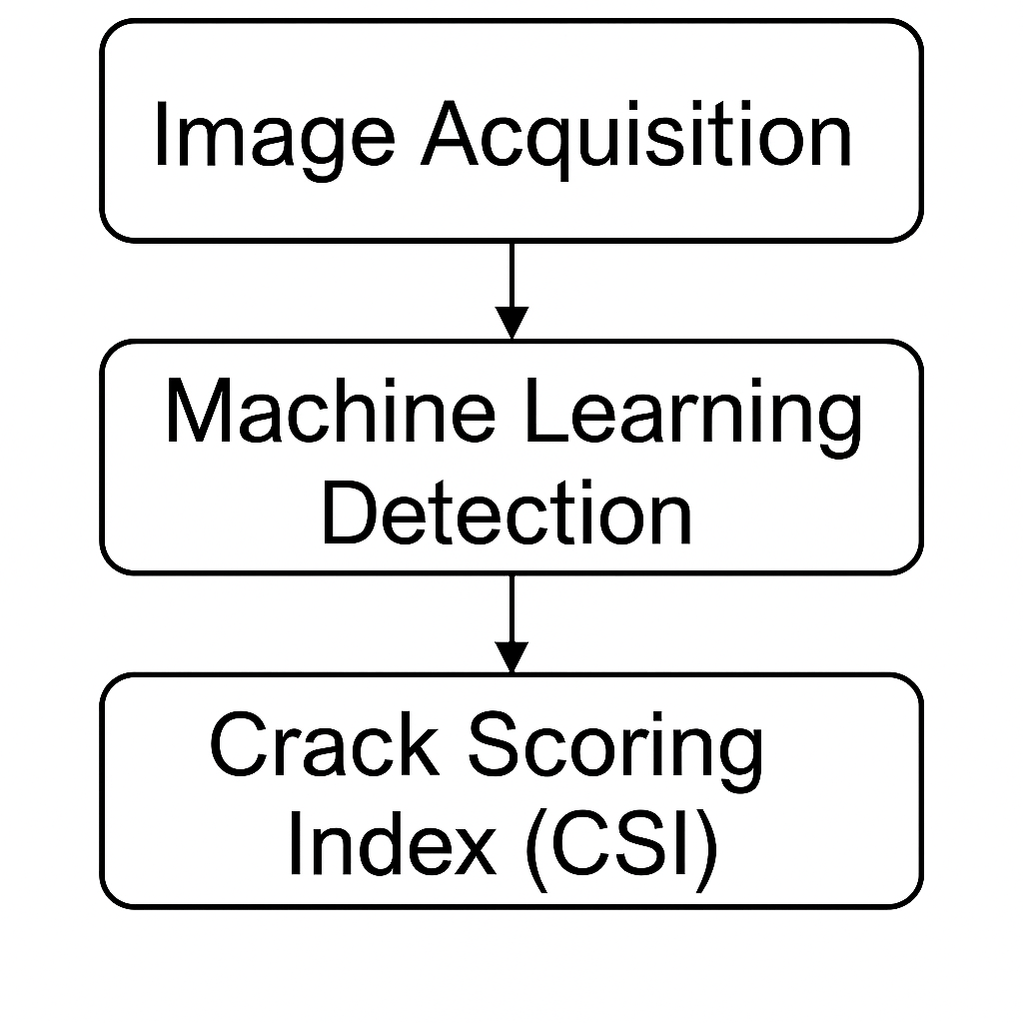
Figure 1. Three core subsystems of the methodology.

The methodology comprises three core subsystems as shown in Figure 1: image acquisition, machine learning-based detection, and evaluation of a crack scoring index (geotechnical based).

Image Acquisition
Imagery is collected via autonomous drone flights conducted at regular intervals, typically weekly or bi-weekly. Flights are configured to ensure high spatial resolution (<5 cm) and consistent lighting conditions. Data is pre-processed to correct for lens distortion, georeferencing errors, and inconsistent terrain alignment.

Machine Learning Detection
The detection engine is based on a modified convolutional neural network (CNN), trained on hundreds of annotated aerial images from open-pit environments. Classes include:
- Longitudinal cracks along benches
- Transverse fissures indicating movement across slopes
- Discontinuities near haul roads or blasting zones

Training data was manually labeled and cross-validated with likely failure events. Data augmentation (e.g., rotation, lighting changes) was employed to increase robustness and more data will be used in the future to enhance. Post-processing removes false positives such as machinery edges, tyre marks, and shadows.

Crack Scoring Index (CSI)
Rather than reporting all cracks equally, the system prioritizes risk through a CSI framework, considering:
- Crack length, width, and depth (where inferable)
- Orientation relative to known geological structures
- Proximity to critical infrastructure (e.g., haul roads)
- Recurrence across time-series imagery
The CSI allows users to sort, visualize, and overlay crack features on 3D terrain models or dashboards, improving decision-making speed.

False Positives
Any ML method using image processing can suffer from excessive false positives. Minimizing the numbers of false positives while not excluding any true positives is a key objective in the commercialization and development of most AI and ML image processing tools. The current research to date has shown that features in images that can trigger false positives include active equipment, disused equipment, pipelines, tools, randomly deposited earth berms, shadows cast from any of the aforementioned items.

Results and Preliminary Application
The system has been deployed at trial sites under real operational constraints. In these initial trials, it was tasked with:
- Processing imagery across large areas (>5 km²),
- Identifying cracks,

Visual validation confirmed that several cracks detected by the process aligned with areas of critical importance.
While full performance metrics remain confidential, the development team reports:
- A significant reduction in manual image review time,
- Earlier detection of critical slope indicators,
- Increased confidence from site-based engineers in interpreting change over time.
A typical earth crack identification from the routine is shown in Figure 2.

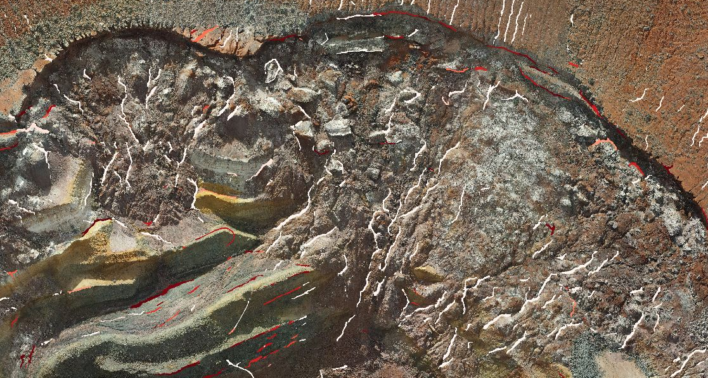

Figure 2. Earth crack identification using the process during one of the mine site trials. The coloring of cracks indicates their importance with red being a high value.

Future phases will include training on more volumes of data across different sites and terrain types (spatial) as well as training across the one site through time with different sun and weather patterns (temporal). Further work is likely to involve integration with 3D digital terrain models (DTMs), use of LIDAR-derived elevation layers, and incorporation of weather or blast schedule metadata to refine false positive filtering.

The output of the tool where the crack risk ranking is highlighted is shown in Figure 3.

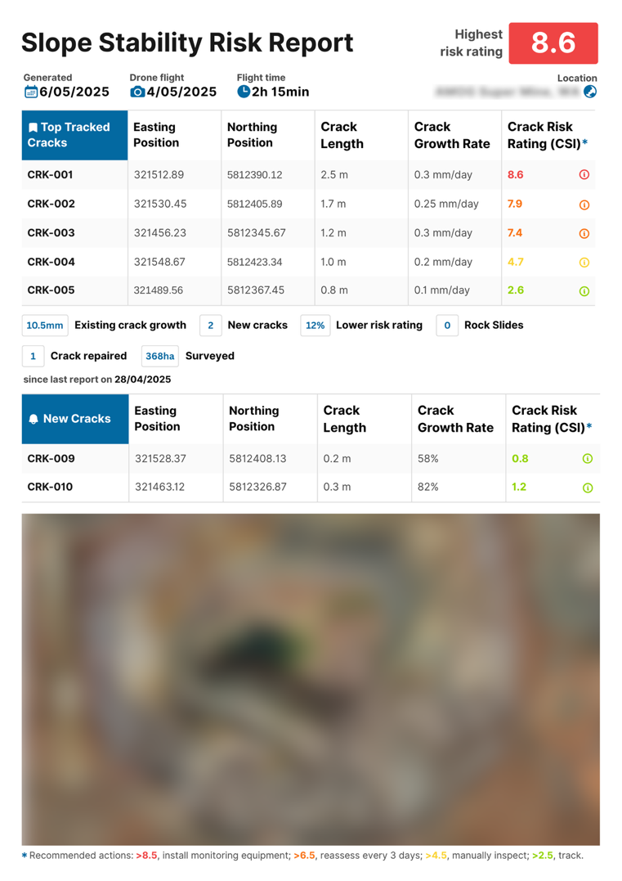
Figure 3. Output of the process showing risk ranking of cracks. Certain details have been blurred for confidentiality.

Discussion
The mining industry has long recognized the value of automation and predictive analysis. However, adoption has often been stymied by integration complexity, data variability, and lack of trust in “black-box” models.

The process outlined herein addresses these concerns by:
- Using transparent feature scoring grounded in geotechnical logic,
- Offering explainable AI that can overlay raw detections with interpretable summaries,
- Enabling local deployment or secure cloud-based integration depending on site requirements.
A key consideration is interoperability. The process outlined herein is designed to ingest output from various drones, export to common GIS formats (e.g., GeoTIFF) and align with standard mining software platforms.

As mining operations expand into deeper pits and more complex geologies, the need for low-latency, reliable slope assessment becomes paramount. The process outlined contributes by offering both speed and relevance, detecting issues before they escalate and guiding using a risk based approach.

Operational Integration
For sites already employing a mix of manual inspections, periodic UAV flights, photogrammetry, and radar monitoring, a representative integration strategy for the proposed system could proceed with minimal disruption. Rather than replacing existing systems, the solution enhances and extends current workflows. In a typical scenario, the system could be integrated as follows:
- Routine UAV surveys: Imagery collection is embedded into existing survey routines, with flight frequency adjusted by slope risk profile. Higher-risk areas could be flown more frequently, while lower-risk benches are covered less often.
- Automated anomaly detection: Imagery is processed through the machine learning pipeline to identify cracks or terrain anomalies. These detections are georeferenced and overlaid on existing mine GIS systems.
- Human-in-the-loop verification: A geotechnical engineer reviews the flagged anomalies in a focused interface, verifying the outputs before triggering any escalation. This significantly reduces the cognitive and time burden compared to reviewing full survey datasets manually, while maintaining engineering oversight.
- Trigger-based escalation: Once verified, alerts can initiate shift-based visual inspections or increased survey frequency. Sites with radar capabilities may escalate to instrumented monitoring if risk thresholds are met.
- Low-overhead implementation: The system is designed to work with standard drone platforms and export to formats compatible with common geotechnical and GIS tools (e.g., GeoTIFF). This limits capital expenditure and avoids the need for major workflow changes or retraining.
- Coverage gap bridging: The system provides an intermediate layer between low-frequency visual inspections and high-cost radar systems, helping to identify early-stage warning signs that may otherwise go unnoticed.
By building on existing operational practices and tools already familiar to site personnel, the proposed approach enables earlier intervention, increases confidence in detection, and supports a more scalable model for slope monitoring in complex and resource-constrained environments.

Applicability for Glacial Flood Risk in Peruvian Andes
Studies in the Peruvian Andes and adjacent regions document between 10 and 160 glacial lake outburst floods (GLOFs) (Baka et al., 2020) linked to glacier retreat, warming temperatures, and intense rainfall (Anacona et al., 2015). The papers report that inventories based on satellite and aerial imagery have quantified these hazards and their triggering factors, with one study citing over 150 events (Emmer et al., 2021) and another noting a tripling of the previous event count (Emmer et al., 2022). In one instance, installation of a sensor‐based early warning system yielded real‐time detection and received positive feedback from local communities (Fluixá-Sanmartín et al., 2016).

Remote sensing techniques dominate current practices, and one paper recommends the use of Interferometric Synthetic Aperture Radar for enhanced monitoring (Klimeš et al., 2021). Such methodologies would require extensive instrumentation and may not be scalable across all risk areas. As such the approach presented in this paper provides an alternative approach to mitigate the risk of GLOFs.

Conclusions
The collaborative development of the process described herein by AMOG and Keen AI represents a step-change in the automation of large area slope stability monitoring. By combining high-resolution aerial imagery, machine learning crack detection, and geotechnically informed scoring, the platform supports proactive management of slope risks in open-pit mining.

This early work demonstrates both feasibility and value: reduced human workload, improved detection confidence, and a foundation for broader geotechnical integration. The next stage will involve greater areas of operational pilots with user feedback cycles, and continuous refinement to ensure deployment readiness across diverse mining contexts.

Acknowledgements
We acknowledge the mining engineers who contributed their expertise through structured interviews, as well as the operations teams who facilitated early-stage field trials. The project has benefited from the combined experience of AMOG’s engineering risk specialists and Keen AI’s machine learning practitioners. We also thank Element-Geospatial for their contributions to image collection.

References

Quinlan, M.; Ten pathways to death and disaster: Learning from fatal incidents in mines and other high hazard workplaces. 2014. The Federation Press, Annadale, NSW.

Shedlock, R.; Assumptions that lead to failure. The 13th International Conference on Steel, Space and Composite Structures (SS18) 2018. Keynote speaker. ISBN : 9781740523929

Badola, S. et al.; Landslide susceptibility mapping using XGBoost machine learning method. 2023 International Conference on Machine Intelligence for GeoAnalytics and Remote Sensing (MIGARS) DOI: 10.1109/MIGARS57353.2023.10064496

Tsachouridis, S. et al.; Monitoring Slope Stability: A Comprehensive Review of UAV Applications in Open-Pit Mining. Land 2025, 14(6), 1193; https://doi.org/10.3390/land14061193

Brown, N.; Kaloustian, S.; Roeckle, M.; Monitoring of open pit mines using combined GNSS satellite receivers and robotic total stations. 2007.

Girard, J.; McHugh, E.; Detecting problems with mine slope stability. n.d.

Harries, N.; Noon, D.; Rowley, K.; Case studies of slope stability radar used in open cut mines. 2006.

Tripolitsiotis, A.; Steiakakis, C.; Papadaki, E.; Agioutantis, Z.; Mertikas, S.; Partsinevelos, P.; Complementing geotechnical slope stability and land movement analysis using satellite DInSAR. 2014.

Lynch, R.; Wuite, R.; Smith, B.S.; Cichowicz, A.; Microseismic monitoring of open pit slopes. 2005.

Baťka, J.; Vilímek, V.; Štefanová, E.; Cook, S.; Emmer, A.; Glacial lake outburst floods (GLOFs) in the Cordillera Huayhuash, Peru: Historic events and current susceptibility. Water 2020.

Iribarren Anacona, P.; Mackintosh, A.; Norton, K.; Hazardous processes and events from glacier and permafrost areas: Lessons from the Chilean and Argentinean Andes. 2015.

Emmer, A.; Cook, S.; Wood, J.; Harrison, S.; Wilson, R.; Diaz-Moreno, A.; Reynolds, J.; Torres, J.; A new GLOF inventory for the Peruvian and Bolivian Andes. 2021.

Emmer, A.; Wood, J.; Cook, S.; Harrison, S.; Wilson, R.; Diaz-Moreno, A.; Reynolds, J. et al.; 160 glacial lake outburst floods (GLOFs) across the Tropical Andes since the Little Ice Age. Global and Planetary Change 2022.

Fluixá-Sanmartín, J.; Garcia Hernandez, J.; Huggel, C.; Frey, H.; Rapre, A.C.; Alfaro, C.; Román, L.; Chacón, P.; Highlights and lessons from the implementation of an early warning system for glacier lake outburst floods in Carhuaz, Peru. 2016.

Klimeš, J.; Novotný, J.; Rapre, A.C.; Balek, J.; Zahradníček, P.; Strozzi, T.; Sana, H. et al.; Paraglacial rock slope stability under changing environmental conditions, Safuna Lakes, Cordillera Blanca, Peru. Frontiers in Earth Science 2021.

