Process Performance evaluation as a tool for thickener modernizations
Mineral Processing and Extractive Metallurgy – Solid / Liquid Separation Operations

Guillermo Bermudez¹, Michelle Ball², Max Alva³
____________________________________________________________________________________

¹ Author: Metso Canada, 5045 South Service Road, Burlington, Canada (guillermo.bermudez@metso.com)
² Coauthor 1: Metso Finland, Rauhalanpuisto 9, Espoo, Finland (michelle.ball@metso.com)
³ Coauthor 2: Metso Peru, Vulcano 156, Lima, Peru (max.alva@metso.com)

SUMMARY

Thickeners and clarifiers play a crucial role in the dewatering stages of mineral processing by facilitating solid-liquid separation; not only thickening the material but also enabling water recovery for reuse within the plant. This concentrated material thickened underflow is either further processed or placed in a tailings storage facility, whose stability is paramount in environmental and safety regulations. With the continuous evolution of ore bodies and throughput targets, the performance of existing thickeners deviates from the original design criteria, often limiting production and creating unnecessary downtime.

The aim of this work is to explore the necessity of upgrades and modernizations, especially when process optimization is constrained by the mechanical limitations of existing equipment and plant footprint. The objective of this work is to address the factors that impact dewatering efficiency, with a focus on changes in ore type, increased throughput, and adjustments in reagent dosages and type.

This paper details the methodology for achieving modernization of thickeners through comprehensive test work and data analysis. The process involves identifying bottlenecks in thickener performance, estimating the potential benefits of upgrades through test work, and evaluating the outcomes post-upgrade.

The implementation of this methodology has shown significant improvements in thickener performance, including enhanced downstream dewatering efficiency, reagent savings, and operational stability. The paper presents this methodology in a case study on the advantages of a feed system retrofit at a Cu-Mo operation in Bagdad, Arizona, an area with metallogenetic similarities to Peruvian deposits, part of the Paleocene–Eocene metallogenic belt, highlighting the potential for replicating these improvements in similar operations in Peru.

Modernizing thickener circuits is essential to meet evolving operational demands and ensure sustainable performance. The paper concludes that adopting enhanced thickener technologies and optimizing existing systems can lead to substantial improvements in dewatering efficiency and overall plant performance. Further research into advanced thickener designs and automation for continuous monitoring of thickener performance to adapt to changing operational conditions are also recommended.

- Introduction

Thickeners are typically designed to meet specific process requirements at a given point in time. While they can operate within a broader range of their original design parameters, their lifespan is so long (often exceeding 20 years) that they are inevitably subjected to changing operational conditions and environmental considerations. In these cases, simple process optimization initiatives are not enough to enhance the thickener’s availability, limit downtime and improve performance, and further interventions/modernization are often needed. Looking more closely at these changes, they can be broken down into three main drivers fueling modernizations and upgrades¹:
- Increased throughput
- Changing feed ore characteristics
- Environmental responsibility and social license to operate.

Increase in throughput

One of the primary drivers for thickener optimization and modernization is the effect of incremental capacity across the entire plant. While individual efficiency initiatives, such as a 1-3% throughput gain, may appear marginal. Their long-term impact on thickener performance is often underestimated. These improvements typically focus on upstream units such as milling, leaching, or flotation circuits, with limited attention given to downstream effects. Over a 10 to 20-year period, however, these incremental gains can collectively result in a 20-50% increase in throughput. This prolonged increase can lead to reduced underflow density, elevated flocculant consumption, and more frequent torque overloads. Compounding this issue, is the rotation of plant personnel and the lack of awareness of the thickener’s original design criteria, making it difficult to recognize these deviations as performance issues.

Changing Ore Characteristics

A second major factor necessitating thickener improvements is the evolving nature of ore feed. As higher-grade, easily processed ore bodies are depleted, operations are increasingly required to process lower-grade material. This shift not only drives the need for higher throughput to maintain production targets and return on investment but can also introduce finer particle size distributions (PSD). Finer PSDs adversely affect the settling behavior of solids, demanding more precise feed control and optimized flocculation strategies to maintain thickener performance. These changes in ore characteristics underscore the need for modernized thickening technologies that can adapt to more complex and variable feed conditions.

Both throughput and ore changes contribute to the changes in operating conditions and can cause thickeners to perform below their original design specifications or fall short of current process requirements. When performance deviates from established benchmarks, several negative outcomes may arise, including reduced water recovery to the plant, increased flocculant consumption, diminished metallurgical recovery, and elevated tailings management costs. These inefficiencies not only compromise process stability but also impact on the overall sustainability and economic performance of the operation.

Environmental responsibility and social license to operate

Over the past two decades, there has been growing recognition of the long-term environmental impacts associated with industrial activities, particularly in the mining sector. As a result, the issuance and continued validity of operating licenses are now subject to more stringent environmental and regulatory oversight. In parallel, local communities are increasingly vocalizing their expectations for mining operations to minimize environmental footprints and adopt sustainable practices. This evolving dynamic, commonly referred to as the “social license to operate”, has become a critical factor in operational decision-making and long-term planning for plant operators.

In response to these three pressures, one viable strategy is the improvement of the solid-liquid separation efficiency of the targeted thickener, using advanced optimization techniques, technologies or modernizations. Compared to the capital-intensive alternative of installing entirely new thickening infrastructure, incremental process performance improvements and modernizations offer cost-effective solutions. They can enable operators to enhance performance and compliance while avoiding the additional expenses associated with relocating services, rerouting piping, and constructing new foundations. As such, process improvements and modernizations not only support environmental and social objectives but also represent a pragmatic approach to sustaining operational continuity.

  - The importance of process performance

Enhancing thickener´s process performance is fundamental to achieve effective results. Thickening is inherently a slow and complex process, influenced by multiple interdependent variables. Disparities in feed mass flow and slurry characteristics necessitate timely and precise adjustments to maintain consistent underflow quality and overflow clarity. Achieving this level of control requires a comprehensive understanding of both the dynamic behavior of the thickener and the broader process context in which it operates.

Thickener optimization strongly depends on effective process control. Conventional thickener control strategies typically rely on single-loop control systems integrated into plant-wide automation platforms. However, extensive operational experience has demonstrated that such approaches often result in sub-optimal performance due to their limited ability to manage multivariable interactions. As an example, Metso Thickener Optimizer has been developed to address these limitations, by leveraging a model-based multivariable control strategy built on the Advanced Control Tools (ACT) platform². This optimizer integrates real-time process measurements - such as feed flow rate and slurry density - and actively adjusts underflow pump rates and flocculant dosage to maintain process stability. By incorporating upstream feed information when available, the system ensures more responsive and robust control, ultimately improving thickener efficiency and reliability (Figure 1).

While optimizing thickener operations is a critical first step towards improving performance, the extent of these gains is often constrained by the inherent limitations of legacy equipment. In cases where the thickener design is outdated or lacks flexibility to accommodate modern process demands, upgrading the equipment may represent the most effective path to enhanced efficiency.

Thickener modernization is not a one-size-fits-all endeavor. Each site presents a distinct set of challenges, shaped by its operational requirements, legacy infrastructure, and strategic objectives. To ensure a successful upgrade, it is essential to adopt a structured and holistic approach that aligns with both technical and business goals. This involves a comprehensive evaluation of multiple interrelated factors that influence the design, implementation, and long-term performance of the modernization effort.

Key considerations include aligning the upgrade with specific process criteria, ensuring maintainability and ease of troubleshooting, and enhancing operability for day-to-day efficiency. Spare parts availability and standardization, particularly the commonality of components, must also be addressed to support long-term reliability. Safety improvements are paramount, as is the need to adapt the solution to existing site constraints and comply with applicable site, industry, and regulatory standards. Finally, effective management of project timelines and budgets is critical to delivering value.

While these factors may appear complex, a methodical and integrated approach enables a smoother transition and ensures that the proposed modernization delivers measurable improvements in performance, safety, and sustainability.

  - Process Guarantees

Key thickener performance parameters, for instance underflow density, overflow clarity, rise rate, and solids loading rate, can vary significantly depending on feed characteristics. Even within similar applications, site-specific factors such as particle size distribution, clay and organic content, water chemistry, and upstream process influences (e.g., grind size and reagent use) can lead to substantial differences in thickener behavior. Additionally, parameters like optimal feed slurry density, flocculant type, and dosage must be tailored to each application. These variables not only affect process efficiency but also have direct implications for capital and operating expenditure.

Given the critical role thickeners play in overall plant performance, the ability to accurately predict and guarantee process outcomes is essential. As such, Process Performance Guarantees from equipment suppliers are often expected and, in some cases, are a prerequisite for securing project financing. These guarantees can be pivotal during early project stages, where confidence in performance outcomes directly influences investment decisions³.

Process Performance Guarantees for thickeners should always be based on accurate test work. A thorough understanding of the upstream process, including its potential modifications and operational variability, is essential to ensure that thickener performance guarantees remain valid and that resulting metrics are technically representative. Without this insight, deviations in feed characteristics or process conditions may compromise the reliability of performance assessments and hinder the representativeness of the guarantee’s evaluation.

  - Thickener test work

Accurate prediction of thickener performance is essential to ensure reliable operation, setting process performance guarantees and minimizing both capital and operating costs. Among the available methodologies, dynamic test work remains the most robust and precise approach for determining thickener sizing and process behavior.

Reputable thickener suppliers have developed a range of dynamic test units, scaled-down versions of commercial thickeners, that replicate key operational features such as feedwells, flocculant dosing systems, underflow pumping, and rake mechanisms. These test rigs enable simulation of full-scale thickening processes under controlled conditions. For instance, Metso commonly utilizes a 99 mm internal diameter bench-scale rig for dynamic testing (Figure 2), other tests include a 190 mm rig with extended wall height and 1 meter diameter test units, are employed for paste thickening and large-scale campaigns. These larger tests are typically conducted on-site due to the volume of sample required and the need to preserve feed characteristics that may degrade during transport, while 99 mm rig test campaigns can often be performed at a test center.

Dynamic test work provides critical insights into the relationship between feed solids loading, underflow density, overflow clarity, and flocculation requirements. It also allows for the evaluation of feed dilution systems or underflow recirculation strategies, depending on the specific application. The benefits of dynamic test work extend beyond accurate sizing. It eliminates the need for conservative safety factors associated with less precise methods, often resulting in smaller, more cost-effective thickener designs. Therefore, the use of dynamic test work is not merely a best practice, it is a critical step in ensuring that thickener systems meet their design targets and deliver long-term operational value⁴.

  - Process ramp-up after the upgrade

Once the decision to modernize has been finalized, the implementation phase marks the transition from planning to execution. This stage often presents a range of logistical and technical challenges, including navigating existing infrastructure (piping and access platforms), working within spatial constraints, coordinating component deliveries with scheduled plant shutdowns, and adhering to tight installation timelines. Additionally, unforeseen equipment conditions, such as wear or damage discovered during disassembly, may require immediate corrective actions, potentially impacting the project schedule.

Following installation, a comprehensive post-upgrade evaluation is essential to confirm that the modernization objectives have been met. This includes not only assessing improvements in operational metrics but also verifying that the thickener is performing in accordance with the process guarantees established during the test work phase. With this in mind, targeted process performance assessments and testing campaigns should be conducted under representative operating conditions, taking in account upstream process conditions and possible deviations from the original upgrade process study. These campaigns are critical to validate that the upgraded system achieves the expected outcomes in terms of underflow density, overflow clarity, flocculant consumption, and overall process stability. Ensuring alignment between predicted and actual performance is fundamental to de-risking the investment and securing long-term operational reliability. Moreover, understanding the upstream processes feeding a thickener is critical for maintaining its operational stability and long-term performance.

2. Objectives

To evaluate the effectiveness of metallurgical test work and operational data analysis in improving process performance of one existing tailings thickener at the Bagdad mine (USA), through the implementation of a Reactorwell™ feedwell retrofit.

2.1 Specific Objectives:

- To assess the metallurgical performance of the thickener before and after the Reactorwell™ retrofit.
- To analyze pre-retrofit and post-retrofit operational data to identify process inefficiencies and quantify improvements in thickener performance.
- To evaluate the impact of the retrofit on flocculant consumption and mechanical wear.

- Data Compilation and Work development

  - Process Studies

In the months leading up to the retrofit, a thorough analysis of historical operational records was undertaken. It was identified that the old feed system, which included a 12-meter Vane Feedwell™ and a 1200 mm diameter pipe, was unable to dissipate the high energy generated by the feed flow into the feedwell. Additionally, historical data showed a consistent underflow density below 50%, limited throughput of 0.97 t/m²r and flocculant consumption of 25 g/t and up.

To investigate potential process improvements, dynamic thickening tests were conducted using a 99 mm diameter Metso laboratory unit to simulate the industrial thickening conditions. The test work was carried out using representative site samples. Feed solids concentration was determined gravimetrically, subsequently optimizing slurry dilution and flocculant dosage was done through preliminary settling tests. The slurry was fed into the testing unit using a variable-speed peristaltic pump, with flocculant injected inline. Solids loading was the primary variable, adjusted by changing the volumetric feed rate. Once established solids bed height was reached, underflow and overflow samples were collected to evaluate thickening performance and overflow clarity, respectively.

Data analysis and test work results were analyzed in detail, considering not only process information but mechanical and structural as well.

  - Proposed Solution: Reactorwell™ retrofit

Based on the results of the investigation, a new feed well was needed to improve feed distribution, residence time and enhance hydraulic stability. The Reactorwell™ feedwell (Figure 3) incorporates a modified feed introduction system aimed at improving hydraulic stability and flocculation efficiency in thickening operations. Its design includes a feed channel connected to the main feed pipe via a transition box, which serves to reduce the transfer of tangential momentum and turbulence into the flocculation zone. This configuration facilitates the dissipation of kinetic energy from the incoming slurry, thereby creating more favorable conditions for particle aggregation⁵.

Discharge nozzles located at the base and inner side wall of the feed trough enable controlled slurry entry into the lower section of the feedwell, where flocculant interaction occurs. This arrangement promotes uniform distribution of the feed and mitigates short-circuiting, particularly under variable flow conditions or elevated feed densities.

Additionally, the system includes circumferential auto-dilution ports at the trough base, which introduce dilution water orthogonally to the slurry flow. This immediate dilution helps maintain target feed density and supports consistent flocculation kinetics.

A conical deflector plate positioned at the bottom of the feedwell restricts upward flow of dilution water, minimizing internal shear and preserving slurry retention. Collectively, these design elements contribute to a more homogeneous feed distribution, extended residence time within the feedwell, and symmetrical discharge into the thickener. The configuration is intended to enhance thickener performance by stabilizing bed levels, improving underflow density, and reducing chemical consumption.

  - Solution implementation

In March 2023, a major retrofit was undertaken involving the installation of a 13-meter diameter Reactorwell™ feedwell, replacing the original Vane Feedwell™. This upgrade also included modifications to the feed piping system to accommodate the new configuration⁶.

To mitigate the high-energy input typically associated with large-scale thickener systems, a break tank was installed upstream of the Reactorwell™. This component served to reduce slurry velocity and prevent the direct transmission of kinetic energy from the feed pipeline. Additionally, two new sections of 1200 mm diameter piping were installed, and the transition box connections were reinforced to ensure proper alignment and a secure leak-free seal.

4. Presentation and Discussion of Results

Feed particle size distribution is a critical variable influencing sedimentation efficiency in thickening operations. For this evaluation, monthly P80 data from 2023 were analyzed and found to consistently range between 300 and 350 µm, aligning with values recorded during the final three quarters of 2022. This stability in feed granulometry following the March 2023 retrofit confirms that no significant changes occurred in upstream grinding or classification processes. As a result, the observed improvements in thickener performance can be attributed primarily to the retrofit itself. The three key process performance indicators evaluated were: solids loading, underflow density, and flocculant dosing.

  - Solids Loading

Solids loading is a critical parameter in the design and operation of thickeners. It is defined as the mass of dry solids fed to the thickener per unit of surface area and time, typically expressed in tons per square meter per hour (t/m²h).

$$Solids Loading=\frac{Dry solids thoughput}{Thickener surface area }$$

This parameter integrates three key operational factors:

- Slurry feed rate (t/m²h): Higher volumetric flow rates increase solids loading and demand greater energy dissipation capacity within the feedwell.
- Solids concentration (t/h): Elevated solids content increases the mass per unit volume and alters the slurry’s rheological behavior.
- Thickener area (m²): Larger surface areas allow for better distribution of solids and promote more effective sedimentation.

Maintaining an optimal solids loading is essential to ensure that:

- The thickener operates within its design envelope, avoiding short-circuiting.
- The clarification zone provides sufficient residence time for fine particle separation.
- Recirculation and turbulence are minimized, preserving overall performance.

At the Bagdad operation, solids loading was calculated based on daily processed tonnage and the effective thickener area of 1,590 m² (corresponding to a 45-meter diameter unit). The results were as follows and detailed in Figure 4:

- Pre-retrofit period (Jan–Mar 2023): Solids loading ranged from approximately 0.95 to 1.05 t/m²h, constrained by turbulence and wear in the original feedwell.
- Post-retrofit period (Mar–Dec 2023): Average solids loading increased to 1.08 t/m²h, with values ranging from 1.05 to 1.15 t/m²h, indicating improved utilization of the active area.

This increase in solids handling capacity reflects the effectiveness of the process-based solution, the Reactorwell™ feedwell.

  - Underflow density

Underflow density, expressed as the percentage of solids by mass in the thickener discharge, is a direct indicator of solid-liquid separation efficiency. A higher underflow density reduces the water content in the discharged material, thereby decreasing the hydraulic load on downstream processes.

For this study, values were obtained from the plant’s data acquisition system using in-line density sensors installed at the thickener discharge, which continuously monitor solids concentration. The results were as follows and detailed in Figure 4:

- Pre-retrofit period (Jan–Mar 2023): The average underflow density was approximately 50% solids, with fluctuations between 49.5% and 50.5%, influenced by turbulence and wear in the legacy feedwell system.
- Post-retrofit period (Mar–Dec 2023): Underflow density stabilized around 51.0%, ranging from 50.5% to 51.5%.

The results demonstrate that the retrofit allowed for higher underflow density at higher solid loading.

  - Flocculant dosing

Flocculant dosage is a critical operational parameter that reflects the interaction between feed characteristics and the effectiveness of the thickening process. Optimal dosing minimizes both operating costs and chemical waste, while overdosing can lead to unnecessary reagent consumption and potential environmental impacts. The results are below and detailed in Figure 4:

- Pre-retrofit (Jan–Mar 2023): Flocculant dosage averaged about 25 g/t, with even higher consumptions before the evaluation period, reaching approximately 35 g/t in 2021.
- Post-retrofit (Mar–Dec 2023): Dosage averaged 20.5 g/t during the second quarter of 2023 and then further to 17.5 g/t, representing approximately 30% reagent reduction overall.

Flocculant consumption data were obtained from the plant’s electronic dosing system. These results confirm that the improved feedwell design significantly reduced the need for flocculant.

5. Conclusions

This study highlights the importance of integrating metallurgical testing and operational data analysis to effectively address common challenges in thickener performance. These challenges can be caused by factors such as increased throughput, changing feed ore characteristics and environmental responsibility and license to operate.
Such issues are often intensified by a limited understanding of mineralogical variability and feed characteristics, highlighting the need for a more comprehensive and process-driven approach to thickener optimization.

Optimizing thickener operations can yield performance improvements, but these gains are often limited by outdated equipment. In such cases, upgrading the thickener design may be the most effective strategy to achieve greater efficiency and meet modern process requirements. Through a comprehensive evaluation at the Bagdad mine, this paper validates the effectiveness of a process-based modernization strategy centered on the implementation of the Reactorwell™ feedwell. The retrofit led to measurable improvements in solids loading, underflow density, and flocculant dosing. The p80 stability during the study period confirms that the observed gains were directly attributable to the feed system upgrade rather than upstream process changes.

Importantly, this paper not only confirms the theoretical benefits of feedwell modernization but also demonstrates their practical impact through a successful and well-documented case study. The methodology and outcomes presented here are highly transferable and offer a valuable reference for operations in Peru and other regions facing similar mineralogical characteristics and hydraulic challenges. By combining experimental validation with digital monitoring, this approach provides a replicable framework for thickener optimization in complex operational environments.

6. Bibliographic reference

¹Metso. (2017, June 14). Key considerations in thickener modernizations. Metso. https://www.metso.com/insights/blog/mining-and-metals/key-considerations-in-thickener-modernizations/
²Metso. (n.d.). Thickener optimizer. Retrieved July 18, 2025, from https://www.metso.com/portfolio/thickener-optimizer/
³McIntosh, A. (2010, March 23). Thickener sizing and the importance of testwork, especially for paste. International Mining. https://im-mining.com/2010/03/23/thickener-sizing-and-the-importance-of-testwork-especially-for-paste/
⁴Metso. (2024, August 29). Maximizing longevity and performance with cutting-edge thickener modernizations to meet the ESG targets. Metso. https://www.metso.com/insights/blog/mining-and-metals/maximizing-longevity-and-performance-with-cutting-edge-thickener-modernizations-to-meet-the-esg-targets/
⁵Metso.(n.d.). Reactorwell™.Metso. https://www.metso.com/portfolio/reactorwell/
⁶V. Hassandazedeh, B. Hendrilsson et al,. (2024). Bagdad thickener modernization: Performance improvements and ESG alignment. Presented at Tailings 2024 – 10th International Conference on Tailings Management, Gecamin.

7. Images and Figures

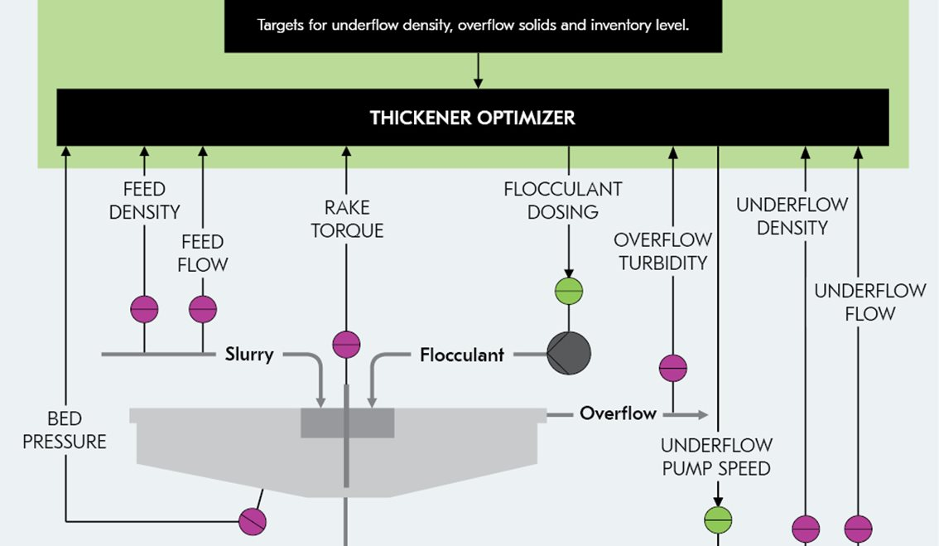

7.1 The control principle of the Metso Thickener optimizer.

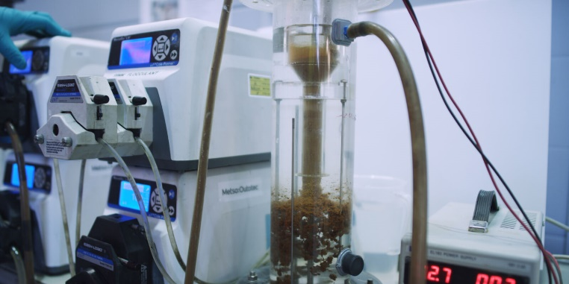

7.2 Metso´s Dynamic 99 mm thickener test unit

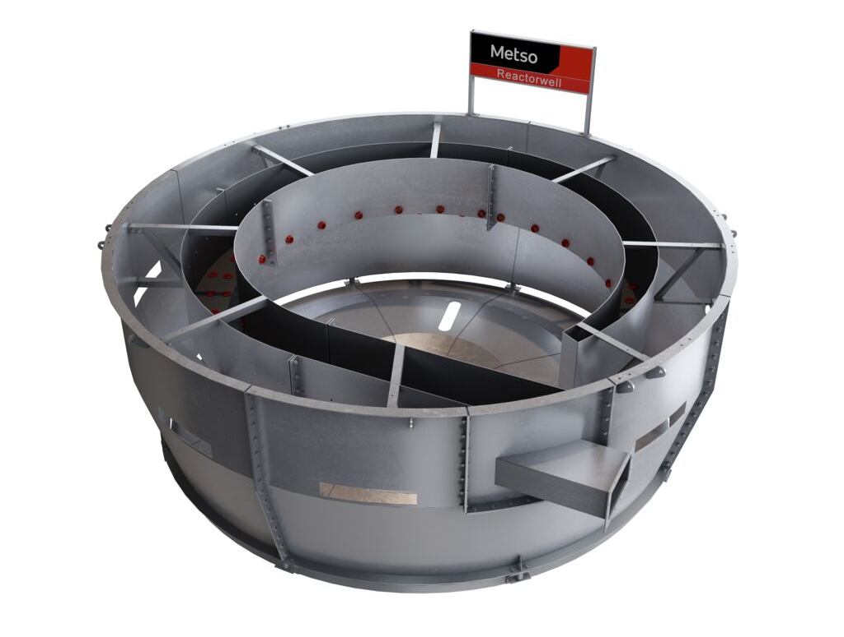

7.2 Reactorwell™ feedwell

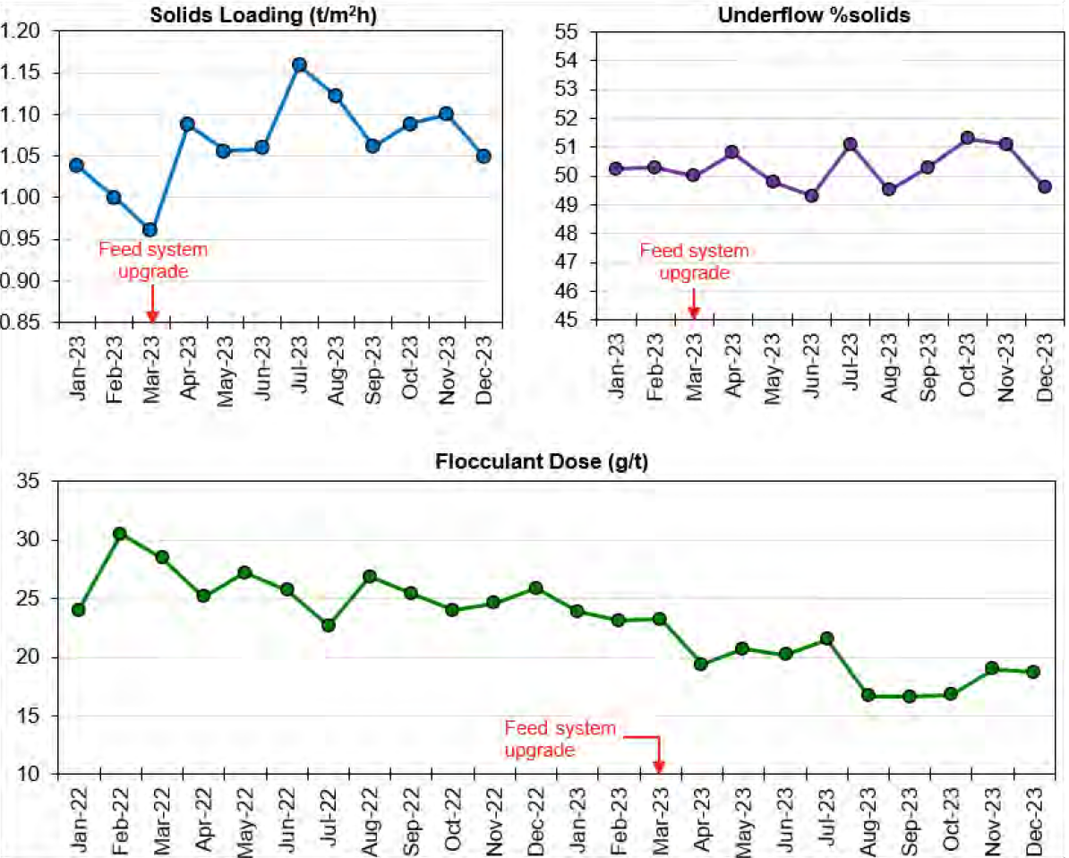

7.3 Process performance analysis of key process parameters of the tailings thickener before and after the feed system upgrade.

8. Videos

8.1 Metso Thickener upgrade solutions: Ensuring optimal performance

8.2 Metso Reactorwell™

Author´s name: Guillermo Bermudez
Brief professional background:
Guillermo currently serves as Director of Product Technical Support in the Beneficiation, Dewatering, and Hydrometallurgy business line at Metso. He has been a valuable member of the company since joining in 2014 as a Process Metallurgist. Guillermo has prior operational experience in pyrometallurgy and hydrometallurgy plants. Throughout his career at Metso, he has excelled in various roles covering sales, product management, and technical support, contributing significantly to Metso’s operations in locations including Mexico, Finland, and Canada. An active member of several mining associations in North America, Guillermo also enjoys mountain biking and golf during the summer months.
Academic Degrees: Chemical Engineer, Master´s in Business and Master´s in Engineering Management (expected class 2026)

Author: Michelle Ball
Brief professional background:
Michelle currently leads a team of process metallurgists and process engineers as a Senior Manager at Metso. She began her career at Metso six years ago as a Process Metallurgist, with prior experience as a Scientist in South Africa and a Plant Metallurgist in England. Her work at Metso has focused on flotation, playing a key role in development and implementation of the ConcordeCell. Michelle is a valuable member of the Beneficiation, Dewatering, and Hydrometallurgy business line and strives to lead her team positively to achieve the best outcomes for all. Outside of work, she enjoys sewing clothes and actively embracing all seasons in Finland, currently training for her first triathlon.
Academic Degrees: Bachelor in Science in Gelogy

Author: Max Alva
Brief professional background:
Max Alva currently works as a Global Process Engineer at Metso, contributing to mineral processing operations in Latin America and other regions. Since joining the company in 2018, Max has focused on flotation, thickening, and filtration, providing support in lab and pilot-scale testing, process optimization, and equipment improvements. His experience also includes research in hydrometallurgy and fieldwork in copper and gold operations in Peru. Max is committed to promoting data-driven innovation and sustainable practices, supporting Metso’s global technical efforts. Outside of work, he enjoys playing soccer and reading novels and literature.
Academic Degrees: Metallurgical Engineer, Data Science Analyst

