Concentrators of the future with Jameson Cells™ and IsaMills™
Mineral Processing and Extractive Metallurgy

Shubhraneel Chattopadhyay¹, Adam Price², Eduardo Morin³

¹ Author: Glencore Technology, Level 29, 180 Ann St, Brisbane, Australia (neel.chattopadhyay1@glencore.com.au - +61410113771)
² Coauthor 1: Glencore Technology, Level 29, 180 Ann St, Brisbane, Australia, (adam.price@glencore.com.au - +61419537241)
³ Coauthor 2: Glencore Technology, Andrés Bello 2457, piso 41, Gran Torre Costanera, Providencia, Chile (eduardo.morin@glencore.cl - +56976220366)

____________________________________________________________________________________

SUMMARY

Concentrators of the future must tackle challenges in the mining industry including declining ore deposit grades and losses of fine/coarse particles to tailings to be economically viable. Additional requirements to minimise an operation’s carbon footprint drives them to seek technologies with lower costs, deliver superior performance, and have a low carbon footprint.
Technologies including the Jameson Cell™ and IsaMill™ were evaluated as solutions for concentrators of the future. The Jameson Cell™ is a pneumatic flotation cell which has seen success in multiple commodities and duties and exhibits superior performance. Technological advancements in the Jameson Cell™ allow it to eliminate up to 9 metres of height, compared to prior layout arrangements which decreased the CAPEX of the design. Investigations into modifying the current Jameson Cell™ design are being conducted to serve as a Coarse Scavenger Jameson Cell™. The primary focus of this flotation cell is to recover coarse particles from a rougher tailing stream. Thus, Coarse Scavenger Jameson Cells™ would enable a circuit to improve the overall recovery.
IsaMills™ have also seen much success in various commodities and applications. By increasing the ceramic media size used in an IsaMill™, this may allow them to be installed in secondary grinding applications. As suggested in the test work reviewed, IsaMills™ in secondary grinding applications yields up to 80% in energy savings relative to a ball mill receiving the same feed.
These findings suggested there is great potential in Jameson Cells™ and IsaMills™ in concentrators of the future, and the technological advancements made in each equipment make them more economically viable and sustainable to adopt.
By combining the Jameson Cell™ and IsaMill™ technologies into a single concentrator circuit (Jameson Concentrator™), operations would find improvements in CAPEX/OPEX, performance and environmental sustainability.

1.0 INTRODUCTION

Currently, the mining industry is facing a key challenge. With increasing demand for various commodities to satisfy societal and technological needs, there are fewer ore deposits which are economically viable to extract from. The low economic return of the low-grade ore deposits is primarily due to the associated high capital and operating expenditures (CAPEX and OPEX respectively) associated with mining and metallurgical costs in each operation.
Direct factors which contribute to the high metallurgical costs and losses of revenue are as follows:
- Declining ore deposit grades: The purity of the deposits is declining globally (Northey et al., 2014). Consequently, the amount of mineral processing required to achieve the same final concentrate grade increases significantly. This directly leads to increased processing costs as a result of increased milling requirements, reagent consumption and more.
- Low fine and coarse particle recovery in a flotation circuit: Some mineral processing equipment are not capable of recovering fine and/or coarse particles (Lynch et al., 1981). This contributes to a greater proportion of valuable particles reporting to tailing dams and leads to losses in natural resources and potential revenue.
- High energy requirements: Current concentrators employ size reduction equipment to liberate minerals for downstream concentrating processes like flotation. Although necessary for mineral liberation, the energy consumption of the size reduction equipment is significant and is a significant contributor to an operation’s total OPEX (Allen, 2021).
Furthermore, to meet environmental sustainability targets, mineral processing circuits must switch to environmentally greener equipment. Specifically, the need for mining operations to reduce the use of water and eliminate the storage of liquid tailings present difficult challenges to current plant designs. Although substituting current equipment with more sustainable options yields great benefit to the environment, short/long term mine economic feasibility may be hindered.
In response to the observations above, the mining industry calls for the design of efficient and economically feasible concentrators of the future. These concentrators of the future would consist of mining technologies which must possess all three of the following key characteristics: high performance mineral processing equipment, high environmental sustainability and low CAPEX/OPEX.
Existing mining technologies which satisfy the characteristics listed above include the Jameson Cell™ and the IsaMill™. Commercialised by Glencore Technology (GT), the Jameson Cell™ and the IsaMill™ are mineral processing equipment designed to deliver superior performance whilst being environmentally sustainable.
To maximise the potential of both technologies, GT designed the Jameson Concentrator™ which uses the Jameson Cell™ and IsaMill™ together. Operations adopting the Jameson Concentrator™ have appreciated high performance and low plant footprints relative to conventional concentrator circuits.
Technological advancements in the Jameson Cell™ and IsaMill™ have further improved the viability of each technology. As a result, the implications of these advancements led to concentrator of the future designs which yield savings in OPEX/CAPEX whilst being environmentally sustainable.

1.1 Objective

Reviews and evaluate the use of Jameson Cells™ and IsaMills™ in existing applications and commodities. This scope also extends to projecting the latest technological developments in the Jameson Cell™ and IsaMill™. This would provide insight into how the technologies would be able to tackle the challenges of the mining industry and its place in the concentrators of the future like the Jameson Concentrator™.

2.0 JAMESON CELL™ REVIEW

The Jameson Cell™ is a pneumatic flotation device which was developed jointly between Mount Isa Mines (MIM) and Professor Jameson from 1986 to 1989. Since 1989, the Jameson Cell™ has undergone various redesigns, however, the principle of operation remained the same.
The key feature of the Jameson Cell™ is the downcomer. Pressurised slurry is fed into a downcomer at a pressure range between 130 – 170kPa. After passing through an orifice lens, a slurry jet is formed which has a velocity range between 15-17m/s and plunges into the slurry surface. Simultaneously, the jet creates a vacuum in the downcomer which enables air to be drawn into the downcomer and interact with the jet. When the jet plunges into the slurry, a highly turbulent mixing zone is created which entrains air into the slurry and shears it into fine bubbles (bubble size range between 300-700µm).
This promotes a high likelihood and frequency of bubble-particle collisions within the downcomer and enables a low residence time requirement in the flotation vessel (Evans et al. 1995). Consequently, this leads to the Jameson Cell™ delivering optimal flotation performance and minimises losses to tailings.
Due to its method of operation, the Jameson Cell™ yields several benefits compared to its conventional flotation cell counterpart:
- Reduction in OPEX: Due to the pneumatic nature of the flotation device, there is no energy requirement during the Jameson Cell’s™ operation. In addition, as moving parts are eliminated from the design of the Jameson Cell™, variable costs related to the maintenance and replacement of moving parts are non-existent in the design.
- Short residence time: Due to the high frequency of bubble-particle interactions in the Jameson Cell™, shorter residence times are required relative to a conventional flotation cell.
  - The significant implication of shorter residence time is the smaller cell design and overall lower plant footprint.
  - Installation of Jameson Cells™ in brownfield operations may aid in debottlenecking the circuit if residence time constrained.
- Fewer units required: As the Jameson Cell™ requires a lower residence time and yields a greater carrying capacity compared to conventional flotation cells, each Jameson Cell™ can obtain higher recoveries per cell. The presence of wash water in the Jameson Cell™ lessens the number of upgrade stages required, further decreasing the number of units required. Consequently, 1 Jameson Cell™ may replace 3-4 conventional flotation cells.
  - This results in Jameson Cells™ yielding a lower plant footprint than conventional cells. By using less space, this suggests savings in CAPEX with regards to structural steel and concrete requirements.
- Greater fine particle recovery: The generation of fine bubbles (300-700µm) allows for a greater surface area to volume ratio. This improves the bubble-particle collision likelihood in the cell, particularly with fine particles. Consequently, this would lead to lower losses of fines to tailing dams and improve the generated revenue of the operation.
Because of the reasons listed, the Jameson Cell™ has seen success in various applications and commodities. Over 500 Jameson Cells™ have been installed globally in copper, coal, lead/zinc and gold-based operations, as well as other base metals, precious metals, and several other commodities. It is a flexible technology which can serve in greenfield or brownfield concentrators in most duties.

2.1 Rougher Duty

The Jameson Cell™ is capable of operating as a rougher in a concentrator circuit. Due to its short residence time and ability to recover fine particles, it positions itself to deliver greater performance with a lower plant footprint. The current largest commercial Jameson Cell™ can accept feed volumes up to ~8300m³/hr of slurry.
Based on a series of rougher feed test work, it was found that rougher duty Jameson Cells™ can achieve final concentrate grade in various operations whilst achieving high recoveries (Figure 1).

Figure 1 indicates that rougher duty Jameson Cells™ can achieve 60-90% of copper recovery while achieving the desired concentrate grade target. Depending on the processing circuit design and mineralogy, this may allow the concentrate stream to report directly to final concentrate product, bypassing a regrinding stage and the cleaner circuit. Consequently, this would yield major savings in energy requirement for the circuit, reducing the throughput and OPEX associated with the regrind milling stage. Furthermore, it would reduce the equipment required for the cleaner circuit, providing even greater CAPEX and OPEX savings.

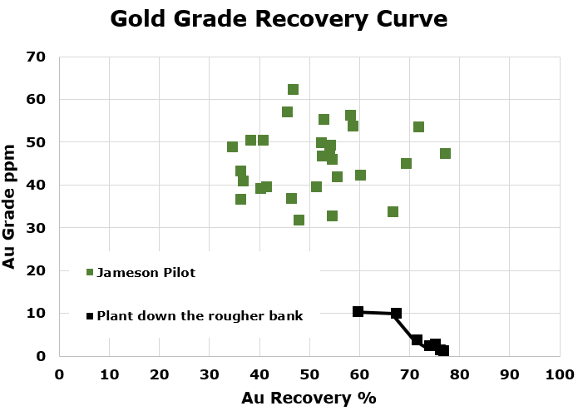
Figure 1 also implies the potential of a Jameson Cell™ as a rougher scavenger. By only focussing on recovery, the high flotation kinetics of the cell enable it to float less liberated and finer particles which were not collected in the prior rougher cell. Consequently, this addition would boost overall recovery in the circuit.
Figure 1: Copper grade-recovery curves of rougher Jameson Cells™ in different operations. Coloured horizontal line corresponds with concentrate grade targets for different operations.

2.1.1 Case Study: Site 1
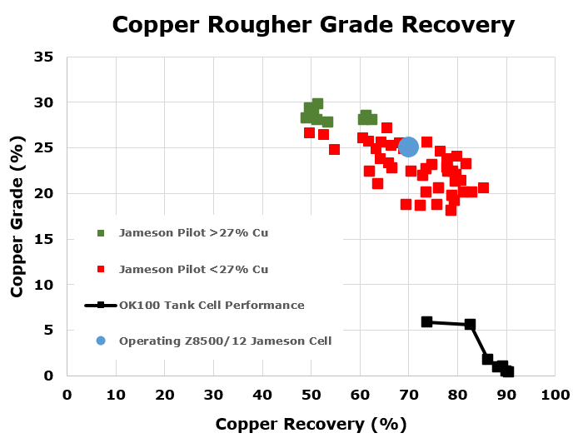
A rougher Jameson Cell™ was installed in Site 1’s copper-gold processing circuit. Figure 2 and 3 demonstrates the copper and gold performance of the Jameson Cell™ relative to the conventional cell.
Figure 2: Copper grade-recovery comparison in Site 1
Figure 3: Gold grade-recovery curve comparison in Site 1
At similar recoveries, the Jameson Cell™ can achieve greater concentrate grades in a rougher duty relative to conventional flotation cells.

As the rougher feed was relatively fine (50% of the particles were finer than 38µm), the Jameson Cell™ was capable of exhibiting greater performance. This performance can be attributed to the Jameson Cell’s high-shear mixing zone which greatly improves the bubble-particle collision frequency. This differs from the conventional cell where bubbles are randomly dispersed in the tank and exhibits lower bubble-particle collision frequency.

2.1.2 Case Study: Ero Copper Caraiba
The Ero Copper Caraiba operation in Brazil had installed a rougher scalper Jameson Cell™. In response to lower feed grade due to mine deepening, the operation required a technology which could process an increased throughput from 400tph to 600tph whilst delivering high performance.

To achieve the target final concentrate grade of 34.5%, the Jameson Cell™ maintained a copper recovery ranging between 75-80%. This was achievable due to the cell’s ability to float fast floating minerals and finer material.

Figure 4: Industrial and pilot Cu grade-recovery curves at Caraiba

2.2 Cleaner Duty
Jameson Cells™ excel in the cleaner duty application of a flotation circuit. Typically, cleaner flotation cells follow a size reduction process in the circuit to improve the degree of mineral liberation.
A cleaner Jameson Cell™ is optimal in a cleaner circuit because of the following factors:
- Fine bubble generation: The increased surface area to volume ratio of the bubbles enables more surface area for the fine hydrophobic particles to attach to and improve fine particle collection.
- High void fraction mixing region: The bubble-particle interactions and collisions all occur in a smaller enclosed mixing region unlike conventional flotation cells. This improves the likelihood of bubble-particle interactions which consequently leads to greater flotation efficiency.
- High upgrade ratios: Wash water is present in cleaner Jameson Cells™. As a result, entrained gangue in the froth phase is removed and improves the grade of the final concentrate.
Wash water is particularly necessary in operations where the ore deposit moderately consists of clay. Clay may form a slime coating around valuable minerals and impede upon the mineral’s floatability (Chen & Peng, 2018). The adoption of wash water would aid in cleaning the clay slime coating off any valuable particle and improve flotation performance.
Based on Jameson Cell™ pilot test work at Luca’s Campo Morado polymetallic operation with clay gangue, the Jameson Cell™ was delivering high upgrade ratios relative to the existing industrial plant. The test work revealed the Jameson Cell™ was delivering Zn upgrade ratios up to ~27 whereas the industrial plant was averaging at ~6 (Luca Mining Corporation, 2023). This demonstrates the high flotation performance of the Jameson Cell™, particularly in clay ore deposits.
Beyond mineralogy, cleaner circuits face other challenges. The prior size reduction stage exposes fresh minerals surfaces to oxygen. This subjects these surfaces of different minerals, particularly sulphide minerals, to surface oxidation. Due to the thin oxidation film present on the surface, this makes bubble and collector attachment to the mineral surface difficult after a long residence time (Moimane et al., 2020).
However, due to the short residence time of Jameson Cells™, bubbles are able to contact with the freshly exposed mineral surfaces after milling in the downcomer with a shorter residence time. Thus, Jameson Cells™ are less prone to recovery losses to mineral surface oxidation relative to conventional flotation cells.
Depending on the cleaner feed mineralogy, Figure 5 demonstrates the Jameson Cell™ can achieve final copper grade concentrate whilst yielding high recoveries in a cleaner duty.
Figure 5: Industrial copper recovery-grade curve

2.2.2 Case Study: Antofagasta Mineral’s Centinela Operation (Pizarro et al., 2022)

In response to their complex ore mineralogy, Centinela sought out technologies for their flotation circuit to mainly:
- Increase global recovery
- Increase Cu grade in the collective concentrate

Consequently, Jameson Cells™ were installed as a part of their cleaner circuit to aid the operation’s economic viability. They were selected based on lower plant footprint (~50% less than columns), lower CAPEX and OPEX and superior metallurgical performance.

Pilot test work was performed on low-grade stock with majority of the particle sizes being less than 37µm.

Figure 6: Jameson Cell Cu grade-recovery curve from Centinela low-grade feed pilot test work. Reconstructed for quality purposes (Pizarro et al., 2022)

Figure 7: Jameson Cell Mo grade-recovery curve from Centinela low-grade feed pilot test work. Reconstructed for quality purposes (Pizarro et al., 2022)
The results of the pilot test work showed that the Jameson Cell™ could achieve high grades and recoveries in both Cu and Mo. This high performance could be attributed to two main factors:
- Fine particle size distribution: As most particle are <37µm, the fine bubbles generated in the Jameson Cell™ positions the technology to be advantageous due to its high bubble surface area to volume ratio.
- Restricted contact zone: The restricted contact zone between the particles and bubbles in the downcomer improves the likelihood of bubble-particle interaction. This is particularly beneficial for Molybdenum recovery as the shape factor of molybdenum minerals may make flotation difficult otherwise (Lawson, 2016).

2.2.3 Case Study: Newmont Cadia (Akerstrom et al., 2018)

Jameson Cells™ were installed in Cadia’s flotation circuit because of the bottlenecks which led to process instability. Key criteria which were used to select the Jameson Cell™ for the expansion of the cleaner circuit included:
- Sufficient cleaner capacity
- Effective rejection of penalty elements, such as fluorine

Post installation of the Jameson Cells™ in the cleaner circuit led to improvement in gold and copper recoveries whilst also yielding major reductions in fluorine in the final concentrate.

- Gold recovery improvement: The global gold recovery improved from 90% to 96% post Jameson Cell™ installation. Notably, recovery of free gold grains <7 µm jumped from 73% to 94%. This highlights the technology’s superior performance in fine particle recovery. Figure 8 further shows the improvement in gold recovery across each size fraction in the cleaner circuit.
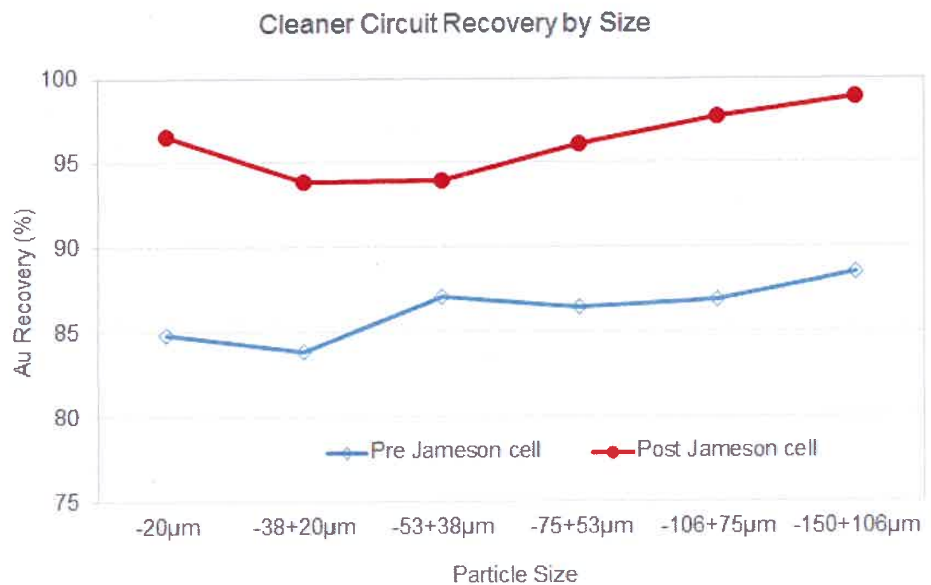
Figure 8: Cleaner circuit gold recovery pre-Jameson Cell™ (blue) and post-Jameson Cell™ (red) installation (Akerstrom et al., 2022)

- Copper recovery improvement: Similar patterns were observed in copper recovery. An increase from 91% to 97% in global copper recovery was observed. This is due to the improvement in recovery across the fine size fraction, particularly in the <7µm bornite particles from 77% to 96%.
- Fluorite reduction: The concentration of fluorine was reduced from ~1000ppm to ~600ppm. This reduction can be attributed to the wash water and operating at deeper froths to obtain a higher-grade concentrate.

3.0 TECHNOLOGICAL ADVANCEMENTS
The GT mineral processing space has investigated methods of minimising CAPEX by optimising the structural arrangement of the technology whilst maintaining robust structural integrity. Other considerations for this space include modifying existing equipment to fulfil other duties in a processing circuit to improve overall commodity recovery and efficiency.

3.1 Low-Profile Jameson Cell™ Design
To improve flotation recovery and level control, the Jameson Cell™ has a recycle mechanism. In larger models of the Jameson Cell™, there is an external recycle mechanism (ERM) which is structurally independent from the main tank of the Jameson Cell™. The ERM is a rectangular box situated beneath the tailings outlet of the cell, consisting of one inlet and two outlets. Each outlet is separated by a weir, as shown in Figure 9.

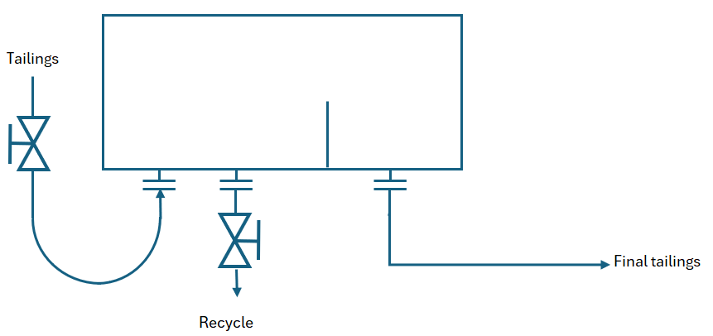
Figure 10: Arrangement of external recycle mechanism (ERM)
The volumetric split between the recycle and final tailings streams is dependent on the recycle valve position. If the recycle valve is in a closed position, all the Jameson Cell™ tailings would report to the final tailings.

Typically, the ERM structure is situated beneath the Jameson Cell™ tank which adds height to the overall structure. This has negative implications on additional structural steel requirements (and thus higher CAPEX) and may prove difficult to install if a Jameson Cell™ is required to fit in a roofed operation.

The low-profile Jameson Cell™ substituted the ERM box beneath the tank with a pipework arrangement. Consequently, this decreased the height of the overall system by up to 9 metres, as depicted in Figure 9.

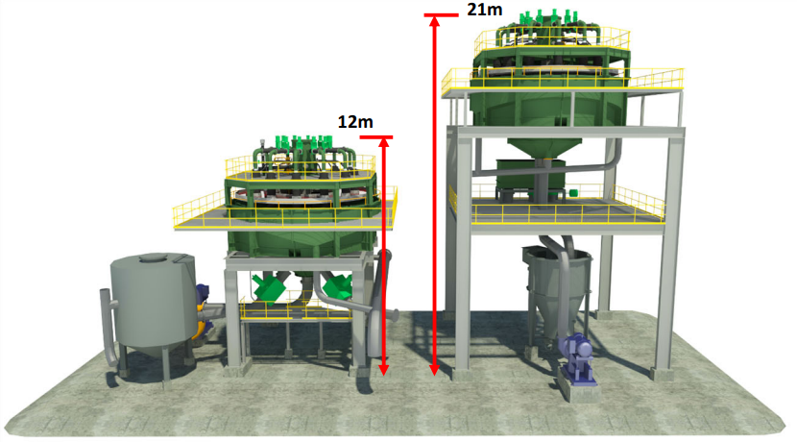
The results of the reduction in height led to lower structural costs for the Jameson Cell™ and enabled the design to be more compact. It was found that the cost of structural steel had dropped to <10% of the total mechanical supply cost for a Jameson Cell™. This positions the Jameson Cell™ technology to be more viable in existing and future concentrators in terms of CAPEX and ease of integration.
Figure 9: Height comparison between structure with external recycle mechanism (ERM) (right) and low-profile design (left)

3.2 Coarse Scavenging in Jameson Cells™

In conventional flotation, particles in the extreme ends of the particle size distribution are difficult to recover. Particularly, coarse particles (+300µm for base metals) are difficult to float because of the high likelihood of bubble-particle detachment in highly turbulent regions of flotation tanks. Also, coarse particles are heavier and cannot be supported by finer bubbles which leads to bubble-particle detachment (Anzoom et al., 2024). As flotation cells aim to generate turbulent regions in the tanks to promote bubble-particle collision and generate fine bubbles, regular flotation methods cannot be applied for coarse particle recovery.

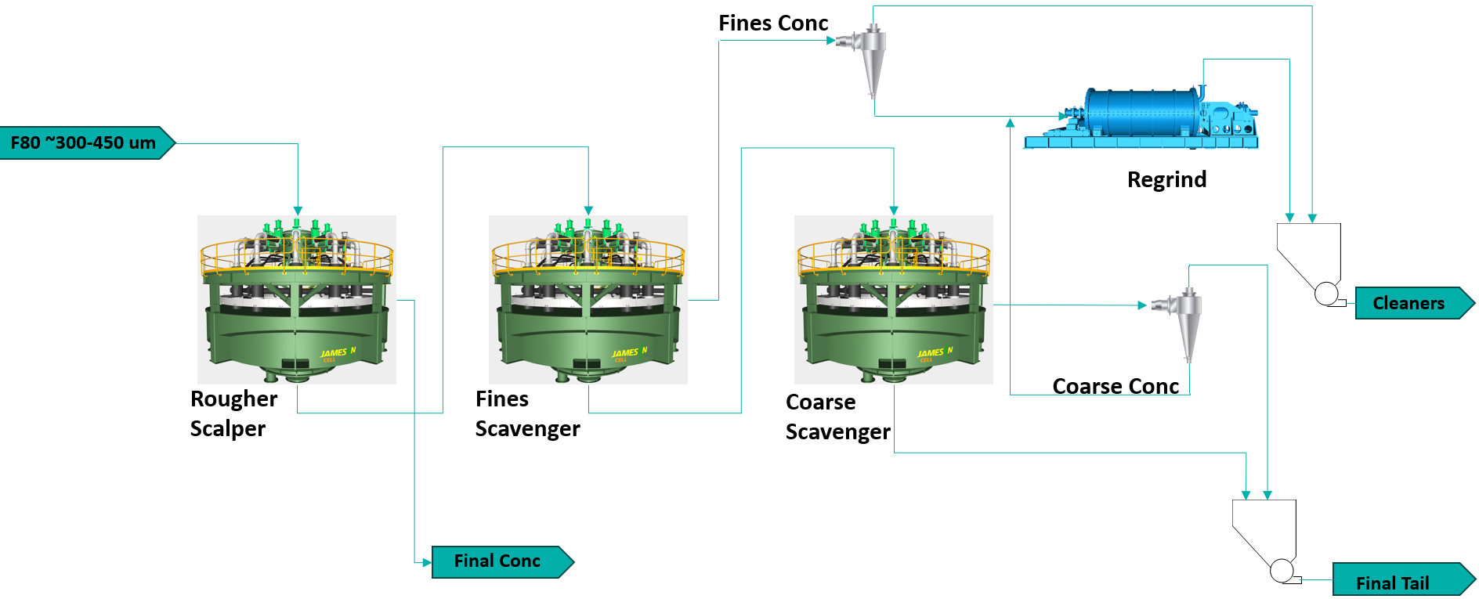
Figure 11: Generic Jameson Cell™ rougher circuit flowsheet with Coarse Scavenger
To improve coarse particle recovery, bubble-coarse particle attachment must occur in a quiescent region in the tank. Existing coarse particle flotation cells use water to generate a fluidised bed and create a less turbulent region in the cell optimised for coarse particle recovery (Demir et al., 2024). However, the addition of fluidisation water could introduce complexities of the water balance of the circuit and increase the water usage. Thus, this may lead to increased OPEX of the processing circuit.

GT proposes to modify the existing Jameson Cell™ into a Coarse Scavenger Jameson Cell™ which focusses on floating coarser particles. It would achieve this objective without the need for external
fluidisation water. Modifications in the Jameson Cell™ will be made such that the turbulence generated in the cell would be minimised, ideal for coarse particle collection. Such modifications include but are not limited to eliminating the froth phase and changing the jet velocity. Redesigns to the downcomer are also investigated to observe their effect on turbulence at the exit of the downcomer.

Installing Coarse Scavenger Jameson Cells™ in concentrators of the future would yield improved overall recovery around the flotation circuit. Its duty would be primarily focussed on receiving the tailings from the rougher circuit and recover the valuable particles in the coarser size fractions. Following the Coarse Scavenger Jameson Cell™, the coarse concentrate can report to a regrind stage and reintroduce the particles back to the main flotation circuit for a second chance for recovery. A generic application can be implemented as shown in Figure 11 but may be implemented in other circuit arrangements depending on various factors.

3.3 Coarse Grinding in the IsaMill™

Size reduction technologies such as the tumbling and ball mills are often used in secondary grinding applications. However, due to the energy inefficiencies associated with tumbling mills, alternative options are being investigated such as stirred mills to minimise plant OPEX and total carbon footprint.
The IsaMill™ is a horizontal stirred mill developed by GT to reach target grind sizes of -10µm. Typically, IsaMills™ are adopted in ultra-fine grinding applications as they can reach fine particle size ranges via an optimised attrition mechanism. The largest operating F₈₀ for an IsaMill™ is dependent on the ceramic media top size available in the market. Existing IsaMills™ can operate with a F₈₀ of 400µm with 6mm ceramic media.
In response to increasing feed particle size distributions to stirred mills, media suppliers have invested in developing greater ceramic media sizes. Given the relationship between ceramic media size and operating F₈₀, this provided the opportunity for IsaMills™ to substitute energy inefficient tumbling mills in a secondary grinding application (Gurnett et al., 2024).
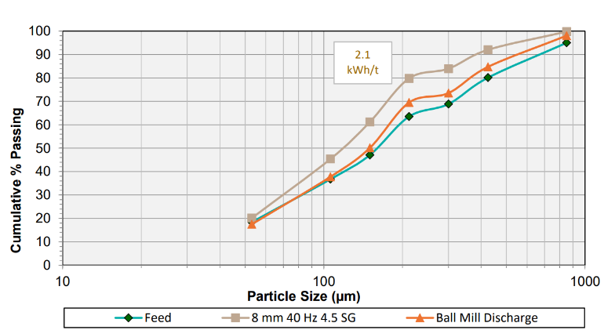
Figure 12: IsaMill™ with 8mm ceramic media (brown square) comparison against Ball Mill (orange triangle) (Gurnett et al., 2024)
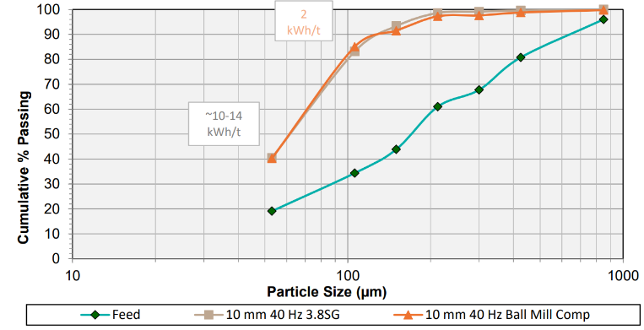
Figure 13: IsaMill™ with 10mm ceramic media (brown square) comparison against Ball Mill (orange triangle) (Gurnett et al., 2024)
A comparative study was conducted between the IsaMill™ and a ball mill. After conducting test work with 8mm and 10mm ceramic media in Hudbay’s Stall Mill in Canada, the results suggested the IsaMill™ is capable of substituting ball mills in secondary grinding applications with significant energy savings (Gurnett et al., 2024).
The results of the test work validated the concept of an IsaMill™ in a secondary grinding application. Although similar particle size distributions were achieved across the IsaMill™ and ball mill, up to 80% less energy was required for the IsaMill™ when using 8mm and 10mm ceramic media (Gurnett et al., 2024).
The implications of the results are as follows:
- Significant energy savings and reduction in carbon footprint can be attained by implementing IsaMills™ in secondary grinding applications. This is due to the optimised attrition mechanism of the IsaMill™ as opposed to the impact and abrasion mechanism in tumbling mills.
- Potential elimination of Fe²⁺/Fe³⁺ ions in the slurry by using inert ceramic media instead of steel grinding media in a ball mill. Iron contamination in flotation feed had been reported to chemically influence the floatability of certain minerals (Peng & Grano, 2010). Removing the Fe ions from the stream would consequently improve flotation performance consistency.
In future concentrators, IsaMills™ yield great potential to substitute energy inefficient ball mills in mineral processing circuits. IsaMills™ could also be used in conjunction with HPGRs to yield a reduction in specific energy requirements by 9.2% and 16.7% against HPGR/ball mill and cone crusher/ball mill circuits respectively (Gurnett et al., 2023).

4.0 THE JAMESON CONCENTRATOR™ NOW AND IN THE FUTURE
The Jameson Concentrator™ is a mineral processing circuit design by GT which incorporates both the Jameson Cell™ and IsaMill™ technologies. By combining the superior performance of the Jameson Cell™ in most flotation duties with the energy efficient IsaMill™ particle size reduction, this results in a concentrator which delivers a cost-effective design which delivers high performance and sustainability.

A major benefit of this design is the low plant footprint of the operation. Figure 14 compares the footprint of a conventional concentrator against the Jameson Concentrator™. Overall, a ~65% reduction in plant footprint can be seen.

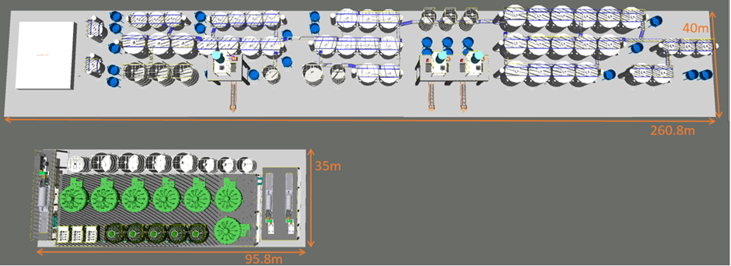
By having a lower plant footprint, the costs associated with structural steel and concrete would be lowered and save on overall CAPEX of the circuit. The Jameson Concentrator™ would also be safer relative to the conventional concentrator as there is less working at height requirements and fewer confined spaces. Finally, due to the fewer number of Jameson Cells™ in the concentrator, this generally leads to simpler process control. The ERM of the Jameson Cells™ further simplifies process control of the concentrator.
Figure 14: Comparison of Jameson Concentrator™ (bottom) plant footprint (95.8m x 35m) against conventional concentrator (top) plant footprint (260.8m x 40m)

4.1 Case Study: Hudbay Minerals New Brittania
A Jameson Concentrator™ was installed in Hudbay Mineral’s New Brittania copper-gold operation.

A key driver behind the selection of the Jameson Concentrator™ over competing technologies is due to the Jameson Concentrator’s™ ability to handle the operation’s feed mineralogy variability. With conventional flotation circuits, high variability in feed characteristics may lead to oversizing of equipment to ensure there is sufficient residence time (Taylor et al., 2021).

The Jameson Cell™ was able to demonstrate its ability to operate at a large carrying capacity range when exposed to varying feed characteristics. Furthermore, it was flexible in which duty it was performing:
- In response to high grade feed, New Brittania can operate the Jameson Cell™ as a scalper to directly produce a final concentrate.
- In response to low grade feed, a bypass could be run and allow the cleaner cell for further upgrade.

Regarding the plant footprint comparison, the Jameson Concentrator™ yielded a 50% lower footprint relative to the conventional flotation circuit. This can be attributed to the Jameson Cell’s™ more compact design; 4 Jameson Cells™ were selected over 12 conventional cells.

After installation, the Jameson Concentrator™ exhibited better performance compared to the pilot plant data. As depicted in Figure 15, the concentrator can consistently achieve ~90% copper recoveries with upgrade ratios ranging between 10-15. Additionally, the Jameson Concentrator™ increased the design capacity to 160% of the original design capacity as of mid-2024.

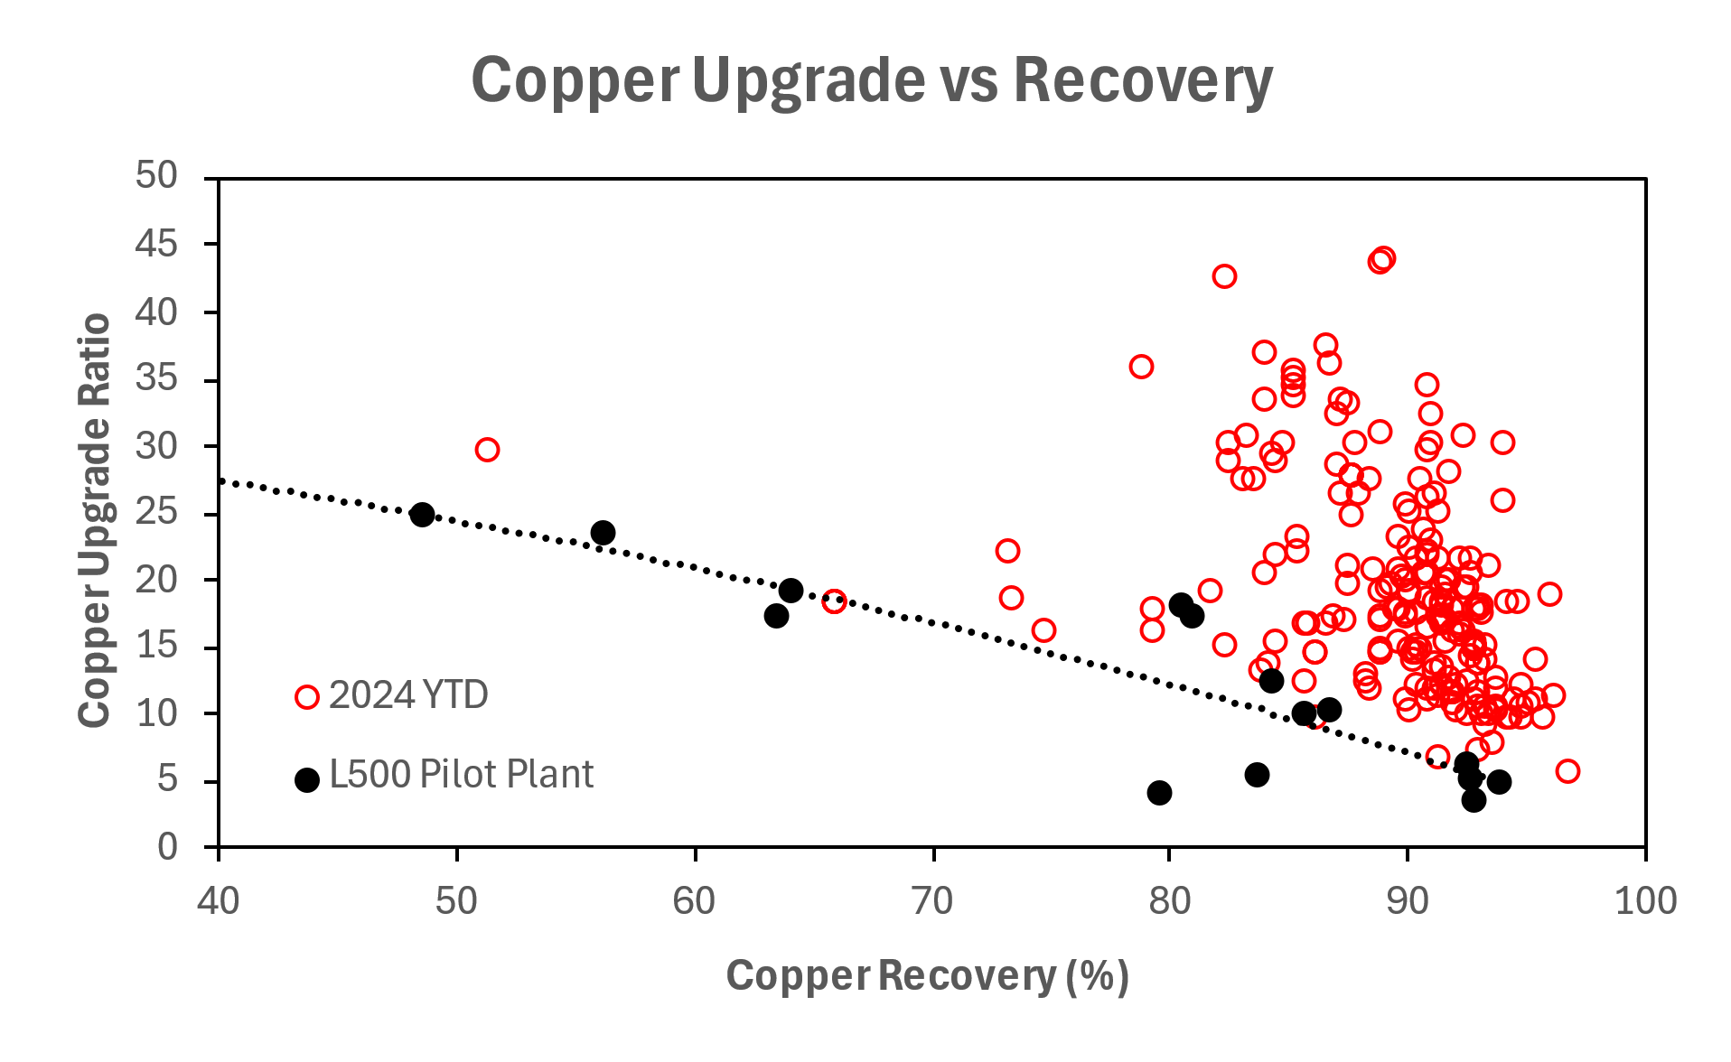
Figure 15: Copper upgrade ratio-recovery curve post-installation of Jameson Concentrator in New Brittania

4.2 Implementation of Technological Advancements into the Jameson Concentrator™
When incorporating the technological advancements of the Jameson Cell™ and IsaMill™ in the Jameson Concentrator™ and other concentrators, the potential for the operation improves from a cost, performance and environmental perspective.
- Implementation of the low-profile Jameson Cell™ design would lessen the overall height of the concentrator. This would lead to further savings in structural material and lessen the risk associated with working at heights.
- Implementation of the Coarse Scavenger Jameson Cell™ would improve the overall recovery of the circuit and minimise losses to tailing dams.
- The potential of implementing of the IsaMill™ in a secondary grinding duty would greatly decrease the energy consumption of the circuit based on the test work reviewed (Gurnett et al., 2024).

A Jameson Concentrator™ of the future for a base metals operation could be simplified as much as the flowsheet as shown in Figure 16, but the design would change from operation to operation, and commodity to commodity.
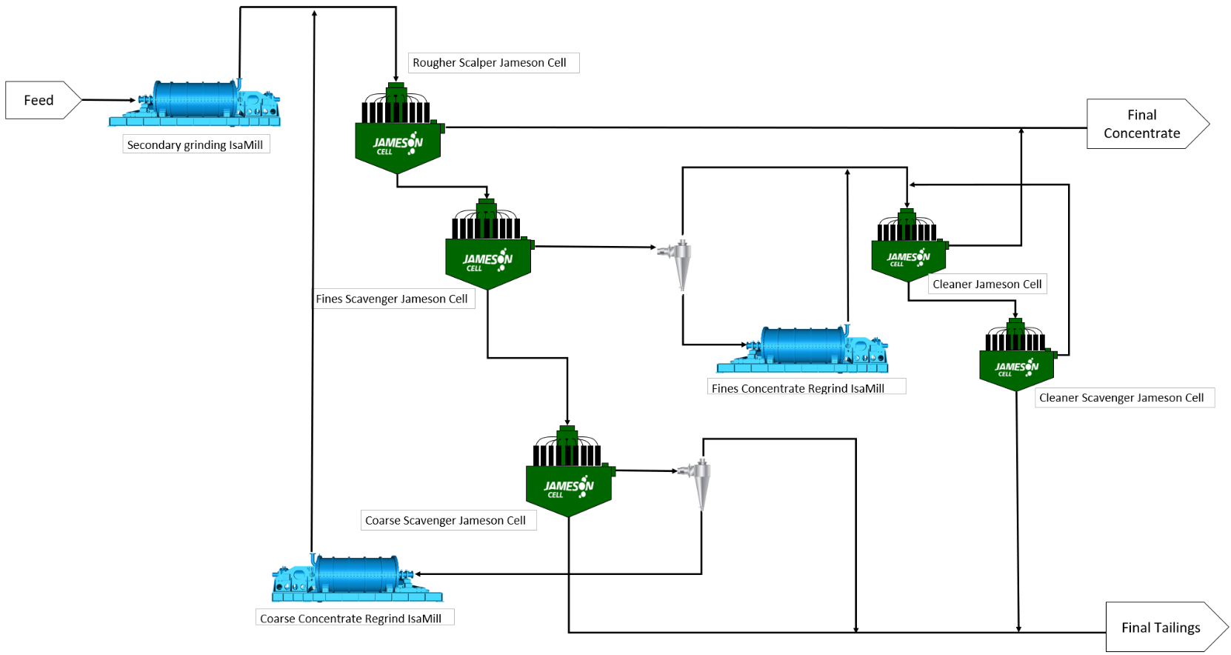
Figure 16: Generic Jameson Concentrator flowsheet with technological advancements

5.0 Conclusion
The current Jameson Cell™ design exhibits superior flotation performance and success in various duties and applications. In addition to the current design, technological advancements in the Jameson Cell™ including the low-profile design and coarse scavenging applications enables future concentrators to be developed with lower CAPEX and OPEX without sacrificing performance and carbon footprint. Isamills™ can be installed alongside the Jameson Cells™ in ultra-fine and shows potential in secondary grinding applications in future concentrators to obtain significant energy savings.
These technologies yield the potential to assist concentrators of the future be economically viable in the face of problems including lower ore deposit grades and losses of fine and coarse particles to tailings. In addition, the Jameson Cell™ and IsaMill™ can bring improved performance whilst minimising the carbon footprint, ultimately being the sustainable solution in the long term.

Bibliography
Akerstrom, B., Seppelt, J., Waters, T., Bubnich, J., & Seaman, D. (2018). Cleaner circuit optimisation at Cadia operations.
Allen, M. (2021). A high-level study into mining energy use for the key mineral commodities of the future.
Anzoom, S. J., Bournival, G., & Ata, S. (2024). Coarse particle flotation: A review. Minerals Engineering.
Chen, X., & Peng, Y. (2018). Managing clay minerals in froth flotation - A critical review. Mineral Processing and Extractive Metallurgy Review, 289-307.
Demir, K., Morrison, A., Evans, C., Kohmuench, J., & Runge, K. (2024). The bubble size produced in a pilot HydroFloat® cell and its effect on flotation. Minerals Engineering.
Evans, G. M., Atkinson, B. W., & Jameson, G. J. (1995). The Jameson Cell. In K. A. Matts, Flotation Science and Engineering (pp. 331-363).
Gurnett, I., Martin, S., & Stieper, G. (2023). Coarse Grinding on a IsaMill™.
Gurnett, I., Swann, A., Weir, T., & Marion, C. (2024). Significant Potential of an IsaMill™ in Secondary Grinding Duty.
Lawson, V. (2016). Enhancing the performance of Cu-Mo circuits using the Jameson Cell.
Luca Mining Corporation. (2023). Jameson Cell Technology Shows Promise in Improving Base and Precious Metals Recoveries at Luca's Campo Morado Mine.
Lynch, A., Johnson, N., Manlapig, E., & Thorne, C. (1981). Mineral and coal flotation circuits: Their simulation and control.
Moimane, T., Plackowski, C., & Peng, Y. (2020). The critical degree of mineral surface oxidation in copper sulphide flotation. Minerals Engineering.
Northey, S., Mohr, S., Mudd, G., Weng, Z., & Giurco, D. (2014). Modelling future copper ore grade decline based on a detailed assessment of copper resources
and mining. Resources, Conservation and Recycling, 190-201.
Peng, Y., & Grano, S. (2010). Effect of iron contamination from grinding media on the flotation of sulphide minerals of different particle size. International Journal of Mineral Processing, 1-6.
Pizarro, L., Bahamondes, R., Catalan, M., & Bello, F. (2022). Centinela, challenges in the concentration of complex ores.
Taylor, M., Stieper, G., & Gurnett, I. (2021). Commissioning of the Jameson Concentrator at Hudbay's New Britannia Mill.

Author's full name: Shubhraneel Chattopadhyay
Brief professional background: Shubhraneel (Neel) Chattopadhyay is a Graduate Metallurgist at Glencore Technology where he focusses on innovation and continuous improvement relating to Jameson Cell technology.

Indicate the Academic Degree(s): Bachelor of Chemical Engineering (Honours), University of Queensland (Brisbane, Queensland, Australia)

Coauthor's full name: Adam Price
Brief professional background: Adam Price is the Manager of Jameson Flotation at Glencore Technology, with over 17 years of experience in minerals processing. He has worked extensively across Glencore base metals operations and now leads the development and deployment of Jameson Cell and Jameson Concentrator technologies.

Indicate the Academic Degree(s): Bachelor of Chemical Engineering (Honours), University of Melbourne (Melbourne, Victoria, Australia)

Coauthor’s full name: Eduardo Andres Morin Cerliani
Brief professional background: Eduardo Andres Morin Cerliani is a professional with 15 years of experience in the mining and metallurgical sector, involved in the management of mineral processing plants and the implementation of projects focussed on the incorporations of new technologies. He has held roles such as Concentrator Plant Superintendent, Process Engineering Superintendent, and Director of Innovation. He currently serves as Latin American Metallurgy Manager for Glencore Technology.

Indicate the Academic Degree(s): Chemical Engineering, Pontifical Catholic University of Valparaiso.
Master’s degree in Mining, University of Chile.

