TÍTULO:
Acid mine drainage bioremediation using an indigenous acidophilic sulfate-reducing bacteria (aSRB) consortium from Cajamarca region.
TEMA:
Pasivos ambientales y Cierre de Minas.
CATEGORÍA:
ESG (Environmental, Social, Governance)
DATOS DEL AUTOR Y COAUTORES:
Luis Felipe Valdez Nuñez (author)
- Universidad Nacional de Cajamarca (Peru)
- Researcher
- Ave./ Universitaria Block C Lot 8, 06002 Cajamarca, Peru
- lvaldez@unc.edu.pe
- Luisfelipe.vanu@gmail.com
- 990018199
Mummar Mansor (co-author)
- Eberhard-Karls Universidad de Tübingen (Germany)
- Research Group Leader
- Schnarrenbergstr. 94-96, 72076 Tübingen · Germany
- muammar.muammar-bin-mansor@uni-tuebingen.de
- +49 7071 / 29-78999
Andreas Kappler (co-author)
- Eberhard-Karls Universidad de Tübingen (Germany)
- Head of the Geomicrobiology Lab, Center for Applied Geoscience
- Schnarrenbergstr. 94-96, 72076 Tübingen · Germany
- andreas.kappler@uni-tuebingen.de
- +49 7071 / 29-74992
PALABRAS CLAVES:
Acid mine drainage, acidophilic, sulfate-reducing bacteria, consortium, mineral formation, Acididesulfobacillus, Desulfosporosinus.
CONTEXTO O ESCENARIO EN QUE SE HA REALIZADO EL TRABAJO Y CÓMO SE HA LLEGADO A PRECISAR SUS ALCANCES.
Acid mine drainage (AMD) is a toxic waste derived from mining activities characterized by its low pH (≤3.0) and high metal and sulfate content. AMD is generated by a combination of abiotic and biotic processes in which sulfide ores (i.e., pyrite (FeS₂)) are oxidized by oxygen and Fe³⁺, catalyzed by the action of chemolithoautotrophic bacteria (i.e., Acidithiobacillus at pH ≤3.0). AMD is responsible for metal pollution once it enters the ecosystems, generating serious concerns to the environment and to human health. Current AMD treatments rely on the addition of chemicals (e.g., CaCO₃) to neutralize the acidity and precipitate metals but the increasing costs of these reagents affect their sustainability. AMD is still one of the biggest challenges of the mining industry.
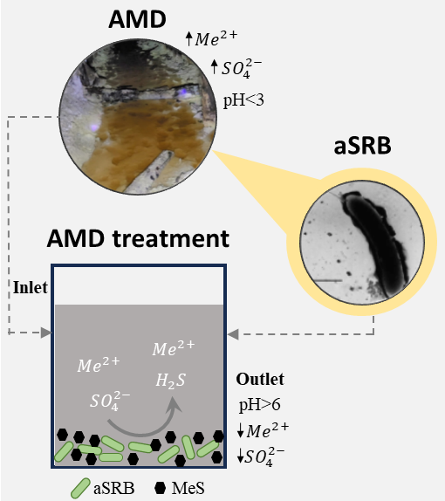
For several years the use of acidophilic sulfate-reducing bacteria (aSRB) has been explored for AMD bioremediation (Figure 1). aSRB perform dissimilatory sulfate reduction, an anaerobic step of the sulfur cycle in which hydrogen sulfide is the end product. Organic matter is also oxidized during this metabolism to simple organic matter (i.e., acetate) or inorganic carbon (i.e., bicarbonate). Both hydrogen sulfide and bicarbonate react with toxic metals and increase pH in the AMD systems, promoting metal precipitation and acidity neutralization. Several aSRB cultures have been tested and probed in several research pointing the effectiveness of these microorganisms for AMD bioremediation. Nonetheless, limitations related to aSRB toxicity to pH lower than 3.6 (i.e., Desulfosporosinus acidiphilus) render the need to search for novel strategies to prompt a more robust and efficient AMD treatment.
Figure 1. AMD system as a source of aSRB and prospects of their biotechnological applications. MeS: metal sulfides.

OBJETIVO DEL TRABAJO
To use an indigenous acidophilic sulfate-reducing bacteria (aSRB)-containing consortium to remove metals and neutralize a synthetic AMD (sAMD) system with pH 2.9.

PROCEDIMIENTO O METODOLOGÍA EMPLEADA EN DEL TRABAJO.
The consortium was enriched using acidic sediments as inoculum collected from an abandoned mine tunnel in Peru and glycerol as carbon source. A bioremediation experiment was set up at pH 2.9 with Fe²⁺ (32.47 mM), aluminum (5.39 mM) and zinc (3.97 mM) as the main metals, mimicking the natural AMD composition. Bottles were inoculated with the acidophilic sulfate-reducing bacteria (aSRB) consortium and 25 mM glycerol, incubated at 30°C for 160 days and monitored for physicochemical parameters (pH, ORP, sulfide, sulfate), mineral formation, and microbial community evolution (microbial community analysis and metagenomics).
RESULTADOS ALCANZADOS
At the end of the experiment, the final pH reached 6.1 and high extents of precipitation of iron, aluminum and zinc (>99 %) were promoted by the acidophilic sulfate-reducing bacteria (aSRB) consortium. Microbial activity led to the formation of XRD-amorphous minerals (e.g., jarosite). Cell encrustation was noticeable during the experiment and correlated with the decrease of dissolved metals and the increase of pH. The microbial consortium was dominated by two representative aSRB, i.e., Acididesulfobacillus and Desulfosporosinus, the latter being more prominent (>30% of the entire community) at the end of the treatment. In addition, two high-quality Metagenome Assembled Genomes (MAGs) were recovered and taxonomically affiliated to the aforementioned aSRB. MAGs showed functional characteristics related to sulfur, nitrogen and carbon cycling. Overall, we obtained a novel aSRB-containing microbial consortium that can be used for metal precipitation and acidity neutralization, prompting future directions for more robust AMD treatment technologies.
CONCLUSIÓN O RECOMENDACIÓN
Overall, we obtained a novel aSRB-containing microbial consortium that can be used for metal precipitation and acidity neutralization, prompting future directions for more robust AMD treatment technologies.
RESEÑA PROFESIONAL
Luis Felipe Valdez Nuñez
Luis Felipe Valdez Nuñez is a Peruvian microbiologist who obtains his master’s degree at the University of Vigo (Spain). Throughout his master’s thesis he studied a real AMD and possible biological treatments (wetlands). His expertise is related to microbial bioprospection in extreme environments such as acid mine drainage with biotechnological purposes. Currently, he is working with aSRB consortia for the bioremediation of AMD (BioSULFIDE project. PROCIENCIA 2022). In addition, he is a collaborator in the project “Bioprospecting for acidophilic microorganisms in high-altitude mining tunnels in Hualgayoc, Peru using omics tools”, a project funded by the Joint Genome Institute (JGI, 2023-currently). Furtherore, he obtained technical skills in planning field campaigns, glovebox handling and culture-dependent and -independent techniques.
Mummar Mansor
Muammar Mansor has been a Junior Research Group Leader at the University of Tübingen since March 2020. He utilizes combined geochemical, cultivation and modeling approaches to study the biominerals of S- and Fe-metabolizing microorganisms (including acidophiles), focusing on the formation of iron sulfide minerals such as mackinawite, greigite and pyrite and their implications to biosignatures and the fate of nutrients and pollutants. In the past four years, he has published 21 papers and is co-supervising/has supervised two postdocs, five PhD students and several more MSc and BSc students.
Andreas Kappler
Prof. Andreas Kappler and his research group for Geomicrobiology at the University of Tuebingen have been working for 20 years on the influence of microbial Fe- (and partially also sulfur-) cycling on metal (im)mobilization. The group uses broad-spectrum approaches including cultivation, molecular biological techniques, fluorescence and electron microscopy (SEM, TEM), geochemistry, mineralogical analyses (e.g. XRD) and different kinds of spectroscopy (Mössbauer, XANES, EXAFS, Raman, FTIR) to quantify the (bio)transformation of different minerals and metals in groundwater, sediments, and soils, and tackle the microbe-mineral interaction. Prof. Kappler has co-authored more than 400 peer-reviewed publications and has supervised more than 60 PhD students, 30 postdocs, 80 MSc and 70 BSc students in his career.

