Title: The First AI Agent in Strategic Mine Planning
Categoría: Minería 4.0
Tema: Optimización de procesos en minería con analítica de datos
Jorge Lozano*¹ , Melissa Amado**²
1. Bee3 Technology SAC, Founder & CTO, San Isidro-Lima Peru, Teléfono móvil +51-01-942767514, jorge.lozano@bee3tech.com
2. Bee3 Technology SAC, Founder & CEO, San Isidro-Lima Peru, Teléfono móvil +51-01-964506823, melissa.amado@bee3tech.com
Palabras claves: Auntonomus, planning 5.0, mine, agent, ai, planning

summary
Introduction: This research focuses on solving NP-type optimization problems in open-pit mining, where the main objective is to maximize the NPV. The motivation lies in the growing need for advanced tools to efficiently manage natural resources and maximize profitability in strategic sectors. To address this issue, the study integrates AI techniques such as RL. An integral approach is proposed that, in addition to solving classical mining challenges, lays the foundation for its adaptation to other fields involving resource optimization. Our goal is not merely to solve the problem, but to teach a machine how to solve the problem.
The following table illustrates the acronyms used throughout this summary:
Tabla 1 Acrónimos
NP | Non-Polynomial
V (NPV) | Net Present Value
IA | Artificial Intelligence
RL | Reinforcement Learning
R | Mining Resources
C, c | Operating Cash Flow
g | Policy of each period of extraccion
F | Oportunity Cost
$$τ$$ | Rate of time for unit of resource
s | Current State of Systems
r | Reward
a | Action
P | Probability
$$γ$$ | Learning Parameter
Methodology: The methodology begins with the development of a mathematical model based on Lane’s Theory, which represents the geological and operational constraints of the mine, such as processing capacities. In parallel, a RL agent is trained to interact with this modeled environment. The agent receives rewards based on the economic and operational impact of its decisions, allowing it to gradually improve the production plan. To better understand, we will briefly explain each finding. In 1988, Lane demonstrated the equation shown in Figure 1, where the maximum economic value could be estimated by solving the definite integral within the range from 0 to R.
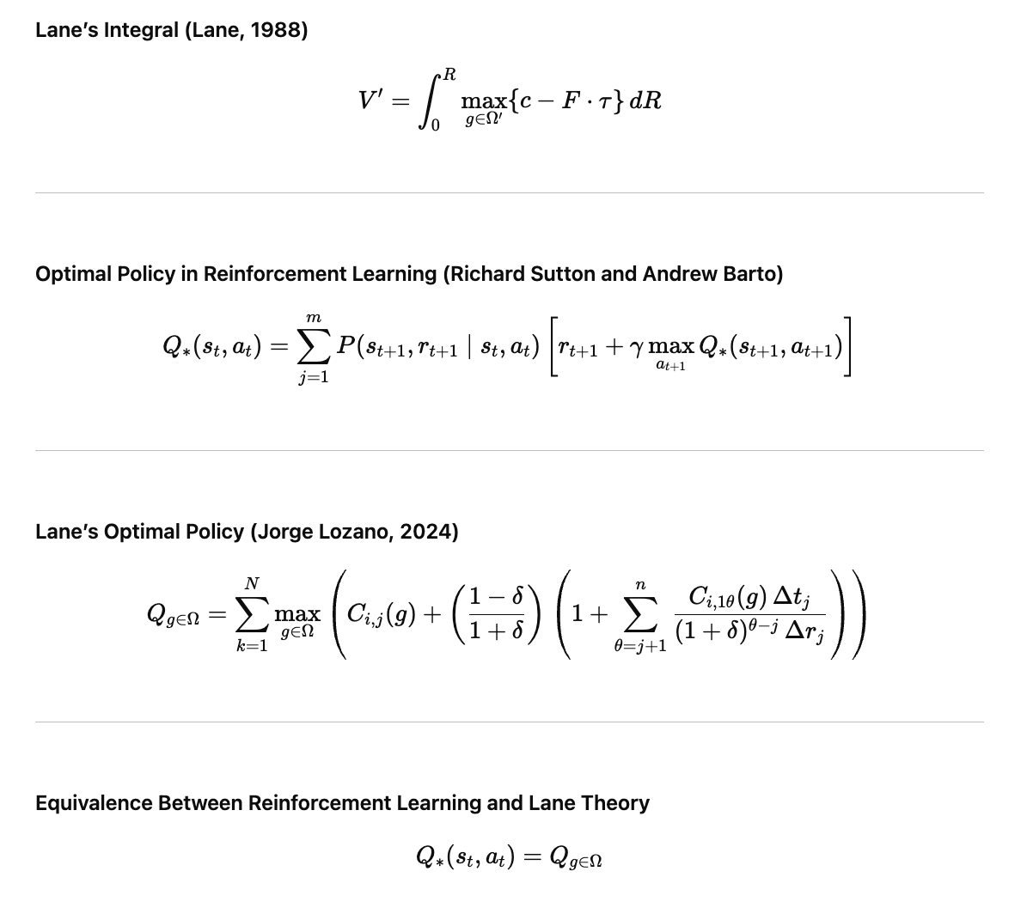
Figure 1 Lane’s Integral, Q Learning Equation and Mining Equivalent
In his 1988 book Economic Definition of Ore, Lane states that the way to solve this problem is through dynamic programming. On the other hand, Richard Sutton and Andrew Barto integrate Bellman equations and Markov Chains to mathematically define the optimal policy in Reinforcement Learning, as shown in Figure 1. This approach aims to teach a machine to perform tasks by training it within a given environment, with specific actions and rewards.In my 2024 Master’s thesis in Computer Science, models mining as a reinforcement learning problem. We show that Lane’s integral can be solved by reframing the mining problem this way, leading to the equation Q-Learning, which is equivalent to the Mining Problems.After proving that a mining problem can be solved using Reinforcement Learning, a software prototype was developed and tested on a simplified mine model. To enhance optimization, a graph-based data structure was added to store the agent’s learning paths, enabling the integration of planning capabilities into the AI system.
Results: It shows a consistent increase in NPV, indicating the agent is approaching the maximum. The RL agent adjusted extraction and processing based on ore grade and capacity, learning only from its environment. It found both the optimal and other feasible solutions useful for engineering analysis.
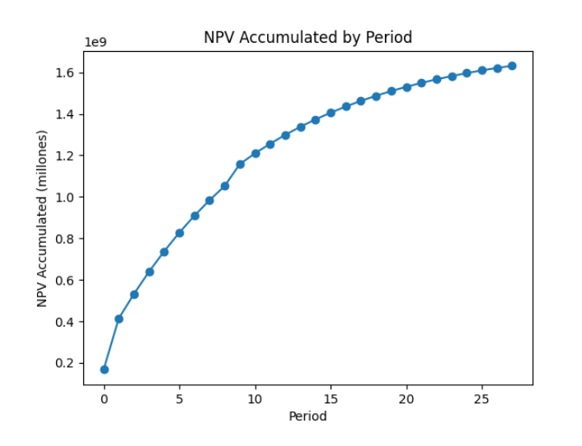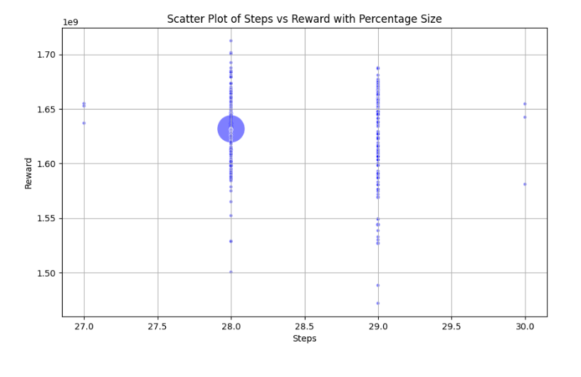
Figura 2 Optimal NPV Results
Conclusions: The integration of RL and Lane’s Theory enables more efficient and profitable long-term mine planning. The system adapts to geological and market changes, offering a smart approach to strategic decision-making. It is the first agent to solve the mining problem without prior mining knowledge, using reinforcement learning as a general abstraction.
Professional Summaries
*Jorge is a Computer Scientist and Mining Engineer with a proven track record in developing AI-powered solutions for heavy industries. He founded and exited three successful ventures—Inti Mining Smart Solutions Peru, IMSS Consultores Chile and Deep Pit Technology—that transformed operational efficiency through advanced analytics and machine learning. Passionate about mathematics, physics, and first principles thinking, he designs sustainable, human-centric systems that drive safety, profitability, and innovation. Currently serves as CTO of Bee3 Technology, focused on R&D and technological innovation.

**Melissa is a visionary entrepreneur and international speaker with a background in International Business Administration and certification as an Ontological Coach. She founded Deep Pit Technology, a pioneering tech company for the mining sector, which was later acquired, and currently serves as CEO of Bee3 Technology, focused on R&D and technological innovation.

