Title: Driving Sustainability: Electric Trucks To Transform Mining Logistics in the Andean Countries
Category: Mining Operations and Asset Management
Topic: Auxiliary services
 | Author | Co-author
Name | Pablo Monsalve | Gerson Bastos
Company | Ausenco | Ausenco
Position | Energy Transition Consultant Intermediate | Energy Transition Consultant Lead
Address | Av. Las Condes 11283, 6th floor, Las Condes, Santiago, Chile | Av. Las Condes 11283, 6th floor, Las Condes, Santiago, Chile
Cell phone number | +56 9 5084 9662 | +56 9 5880 1131
Corporate e-mail | pablo.monsalve@ausenco.com | gerson.bastos@ausenco.com
Brief professional | Industrial Engineer with mention in Mechanics from Universidad de La Frontera, and European Energy Efficiency Management - EUREM, Universidad del Desarrollo - AHK Chile, with experience in implementation and maintenance of Energy Management Systems ISO 50001, Energy Audits, Fleet electrification, and carbon footprint quantification | Gerson has more than 20 years of experience, and for more than 10 years he has been working in the management of multidisciplinary and global teams, obtaining his Project Management Professional (PMP) and Scrum Master certifications. He focuses on creating knowledgeable and successful project teams. He is committed to finding a better way to solve problems by prioritizing innovation. Leveraging this experience, he creates opportunities to increase project and environmental sustainability.
ABSTRACT:
Introduction: Copper and lithium are critical minerals for the energy transition and will be required to be low in carbon in the coming decade. Chile, Peru, and Argentina collectively produce over 30% of global copper and lithium, with this share set to rise as new mines become operational. The mining industry in the Andes faces unique logistical challenges due to the region's geography. Mines at high altitudes require transporting ore to sea-level ports, traditionally using diesel-powered trucks. These trucks, however, present significant environmental and operational drawbacks. This paper explores the potential of replacing logistics diesel trucks with electric alternatives, particularly when energy recovery during downhill transport can be optimized. It highlights sustainability benefits, also considering financial gains as secondary yet persuasive advantages.
Objective of the paper: This paper explores the potential of replacing logistics diesel trucks with electric alternatives, particularly when energy recovery during downhill transport can be optimized. It highlights sustainability benefits, also considering financial gains as secondary yet persuasive advantages.
Methodology: The study examines the benefits reported on study cases related to European logistics BEV trucks, operational underground mining BEV trucks, and last mile logistic BEV trucks to identify the potential benefits of BEV trucks applied to mining product logistics. The study also reviews the operational dynamics of current diesel trucks that transport mining products in the Andean countries, where trucks descend heavily loaded and ascend empty. Regenerative brake systems in electric trucks can convert gravitational potential energy into electricity during downhill operations. This energy can be stored in onboard batteries or could be transferred to external storage systems to avoid wastage in cases of extended descents. The key benefits found in referential study cases include noise reduction, community relations, operational costs, productivity, and reliability. Challenges such as reduced battery efficiency in extreme conditions and infrastructure requirements are also evaluated.
Results: Electric trucks can offer significant sustainability and operational benefits for mining. They can reduce environmental impact by minimizing noise and vibration, improving air quality, and fostering better community relations. By eliminating 100% of emissions and pollution, these vehicles can improve the quality of life of the inhabitants of mining areas, generating a healthier and more attractive environment for tourism development. This synergy between mining and tourism can boost local economic development and strengthen ties between the industry and communities. Drivers can also benefit from quieter, smoother equipment, enhancing working conditions and workforce retention.
Operationally, electric trucks can lower TCO, total cost of ownership, by replacing diesel with electricity, offering higher energy efficiency, faster acceleration, and less downtime due to reduced maintenance needs. They also help mining companies save on carbon taxes, supporting long-term financial viability. Study cases report that an electric fleet can reduce TCO by more than 10% in some cases, but it must be reviewed case by case.
However, challenges remain. Batteries may perform poorly in extreme conditions, like high altitudes and low temperatures, limiting range and reliability compared to diesel trucks. The proper design of regenerative braking and charging solutions is essential to maintaining operational efficiency. High initial costs for trucks, microgrids, and energy storage systems pose financial barriers, especially in remote areas. Additionally, regulatory adaptations, such as trolley-assisted systems, and a shift in the mindset of local suppliers—who often focus on LNG rather than electric solutions—are necessary for widespread adoption.
Despite these hurdles, electric trucks represent a promising step toward decarbonizing mining operations.
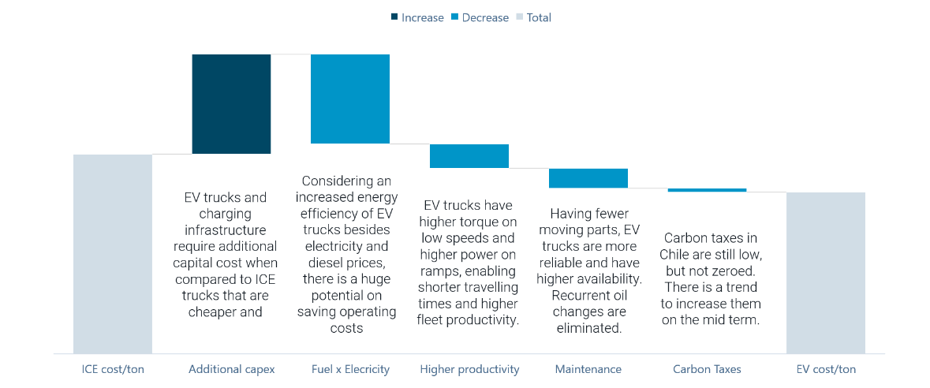
Figure 2 Illustrative business case for electric trucks on mining products logistics with qualitative data.
Conclusions: The transition from diesel-powered to electric logistics trucks for mining products offers transformative sustainability benefits for Andes mining operations. Regenerative braking and external energy storage systems enable mining companies to significantly reduce their environmental impact and carbon footprint while improving community relations. These sustainability benefits are complemented by financial advantages, including lower operational and maintenance costs, increased productivity, and reduced carbon taxes. Addressing challenges related to battery efficiency, infrastructure, and policy frameworks is essential to achieving these outcomes. Electric trucks represent a critical step toward aligning mining operations with global decarbonization goals, ensuring copper and lithium production supports a sustainable energy transition.
Keywords: Andes mining operations, electric trucks, decarbonization, environmental impact, community relationship.

