“Mining Wastewater Treatment and Recirculation for Reuse: a System Integrating Uninterrupted Steady-State Ion Exchange and Regenerant Recovery”
Topic: Water management in operations and the surrounding environment
Category: 4. ESG (Environmental, Social, and Governance)
Author: Gabriela Luiza Almeida Silva, Nexa Resources S.A., Innovation Engineer, 1440 Sergipe Street, 8º floor, Savassi, Belo Horizonte, Minas Gerais, Brazil. Zip code 30130-174. ext.gabriela.silva@nexaresources.com / gabrielaluiza2001@gmail.com / +55 31 997122611
Co-author: Vinoj Kurian, Renix INC.; Science Manager, 316 Rectory Street, London, Ontario, Canada. Zip Code N5W 3V9. vkurian@renix.ca / vinojkk@gmail.com / +1-519-636-9895
Co-author: Robert Andrew Haas, Renix INC.; Director of Engineering and Project Delivery, 316 Rectory Street, London, Ontario, Canada. Zip Code N5W 3V9. rahaas@renix.ca / haas.roberta@gmail.com / +1-519-318-2316
Key words: steady state ion exchange, sulfate removal, sustainable water management, ESG, mining water reuse, co-product generation
ABSTRACT:
In Nexa’s mining operations, ore is processed into zinc, copper, and lead concentrates. The run of mine, which is the raw ore extracted from the mine, goes through multiple processing stages including comminution, concentration, thickening, and filtration to produce these concentrates. Water use is essential throughout the beneficiation process and must be treated before discharge or recirculation. However, due to the nature of the processed material, which comes from volcanogenic massive sulfide deposits and frequently contains carbonates and quartz, both the treatment of the effluent for compliant discharge and its reuse in the process present challenges.
In this context, Nexa has been looking for technological solutions to improve the recirculation of water and its reuse through the removal of sulfate, heavy metals and hardness, presented as calcium and magnesium carbonates, from the wastewater of an industrial mining site. Through Mining Lab Challenge 2024, Nexa’s innovation program, external ideas from universities and companies to address these challenges were evaluated both technically and economically and the Renix technology was selected for testing phase.
RenixUIX™ Steady-State Ion Exchange technology removes dissolved compounds while regenerating media simultaneously. Steady-state operation provides high regeneration efficiency, reduced energy and chemical use and allows uninterrupted operation without frequent downtime for off-line resin regeneration. Furthermore, steady state operation generating consistent and stable outflows supports sodium hydroxide (NaOH) regenerant recovery through calcium sulfate (CaSO₄), gypsum, which is a potentially marketable co-product. Typical operating profiles for fixed bed systems can be seen in comparison to the uninterrupted steady-state profile in figure 1.
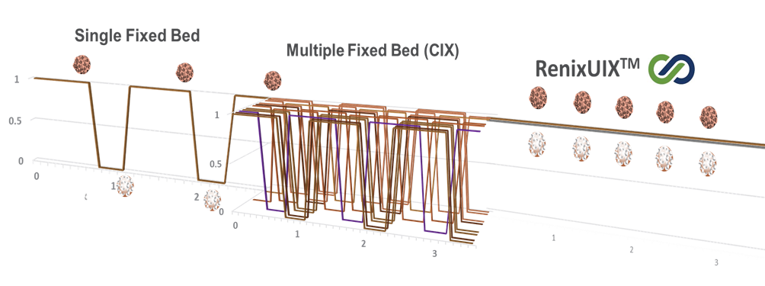Fig. 1 Operating Profiles of Batch, Continuous Batch, and Renix Steady-State Ion Exchange Platforms
Therefore, this study aimed to evaluate the performance of Renix’s technology to reduce sulfate, heavy metals and hardness to the limits defined by Nexa, supporting water reuse.
Treatment was completed in three sequential stages: (I) sulfate removal, followed by (II) heavy metal reduction, and finally (III) hardness removal. Sulfate was removed by the steady-state ion exchange process with NaOH as eluent. The product of this step was a low-sulfate water with elevated pH. The basic pH supports metal precipitation allowing metal separation by settling. This step produced water low in sulfate and metals, with slightly reduced hardness. Additional hardness was removed by a subsequent ion exchange step with H₂SO₄ as eluent. The final effluent, with neutral pH and low levels of sulfate, metals, and hardness, was analyzed using in-house pH, conductivity meter, Sulfaver 4 and Ion Chromatography. The NaOH can also be recovered in a step that will also generate a high purity calcium sulfate (CaSO₄).
Experiments were conducted in two phases: benchtop trials and in-house lab pilot testing, using both synthetic and site water samples for each. Benchtop trials used batch columns to select resin and generate resin chemistry data used in RenixUIX™ configuration modeling. Loading was performed in a 100 mL resin bed at 5 BV/hr with breakthrough occurring at 12-15 BV. Elution was performed in a 50 mL bed at 2 BV/hr with full regeneration occurring at 3-4 BV. The RenixUIXTM in-house lab pilot was used to validate the design configuration model for sulfate removal used in scaling performance to full scale. During pilot testing, steady-state flow rates for Feed and Eluate of 100 to 150 mL/min and 20 to 25 mL/min respectively were used. Schematics of the benchtop and in-house lab pilot equipment configurations are shown in figures 1 and 2 respectively.
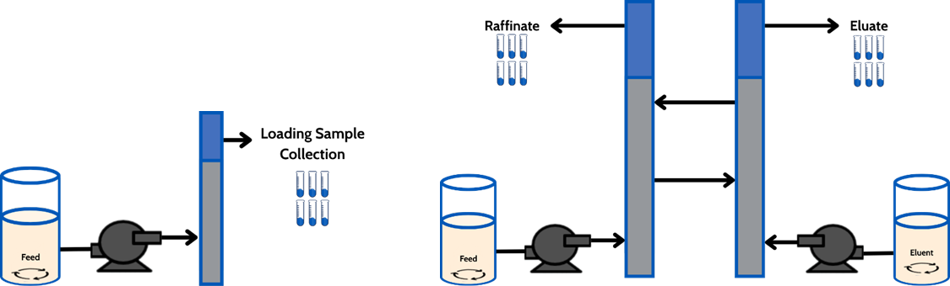
Fig 2. Benchtop Resin Loading Schematic Fig. 3. In-house Lab Pilot Schematic
The results demonstrated strong performance in both benchtop and in-house lab pilot tests. High efficiency was observed across synthetic and real samples, with minimal variability and strong replicability. After ion exchange treatment, sulfate levels were reduced to < 250 mg/L from a peak of > 3,000 mg/L, meeting the target limit of 250 mg/L; post-settling residual metals were below the limits established by Nexa for this challenge; and after subsequent ion exchange treatment hardness was reduced to < 400 mg/L from peak concentrations > 1,400 mg/L, enabling safe reuse.
In conclusion, the RenixUIXTM uninterrupted steady-state ion exchange technology proved to be an effective solution for treating high sulfate and high hardness mining effluents. It successfully achieved compliance with environmental standards using both synthetic and real water samples, while offering additional benefits such as simple steady-state operation, regenerant recovery, reduced scaling and supports sustainable water reuse.

Professional summary:
- Gabriela Luiza Almeida Silva: Chemical engineer and chemistry technician with experience in innovation, and research and development
- Vinoj Kurian: PhD and master's degrees in chemical engineering with experience in process engineering, research and technology development
- Robert Andrew Haas: Mechanical engineer with experience in project engineering and platform engineering

