Mining Wastewater Treatment and Recirculation for Reuse: a System Integrating Uninterrupted Steady-State Ion Exchange and Regenerant Recovery
(ESG - Water management in operations and the surrounding environment)

Gabriela Luiza Almeida Silva¹, Vinoj Kurian² and Robert Haas³

¹ Author: Nexa Resources S.A.,1440 Sergipe Street, 8º floor, Savassi, Belo Horizonte, Minas Gerais, Brazil. (gabrielaluiza2001@gmail.com / +55 31 99712-2611)
² Coauthor 1: Renix INC. 316 Rectory Street, London, Ontario, Canada. (vinojkk@gmail.com / +1 519 636 9895)
³ Coauthor 2: Renix INC. 316 Rectory Street, London, Ontario, Canada. (haas.roberta@gmail.com / +1 519 318 2316)

ABSTRACT

Contaminated mining effluents must undergo adequate treatment before discharge, as required by Brazil’s CONAMA Resolution No. 357/2005. Water reuse helps reduce freshwater consumption and effluent discharge but demands effective treatment, particularly for hardness removal to prevent scaling. To address this challenge of water recirculation, Nexa evaluated an innovative treatment system developed by Renix, selected through the Mining Lab Challenge 2024, based on their proposed solution for application at Nexa’s mining unit.

Benchtop and lab-scale pilot tests were conducted using mock and real site effluents. The proposed system combines steady-state ion exchange for sulfate removal, precipitation and settling for heavy metal reduction, and optional cation exchange for hardness control. Results showed consistent reduction of sulfate concentrations from over 2,600 mg/L to below 130 mg/L, and partial hardness reduction to levels enabling recirculation. Heavy metal concentrations are within the limits permitted by law.

Unlike conventional batch ion exchange processes, the steady-state configuration ensured continuous operation without frequent shutdowns for resin regeneration. This uninterrupted mode significantly reduced downtime and minimized backwash waste. Furthermore, the system promotes regenerant recovery and offers the potential for gypsum generation that will be commercialized, contributing to circularity and cost reduction.

Overall, the study described the technical feasibility and potential cost savings of this treatment system, supporting more sustainable water management in mining.

1. Introduction

1.1 Effluent generation in mining

Although the mining sector plays a significant role in economic development, it faces substantial barriers to achieving sustainability due to the social and environmental nature of its activities (Azapagic, 2004). Mining operations are highly water-intensive, encompassing unit operations such as comminution, flotation, thickening, as well as auxiliary activities. According to Brazilian Mining Association [IBRAM] & National Water Agency [ANA] (2013), the relationship between mining and water is defined by its dual nature: while it’s vital for most operational activities, it is also a source of environmental, legal and financial challenges. In this regard, adequate water management is a key element in the pursuit of more sustainable mining.
1.2 Water treatment and environmental regulations
This intensive water use frequently results in contaminated effluents containing suspended solids, dissolved metals, sulfate ions and organic compounds. These mining effluents must undergo adequate treatment to achieve the quality required by environmental legislation before discharge into natural water bodies, as emphasized by IBRAM & ANA (2013).

In Brazil, the maximum effluent discharge limits into surface water bodies are regulated by Conselho Nacional do Meio Ambiente (CONAMA) Resolution No. 357/2005. According to this legislation, sulfate levels are restricted to 250 mg/L, and several heavy metals that are commonly found in mining wastewater are also regulated. Table 1 presents the complete list of discharge limits for sulfates and heavy metals.

Table 1: Maximum effluent discharge limits per parameter

Parameter | Maximum Concentration
Sulfate (SO₄²⁻) | 250 mg/L
Arsenic (total) | 0.5 mg/L
Barium (total) | 5.0 mg/L
Boro (total) | 5.0 mg/L
Cadmium (total) | 0.2 mg/L
Lead (total) | 0.5 mg/L
Copper (dissolved) | 1.0 mg/L
Chromium (total) | 0.5 mg/L
Iron (dissolved) | 15.0 mg/L
Manganese (dissolved) | 1.0 mg/L
Mercury (total) | 0.01 mg/L
Nickel (total) | 2.0 mg/L
Selenium (total) | 0.3 mg/L
Silver (total) | 0.1 mg/L
Zinc (total) | 5.0 mg/L
Sulfide | 1.0 mg/L
Source: CONAMA (2005).
1.3 Water reuse and scaling
Water reuse can be an essential strategy in mining to reduce freshwater consumption and decrease effluent discharge. According to the Brazilian Mining Association and the National Water Agency (IBRAM & ANA, 2013), optimizing recycling processes can allow for the reuse of up to 80% of water in operations such as iron ore processing.

However, effective recirculation also requires proper treatment, particularly to prevent scaling. Scale forms by the precipitation of hardness minerals, mainly calcium carbonate (CaCO₃), magnesium hydroxide (Mg(OH)₂), and magnesium carbonate (MgCO₃) (Belattar et al, 2018). These deposits can lead to pipe blockage, increased pressure loss, higher maintenance needs, and reduced heat transfer efficiency (Pepper, 1979).

According to the American Water Works Association (AWWA), water hardness is typically expressed as an equivalent concentration of calcium carbonate (CaCO₃), with water classified as soft when it contains less than 75 mg/L, moderately hard between 75 and 150 mg/L, hard between 150 and 300 mg/L, and very hard above 300 mg/L (AWWA, 1999). Additionally, the tendency of effluents to form scale can be assessed through the Langelier Saturation Index (LSI), which considers several variables such as temperature, calcium concentration, alkalinity, and total dissolved solids (Uechi, Gabas, & Lastoria, 2013). This means that while calcium concentration is an important factor, other variables also influence the scaling tendency. Even so, keeping hardness levels to concentrations close to 300 mg/L is a safe practice to avoid scaling and ensure the efficiency of water reuse systems in mining.

1.4 Importance of innovative treatment technologies

Considering these challenges, technological innovation has become an important enabler for improving the sustainability of mining operations. As noted by IBRAM and ANA (2013), improving mining processes offers considerable potential for reducing environmental impacts and optimizing water use, while the adoption of emerging treatment technologies has already contributed to substantial reductions in pollution levels associated with mineral processing activities. Therefore, innovation plays a critical role in both enabling water reuse within industrial circuits and ensuring compliance with discharge quality standards.

In addition to environmental compliance, the adoption of innovative and efficient treatment systems has also progressed to reduce operational costs. As reported by IBRAM and ANA (2013), one of the key economic advantages of such systems lies in their ability to reduce freshwater intake, particularly by minimizing the need for long-distance water pumping, which often represents a significant portion of water management costs. Moreover, new technologies can support circular economy strategies by enabling the recovery and valorization of byproducts, which contributes to lowering waste disposal expenses and generating additional value from residual streams.

1.5 Open Innovation
In this context, Nexa has sought technological solutions to improve the water treatment system of an industrial mining site, aiming to meet quality standards for both water recirculation and environmental discharge by removing sulfate, heavy metals, and hardness. Besides environmental criteria, the potential for operational cost reduction has also been considered. Through Mining Lab Challenge 2024, Nexa’s open innovation program, external proposals from universities and companies were evaluated from both technical and economic perspectives. As a result, the Renix solution was selected for the testing phase, incorporating ion exchange among other separation technologies.

1.6 Ion exchange challenges

Ion exchange is a water treatment process involving the reversible exchange of ions between a solution and solid ion exchange materials, primarily categorized as cation or anion exchangers (FBT, 2023). It is widely used for purification of aqueous solutions by selectively removing contaminants through cyclic operation, where resins become saturated and require regeneration by backwashing with concentrated solutions. The method is considered cost-effective, requiring low energy and allowing multiple resin regenerations with a long operational lifespan if maintained properly. However, limitations such as the generation of backwash waste and the batch operations restrict its broader application despite its advantages (Kansara, Bhati, Narang, & Vaishnavi, 2016).

1.7 Proposed treatment system

The system consists of three sequential stages: (I) sulfate removal, followed by (II) heavy metal reduction, and finally (III) hardness removal, as presented in Figure 1.

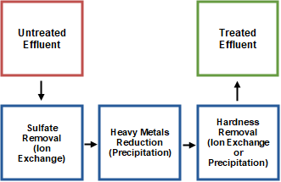

Figure 1: Treatment system simplified flowchart
Source: Prepared by the authors (2025).

2. Objectives

2.1 General Objective

Evaluate the technical feasibility and potential cost savings of an innovative effluent treatment system incorporating steady-state ion exchange technology, proposed for application at Nexa’s mining unit.

2.2 Specific Objectives

2.2.1 Treatment Performance
Assess the system’s effectiveness in removing sulfates and keeping the heavy metals within CONAMA standards, and in reducing water hardness to levels that prevent scaling and allow safe water recirculation.

2.2.2 Estimated Financial Savings

Analyze the economic benefits of the system proposed, including uninterrupted regeneration, regenerant recovery, and the generation of a co-product.

3. Methodology

Samples were collected at the inlet and outlet points of the wastewater reservoir, denominated WI and WO respectively, and sent to Renix’s laboratory, where all tests were conducted under Nexa’s guidance.

3.1 Characteristics of the effluent

The properties of the feed liquids were analyzed before conducting any treatment or pre-treatment step. As shown in Figure 2, WI samples had observable solids settled at the bottom of the container, and WO samples were a noticeable green coloration. The greener appearance of the WO feed may be attributed to the biological activity of the effluent while it passes through the reservoir before exiting as WO.
A
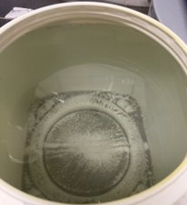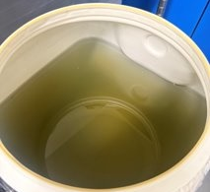
B
A
B

Figure 2: A - WI Sample, B - WO Sample
Source: Prepared by the authors (2025).

3.2 Resin loading and elution

The resin loading and elution testing are described as column adsorption and desorption trials, respectively. In the resin loading tests, experimental parameters such as resin bed size or flow rate were adjusted to achieve more representative results.

First, 50 mL of resin was loaded into a 150 mL Kontes column. Then, feed was pumped through the column from the bottom to maintain up-flow. Flow rate was expressed as bed volumes per hour (BV/hr), indicating the volume of solution processed relative to the volume of the resin bed per hour. Figure 3 illustrates the apparatus used for the resin loading test. The amount of feed passed through the column and the speed at which the feed was passed through the column can be adjusted and experimentally optimized to represent RenixUIX™ operating conditions. The liquid that exits the column at the top of the resin bed (referred to as raffinate) was expected to have a composition similar to the original feed, except with targeted ions removed. By comparing the concentration of ions in the raffinate to the amount of ions in the feed, the percentage removal of the ions by the resin within the column was determined.

The feed liquid was pumped and raffinate sampled every 50 mL exiting the column (known as “bed volume”) and analyzed for representative ions. Analytical results were plotted as ion concentration versus number of bed volumes passed. The feed continued until the representative ion concentration in the raffinate was identical to the feed.

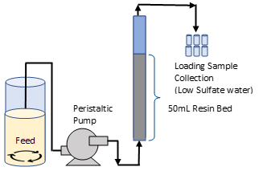

Figure 3: Benchtop testing set up for resin loading
Source: Prepared by the authors (2025).

Similarly, elution or desorption testing was used to evaluate the elution of ions from loaded resin (also referred to as resin regeneration). This procedure was used to optimize eluent selection, eluent composition, and eluent flowrate. The loaded resin bed from resin loading testing was washed with a liquid that does not elute the ions (in this case DiH₂O). Following wash, an eluent solution (in this case 4% NaOH) was pumped through the bed from the top of the column to maintain downflow. Figure 4 illustrates the apparatus used for elution testing. The exiting liquid (referred to as eluate) was sampled every 50 mL, collected and analyzed for representative ions. Analytical results were plotted as ion concentration versus number of bed volumes passed and used to determine the portion of ions removed/recovered from the resin. The elution continued until the concentration of the ions in the eluate became zero.

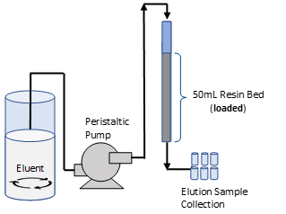

Figure 4: Benchtop testing set up for resin elution
Source: Prepared by the authors (2025).

3.3 Resin selection and mock feed preparation

Resin selection is a critical factor in the success of any ion exchange application. A wide range of candidate resins is available from various suppliers, including cationic or anionic types, and macro-porous or gel-type structures. Potential resins are identified based on a number of factors such as exchange capacity, charge and size of target ion, resin physical characteristics (for sample particle size, density, water retention, uniformity, expansion, among others), physical and chemical properties of the liquid (for example density, viscosity, pH, TDS, presence of fouling/scaling compounds, among others), price, bulk availability, among others. A short list of potential resins was prepared from options based on previous experience and RenixUIX™ system modeling. Using short-listed resins, loading curves were generated using a mock feed to confirm the resin loading exchange chemistry and resin performance, and compare resins to rank them and select the best performing resin for further testing with real feed.

Initial benchtop testing for resin evaluation was performed with a mock feed solution, prepared using salts to mimic site feed. The composition of the mock feed solution and the salt mass used for preparing the mock solution is shown in Table 2.

Table 2: Composition of mock feed solution and the salt mass used as recipe

Salt mass used for preparing 1 L (g) |  | Ion Concentration (mg/L)
CaSO₄ | 1.63 | Calcium | 480
MgSO₄ | 0.06 | Magnesium | 12
Na₂SO₄ | 1.482 | Sulfate | 2200
NaCl | 0.06 | Chloride | 73
 |  | Sodium | 503
Source: Prepared by the authors (2025).
Both benchtop and lab-scale pilot tests were conducted using the best-performing resin, identified through resin selection tests with mock and site feed solutions.

3.4 Benchtop tests

Benchtop tests were conducted using the loading and elution methods explained above. All tests were conducted at room temperature (22ºC). Resin loading experiments were performed at a rate of 5 BV/hr in a 50 mL resin bed. Elution experiments were performed at 2 BV/hr using 4% caustic solution. The parameters were based on previous RenixUIX™ experience from previous similar applications. For both resin loading and elution testing, samples were collected every 50 mL and analyzed for pH, conductivity, sulfate, metals, and hardness.

3.5 In-house lab pilot tests

Based on the results of benchtop testing, Renix in-house modelling was used to establish the expected RenixUIX™ in-house lab pilot configuration. Using the model results, Renix’s lab pilot RenixUIX™ was set up for this application. Figure 5 illustrates the apparatus used for lab pilot testing.

Four test runs were first performed with mock feed to validate the RenixUIX™ configuration and optimize the operating window and limits of the configuration. WI and WO water samples were then treated using the configuration and operating parameter sets identified using mock feed. A total of four feed trials were performed using site feed, with a duration of approximately 6 to 9 hours each: two on WI and two on WO. WI and WO trials were alternated in order to manage use of site samples, allow for analysis of respective ions, and to confirm repeatability. Raffinate and eluate were sampled every hour throughout the runs, and analyzed for pH, conductivity, sulfate, metals, and/or hardness as appropriate.

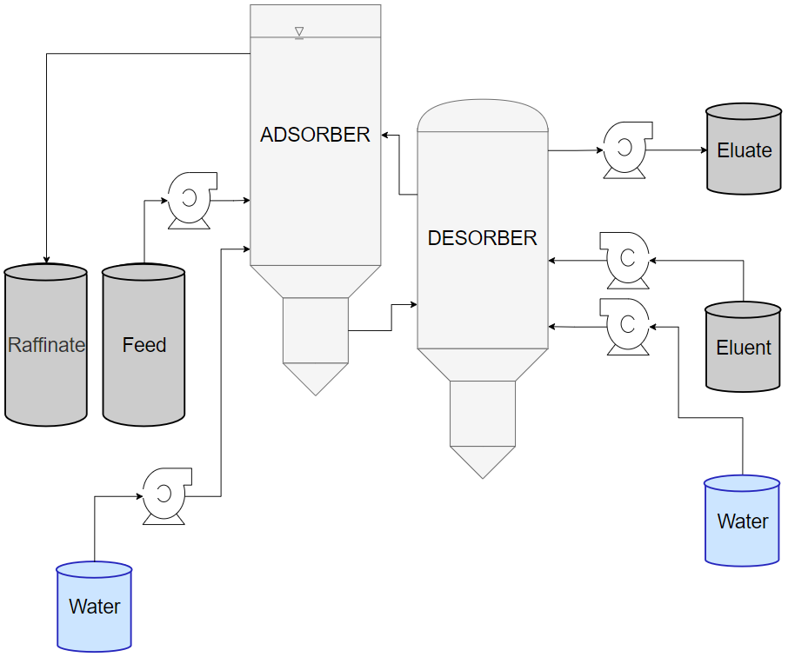

Figure 5: Apparatus of in-house lab pilot testing
Source: Prepared by the authors (2025).

3.6 Additional bench tests

Simple Settling: In addition to the previous described analysis, the potential for reduction of metal concentrations post-RenixUIX™ Sulfate treatment using precipitation was simply evaluated. Raffinate samples from WI and WO site feed benchtop testing and site feed lab pilot trials were set aside for a simple settling test. The samples were placed in beakers and allowed to sit undisturbed for a period of 2 days. From these samples, the supernatant was sampled without disturbing settled precipitates. These liquid samples were submitted for third-party ICP analysis to determine the metal content.

Hardness Reduction: To evaluate the recirculation potential of water post-RenixUIX™ Sulfate treatment, raffinate water hardness was investigated. Raffinate samples from lab-scale benchtop tests using WI and WO site feeds were analyzed for hardness, expressed as CaCO₃. To demonstrate the potential to further reduce hardness, a standard cationic resin was used to generate resin loading curves using the same resin loading method previously described.

Eluent recovery: Renix has proposed the evaluation of an eluent recovery step for the purpose of reducing eluent costs and offer options for eluate management in support of sustainability goals by reducing waste management. In this proposal, this recovery step may use calcium hydroxide (Ca(OH)₂) for OH⁻ recovery while generating calcium sulfate (CaSO₄) for valorization. The possible chemical reaction involved in the regenerant recovery is illustrated below:

$${Na}_{2}SO_{4}+Ca{\left(OH\right)}_{2}→2NaOH+CaSO_{4}$$

The formed caustic can be reused for elution and calcium sulfate as a co-product. Given the nature of this reaction, specific process conditions for this step will determine the efficiency and recovery potential and will be completed post-Proof of Concept during a site pilot and/or engineering phase. Nevertheless, an estimated recovery rate based on the stoichiometric equation above was calculated.

3.7 Analytical methods and data collection

Sulfate: Sulfate concentration was measured in-house using a Hach DR 1900 Spectrophotometer along with the provided method (Method 8051 – USEPA SulfaVer Method), which has a theoretical precision of 95%. The SulfaVer 4 is a commercially available test developed by Hach Company, commonly used in environmental monitoring, wastewater treatment, and drinking water testing. The test is a colorimetric method used to measure sulfate (SO₄²⁻) concentration in water.

Metals: The metals in the feed and raffinate were analyzed at a third-party facility using ICP-MS (Inductively Coupled Plasma Mass Spectrometry). The raffinate samples were taken after allowing the solids to settle. The third-party analysis for hardness of these liquid samples was estimated as mg/L of CaCO₃ using the Calcium and Magnesium concentration.

Hardness: Hardness was analyzed in-house using EDTA titration; a complexometric titration method used to determine the concentration of metal ions in solution. It involves the use of ethylenediaminetetraacetic acid (EDTA), a chelating agent that forms stable complexes with metal ions such as Ca²⁺ and Mg²⁺. The titration is performed at a controlled pH, using a suitable buffer and a metal ion indicator (in this case calmagite), which changes color when all metal ions have reacted with EDTA. Hardness values are calculated following the provided calculations and reported as mg/L of CaCO₃.
3.8 Scale-Up modeling
Based on the results from in-house lab pilot operation using mock feed and site feed samples, Renix in-house modelling was used to confirm the system configuration at scale. These models were used to provide mass balance projections and process flow sheets for treating 125 m³/hr of the effluent. The mass balance provided input and output flows with representative ion concentrations. Additionally, the modeling provided system sizing estimates to support project planning.

4. Results and discussion

4.1 Feed characterization

Table 3 shows properties of the WI and WO feed.

Table 3: WI and WO sample analyses

Parameter | WI Sample | WO Sample
pH | 3.18​ | 3.29​
Total Calcium (mg/L)​ | 401​ | 401​
Total Hardness (mg CaCO₃/L)​ | 1002​ | 1002​
Sulfate (mg SO₄/L)​ | 2650​ | 2850
Source: Prepared by the authors (2025).
The sulfate concentration was measured using the SulfaVer 4 test kit at Renix facility. The calibration of this test kit was completed by comparing with third-party analysis. Sulfate concentrations at different levels similar to that of feed, raffinate, and eluate were used for the calibration to evaluate the whole range of values. Figure 6 shows the alignment of Renix sulfate measurement results using the Hach test kit when compared to third-party analysis completed using ion chromatography method.

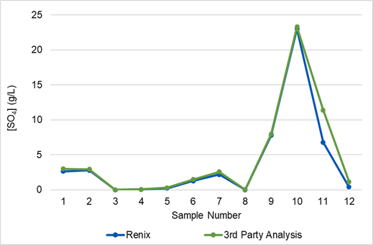

Figure 6: Calibration results of SulfaVer 4 test kit by third-party analysis
Source: Prepared by the authors (2025).

4.2 Benchtop testing with mock feed

Four short-listed resins were used for initial screening with mock feed. Sulfate removal is illustrated in the Figure 7. Sulfate breakthrough, which is the point at which sulfate appears for the first time in the raffinate, is shown for each of the tested resins. For UP5013SB1 resin breakthrough happened at nineth bed volume whereas, for LA100SB2 and LA663SB1 resins breakthrough happened at seventeenth bed volume.

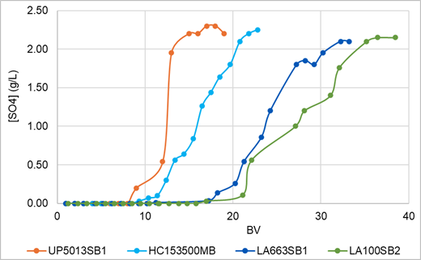

Figure 7: Benchtop loading results of the four resin candidates
Source: Prepared by the authors (2025).

From the loading curves obtained, two resins (LA663SB1 & LA100SB2) were selected for elution testing under one set of elution conditions, the results of which are shown in Figure 8.

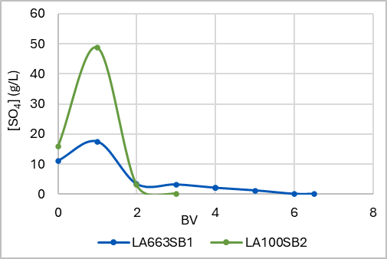

Figure 8. Elution testing of the two selected resins
Source: Prepared by the authors (2025).

The elution curve of LA100SB2 shows that the majority of sulfate was removed within 2 bed volumes, whereas 5-6 bed volumes were required for LA663SB1. From the loading and elution results, LA100SB2 was selected for the remaining benchtop testing and in-house lab pilot testing.

4.3 Bench top test with site samples

Using the WI and WO water samples, loading and elution curves were repeated as previously described, using the selected resin, LA100SB2. Figures 9 and 10 show the loading and elution curves respectively in comparison to the previously generated mock feed curves.

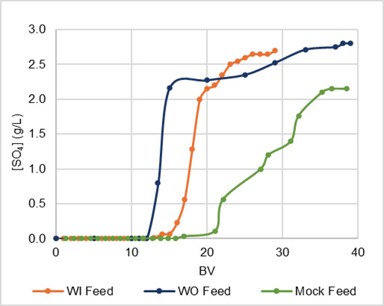

Figure 9: Loading curves for site feed samples on selected resin LA100SB2
Source: Prepared by the authors (2025).

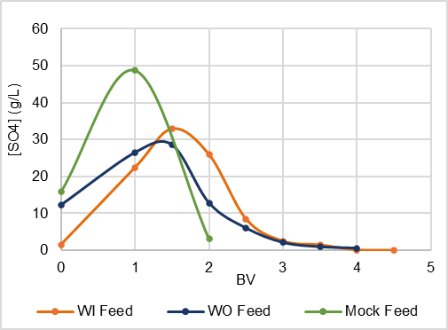

Figure 10: Elution curves for site feed samples on selected resin
Source: Prepared by the authors (2025).

As anticipated, WI and WO loading and elution curves showed earlier breakthrough and prolonged elution compared to the representative mock feed. This is due to additional competing ions in the site feed vs the mock feed that occupy resin capacity and contribute to longer elution. The loading and elution curves from the site samples were within the expected RenixUIX™ configuration parameters and were used for in-house lab pilot modeling.

4.4 In house lab pilot tests

Mock Feed: Figure 11 shows the results of lab piloting with mock feed using four different operating parameter sets over a total operating time of more than 65 hours. The first parameter set from hour 0 to 18 was a conservative set for initial analysis of the configuration; the raffinate (treated water) sulfate concentration was consistently 0 mg/L throughout and the average eluate (concentrate) sulfate concentration was 11 g/L.

The second parameter set from hour 19 to 36 was an aggressive set intended to drive the configuration to the upper operating window resulting intentionally in some raffinate values above the acceptable limit. The raffinate sulfate concentration ranged up to 600 mg/L with an average of 370 mg/L and average eluate sulfate concentration of 8 g/L.

The final two parameter sets from hour 36 to 67 illustrate steady state operating parameters. Except for two samples at hour 40-41 due to a mechanical issue, these final two sets yielded consistent raffinate sulfate below 250 mg/L (average raffinate sulfate concentration of 176 mg/L and 134 mg/L respectively) and average eluate sulfate concentration of 11 g/L and 10.6 g/L respectively.
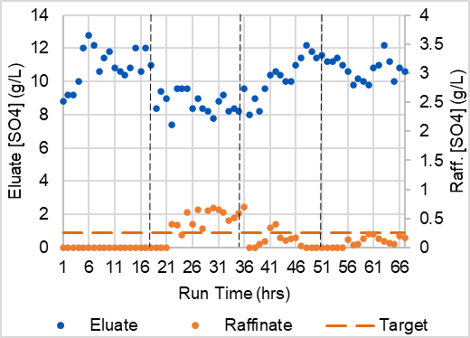

Figure 11: Mock feed in-house lab pilot testing
Source: Prepared by the authors (2025).

Site Samples: WI and WO water samples were treated in the RenixUIX™ lab pilot using the configuration and operating parameter sets identified through mock feed lab pilot testing. A total of four feed trials were performed with a duration of approximately 6 to 9 hours each: two on WI and two on WO. WI and WO trials were alternated in order to manage use of site samples, allow for analysis, and to confirm repeatability. Figure 12 shows WO trial 1 average sulfate breakthrough concentration was 83 mg/L and average eluate sulfate concentration was 10.8 g/L. Figure 13 shows WI trial 1 average sulfate breakthrough concentration was 110 mg/L and average eluate sulfate concentration was 9.5 g/L. Figure 14 shows WO trial 2 average sulfate breakthrough concentration was 78 mg/L and average eluate sulfate concentration was 9.6 g/L. Figure 15 shows WI trial 2 average sulfate breakthrough concentration was 60 mg/L and average eluate sulfate concentration was 8.2 g/L.

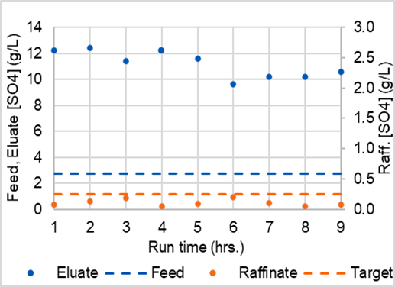

Figure 12: WO Trial 1 (WO-1)
Source: Prepared by the authors (2025).

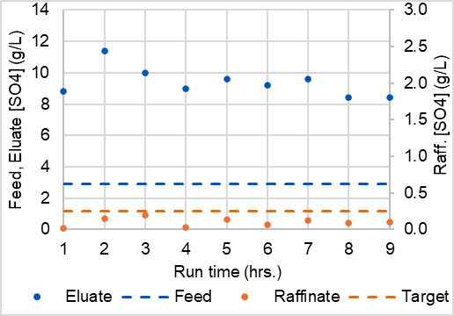

Figure 13: WI Trial 1 (WI-1)
Source: Prepared by the authors (2025).

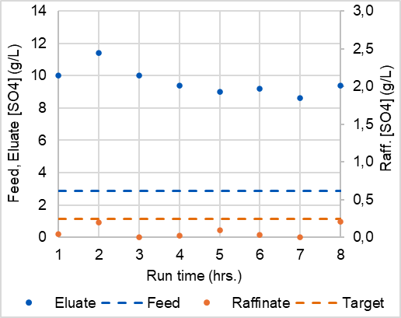

Figure 14: WO Trial 2 (WO-2)
Source: Prepared by the authors (2025).

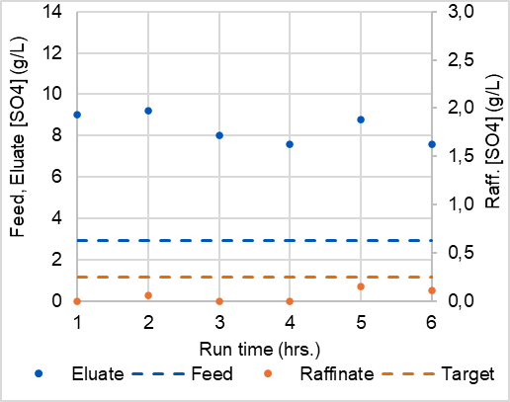

Figure 15: WI Trial 2 (WI-2)
Source: Prepared by the authors (2025).

Throughout over 30 hours of run-time with WO and WI water samples, the raffinate sulfate concentration was consistently below 250 mg/L. Following the completion of lab pilot testing, samples of WI and WO raffinate were collected and analysed, as shown in Table 4.

Table 4: Renix UIXTM in-house lab pilot sample analyses

Parameter | WI Sample |  | WO Sample
Parameter | Pre Sulfate Treatment | Post Sulfate Treatment | Pre Sulfate Treatment | Post Sulfate Treatment
pH | 3.18​ | 12.5 | 3.29​ | 12.5​
Sulfate (mg SO₄/L)​ | 2650​ | 127 | 2825​ | 96
Total Calcium  (mg/L)​ | 401​ | 121 | 401​ | 188
Total Hardness  (mg CaCO₃/L)​ | 1002​ | 302 | 1002​ | ​470
Source: Prepared by the authors (2025).
4.5 Heavy metals settling tests

Post RenixUIX™ Sulfate Treatment and subsequent settling, the metal concentration in the water was reduced below the CONAMA limit by the precipitation of metals as metal hydroxides. In addition, water hardness (as illustrated by calcium and magnesium concentrations) was partially reduced. Figures 16 and 17 show the results after simple settling tests from lab benchtop samples and in-house lab pilot samples respectively.

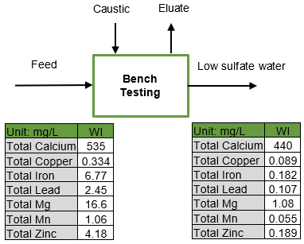

Figure 16: Simple settling test results (Lab Benchtop Trial Samples)
Source: Prepared by the authors (2025).

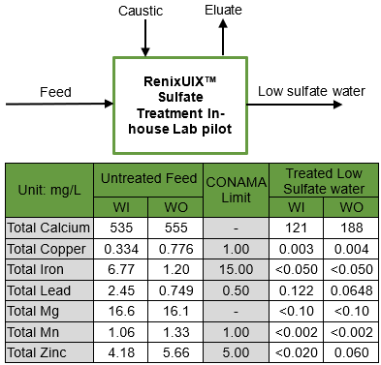

Figure 17: Simple settling test results (In-house Lab Pilot Trial Samples)
Source: Prepared by the authors (2025).

4.6 Hardness Reduction

Following lab benchtop testing with site feed, further hardness reduction by standard cationic resin was found to be a readily available subsequent treatment step. To illustrate this option samples of the low sulfate raffinate water were used to generate a breakthrough curve using a standard cationic resin. Figure 18 shows it will be quite feasible to further reduce the hardness below 400 mg/L.

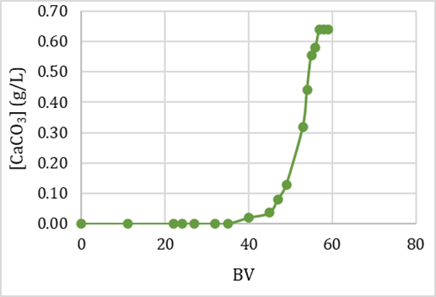

Figure 18: Breakthrough curve for subsequent hardness treatment
Source: Prepared by the authors (2025).

Raffinate water samples from in-house pilot trials post-sulfate removal and post-settling were analyzed for hardness. With no subsequent cationic treatment, the hardness of raffinate water was reduced to 300-500 mg/L as CaCO₃, as shown in Figure 19. This reduction is attributable to precipitation of calcium and magnesium hydroxides as described in the metal settling testing above.

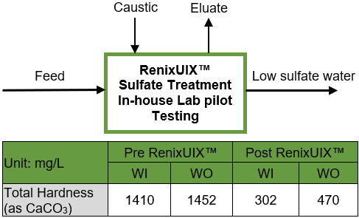

Figure 19: Hardness (In-house Lab pilot samples)
Source: Prepared by the authors (2025).

4.7 Scale-Up Modeling

Based on the results from over 65 hours of in-house lab pilot operation using mock feed and more than 30 hours of lab pilot operation using site feed samples, Renix in-house modelling was used to confirm the RenixUIX™ configuration at scale. These models were used to provide mass balance projections and process flow sheets as shown below in Figures 20 and 21 respectively. The projected process water recovery was 120 m³/h, corresponding to over 95% of the initial effluent, with 10 m³/h intended for internal reuse in the system. Estimated production of co-product calcium sulfate was 0.3 tonne/hr, and high pH water from eluate will be recycled within the process.

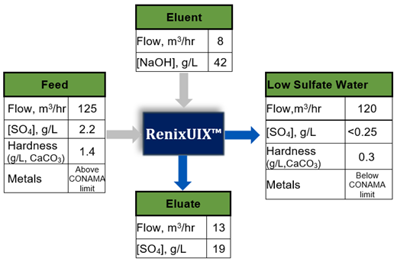

Figure 20: Mass balance projections for the mining unit
Source: Prepared by the authors (2025).

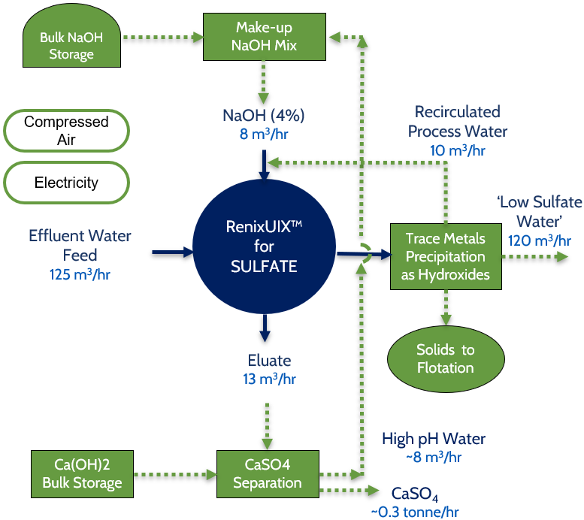

Figure 21: Proposed process flow sheet for the mining site
Source: Prepared by the authors (2025).

4.8 Estimated Cost reductions

The recirculation and reuse of 120 m³/h of treated effluent in mining operations would significantly reduce freshwater consumption, leading to operational cost savings.

Regarding gypsum commercialization, the market value in Brazil is approximately R$ 150,00 per tonne. With an estimated production of 0,3 tonnes per hour, the potential revenue from selling gypsum would be approximately R$ 45,00 per hour. Assuming continuous operation, this results in annual revenue of about R$ 395.000,00 which corresponds to approximately USD 67.386,00 per year considering an exchange rate of 5,85 BRL/USD.

5. Conclusions

The proposed treatment system is composed of three sequential steps: (I) sulfate removal via steady-state ion exchange, (II) heavy metal control, and (III) optional hardness removal. The system demonstrated effective and consistent performance, with sulfate and heavy metals concentrations in compliance with CONAMA Resolution No. 357/2005 and lowering water hardness to prevent scaling. This enables water recirculation and improves site water management. Even without the third step, hardness levels after sulfate treatment were sufficiently low to allow reuse, increasing operational flexibility.

Unlike conventional batch ion exchange processes, the steady-state configuration ensured continuous operation without frequent shutdowns for resin regeneration. This uninterrupted mode significantly reduced downtime and minimized backwash waste. Furthermore, the system promotes regenerant recovery and offers the potential for gypsum generation, contributing to circularity and cost reduction.

Therefore, the results validate the technical feasibility and economic advantages of the proposed treatment system.

6. References

American Water Works Association. (1999). Water quality and treatment (5th ed.). McGraw-Hill. https://isbnsearch.org/isbn/0070016593

Azapagic, A. 2004. Developing a framework for sustainable development indicators for the mining and minerals industry. Journal of Cleaner Production, v. 12, p. 639-662. https://doi.org/10.1016/S0959-6526(03)00075-1

Belattar, M., Hadfi, A., Aazza, S. B., Mohareb, S., Hafid, N. 2018. Characterization of scale deposits formed in sanitary hot water pipelines in the northern tourist zone of Agadir city. Mediterranean Journal of Chemistry, v. 7, p. 86-92. https://doi.org/10.13171/mjc721808027ah

Brazilian Mining Association (IBRAM), National Water Agency (ANA). 2013. Water resource management and the mining industry. Brasília: ANA/IBRAM. https://www.ana.gov.br/

Conselho Nacional do Meio Ambiente. 2005. Resolution No. 357, of March 17, 2005: Provides for the classification of water bodies and environmental guidelines for their framework, as well as establishes conditions and standards for effluent discharge. Ministério do Meio Ambiente. https://conama.mma.gov.br/?option=com_sisconama&task=arquivo.download&id=450

FBT. (2023). Ion exchange technique for environmental and industrial applications. Future Biotechnology, 3(03). https://doi.org/10.54393/fbt.v3i03.51

Kansara, N., Bhati, L., Narang, M., & Vaishnavi, R. (2016). Wastewater treatment by ion exchange method: a review of past and recent researches. ESAIJ (Environmental Science, An Indian Journal), 12(4), 143-150.

Pepper, J. C., Larkin, B. J. 1979. Carbonate scaling – literature review and analysis. https://doi.org/10.2172/5595661

Uechi, D. A., Gabas, S. G., & Lastoria, G. (2013). Importância da determinação dos índices de incrustação e de corrosão de águas subterrâneas em sistemas de abastecimento: um caminho para o uso sustentável. Associação Brasileira de Recursos Hídricos (ABRHidro). https://files.abrhidro.org.br/Eventos/Trabalhos/66/SBRH2013__PAP013147.pdf

Gabriela Luiza Almeida Silva
Chemical Engineer graduated from the Federal University of Minas Gerais (UFMG), with a technical background in Chemistry from COLTEC-UFMG. Currently working in the Innovation area at Nexa Resources, with a focus on circular economy initiatives related to solid waste and effluent treatment. Professional experience includes Research & Development and Innovation.

Vinoj Kurian
Holds a PhD and a Master’s degree in Chemical Engineering from the University of Alberta and the Indian Institute of Technology Madras, respectively. Serves as Science Manager at Renix, overseeing feasibility evaluations, application configuration, platform R&D, engineering support, process engineering, site trials, and post-commissioning validation. Brings over 10 years of experience in research, technology development, process engineering, and engineering support across various process sectors

Robert Andrew Haas
Robert is Director of Engineering and Project Delivery at Renix, where he manages platform and project engineering, from design through installation, commissioning, and service integration. Holding a Bachelor of Engineering Science in Mechanical Engineering from the University of Western Ontario, he is also a registered Professional Engineer in Ontario, Canada. Prior to Renix, Robert accumulated more than 25 years of experience in project management and equipment design within the municipal and industrial water and wastewater treatment sectors

