The First AI Agent in Strategic Mine Planning
(Minería 4.0)
Jorge Lozano*¹ , Melissa Amado**²
1. Genius Mining AI, Founder & CTO, San Isidro-Lima Peru, Teléfono móvil +51-01-942767514, jorge.lozano@bee3tech.com
2. Genius Mining AI, Founder & CEO, San Isidro-Lima Peru, Teléfono móvil +51-01-964506823, melissa.amado@bee3tech.com

INTRODUCTION:
This research focuses on solving NP-type optimization problems in open-pit mining, where the main objective is to maximize the NPV. The motivation lies in the growing need for advanced tools to efficiently manage natural resources and maximize profitability in strategic sectors. To address this issue, the study integrates AI techniques such as RL. An integral approach is proposed that, in addition to solving classical mining challenges, lays the foundation for its adaptation to other fields involving resource optimization. Our goal is not merely to solve the problem, but to teach a machine how to solve the problem. In the Figure 1 show an overview of our solution.
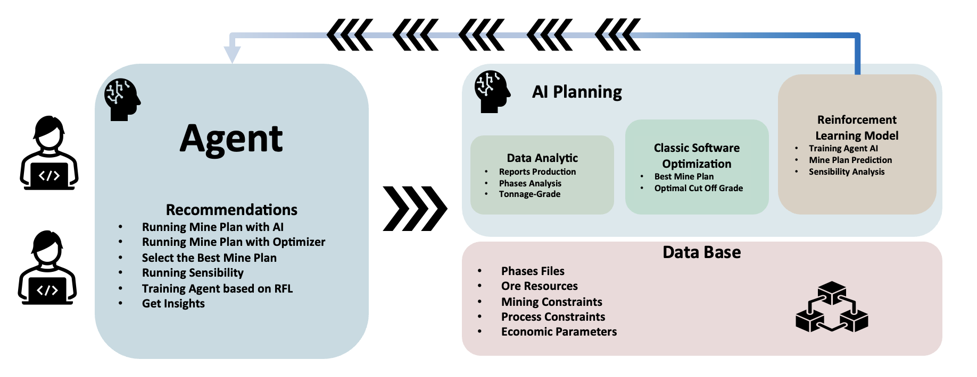Figure 1: Overview of Solution Architecture
The following table illustrates the acronyms used throughout this summary:
Tabla 1 Acronyms
Code | Meaning
V (NPV) | Net Present Value
IA | Artificial Intelligence
RL | Reinforcement Learning
R | Mining Resources
C, c | Operating Cash Flow
g | Policy of each period of extraction
F | Opportunity Cost
$$τ$$ | Rate of time for unit of resource
s | Current State of Systems
r | Reward
a | Action
P | Probability
$$γ$$ | Learning Parameter
MILP | Mixer Integer Lineal Programming
$$Ω$$ | Set of polices
MDP | Markov Decision Process
LLM | Large Language Model
NP | Non-Polynomial
LOM | Life of Mine
GRASP | Metaheuristic Algorithm
TABU | Metaheuristic Algorithm

METHODOLOGY:
The methodology begins with the development of a mathematical model based on Lane’s Theory (Lane,1988), which represents the geological and operational constraints of the mine, such as processing and mining capacities and serve like modeled environment. In parallel, a RL agent is trained to interact with this modeled environment. The agent receives rewards based on the economic and operational impact of its decisions, allowing it to gradually improve the production plan through the training process. To better understand, we will briefly explain each finding.
First, Kane Lane (Lane,1988) propose the Equation 1. The purpose of the equation is to determine the maximum Net Present Value (NPV) of the mining project and optimal cut‑off grade in the R space.
$$V^{'}= \int_{0}^{R}{\max_{g ∈Ω}\left\{c-F∙τ\right\}dR \left(1\right)}$$
In his 1988 book Economic Definition of Ore, Lane (Lane,1988) states that the way to solve this problem is through dynamic programming where for each infinitesimal tonnage increment, the integrand selects the largest economic margin across all policies g. Integrating over R yields cumulative NPV sensitivity to incremental cut‑off changes. On the other hand, Richard Sutton and Andrew Barto integrate Bellman equations and Markov Chains to mathematically define the optimal policy in Reinforcement Learning, as shown in Equation 2. This approach aims to teach a machine to perform tasks by training it within a given environment, with specific actions and rewards. The optimal value equals expected immediate reward plus discounted best future return.
$Q_{*}\left(s_{t},a_{t}\right)=\sum_{j=1}^{m}{P\left(s_{t+1},a_{t+1} | s_{t},a_{t}\right)}\left[r_{t+1}+γ\max_{a_{t+1}}{Q_{*}\left(s_{t+1},a_{t+1}\right)}\right] \left(2\right)$
Based on master’s thesis in Computer Science (Lozano,2024), the mining process was modeled as a Reinforcement Learning (RL) problem. The study demonstrated that Lane’s integral presented in Equation 1 can be addressed by reformulating the mining optimization challenge through RL framework as shown in Equations 3 and 4.
$Q_{g∈Ω}= \max_{g∈Ω}\left(C_{i,j}+\left(\frac{1-δ}{1+δ}\right)\left(1+\sum_{θ=j+1}^{n}{\frac{C_{i-1,θ}}{{\left(1+δ\right)}^{θ-j}}}\right)\frac{Δ_{t_{j}}}{Δ_{r_{j}}}\right) \left(3\right)$
$$Q_{*}\left(s_{t},a_{t}\right) ≅ Q_{g∈Ω} \left(4\right)$$

REINFORCEMENT LEARNING IN MINING:

The optimization of non-renewable resources, such as mining, is a significant challenge for both industry and academia. Traditional approaches, using algorithm that implement MILP or Metaheuristics, have proven effective in finding optimal solutions under given initial conditions. However, these methods exhibit several limitations, including the generation of a single solution, lack of adaptive learning, the need for re-optimization with parameter changes, and uncertainty in the success probability of the obtained solution.
In this context, we propose an abstraction of mining problems using Reinforcement Learning (RL). Mining problems can be naturally modeled as reinforcement learning games, where periods represent states, extraction decisions correspond to actions, and the cash flow of the mining model serves as the reward like we can show in Figure 2 and Figure 3. This approach addresses the limitations of classical optimization methods, providing a more flexible and adaptive framework.
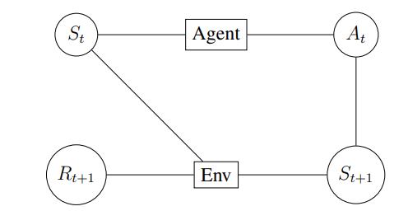
Figure 2: Overview of Reinforcement Learning
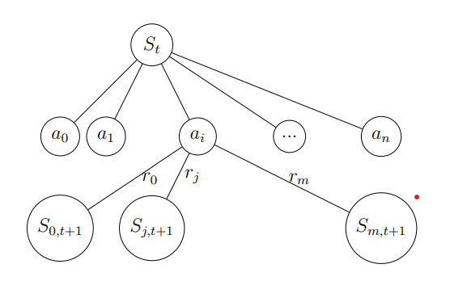
Figure 3: Topology Markov Decision Process
Reinforcement Learning offers several advantages over traditional methods. First, it can explore multiple potential solutions instead of converging on a single solution, preserving diversity in the solution space. Second, it incorporates a mechanism of continuous learning, allowing the system to improve its performance over time through accumulated experience. Third, it dynamically adapts its policies in response to parameter changes, eliminating the need for full re-optimization.
The mining problem used as an example can be more generally and technically conceptualized through the framework of Reinforcement Learning (RL). This approach allows modeling the problem as a sequential decision-making game, where each system state, available actions, and obtained rewards are considered within a formal structure called a Markov Decision Process (MDP). We can decompose the Mining Problem into an MDP:

- States ($S$): In this context, a state $s_{t} ∈S$ at time $t$ represents a complete description of the mining environment at a given moment. This includes, among other factors, the remaining resources, geological conditions, available equipment, and any other relevant parameters influencing mining operations.
- Actions ($A$): Actions $a_{t} ∈A\left(s_{t}\right)$ are operational decisions that the agent (decision-maker) can execute in state $S_{t}$. These may include decisions such as the volume of material to extract, the type of technology to use, transportation routes, and other operational strategies like cut off police. Each action influences the transition from the current state to the next.
- State Transition Function ($P$):The transition function $P\left(s_{t+1},a_{t+1} | s_{t},a_{t}\right)$ defines the probability of transitioning from state ($s_{t}$) to state ($s_{t+1}$) after executing action ($a_{t}$). This function captures the stochastic dynamics of the mining environment, incorporating uncertainties such as geological variations, machinery failures, and environmental conditions.
- Rewards ($R$): The reward function $R\left(s_{t},a_{t}\right)$ assigns a numerical value to the immediate reward obtained after executing action $a_{t}$ in state $s_{t}$ .In the mining context, this typically corresponds to the cash flow generated by mining operations, adjusted by operational costs and other economic factors.
This formulation of the mining problem as an MDP enables the generalization of the approach to other problems that can be modeled under the premises of states, actions, and rewards. Essentially, any problem that can be described using these elements is amenable to being solved through Reinforcement Learning techniques.

CASE OF STUDY:
This section presents a detailed case study in the mining sector, focusing on the application of advanced data analysis techniques and machine learning algorithms to optimize mineral resource exploitation. The main objective is to maximize the Net Present Value (NPV) of the project, considering the operational and economic constraints of the mining environment. Using Reinforcement Learning approach, the goal is to develop production strategies that are not only economically viable but also technically feasible, enabling more efficient management of mineral resources.
In Figure 4 it can be see the relationship between cut off grade, tonnage and average grade of resources. Also, in Figure 5 it can be see the economic parameters of mining operations that include processing, mining cost, prices of commodities and other parameters that permit evaluated in economic terms the feasibility of the project.
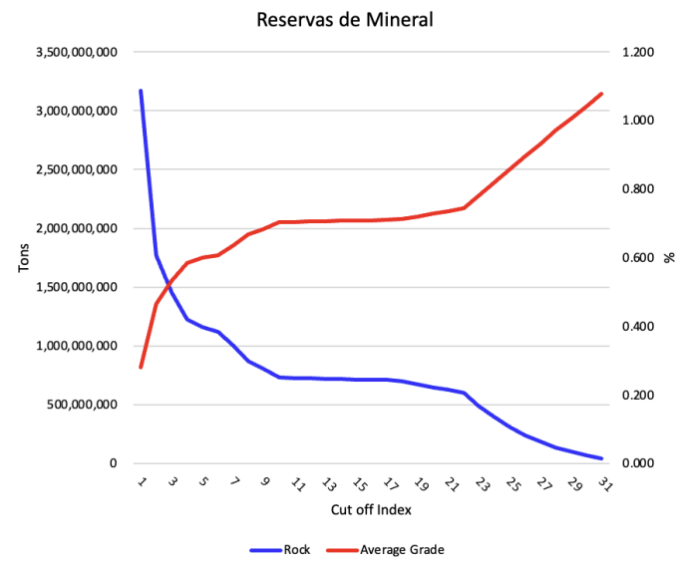Figure 4: Geology Resources
In Figure 6 we can see the operating parameters such processing and mining capacities in terms of tonnage of rock by year.
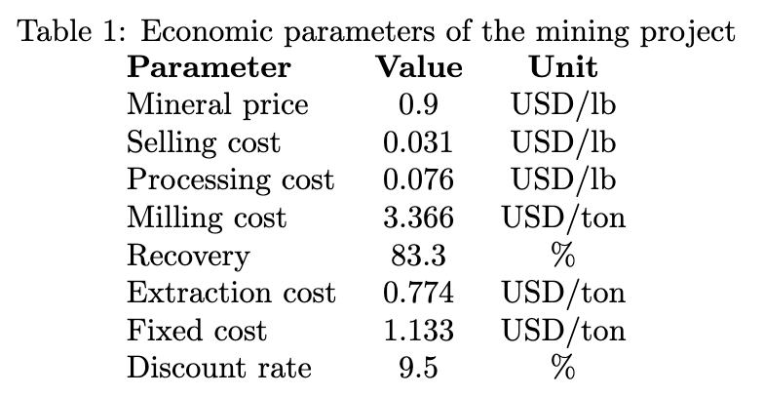Figure 5: Economics Parameters
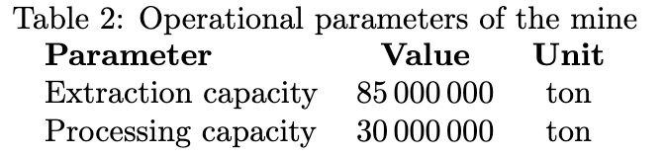Figure 6: Operating Parameters

AGENT AI IMPLEMENT AND INTEGRATE WITH LLM:
To enhance user interaction with the Agent, we integrated our AI Agent with a Large Language Model (LLM) such a Claude by Anthropic. This communications layer enables seamless integration between multiple agents, improving usability and acceleration interaction. As illustrated in Figure 7, the user can easily select different functionalities, such a training a new agent or making predictions using a specific pre trained model. Subsequently, the LLM interacts with both the user and the AI Agent to assist in executing various tasks, as shown in Figure 8. While a LLM alone lacks the domain-specific expertise to perform complex mining task such as generating a Life-of-Mine (LOM) plan, it can effectively communicate with specialized agents like ours to carry out such operations. In this architecture, the LLM functions as an intelligent communication layer.

Figure 7: Claude Applications

Figure 8: Claude interactions with Agent
RESULTS:
The results of this agent permit not only training also predicts mine plans with out especific knowlegemt of mining theories or algorithms. It shows in Figure 9 the mining plan with waste and ore requirements by period.
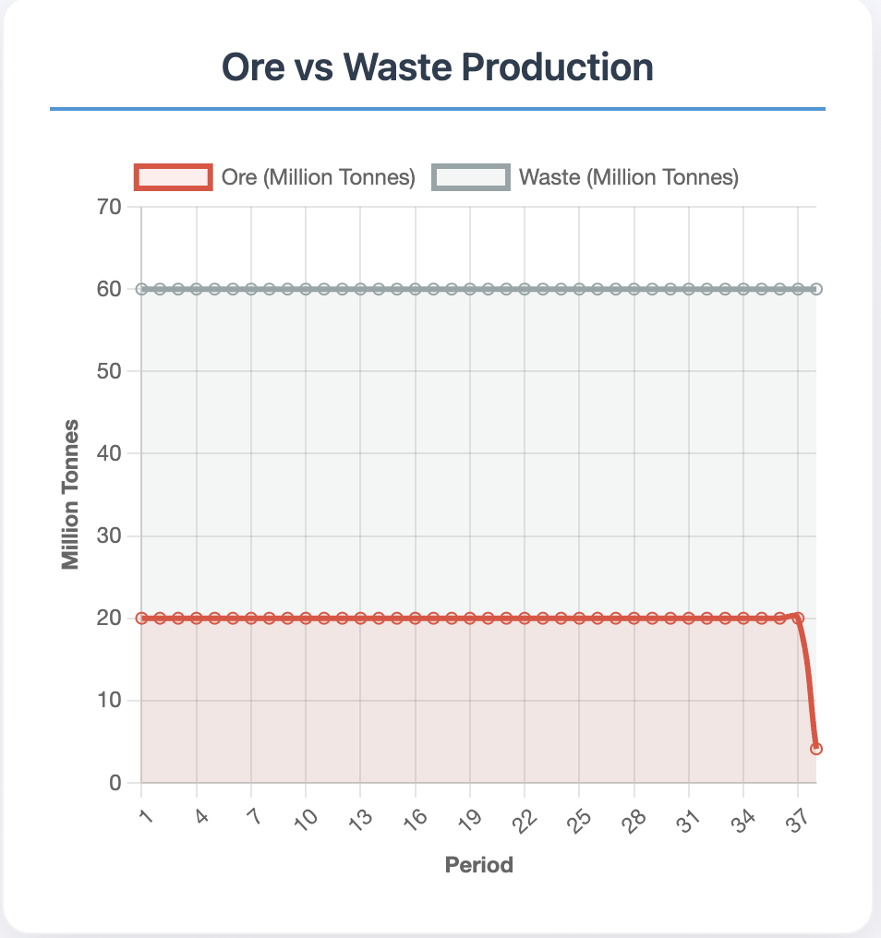 Figura 9 Production Mine Plan
Figure 10 shows that the agent selects the optimal cut-off in the initial periods to maximize project’s Net Present Value (NPV), resulting in improved cash flows at the beginning of the mining operation. This type of optimization strategy is common in different approach like Mixed-Integer Lineal Programming (MILP) or metaheuristic algorithm (GRASP, TABU SEARCH). However, when using Reinforcement Learning (RFL) approach, the agent has the power of select other goals or include new paradigms in project evaluations such real options analysis, enabling of better opportunities throughout the mine’s life cycle.
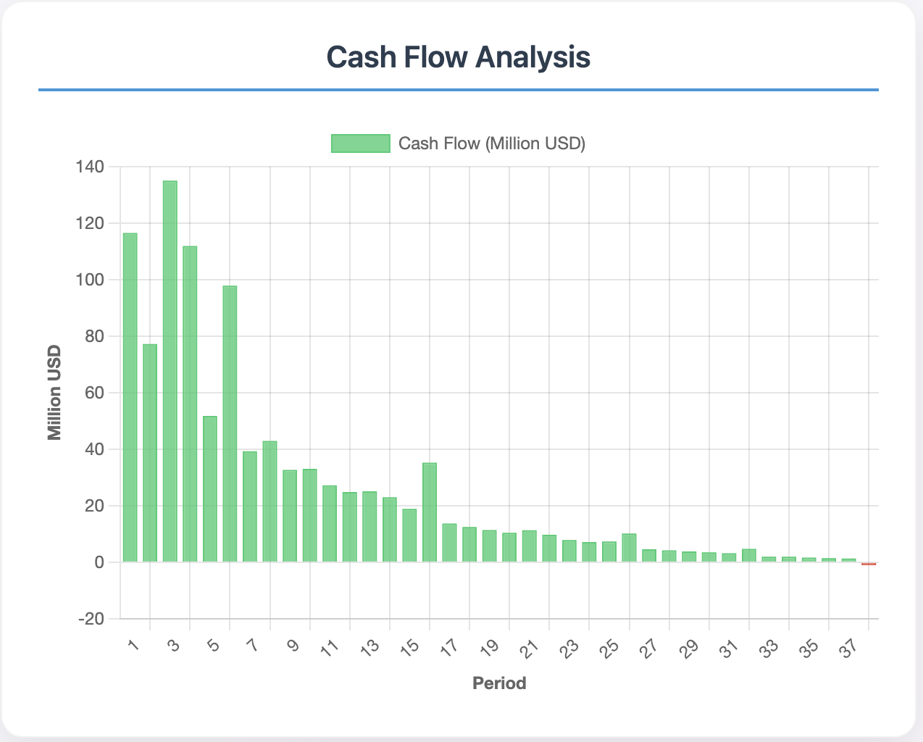Figura 10: Cash Flow by period
It shows in Figure 11 a consistent increase in NPV, indicating the agent is approaching the maximum. The RL agent adjusted extraction and processing based on ore grade and capacity, learning only from its environment. It found both the optimal and other feasible solutions useful for engineering analysis.
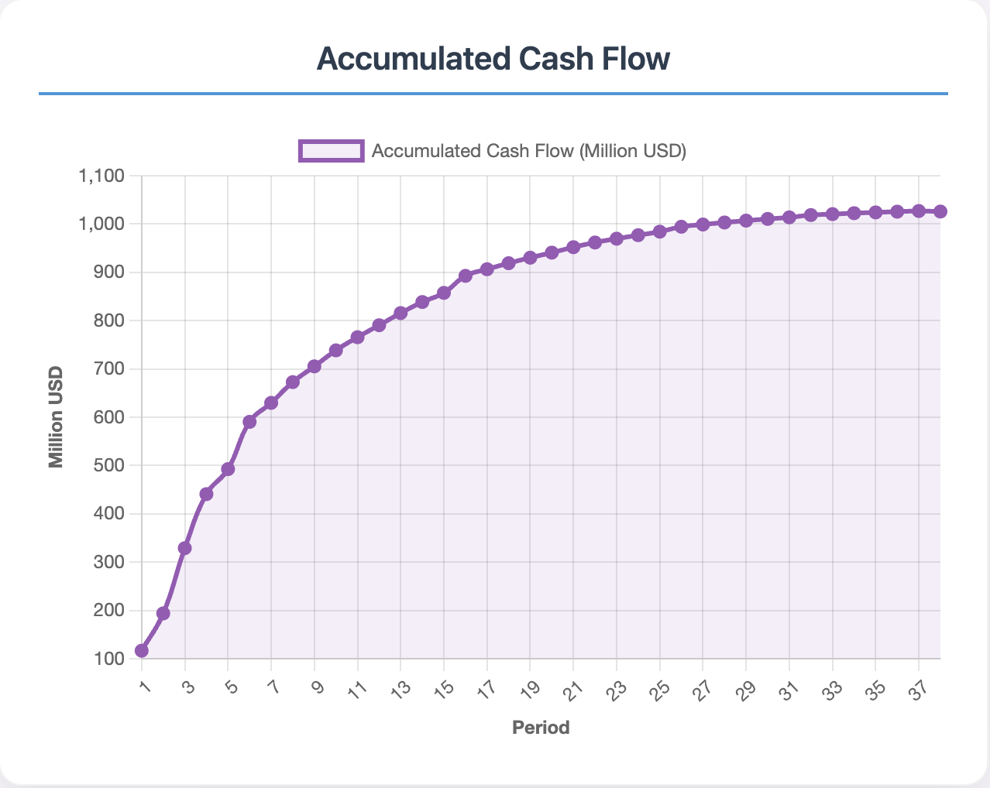Figura 11 NPV Accumulated
With the power of create many mining plans in parallel way, is possible to have a variety of solutions like it shows in Figure 12. This variety of solutions permit us to identify different solutions, risk and opportunities to enhance the strategy of mining and processing.
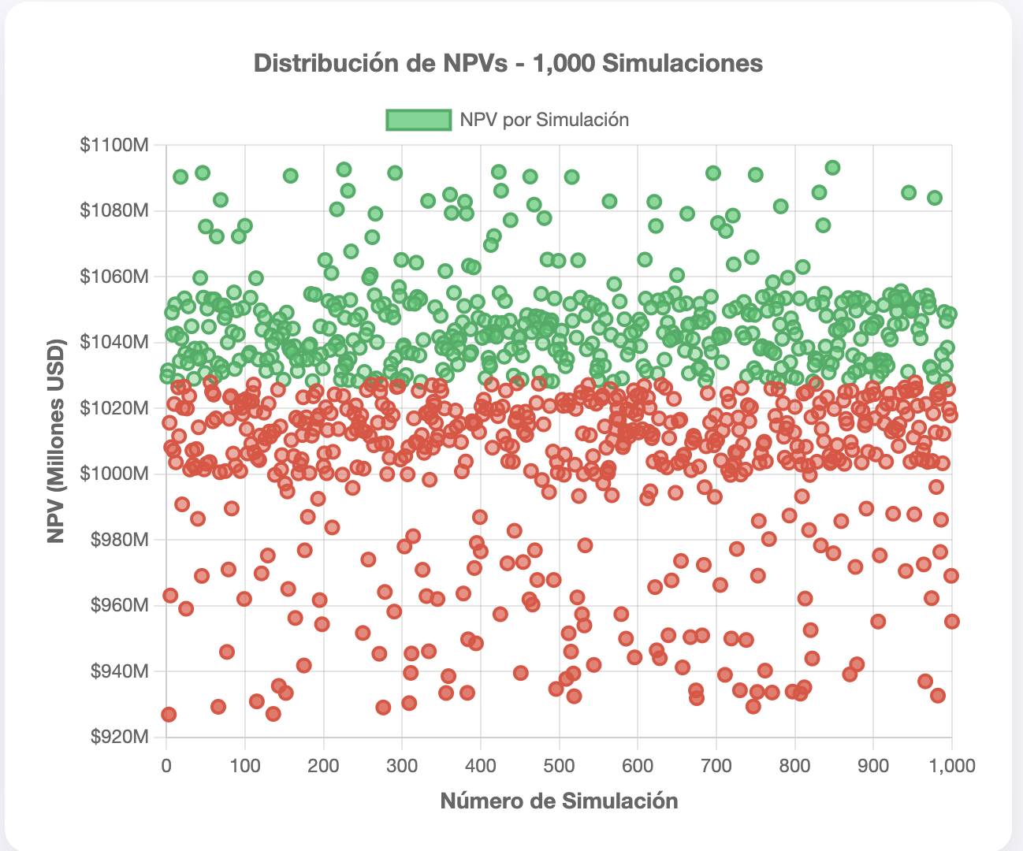Figura 12 Sensibility Analysis of NPV
CONCLUSIONS
- MDP formulation of strategic planning
The open-pit mine planning problem can be rigorously modeled as a Markov Decision Process (MDP). States, actions, transition dynamics, and economic rewards consolidate geological, operational, and financial variables into a single decision-making framework.
- Lane–Bellman mathematical equivalence
By linking Lane’s integral (dynamic cut-off optimization) with the Bellman equation, a formal equivalence was established. This lets Reinforcement Learning (RL) maximize Net Present Value (NPV) without the restrictive assumptions of classical dynamic programming.
- Optimal cut-off policy and cash-flow acceleration
The RL agent learned to raise the cut-off grade in early periods, front-loading revenue and producing stronger initial cash flows—without any explicit mining heuristics.
- Stable convergence to maximum NPV
Training showed a consistent, cumulative increase in NPV, confirming that the agent converges on the economically optimal policy while dynamically adjusting extraction volumes and processing rates.
- Portfolio of plans and risk analysis
Generating multiple plans in parallel creates a frontier of feasible solutions, enabling sensitivity analyses and clear identification of upside opportunities and risk scenarios.
- Continuous learning without full re-optimization
Unlike MILP or metaheuristic models, the RL agent updates its policy iteratively. Parameter changes do not require a complete re-optimization run, and solution diversity is preserved.
- Methodology transferable to other resources
The state-action-reward structure can be applied to any non-renewable resource or complex production system with sequential dynamics and economic objectives.
- Operational integration in a simulated environment
The simulation environment—built on Lane’s theory—embeds capacity constraints, costs, and prices, giving the agent a sandbox where it learns policies that honor both operational feasibility and economic maximization.
These findings confirm that the proposed RL-based architecture overcomes the limits of deterministic methods and lays a solid foundation for autonomous, adaptive mine-planning systems.
REFERENCES
Jorge Lozano (2024), Reinforcement Learning for Autonomy Optimization of No Renewable Computer Science MSc, Universidad Nacional de Ingeniería – Perú

Kane, Lane (1988). The Economic Definition of Ore. 4.a ed. Suite 16, Sea Air, 141 Shore
Street West, Cleveland-Queensland 4163, Australia: COMET Strategy Pty Ltd.
Professional Summaries
*Jorge is a Computer Scientist and Mining Engineer with a proven track record in developing AI-powered solutions for heavy industries. He founded and exited three successful ventures—Inti Mining Smart Solutions Peru, IMSS Consultores Chile and Deep Pit Technology—that transformed operational efficiency through advanced analytics and machine learning. Passionate about mathematics, physics, and first principles thinking, he designs sustainable, human-centric systems that drive safety, profitability, and innovation. Currently serves as CTO of Bee3 Technology and Genius Mining AI, focused on R&D and technological innovation.

**Melissa is a visionary entrepreneur and international speaker with a background in International Business Administration and certification as an Ontological Coach. She founded Deep Pit Technology, a pioneering tech company for the mining sector, which was later acquired, and currently serves as CEO and Founder of Bee3 Technology, focused on R&D and technological innovation.

