Título: 3D-Stability Validation of a Heap Leach Pad in the Peruvian Andes Using LEM and SSR Technique
Tema: Geotecnia / Geomecánica | Categoría: 2. Operaciones Mineras y Gestión Activos
Autores y coautores:
Nombres | Empresa | Cargos | Dirección | Correo corporativo / Correo personal | Celular
Jean Paul Minaya Muyon | Ausenco | Geotechnical Engineer, Intermediate | Lima, Perú | Jean.minaya@ausenco.com  jminayam@uni.pe | 941142328
Laura Rojas Perea | Ausenco | Geotechnical Geological, Intermediate | Lima, Perú | Laura.rojas@ausenco.com  laurarojasperea260396@gmail.com | 922535703
Jimmy Tapia Vasquez | UNI | Geotechnical Engineer, Senior | Lima, Perú | jtapiav@uni.pe  j.tapia.v@outlook.com | 961786564
Keywords: Heap leach pad, Three-dimensional slope stability analysis, limit equilibrium method, failure surfaces, spline, shear strength reduction method
Abstract
Three-dimensional slope stability analyses using the Limit Equilibrium Method (3D-LEM) often raise questions about the realism of assumed failure surface shapes. While spherical, ellipsoidal, and spline geometries are commonly used, spline surfaces offer greater flexibility and often yield lower factors of safety. To validate these surfaces, a comparison with the Shear Strength Reduction Method (SSRM) is appropriate, as SSRM does not rely on predefined assumptions about failure surface shape or location. This study presents a 3D-LEM stability analysis of a heap leach pad located in the Peruvian Andes, characterized by complex stacking geometry (including concave and convex plan-view zones) and a heterogeneous foundation composed of sectorized soft clayey soils. The analysis considers drained conditions and adopts the Mohr-Coulomb failure criterion. Failure surfaces—spherical, ellipsoidal, and spline—were generated using the Particle Swarm Search algorithm. Validation was performed using SSRM, demonstrating that spline-shaped surfaces provide the closest match and most representative factor of safety compared to SSRM results.
Introduction
In slope stability analyses, the limit equilibrium method (LEM) is one of the most widely used, which, through the use of a priori defined surfaces, seeks the one with the lowest safety factor to define the critical failure surface (Duncan, 1996; Rocscience, 2004); however, there is always the question of whether these studied failure surfaces can occur in reality. In the case of three-dimensional analyses, 3D-LEMs have been developed that test spherical, ellipsoidal and spline surfaces, the latter standing out because it is more flexible and adopts almost any shape providing lower factors of safety than spherical or ellipsoidal ones (Ma & Javankhoshdel, 2023).
A common practice is to compare LEM results with failure surfaces obtained with the shear strength reduction method (SSRM), since this method has the advantage of not requiring preliminary hypotheses to define failure surface mechanisms, such as shape or location (Griffiths & Lane, 1999; Rocscience, 2004). Several authors have studied theoretically the SSRM and how close to reality the obtained surfaces could be (Duncan, 1996; Griffiths & Lane, 1999); which would allow affirming that the SSRM is an adequate validation methodology for the fault surfaces obtained by the LEM.
This study analyzes the three-dimensional slope stability of a heap leach pad located in the Peruvian Andes, which has a complexity inherent to its stacking geometry (concave and convex zones seen in plan) and to the stratigraphic distribution of its foundation (sectored clayey soils in the northwest foot); and focuses on the comparison and validation of the critical failure surfaces obtained with the 3D-LEM, with those obtained by the 3D-SSRM in conjunction with the finite element numerical method.
Methodology
Three-dimensional stability analyses were run to determine the global potential failure surface across the soft clay stratum of the heap leach pad foundation for long-term static conditions (i.e., drained conditions), using the LEM and SSRM methodologies.
The 3D-SSRM employed the finite element numerical method, with 4-node tetrahedral elements; the Mohr-Coulomb constitutive model was used for the pile and the clay foundation. The Spencer 3D-LEM searched for failure surfaces with spherical, ellipsoidal and spline shapes (both optimized and non-optimized) with Particle swam search method; the Mohr-Coulomb failure criterion was used for stacking and clay foundation.
Finally, the critical failure surface obtained with the 3D-SSRM is selected to proceed to validate the failure surfaces obtained with the 3D-LEM and to identify the 3D-LEM failure shape that would better represent the real behavior of the heap leach pad.
Results
According to Table 1, Table 2 and Table 3, it can be concluded that the spline failure surface best represents the actual stability behavior of the leach pad with soft clay foundation. In this regard, Terence Ma et al. (2023) point out that the spline surface is especially useful for identifying critical failures in three-dimensional slopes due to its geometric flexibility. As demonstrated, the spline is a versatile option that allows local optimization by various methods, such as the inclusion of weak layers, making it a more effective tool than ellipsoidal and spherical surfaces.
Table 1 Failure surfaces and safety factors (SF) obtained from 3D-LEM
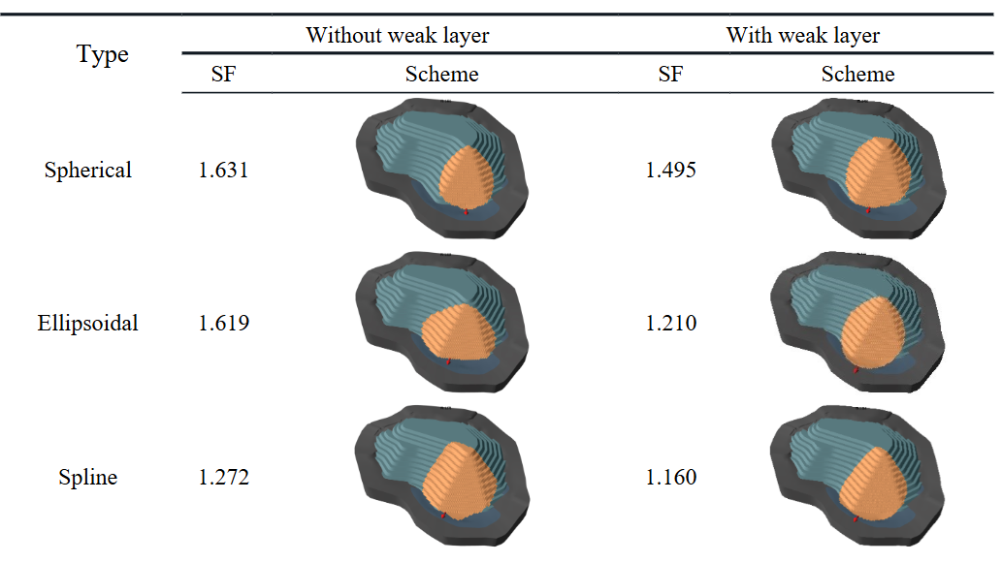
Table 2 Failure surfaces and strength reduction factors (SRF) obtained from 3D-SSRM
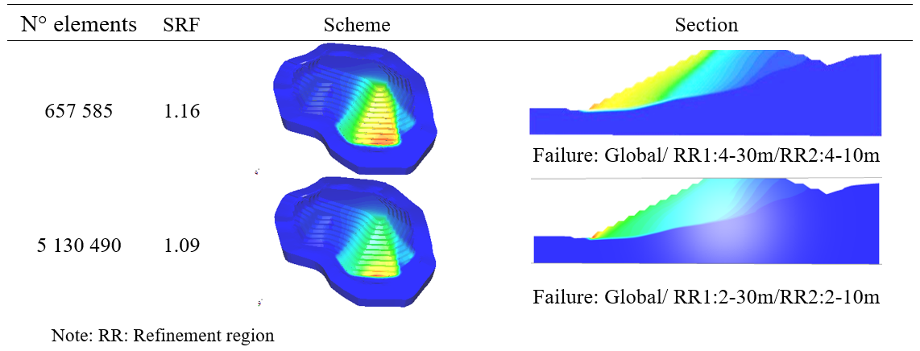
Table 3 Comparison of the 3D-SSRM with failure surfaces from 3D-LEM
