SUSTAINABLE COPPER PRODUCTION: HIGH-PERFORMANCE BIOLEACHING WITH NATIVE BACTERIAL CONSORTIUM
Authors:
Fernando Clarense Zeballos Zeballos, Compañía de Minas Buenaventura SAA, Director of Metallurgical Projects, Calle Las Begonias 415, Piso 19, San Isidro, Lima, Perú, fernando.zeballos@buenaventura.pe, ferzeb@hotmail.com, +51 995279403.
Julio Emilio Ayquipa Tapia, Compañía de Minas Buenaventura SAA, Chief of Process, Unidad Molle Verde, Calle Las Begonias 415, Piso 19, San Isidro, Lima, Perú, julio.ayquipa@buenaventura.pe, jayquipatapia@gmail.com, +51 991956226.
Subject: Procesos hidro-electrometalúrgicos.
Category: Procesamiento de Minerales y Metalurgia Extractiva
Key words: sustainable, bioleaching, redox-potential, ferric, mesophiles, bacterial-consortia
Summary
Buenaventura owns the Trapiche copper project, a porphyry copper-molybdenum deposit of Oligocene age located on the southwestern margin of the Andahuaylas-Yauri metallogenic belt. The Trapiche orebody is characterized by a significant content of secondary copper sulfides, minor oxides, and a consistent presence of primary copper sulfides within the supergene zone.
A key feature of the supergene zone is its immature enrichment profile. As a result, the ore is not amenable to conventional leaching techniques due to excessive acid consumption (>20 kg/t) and prolonged leaching cycles, which negatively impact process operating expenditures (OPEX) and project feasibility. To overcome these limitations, a native bacterial consortium was developed on-site using bacterial strains isolated from various sources within the Trapiche area. This consortium demonstrated high efficiency in leaching sulfide minerals and emerged as a sustainable, low-acid alternative for copper extraction by facilitating in-situ acid generation via bio-oxidation of primary sulfides.
The process, internally termed BioCuprum, promotes elevated total iron concentrations (FeT > 25 g/L) in the leach solution, with most of the iron oxidized to ferric iron (Fe³⁺). This strategy enhances the redox potential—maintained around 800 mV vs. SHE —through the biological oxidation of ferrous iron (Fe²⁺) by iron-oxidizing bacteria. The elevated Fe³⁺/Fe²⁺ ratio accelerates the oxidative dissolution of copper sulfide minerals, such as chalcocite, covellite, and partially chalcopyrite, resulting in improved copper recovery, reduced acid consumption, and shortened leaching cycles, particularly in ores with reactive gangue components. The following figures show the extraction of copper above the leachability index (acid-soluble copper + cyanide-soluble copper) and the low acid consumption in leaching.
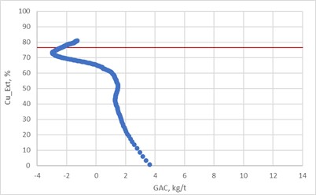 | 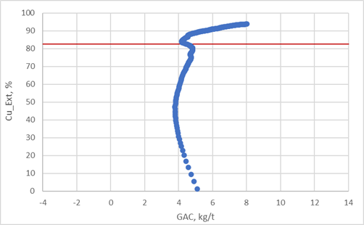
Gangue acid consumption Vs Copper extraction. Enriched ore | Gangue acid consumption Vs Copper extraction. Mixed ore

In the figures above, the red line corresponds to the leachability index. For the Enriched ore, it is 76.5%, and for the Mixed ore, 82.5%, note in both cases how copper extraction exceeds the leachability index and with a low acid consumption rate. The leaching cycle was 240 days.
The primary objective of this study is to demonstrate the effectiveness of maintaining high redox potential through bio-oxidation to improve leaching efficiency and sustainability in copper production. Column leaching tests were conducted on-site using two different ore types as is shown in the figures above.
Results demonstrated copper recoveries approaching those typically associated with oxide and secondary sulfide ores within 180 days, with further partial leaching of chalcopyrite observed during the subsequent 60 days. Ferric iron accounted for over 97% of total iron in the solution, indicating a high bacterial oxidation rate. This not only enhanced copper dissolution but also reduced acid consumption by limiting jarosite formation and boosting in-situ sulfuric acid production.
Reducing acid consumption during the leaching process not only minimizes the logistical demand for large-scale acid transportation to the project site —thereby reducing associated environmental and operational risks— but also offers significant economic benefits. Over the projected 18-year mine life, this reduction could translate into operational cost savings estimated between $450 and $780 millions. Additionally, improved copper recovery rates exceeding the conventional leachability index contribute to enhanced project revenues and overall economic viability.
Conclusion:
BioCuprum technology, based on a high-performance native bacterial consortium for redox potential control, significantly enhances the efficiency, sustainability, and environmental performance of heap bioleaching at the Trapiche project which will allow improve the project NPV or what is the same, its viability. Pilot-scale validation is recommended before full-scale industrial implementation.

Professional review:
Fernando Zeballos is graduated in Chemical Engineering from the Universidad Nacional San Agustín (1995) and has a master’s degree in metallurgical and Materials Engineering from the PUC-RJ (2001), and currently is MBA candidate from CENTRUM PUCP.
He has over 26 years of experience operating and mainly developing projects in mining and oil and gas areas with different positions and responsibilities. Currently Fernando is working in Compañía de Minas Buenaventura as Director of Metallurgical Projects.

Julio Ayquipa is a Metallurgical Engineer graduated from the Universidad Nacional de San Marcos, with a master’s degree in Process and Project Management from the University of Lima.
He has 20 years of experience in concentration and leaching processes, process research and development. Currently works as Process Chief in the Trapiche project, in charge of the on-site metallurgical laboratory developing investigations of hydrometallurgical copper recovery.

