High-Confidence Expansion Drilling in an Iron-Oxide Copper Group Deposit in Candelaria-Punta del Cobre, Chile using Geological Logging Proxies in AI-Driven Resource Modelling
(Geología y Exploraciones – Tecnologías Digitales y de IA)

Farzi Yusufali¹, David M First ² Daniel Mogilny ³

¹ Author: Stratum AI, CEO, 50 Gracedale Drive, Richmond Hill, Toronto, Canada (farzi@stratum.ai – Phone: +1 519 7293452)
² Coauthor 1: Stratum AI, Chief Geologist, 68 Robertson Street, Sherwood, Australia (david@stratum.ai – Phone: +61 409919509)
³ Coauthor 2: Stratum AI, CTO, 50 Gracedale Drive, Richmond Hill, Toronto, Canada (daniel@stratum.ai – Phone: +1 516-914-7634
____________________________________________________________________________________

SUMMARY

This study explores the application of geological logging as proxies to economic mineralization using machine learning techniques and evaluation by producing high-confidence expansion drill program targets. The authors introduce chosen features considered and included in the resource modelling process, the relative improvement in block-level estimation metrics compared to the mine site’s resource model, and the drilling results from the mineralization zones identified by this approach. The authors present the results of this study and drill program for an iron-oxide copper group deposit in Candelaria-Punta del Cobre region, Atacama Desert in the northern region of Chile.

The authors demonstrated methods include 1) identifying statistically significant non-linear correlated lithological features using data analysis and visual inspection 2) limited feature selection to prevent overfitting, and 3) evaluation criteria to determine efficacy of the AI-based resource estimation method. The AI-based model’s blind reconciliation of data tested over 8 quarters, with 0.5% Cu cut-off grade, shows an increase of 1.67x reconciled mineralization while maintaining the same sensitivity (false positive rate) as the benchmarked site resource model. The AI-based model includes input channels of assayed Cu and visually logged barren rock where the visually logged barren rock is pattern-matched against assayed 0.0% Cu to teach reduce the error of the visual logs.

The model was used to produce a 2000m underground expansion drilling program; the program successfully identified three new mineralization zones of economic Cu where waste was previously predicted by the benchmark site model. A total of 11 holes were drilled where all holes intersected high grade Cu zones (3 times higher than cut-off), all at least 10m away from known mineralization. The total in-situ value uniquely identified and verified to Measured was 7.7kT of Cu above cut-off grade. Future work should focus on expanding geochemical and lithological datasets and exploring additional geological variables to improve predictive capabilities specific to each deposit and regional archetype.

1. Objectives

- To create a method of reliably feature engineering geological logging for mine-site spatial modelling. Feature engineering refers to the selection criteria and techniques needed to incorporate data into machine learning.
- To evaluate whether DL models that use geological logging are more accurate than models based entirely on geochemistry and/or Kriging models (based on categorical indicator Kriging (CIK) and/or mineralized zone (MZ) domaining).
- To create a computationally efficient method for screening which geological logs are useful for DL modelling prior to model training.

The deposit where the pathfinder screening algorithm (PSA) system is applied is a Copper mine, Manto-type iron oxide copper gold deposit, located in the Candelaria-Punta del Cobre district, Region III, Chile.

2. Background
Machine Learning and Deep Learning
Recently, machine learning (ML) has emerged as a powerful tool for revealing complex patterns in data. At its core, ML algorithms learn from historical data to better forecast a future pattern or trend. Although ML, and more generally, AI is defined as such above, DL is the term used for one of the most powerful ML algorithms; it uses multiple layers of artificial neurons that are composited into a deep neural network (i.e. convolutional neural network (CNN) (O'Shea and Nash, 2015). The concept is loosely modelled on the way neuroscientists believe the brain behaves when it identifies patterns in very large data sets. DL has seen much success in the field of image recognition (e.g. medical imaging) as well as machine translation, the AI process of automatically translating text from one language to another (Goodfellow, Bengio and Courville, 2016).
ML and DL’s inherent advantage over traditional Kriging methodologies is its unique ability to leverage non-linear correlation trends, its capacity to model geological logging data and identify high quality data sources by learning from historical data. Geological logging data can be defined as any type of data that is collected through visual inspection of samples, done typically with drill core. While geological logs are inherently qualitative in nature when compared with assays, it nevertheless has significant value as a dataset. The biggest advantage of geological logging is its cost-efficient acquisition. However, the major challenges of working with geological logs in spatial modelling include identifying how to best leverage the data while considering its qualitative limitations, interpretation bias (e.g. a deposit logged by multiple geologists with evolving interpretations) and a relatively low SNR ratio (given that some of the parameters logged may be irrelevant to spatial modelling).
The DL algorithm and nomenclature referenced in this paper by First et al (2023) is repeated in this paper. For example, DRC(Au, MZ) ~ DR references a gold resource model that uses diamond drillholes (D), RC drillholes (R), rock-chip (C) assays as inputs into the model, Au assays and MZ geological logging data as a separate input channels and DR (on the righthand side) as drillholes (D) and RC drillholes (R) as a proxy for ground truth or the ‘correct’ answer, by which the DL model learns the spatial distribution of gold.
The primary advantage of subdividing the inputs from the ground-truth readings is to manage lower quality assays, such as rock-chip samples, which may be useful in spatial modelling but cannot be relied on greatly to teach the model the accurate answer on a block level. In other words, rock-chipping 10g/t Au from a block may be useful information for a machine learning model to understand the spatial distribution of gold; however, that sample cannot be used to denote the entire 3m x 3m x 3m smallest mining unit (SMU) as 10g/t Au given that the chip samples could be collected inside of a 50cm vein, a highly bias form of data.
The ML algorithms used in this paper are written in Python, a programming language that distinguishes itself from other programming languages with its flexibility, simplicity and large number of available open-source tools required to create modern software, including machine learning algorithms. Python helps software engineers focus on solving logical problems rather than spending time on the basics of the programming language. This is one of the primary reasons that Python is the language of choice for machine learning and data science in general. PyTorch is the ML library that houses the open-source tools used to construct neural network layers. These neural network layers are paired with CUDA (Compute Unified Device Architecture), a computing platform developed by NVIDIA to interact with Graphics Processing Units (GPUs). NVIDIA is a technology company that designs and manufactures GPUs.
Deep Learning Limitations
While powerful, DL models are not without limitations. A DL model is inherently error-resistant to a certain level of noise within data but are not totally immune. Unfortunately, most geological logging data is noise from the perspective of its usefulness in resource estimation. Most geological logs carry limited value for copper grade modelling. However, a recently developed method, ablation analysis, has been found to be invaluable when selecting which geological data channels are productive inputs into DL models (Meyes et al, 2019).
The ablation analysis method individually runs all potential input channels to identify which ones add value to an estimation. For example, if the objective is to build a gold resource model that is enhanced using geological logging, ablation analysis will produce recommendations akin to D(Au, X) ~ D, where every X is a unique geological logging code, whether it be a lithology, alteration or geotechnical code.
However, many particularly larger deposits, have a penchant for numerous unique lithological and alteration logging codes, making the analytical process cumbersome and computationally impractical. The techniques to identify which input channels to use and the most efficient way to encode them, collectively feature engineering, is explained in Methods.
Geological Logging Limitations
Geological logging has two major applications when being applied to spatial modelling at mine sites: 1) a pathfinder for mine site exploration and resource estimation and 2) as a proxy for a geochemical assay or mineralogical test.
Its usefulness as a pathfinder in the discovery of new and/or missed ore is evident when drill core is logged as being barren or poorly mineralized but contains a geological logging code that is directly or indirectly indicative of high-grade mineralized zones nearby. A common example discussed below is mineralized zone (MZ) logging.
Geological logs can be used as proxies for assays, alteration mineralogy, rock competency, etc. Most mines only prescribe a full assay suite (ICP-MS), detailed mineralogy / petrology or rock strength tests on a select few mine site samples (as it would be prohibitively expensive to collect thorough assay suites for all inputs used in a resource model).
Mines, particularly underground operations, have significant budgetary constraints on data collection expenditure, therefore the number of samples assayed, especially from third party laboratories, are restricted and/or relegated to mine site laboratory, apart from a few confirmation assays. The total meterage of core assayed is also restricted, often resulting in weak to moderately mineralized core not being assayed at all if it visually appears to not host economic mineralization, thereby directly impacting modelling accuracy.
However, fortuitously geological logging can serve as a proxy for a geochemical assay and alteration mineralogy. While out of scope for this paper, geotechnical parameters such as RQD, have the potential to be a proxy for rock competency that cannot easily be measured in a laboratory.
Geological logging is already used in spatial modelling in the mining industry in two major ways: categorical indicator Kriging (CIK) and MZ domaining (Glacken and Blackney, 2022). In categorical indicator Kriging, categorical logs are used to encode whether a sample is oxide, transitional or sulphide and is represented by integer values when applying Kriging to the data; for example, oxide ore is represented by 0, transitional ore by 0.5, sulphide ore by 1. The final estimates are rounded based on the mine’s error tolerance in each class. Some mines may vary the transition ore estimate (e.g. 0.7 considered to be sulphide) depending on processing constraints.
Domaining with geological logs has some unique challenges, particularly with respect to nuggety and structurally controlled deposits. Many orogenic and intrusion-related gold deposits, geologically log MZ and quartz veins. Essentially, if the core from the geologist’s perspective visually looks like it is potentially mineralized, it is logged as such, irrespective of the gold assay collected later. An issue of note is that MZ is often used as a descriptor for many of the pre-mineral lithologies, resulting in extra lithological codes.
The logging data used to assist in the construction of domains by constraining the mineralized zones of these nuggety deposits, thereby critical to the mineral resource estimation process as there is extreme variation in gold distribution within a small volume. Frequently within these orebodies, unrepresentative (barren or subeconomic) rock-chip or drill core assays can be sampled in very close proximity to well-mineralized drill core; as such, RC chip or rock-chip samples make grade estimation of ore blocks very challenging.
While geologists are proficient at handling the non-linear nature of geological logging, there is substantial risk, as the resource model becomes beholden to the subjective interpretation of the geological logging team and potentially an overreliance on categorical indicator Kriging and/or mineralized zone domaining (Glacken, Rondo and Levett, 2023; Sims, 2023).
While these two methods demonstrate that geological logging has inherent value in spatial estimation, they are limited in its usefulness due to Kriging’s inherent linear interpolation-based algorithm. The two methods are also incapable of accurately modelling mixed data types, like unassayed core where it could be interpreted as either barren or weakly mineralized even though it visually appears barren. There are non-linear geostatistical methods that have been applied, like multiple indicator Kriging and localized uniform conditioning; however, they have proved challenging to implement (Zhang & Glacken, 2023).
As discussed above, geological logs are critical when manually domaining an orebody but have proved imperfect when modelling due to the subjective nature in the logging process. There is a natural tendency for geologists to subdivide or split the lithologies instead of looking holistically for commonality within the data such that productive modelling inputs are derived by lumping lithologies together.
This results in situations where a large component of the ‘signal’ is lost such that the detailed information is not incorporated into the Kriging model. To circumvent this issue, many mines create ever smaller domains with the aim of capturing the geological complexities of the deposit. This results perversely in the domains guiding mine planning and mine site exploration, rather than Kriging estimation.
A naïve solution would be to undertake an ablation analysis on the ten most common logging codes. Regrettably, the most common codes are not necessarily the most useful ones for resource modelling as the economic mineral resources is invariably restricted to anomalous geologically zones. Therefore, it has become necessary to derive a method that can screen geological logs with relatively high degree of accuracy for their usefulness in spatially estimating a parameter (e.g. gold or copper value).

3. Method

Machine learning models are trained using geological logs at three deposits to test the applications of proxy and pathfinder logging under different geological environments. This protocol derives a general solution with wide applicability for feature engineering of geological logging.
Copper Mine – Introduction
The mine is located at Region III Chile. The district is characterized by an early-Cretaceous volcanic-sedimentary arc sequence with mineralization hosted primarily in the upper part of the Lower Andesite member Punta del Cobre Formation, which is overlain by volcano-sedimentary and dacite members. This host sequence consists of a thick succession of volcanic andesite flows and intercalated volcaniclastic breccias. This is overlain by the marine-sedimentary Chañarcillo Group. To the west the Copiapó batholith (diorite to quartz monzonite) was emplaced during a period of regional tectonic reversal from extensional to transpressional. Geochronological studies infer that the main phase of mineralization overlaps with the two major early phases of the Copiapó batholith emplacement, although there is no conclusive evidence to indicate from the exposed phases of the batholith that it was the source of mineralizing fluids (del Real, Thompson and Carriedo, 2018).
The orebodies are mineralized with magnetite, chalcopyrite, and pyrite, with lesser pyrrhotite and sphalerite as veinlets and disseminations (locally semi-massive sulphide bodies) and is hosted within highly altered favorable lithological units, fault zones and breccias. These mineralizing fault systems are predominantly controlled by a series of high-angle, northwest-striking regional structures. The stratigraphically controlled replacement mineralization forms extensive stratabound ore bodies that are locally termed ‘Mantos’. Textural studies indicate that the hydrothermal system evolved and progressed outwards and upwards from sub-vertical feeder structures as the replacement occurred. These sub-vertical feeder structures manifest as the mineralized fault zones and breccias, which acted as primary conduits for hydrothermal fluids to access and spread laterally within the more permeable and reactive andesitic host rocks.
A distinctive early sodic-calcic alteration (actinolite, albite, scapolite, epidote) characterizes the district, which is locally overprinted by potassic ± calcic alteration (actinolite - biotite (green – high Mg) - K-feldspar) alteration associated with the Manto mineralization (Ichii et al, 2007). This later potassic assemblage is texturally and genetically linked to the main chalcopyrite mineralization event, defining the core of the economic orebodies.

Copper Mine – Methodology
Copper resource modelling integrated with lithology logging is another example of a proxy logging application. Roughly half the mine drillhole data set is visually deemed to be barren and remains unassayed for copper or any other element. However, irrespective as to whether the core remains unassayed, it cannot be assumed to be barren (~0.0% Cu) from a modelling perspective. Although the underground mine has a relatively high cutoff grade (0.5% Cu), a weakly mineralized 0.2% Cu assay is fundamentally different from barren 0.0% Cu assay, as the former sample may indicate mineralization in close proximity, while the latter is likely to have little significance and be indicative of a barren zone.
Two solutions are proposed to resolve the issue:
- D(Cu, ZFCU) ~ D(Cu), Utilize an independent input channel. Rather than assuming that unassayed core can be assigned a 0.0% Cu value, use the ZFCU (zero filled copper) as an extra channel into the model to indicate material that has been visually logged to be barren but is unassayed.
- D(Cu, ZFCU) ~ D(Cu, ZFCU). Utilize both as an independent input channel and as a measure of ground truth. In addition to approach 1, for samples that are unassayed and logged as barren, assign 0.0% Cu, and use it to teach the model the correct answer for the copper grade for a certain block.
It is impossible to sample the true copper distribution for unassayed core without additional data collection (assaying) and it is improbable the mine will assay significant quantities of core previously logged as barren or weakly mineralized and excluded from their mineral resource model.
Three DL models are created: 1) using available Cu assays only, 2) using the Cu assays and unassayed drill core (ZFCU) as an independent input and 3) using the second method as input but with a measure of ground truth for areas that are geologically logged as barren (i.e. unassayed).
Figure 2 illustrates it is not easy to visually differentiate barren core (<0.05% Cu) from low-grade (weakly mineralized) core (0.05 - 0.25% Cu). Visual observations indicate that assigning a 0.0% Cu grade to unassayed core carries a substantial risk to the DL model as the algorithm is likely to determine an area is barren to economic mineralization due to the predominance of unassayed core.

4. Results
DL MODEL EVALUATION
It is necessary to create an accurate method by which to test and evaluate DL models against one another to establish the value of incorporating lithology logs for each deposit into the DL modelling process.
Overview
As the Atacama Kozan is an underground operation it was best to evaluate the quality of each model by their forward-facing precision and recall; the copper DL model is created using data collected prior to 2021 and compared against drilling data collected in 2021 - 2022. To ensure enough data was used to evaluate the copper DL model, two years of data collection were used for comparison instead of one. The models were evaluated based on precision and recall.
- Precision is the percentage of blocks predicted as economic high-grade (HG) that are reconciled as HG in forward-facing diamond and RC drilling. It tracks the frequency of false occurrences, as in incidences when a HG block or vein projected in the mine plan reconciles as waste.
Precision can alternatively be interpreted as the false positive rate, denoted in Figure 3a. A model with a precision of 100% reconciles HG in all blocks predicted as HG while a model with a precision of 0% exclusively reconciles waste inside of HG blocks
- Recall is the percentage of reconciled HG that is predicted as HG. It tracks the frequency of false negative occurrences, as in occurrences that veins exist, but were missed by the resource model.
Recall can alternatively be interpreted as the missed mineralization rate, denoted in Figure 3b. A model with a recall of 100% misses no mineralization while a model with a recall of 0% does not predict any block drilled as high-grade.
The objective of the resource model is to model additional copper mineralization that can be incorporated into the resource definition drilling targeting program, without lowering the sensitivity of HG misclassification beyond a minimum threshold (i.e. cutoff grade).
Copper Mine
Figure 3a and Figure 3b illustrate false positive and missed mineralization rates, respectively, between different DL models. The 2021 Kriging model is also included which is created using ordinary Kriging in mineralization domains.
The elevated forward-facing false positive rate in reconciliation is common in resource definition drilling of underground base metals and precious metals deposits. This is because resource definition drilling tends to be drilled in areas with less data than grade-controlled regions in underground deposits, which tend to have a higher cut-off grade. This invariably results in less HG blocks defined as a whole, when compared to waste. The false positive rate generally decreases to <50% for grade control drilling. Furthermore, for expanding the resource, the sensitivity towards finding more economic ore should be greater than the sensitivity to finding waste predicted as ore.
For the D(Cu, ZFCU) ~ D(Cu, ZFCU) model, it has the lowest missed mineralization rate of 71.8% compared to the Kriging model rate of 83.2%, whereas the D(Cu) ~ D(Cu) model is 82.8%. The D(Cu, FCU) ~ D(Cu, ZFCU) model missed mineralization rate of 71.8% indicates that 28.2% of material reconciled as HG in 2021 - 2022 was predicted as HG by the DL model using pre-2021 data. Similarly, the Kriging model missed mineralization rate of 83.2% indicates that 16.8% of material reconciled as HG in 2023 was predicted as HG by the Kriging model using pre-2021 data. This translates to a 1.67x increase in reconciled mineralization while having the equivalent sensitivity (i.e. false positive rate) as Kriging. D(Cu, ZFCU) ~ D(Cu, ZFCU) uses assayed copper and visually inspected (i.e. barren vs not-barren) copper as two separate channels into the model.
The model inputs use unassayed visually barren core as an example of ground truth to teach the model that visually determined barren material has a copper grade of 0.0%. The D(Cu, ZFCU) ~ D(Cu, ZFCU) model has a lower missed mineralization rate than both D(Cu) ~ D(Cu) model (which ignores all visually inspected core) and the D(Cu, ZFCU) ~ D(Cu) model (which uses logged core as an input without ground truth to verify the accuracy of the log).
Drill Program Field Testing
Extensive testing has been undertaken at Atacama Kozan mine site. The DL models were used to guide a successful 2,000m underground drilling program that successfully identified three new zones of additional economic copper ore, where waste was previously predicted by the Kriging model. The constraints in which areas are identified as economic and uneconomic as well as the minimum economic volume to be considered worthwhile for adding to mine plan were also considered. Three zones were considered for drilling where the optimal outcome would be to classify as many blocks in those zones as Measured, thereby making it eligible for addition to mine plan. The threshold chosen to classify an area as unique was a 60% difference in contained lbs. Cu where the DL models predict a given volume as economic (above cut-off grade) whereas the site’s Kriging-based model predicts it as waste.
Three zones were chosen, mineralization zones 6, 16, and 65 to evaluate the performance of the DL model over Kriging in finding areas of unique economic ore. The eligible mineralization zones are at least 10m away from any known mineralization (denoted in the depletion model or the site’s Kriging model); this would rule out natural extensions from pre-existing mineralization zones. The threshold for success was 0.24kT of in-situ Cu that would be added to mine plan (i.e. verified to Measured). A total of 12 holes were drilled in each of abovementioned clusters to execute this evaluation; the length of the drillholes ranged from 100m to 296m and is drilled from within the infrastructure.
Table 1 presents, for each target mineralized zone, the statistics that illustrate the estimated values prior to drilling and the results obtained after drilling
Visually, all holes hit high grade intercepts (>0.5% Cu) and each contributed to adding a large percentage of the predicted mineralized target to Measured. Target 65 was interesting as it was predicted outside of a fault zone, that was initially understood to have caused mineralization discontinuity. The verification of high-grade mineralization in this zone resulted in re-evaluating that region west of the core infrastructure as being more likely to be a largely justified shear as opposed to a hard fault that would have stopped fluid from traversing that structural discontinuity. Furthermore, it was verified that the orientation and pattern done in previous drilling and marginal Cu grades from those assays were contributing factors to the difference in evaluation of each target prior to the use of the DL models. Furthermore, it shows that certain areas within the overall volume of each target have more high-grade mineralization and those areas should be added to the mine plan first, after which low-cost RC drilling can be employed later to evaluate the remaining lower grade blocks of the volume (after the stopes have been planned). Therefore, the DL model is particularly useful in finding the outlier high grade Cu blocks within a larger volume that would be ordinarily smoothed by a Kriging-based model.
The figures 5, 6 and 7 illustrate the drilling done prior to the evaluation above and the drill plan that was created for each target.
These figures emphasize the importance of orientation and retaining high grade assay information when modelling the resource. For example, in target 16, the lone drillhole that hit the boundary did show high grade intercepts, however, the fan pattern used and the length of the holes resulted in the majority of the volume being missed. Targets 6 and 65 historical drilling have suboptimal orientations that cut perpendicular to the high grade mineralization; therefore, when compositing, the high grade is smoothed such that the overall value of these zones are smoothed to marginal or uneconomic volumes.
The final result of the drill program added 7.7kT of in-situ copper to the mine plan where two of the verified economic zones were found within infrastructure and other explored into areas outside the infrastructure for expansion. The total number of meters drilled was 2200 meters. Table 2 shows the performance of the DL models as applied to this drill program compared to benchmark drilling done in the previous 2 years.
Assuming the same number of meters drilled between the two years, the estimated savings per meter for each kT verified is 25%. This study also concludes that efficient drilling to target potential mineralization zones does cause a substantial decrease in drilling costs.

5. Conclusions

ML application at the copper mine has demonstrate the efficacy and best practices surrounding the use of proxy logging, the use of visual logging as a proxy for geochemical assays in resource modelling. Visual logging is best used as a supplementary input channel into DL models, including but not limited to binary codes for core unassayed but visually assumed to be barren for Cu modelling. Additionally, for coordinates that do not have geochemical assays but do have logging; logging, despite its limitations, is a beneficial example of ‘ground truth’ by which to each the model correct answers by converting geological logs to their respective most likely geochemical proxy, for example, converting visually barren core to 0.0% Cu.
The result of the drilling program was 7.7kT or ~$64M in-situ value of economic copper that was not found by the existing resource model at Atacama Kozan. Furthermore, this study showed that efficient pad placement, spacing, and orientation also reduced drilling costs by 25% over the baseline drilling done by the site between 2020 and 2021.

The results have determined that DL models that use geological logs as input are more accurate than DL models based exclusively on geochemistry and/or Kriging models, utilizing categorical indicator Kriging (CIK) and/or mineralized/unmineralized domaining in a wide range of deposit classes. Both pathfinder and proxy logging proved to be highly applicable in machine learning resource modelling and can be used both to reduce the missed mineralization rate, false positive rate, and mathematically identifying areas where unique economic ore can be found. Furthermore, retaining high grade information that is usually lost in compositing can lead to a natural “downgrade” to the quality of any area of interest within an orebody; for complex deposits like IOCG, high grade information should be retained to find the high-grade pockets within a larger but more marginally mineralized zone. These lithological and compositing considerations done with the inputs directly into the DL model yielded the aforementioned drill program results.

6. Acknowledgements

The authors wish to acknowledge the anonymous reviewers who approved the contents and structure of the paper. S.C.M. Atacama Kozan, for permission to access the Atacama Kozan mine database and discussions with Katsuhito Terashima. The authors also acknowledge Ady Aguilar for her help in creating several figures for the paper.

7. Bibliographic references

del Real, I, Thompson, J F H and Carriedo, J, 2018 Lithological and structural controls on the genesis of the Candelaria-Punta del Cobre Iron Oxide Copper Gold district, Northern Chile: Ore Geology Reviews 102:106-153
First, D. M, Sucholutsky, I, Mogilny D and Yusufali F, 2023. Introducing deep learning and interpreting the patterns – a mineral deposit perspective; in Proceeding Mineral Resource Estimation Conference 2023, pp 2-14, (The Australasian Institute of Mining & Metallurgy).
Glacken, I M and Blackney, P C J, 2022. Categorical and multiple indicator Kriging – are we ignoring the geology? in Proceeding 12th International Mining Geology Conference 2022, pp 67-77, (The Australasian Institute of Mining & Metallurgy).
Glacken, I, Rondon O and Levell, J, 2023. Drill hole spacing analysis for classification and cost optimisation – a critical review of techniques; in Proceeding Mineral Resource Estimation Conference 2023, pp 179-191, (The Australasian Institute of Mining & Metallurgy).
Ichii, Y, Abe, A, Ichige, Y, Matsunaga, J, Miyoshi, M, Furuno, M and Yokoi, K, 2007. Copper exploration of the Atacama Kozan Mine, Region III, Chile, Shigen-Chishitsu, 57(1): 1-14
Meyes, R, Lu, M, Waubert de Puiseau, C and Meisen, T, 2019. Ablation studies in artificial neural networks. arXiv preprint arXiv:1901.08644. Available from: <https://arxiv.org/pdf/1901.08644.pdf> [Accessed: 12 January 2024].
O'Shea, K and Nash, R, 2015. An introduction to convolutional neural networks, arXiv preprint arXiv:1511.08458. Available from: <https://arxiv.org/pdf/1511.08458.pdf> [Accessed: 12 January 2024].
Sims, D A, 2023. An estimation error; in Proceeding Mineral Resource Estimation Conference 2023, pp 246-249, (The Australasian Institute of Mining & Metallurgy).
Zhang, G and Glacken, I, 2023. Best practise in Multiple Indicator Kriging (MIK) – importance of post-processing and comparison with Localised Uniform Conditioning (LUC); in Proceeding Mineral Resource Estimation Conference 2023, pp 76-85, (The Australasian Institute of Mining & Metallurgy).

8. Images & Tables

Figure 1: S.C.M Atacama Kozan Geological Profile

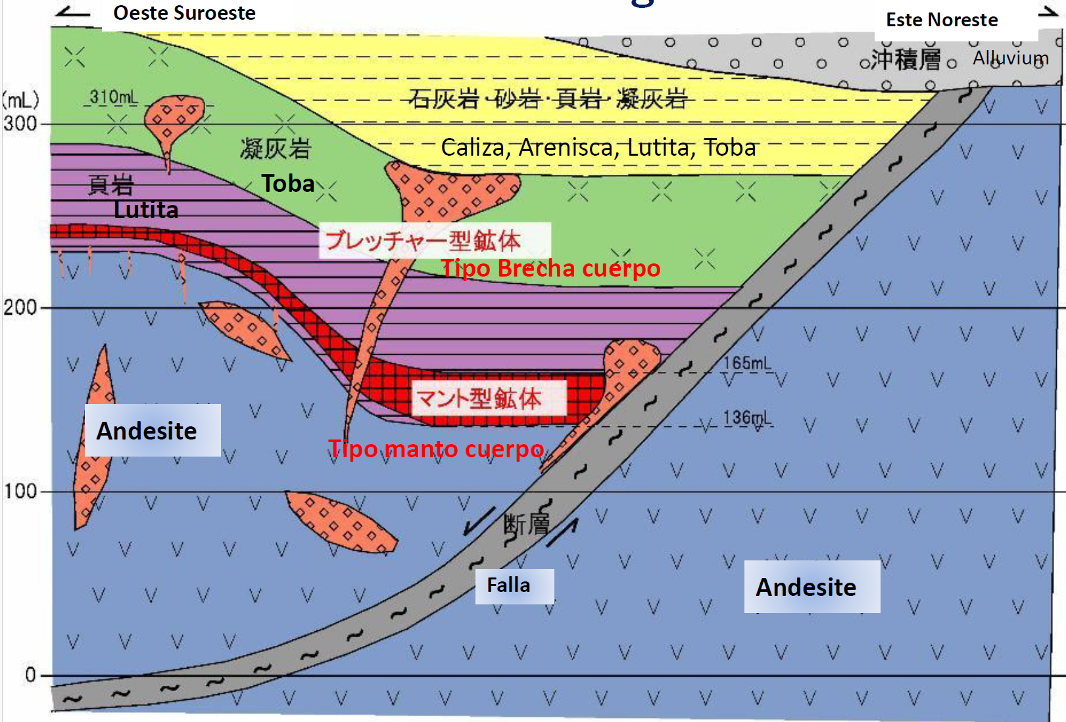
Atacama Kozan, “Introduction presentation,” PowerPoint presentation, 2021.

Figure 2: Visual inspection of low-grade material from the Copper Mine

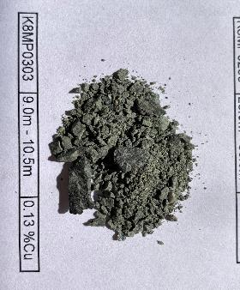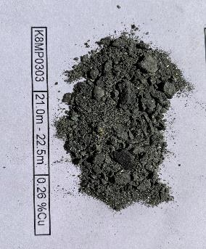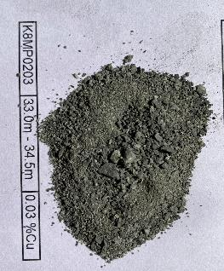
Atacama Kozan, “Introduction presentation,” PowerPoint presentation, 2021.

Figure 3a: False positive mineralization (>0.5% Cu) 2021 – 2022 for the copper mine
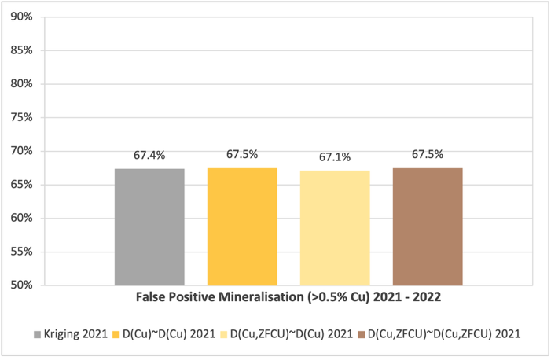
Own elaboration based on Stratum AI data.

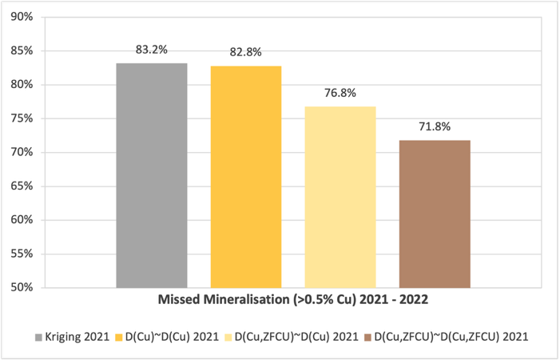
Figure 3b: Missed mineralization (>0.5% Cu) 2021 – 2022 for the copper mine.
Own elaboration based on Stratum AI data.

Figure 4: AI Unique Mineralization Zones
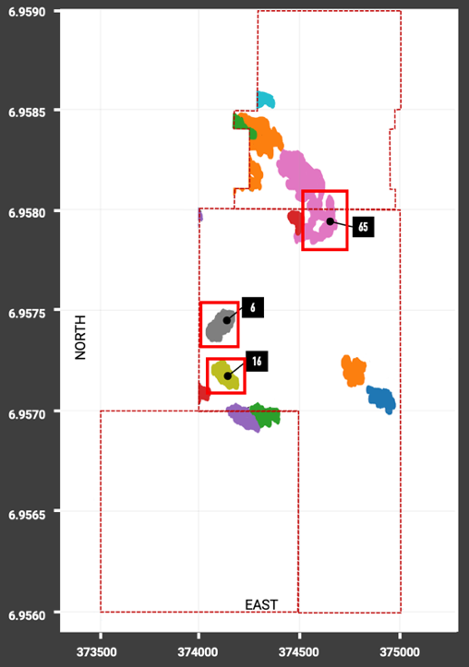
Own elaboration based on Stratum AI data.

Figure 5: Target 6: Historical Drilling vs Drill Plan
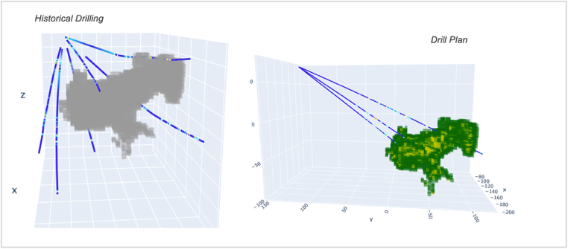Own elaboration based on Stratum AI data.

Figure 6: Target 16: Historical Drilling vs Drill Plan
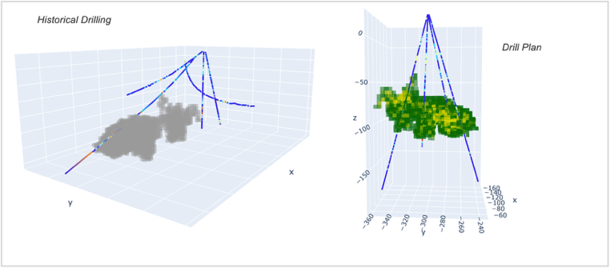Own elaboration based on Stratum AI data.

Figure 7: Target 65: Historical Drilling vs Drill Plan
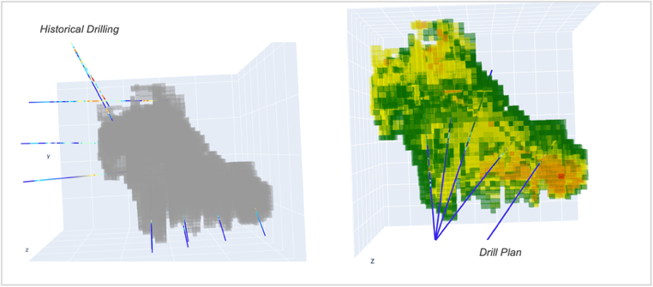Own elaboration based on Stratum AI data.

Table 1: AI Unique Mineralization Zones results

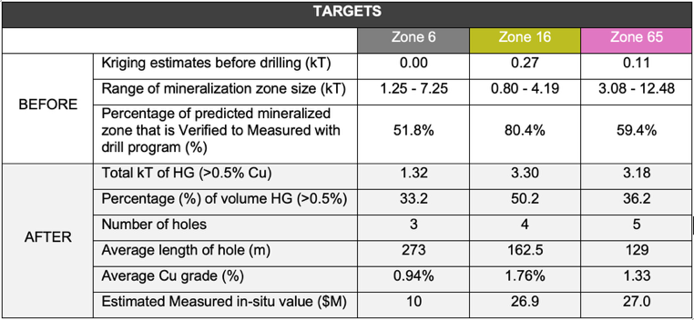
Own elaboration based on Stratum AI data.

Table 2: AI Guided Drillholes results

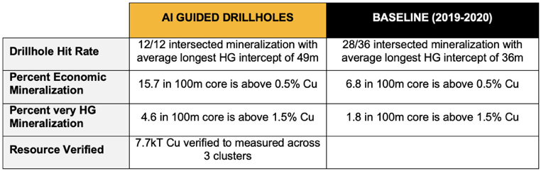
Own elaboration based on Stratum AI data.

Farzi Yusufali
Farzi is a cofounder of Stratum AI, a mining tech company that produces 3D maps of minerals in the ground that are significantly more accurate than the mining industry standard, all while using the data already available. Farzi's technical background in physics, hardware, and machine learning engineer from the University of Waterloo is born from her interest to design elegant solutions to tough problems. This coupled with her personal history in mining has led her to tackle a fundamental challenge that would affect every single mine in the world.

David First
David is a highly experienced geologist with over 35yrs of mineral exploration experience, primarily focused on the discovery of world-class Cu &/or Au deposits in Australia, SW Pacific, East & SE Asia, Europe and North America. He also has familiarity exploring for base metal (VMS, sed-hosted Cu, SEDEX Zn-Pb) and Ni-sulfide / PGM deposits. David has held several senior technical and management roles for Billiton, BHP Billiton, Phelps Dodge and Freeport-McMoRan, primarily focused on generating and evaluating exploration opportunities. He is a graduate from the Royal School of Mines, Imperial College, London.‍

Daniel Mogilny
Daniel is a machine learning engineer from the University of Toronto. He has worked with data science teams at pre-seed to late-stage startups in industries such as pharmaceuticals, marketing, and agriculture. Daniel's inspiration is to do his part to make sure the mining industry is not left behind in the upcoming AI revolution.

