Enhancing Water Recovery in Mining Operation: A Case Study from a Copper Mine Trial in Peru
(Solid/Liquid Separation Operations)

Trong Dang-Vu1, Ronny Guido García Mallqui2, Juan José Cahuana Cuba3

1Author: Trong Dang-Vu, SNF, Mining R&D Manager, Canada, tdanguu@snf.com, +1(437)9796869.
2Coauthor 2: Ronny Guido García Mallqui, SNF Peru, Technical Advisor, Av. José pardo 434 Miraflores, rogarcia@snf.com, 970974091.
3Coauthor 3: Juan José Cahuana Cuba, Angloamerican Quellaveco, Process Manager, Peru, Juan.cahuana@angloamerican.com, 996328351.

ABSTRACT
Water scarcity and environmental constraints have made water recovery a critical challenge in copper mining, particularly in arid regions like Peru. As operations expand in water-limited areas, maximizing the recycling of process water from tailings has become the focus. While mechanical dewatering methods (e.g., filter presses and centrifuges) are often employed, chemical approaches offer a parallel strategy for improving thickener efficiency. This study presents a full-scale trial of an innovative water-soluble polymer flocculant for thickener application at an operating copper mine in Peru. The new flocculant was evaluated against the standard flocculant at equal dosage (11.5 g/t) in the tailings thickener, with key parameters closely monitored via ThermoFisher rheometer.

The new flocculant chemistry significantly enhanced flocculation performance: under similar conditions it increased water recovery by approximately 8%, raising the thickener underflow solids from 49% (with the standard flocculant) to
52%. This higher underflow density translated to roughly 560 m³/h of additional water being
reclaimed. Moreover, the improved rheology enabled stable operation at these elevated
underflow solid concentrations without modifications to pumping infrastructure. These results demonstrate that advanced flocculant
chemistry can substantially improve thickener performance and tailings dewatering, contributing to
more sustainable water use and improved tailings management in modern mining operations.

1. Introduction

Copper mining operations in Peru face increasingly pressure from water scarcity, stringent environmental regulations, and growing expectations for sustainable resource management [1]. As a result, maximizing water recycling has become a critical operational objective. Thickener
performance plays a central role in this effort, influencing directly water recovery, tailings handling, and downstream processing efficiency.

While mechanical dewatering technologies, such as filter presses and centrifuges are effective at increasing water recovery and reducing tailings volume; they often involve high CAPEX and OPEX, long lead time, and significant maintenance requirements. Chemical approaches, particularly using flocculants, have gained traction as a flexible and cost-effective alternative, requiring no major infrastructure changes. These chemicals can be injected directly into the existing system [2].

Conventional flocculants are effective in improving water recovery; however, increase in thickener underflow (UF) often leads to high UF yield stress, which can present pumping challenges [3]. One solution is to upgrade the pumping system, but this is typically expensive and time-consuming. To address his issue, a new flocculant, referred to as the Water Recovery Enhancer (WRE), was developed to achieve both high water recovery and favorable rheological characteristics for existing pumping system.

A full-scale trial of this novel flocculant was conducted at the Quellaveco copper mine in Peru. This collaborative effort between SNF and Quellaveco aimed to evaluate the performance of the WRE in comparison to the incumbent flocculant. Key parameters assessed included UF solids content, water recovery, UF rheology, and operational stability. The trial sought to demonstrate how advanced flocculant formulations can contribute to improved water management under the challenging environmental and operational conditions typical of the Peruvian mining industry.

2. Objectives

The primary goal of this plan trial is to assess the effectiveness of the Water Recovery Enhancer
(WRE) flocculant in improving water recovery at a copper mine in Peru. Specifically, the study evaluates whether the WRE can increase the solids content of thickener underflow while maintaining pumpability comparable to that of the incumbent flocculant. The increase in UF density enables more water to be recovered from the thickener circuit. Specific objectives include:

1. Quantify the improvement in water recovery using WRE to support more sustainable water management in mining industry.

2. Assess operational stability during WRE
application.

3. Analyze the rheological properties of thickened tailings treated with WRE to confirm compatibility with existing pumping systems.

The milestone of the trial is to recover higher volume of water, maintaining similar OF quality with higher UF solids higher than 51%, torque similar or less than that for the incumbent product,

3. Full-scale Plant Trial

Thickener performance was continuously monitored for 24-h periods with data recorded every three hours. Key operational parameters included:
• Thickener feed flow rate: Slurry was distributed between thickener 1 (TH1) and thickener 2 (TH2) via a distribution box. Flowrates were recorded using inline flowmeters.
• Thickener feed solids content: recorded from a control room and verified through sampling.
• Particle size of thickener feed (P80):
measured following ASTM standards.
• Thickener feed density: reported by the control room system.
• Flocculant dosage: Calculated from polymer solution flowrate and feed properties.
Polymer solution was prepared at 3g/L and then diluted to 0.3g/L before injection.
• Yield stress: measured using ThermoFisher rheometer.
• Rak torque: Monitored though the control room.
• Mud/water interface height
• Bed mass (kPa)
• Throughput (Mt/h)
• Clay content: determined by XRD. Two samples were collected for XRD analyses per 24-h period.
• Baseline data: collected with the incumbent flocculant for comparison.

A representative example of thickener feed characteristics for both thickener 1 (TH-1) and 2 (TH-2) for January 29 is shown in Table 1. Data was collected over 24 hours at 3-hour intervals. Both flow characteristics and clay content were monitored for consistency.

4. Results and Discussion

Table 2 summarizes the thickener performance metrics recorded on January 29, 2025, over 24 hours with 3-hour intervals, during the first day of the trial. Underflow solids content, yield stress, flocculant dosage, interface height, and rake torque were measured for both thickeners using conventional (Product B) and novel (Product A - WRE) flocculants.

Figure 1 presents the thickener feed flowrate for both TH-1 and TH-2 during the trial. While additional data were collected on February 5, 6, 7, and 9, significant flow variability during these days made them unsuitable for comparative evaluation. As feed flowrate directly influences dilution, flocculant mixing, and settling behavior, only data collected under stable flow conditions were analyzed.

Clay content, a key factor influencing thickener performance and overflow clarity, was measured using XRD. Only test periods with comparable clay levels (~5.9%) were included in the final analysis to avoid confounding effects. Table 3: Clay content measured by XRD of the thickener feed slurry. Note that only data from January 29, 31, February 1, and
8 (highlighted green in the original table) were used for performance comparisons.

The impact of the WRE flocculant on underflow solids content and rheology is illustrated in Figure 2. For TH-1, the incumbent flocculant resulted in underflow solids between 48.5% and 50%, with yield stress ranging from 25 to 31 Pa. In contrast, the WRE flocculant increased underflow solids to
~53% while maintaining or reducing yield stress. Similar trends were observed in TH-2.

Rake torque data further confirmed the rheological benefit of the WRE flocculant. As shown in Figure
3, the novel flocculant consistently maintained or
reduced torque levels, even at higher underflow densities. This indicates that WRE improves compaction without overloading the rake mechanism or increasing energy consumption.
The results from Figures 2 and 3 clearly indicate that novel flocculant allowed thickeners to operate at higher underflow solids to 53% as compared to 48-
49% for conventional flocculant, while maintaining comparable or even lowering torque rake. According to data from Quellaveco’s Smart System, applying WRE flocculant at the same polymer dosage of 16 g/t resulted in significant gain in UF solids. For thickener 1, UF solids increased from
48.2% to 52.5%, and for thickener 2 - from 47.4% to
53.5%. These improvements corresponded to an additional 562.4 m3/h of water recovery, or approximately 4.93 million m3/year.

The improvement in water recovery is also reflected in the water/mud interface height. As shown in Figure 5, the WRE flocculant increased interface height from 3.3–3.5 m to 4.0–4.2 m, indicating more effective solids settling and clearer overflow.

5. Conclusions

The plant trail successfully achieved its milestones, demonstrating the superior performance of the novel flocculant compared to the incumbent flocculant.
The ley outcomes of the trial include:
• Enhanced water recovery: Application of the WRE flocculant led to an increase of 562.4 m³/h in water recovery, equivalent to nearly
5 million m³ annually.
• Higher UF solids content: UF solids increased to 53% while maintaining lower
rake torque.
• Improved OF clarity: Higher mud-line height reflected more robust floc formation and
better water/solids separation.

Additional operational benefits observed:
• Reduced tailings disposal volume, therefore extending the lifespan of the tailings storage
facility.
• Lower energy consumption by reducing yield stress of the UF solids.

These results confirm the WRE flocculant as an effective and sustainable solution for optimizing thickener performance, improving both water recovery and enhancing operational efficiency in copper mining operations.

6. Annexes
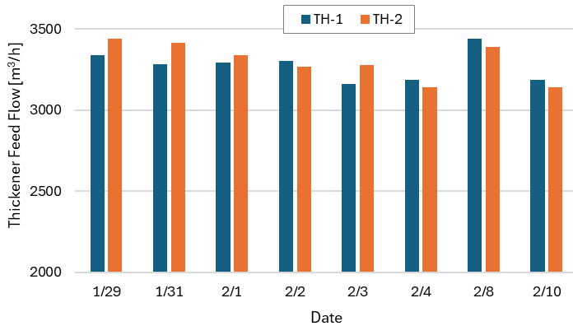
Figure 1. Flow rate of the thickener feed slurry

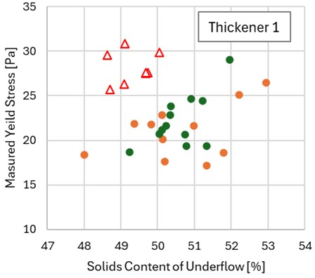

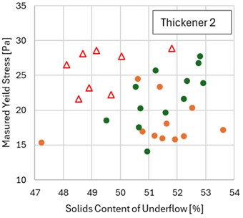

Figure 2. The relationship between UF solids content and yield stress; where open triangles (△) represent conventional flocculant and filled circles (◯) represent novel flocculant.
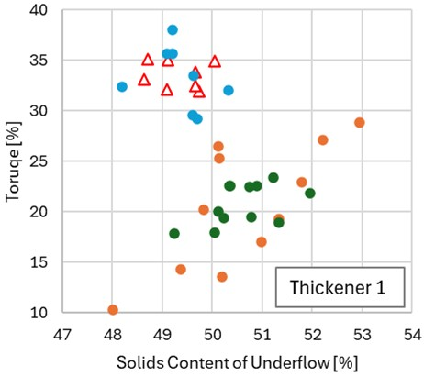

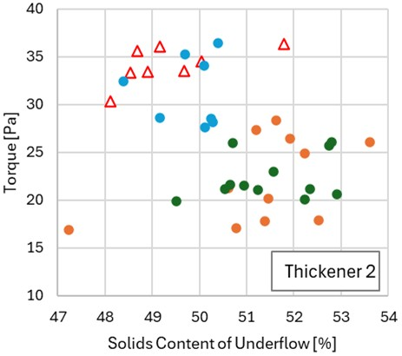

Figure 3. The relationship between solids content of the thickener and rake torque; where open triangles (△) represent conventional flocculant and filled circles (◯) represent novel flocculant.
Figure 4. OF flowrate for conventional and novel flocculants.

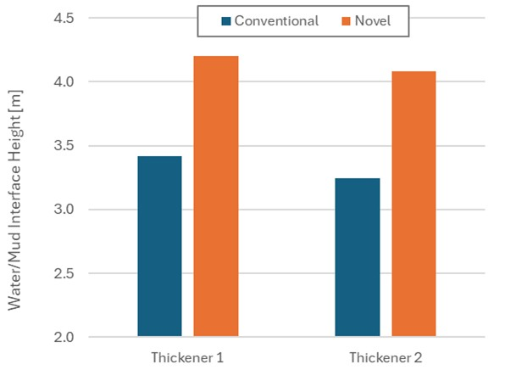
Figure 5. Mud/water interface height.

8. References

1. Fraser J., Kunz N. C. (2018). Water stewardship: Attributes of collaborative partnership between mining companies and communities. Water 10 (8) 1081.
2. Bembrick D. (2008). The Impact of Flocculant
Addition on a Tailings Storage Facility. In
MetPlant 2008 Conference Proceedings, pp 541-
550 (The Australasian Institute of Mining and
Metallurgy).
3. Vargas C. C., Pulido A. M. (2022). Sustainable
Management of Thickened Tailings in Chile and Peru: A Review of Practical Experience and Socio-Environmental Acceptance. Sustainability
2022, 14, 10901.

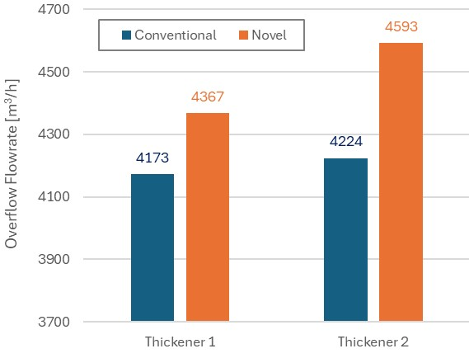
8. Illustrations / Images / Tables

Average
Time  08:00 | Thickener  TH-1 | Tailing flow rate, [m3/h]  3169 | P80 um thickener UF  242 | % clay (XRD)  5.75
11:30 | TH-1 | 3298 | 225 | 5.75
15:00 | TH-1 | 3536 | 227 | 5.75
18:00 | TH-1 | 3023 | 237 | 5.75
21:40 | TH-1 | 3429 | 230 | 5.95
00:00 | TH-1 | 3130 | 243 | 5.95
03:00 | TH-1 | 3271 | 223 | 5.95
06:00 | TH-1 | 3846 | 221 | 5.95
Average  Standard Deviation |  | 3337.8 | 231 | 5.9
 |  | 245.6 | 8 | 0.1
08:00 TH-2 |  | 3906 | 229 | 5.75
11:30 | TH-2 | 3134 | 231 | 5.75
15:00 | TH-2 | 3428 | 235 | 5.75
18:00 | TH-2 | 3030 | 231 | 5.75
21:40 | TH-2 | 4387 | 251 | 5.95
00:00 | TH-2 | 3044 | 241 | 5.95
03:00 | TH-2 | 3165 | 251 | 5.95
06:00 | TH-2 | 3428 | 245 | 5.95
06:00 |  | 3440.3 | 239.3 | 5.9
Standard Deviation |  | 423.1 | 8.1 | 0.1

Table 1: Characteristics of the thickener feed collected on January 29 over 24 hours with 3-hour interval as a baseline with conventional incumbent flocculant.

Time | TH | UF solids  [%] | Yield stress  [pa] | Flocculant dosage [g/t] | Interface recovery water [m] | Torque [%]
08:00  11:30 | TH-01 | 48.70 | 25.73 | 12.0 | 3.07 | 35.09
08:00  11:30 | TH-01 | 49.11 | 30.83 | 12.0 | 3.35 | 35.00
15:00  18:00 | TH-01 | 49.10 | 26.34 | 12.0 | 3.21 | 32.10
15:00  18:00 | TH-01 | 48.63 | 29.58 | 12.0 | 3.57 | 33.09
21:40  00:00 | TH-01 | 49.67 | 27.49 | 10.0 | 3.70 | 33.88
21:40  00:00 | TH-01 | 49.74 | 27.60 | 10.0 | 3.54 | 31.90
03:00  06:00 | TH-01 | 49.67 | 27.56 | 11.0 | 3.45 | 32.51
03:00  06:00 | TH-01 | 50.04 | 29.88 | 11.0 | 3.44 | 34.90
08:00 | TH-02 | 48.12 | 26.52 | 17.0 | 3.00 | 30.32
11:30  15:00 | TH-02 | 51.80 | 28.86 | 17.0 | 2.97 | 36.34
11:30  15:00 | TH-02 | 48.68 | 28.16 | 17.0 | 2.96 | 35.62
18:00  21:40 | TH-02 | 49.16 | 28.57 | 17.0 | 3.38 | 36.04
18:00  21:40 | TH-02 | 48.53 | 21.61 | 15.0 | 3.40 | 33.33
00:00  03:00 | TH-02 | 48.91 | 23.20 | 15.0 | 3.64 | 33.43
00:00  03:00 | TH-02 | 50.04 | 27.79 | 15.0 | 3.46 | 34.54
06:00 | TH-02 | 49.67 | 22.23 | 15.0 | 3.14 | 33.51
Table 2: Thickener performance recorded on January over 24 hour with 3-hour intervals.

Date | Jan. /29 | Jan. 31 | Feb. 1 | Feb. 2 | Feb. 3 | Feb. 4 | Feb. 8 | Feb. 10
Sample 1 | 5.8 | 6.0 | 5.2 | 5.7 | 4.1 | 3.4 | 6.3 | 4.5
Sample 2 | 6.0 | 6.2 | 6.1 | 4.2 | 3.7 | 4.4 | 5.9 | 4.0
Table 3: Clay content
Trong Dang-Vu (1) is an experienced specialist in solid-liquid separation and water-soluble polymer applications, with over 25 years of global experience bridging academia and industry. He holds a M.Sc. Ph.D. in Chemical Technology in Poland and has developed a strong reputation for advancing dewatering technologies across mining and oil sands sectors. Dr. Dang-Vu has successfully led numerous research and industrial projects focused on the integration of novel polymer technologies for sustainable water recovery. His expertise bridges fundamental engineering principles and practical, scalable solutions, making him a key contributor to innovation and operational efficiency in resource processing industries.

He is recognized for his ability to collaborate effectively with multidisciplinary teams including researchers, plant operators, and engineering groups to tailor polymer formulations and process conditions that meet stringent environmental regulations and operational requirements. Dr. Dang-Vu is also actively involved in knowledge sharing through technical workshops, publications, and training sessions aimed at advancing the state of practice in solid-liquid separation technologies.

Ronny Guido García Mallqui (2) is a Metallurgical Engineer from Universidad Nacional de Ingeniería (UNI) with over 10 years of experience in the metallurgical industry, specializing in mineral concentration processes. He combines strong technical expertise with commercial acumen, currently serving as a Senior Application Engineer at SNF, where he bridges metallurgical knowledge with B2B polymer applications.

Throughout his career, Ronny has worked closely with multidisciplinary teams to optimize processes, improve performance, and develop tailored solutions for industrial and mining projects. His profile blends a solid technical background with a strategic approach to business development and client-focused service.

Juan José Cahuana Cuba (3) is a Metallurgical Engineer from Universidad Nacional de San Agustín, MBA in Mining Management. With over 17 years of experience in the mineral processing field, he has built deep expertise in large-scale concentrator operations, particularly in grinding, flotation, thickening, and tailings handling.

He has held senior roles such as Plant Metallurgist and Senior Supervisor in concentrators handling over
100,000 tpd, with operational experience across SAG mills, HPGR circuits, and Cu-Zn-Mo flotation. His international exposure includes technical visits and participation in global seminars across Chile and Canada, contributing to continuous professional development and corporate impact.
AUTORIZACIÓN DE PARTICIPACIÓN

Yo Juan José Cahuana Cuba; autorizo que el trabajo titulado “Enhancing Water Recovery in Mining

Operation: A Case Study from a Copper Mine Trial in Peru” presentado por el autor Ronny Guido García

Mallqui y coautores (Trong Dang-Vu y Juan José Cahuana Cuba) sea presentado en el concurso del

Premio Nacional de Minería del evento PERUMIN 37 Convención Minera en las fechas del 22 al 26 de

setiembre del 2025 en la ciudad de Arequipa.

Cahuana Cuba, Juan José
Digitally signed by Cahuana Cuba, Juan José
Date: 2025.07.25
15:24:43 -05'00'

Firma DNI/Pasaporte Fecha

Nota:

Esta autorización se entrega solo en el caso de que el participante se presente de manera independiente y el trabajo implique el desarrollo en el marco de una empresa o institución. La indicada autorización deberá ser entregada en hoja membretada.

