MATHEMATICAL MODEL FOR THE OPTIMIZATION OF CAPEX AND OPEX IN THE PRODUCTION AND STORAGE OF GREEN HYDROGEN FOR MINING OPERATIONS
Categoría: Regulación y Economía Minera
Tema: Impacto de la Transición Energética en la minería
Author: Hayro Anthony Pumalloclla Castilla
Institution: National University of San Antonio Abad of Cusco (UNSAAC)
Degree: Bachelor's in Electrical Engineering
Address: San Jerónimo Cusco, Perú
Corporate Email: 150139@unsaac.edu.pe
Personal Email: hayroeyes18@gmail.com // hayro.pumalloclla.c@gmail.com
Phone: +51 936764866
Keywords: Green hydrogen, sustainable mining, CAPEX, OPEX, mathematical model, energy storage
Abstract:
In the context of mining decarbonization and the global energy transition, green hydrogen has emerged as a promising alternative to replace fossil fuels in off-grid and energy-intensive operations. This study proposes an optimization model to assess the economic feasibility of integrating an electrolyzer and hydrogen storage system into a mining environment. The objective is to minimize the total capital (CAPEX) and operational expenditures (OPEX) while satisfying the hydrogen demand of the mining operation.
Methodology:
An optimization model was proposed to analyze the investment and operational costs associated with the integration of an electrolyzer and hydrogen storage system within a mining context.
$$\left(k_{0}+k∙\sum_{p∈Ω_{fases}}{\sum_{t∈Ω_{T}}{{\left(P_{H2_{\left(t,p\right)}}∙γ_{1}\right)}^{α-1}∙{\left(\frac{Y}{Y_{0}}\right)}^{β}}}\right)∙P_{H2_{\left(t,p\right)}}∙γ_{1}+$$  $$3\%∙\left[\left(k_{0}+k∙\sum_{p∈Ω_{fases}}{\sum_{t∈Ω_{T}}{{\left(P_{H2_{\left(t,p\right)}}∙γ_{1}\right)}^{α-1}∙{\left(\frac{Y}{Y_{0}}\right)}^{β}}}\right)∙P_{H2_{\left(t,p\right)}}∙γ_{1}\right]+$$  $$ϑ_{1}∙\sum_{p∈Ω_{fases}}{\sum_{t∈Ω_{T}}{\left(\frac{1}{S_{H2_{\left(t,p\right)}}}\right)}}+$$  $$2\%∙\left[ϑ_{1}∙\sum_{p∈Ω_{fases}}{\sum_{t∈Ω_{T}}{\left(\frac{1}{S_{H2_{\left(t,p\right)}}}\right)}}\right]$$ | ( 1 )
Equation (1) defines the objective function, which aims to minimize the total investment and operating costs of the electrolysis system and the hydrogen storage tank. The operating cost of the electrolyzer is estimated to range between 2% and 3% of its capital cost (Rogeau et al., 2023). Similarly, the storage tank incurs an operational cost of approximately 2% of its capital cost (Moran et al., 2024).
Restrictions
Hydrogen production through electrolysis is determined by Equation (2), which considers the input power to the electrolyzer at each time and phase (𝑡, 𝑝), accounting for conversion efficiency, as well as purification and compression losses (Dinh et al., 2021).
$${Prod}_{H2_{\left(t,p\right)}}=\frac{P_{H2_{\left(t,p\right)}}∙E_{elec}}{\left(\frac{E_{elec}}{η_{conv}}+E_{pcl}\right)}$$ | ( 2 )
Equation (3) establishes a balance between the power used for hauling truck charging and the electrolyzer plant's power, which must equal the external power.
$$P_{{in-veh}_{\left(t,p\right)}}+ P_{H2_{\left(t,p\right)}}=P_{{ext}_{\left(t,p\right)}}$$ | ( 3 )
Equation (5) defines the hydrogen storage capacity constraint.
$$S_{H2_{\left(t,p\right)}}∙ψ_{1}≤C_{stor_{p}}$$ | ( 4 )
Equation (8) defines the hydrogen balance, accounting for storage levels, storage losses, demand, and production over time.
$$S_{H2_{\left(t,p\right)}}∙ψ_{1}+S_{H2_{\left(t,p\right)}}^{loss}+D_{H2_{\left(t,p\right)}}={Prod}_{H2_{\left(t,p\right)}}$$ | ( 5 )
Equation (7) defines the green hydrogen production targets set as part of the system's operational objectives.
$$\sum_{t∈Ω_{T}}{{Prod}_{H2_{\left(t,p\right)}}≤G_{{targets}_{\left(t,p\right)}}}$$ | ( 6 )
Results
Figure 1 presents the hydrogen production, storage levels, and associated storage losses across the three phases of the project: initial, intermediate, and final. Meanwhile, Figure 2 illustrates the external power supplied to the mine for hydrogen production to meet the projected demand. Additionally, it highlights a portion of the power that could potentially be allocated to charge electric haul trucks. The estimated investment costs include a CAPEX of USD 37.36 million and an OPEX of USD 1.12 million for the electrolyzer, as well as a CAPEX of USD 12.71 million and an OPEX of USD 0.25 million for the hydrogen storage system.
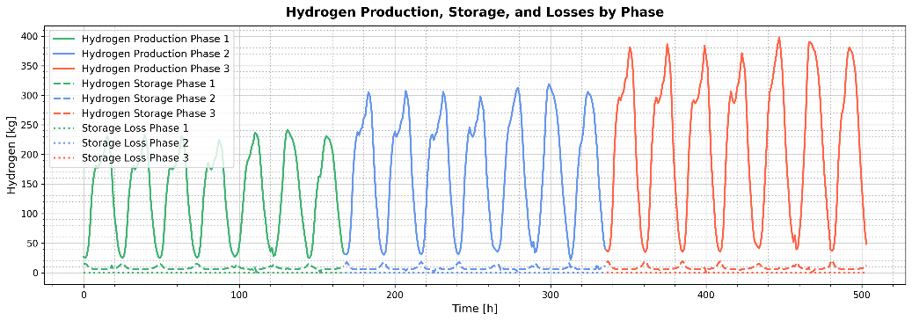
Figure 1 Hydrogen Production, Storage, and Losses by Phase
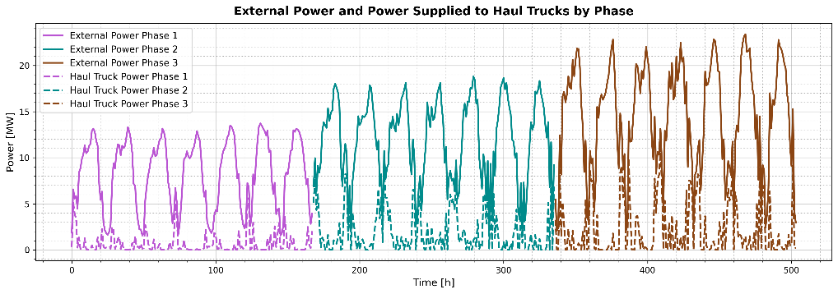
Figure 2 External Power and Power Supplied to Haul Trucks by Phase
The professional profile of the author:
Hayro Anthony Pumalloclla Castilla holds a Bachelor's degree in Electrical Engineering from UNSAAC and is currently pursuing a Master's at the Federal University of ABC (Brazil). His thesis explores offshore wind farm layout optimization for renewable electricity and hydrogen production, using tools like Python, GAMS, and AMPL. He has experience in power system planning at Electro Sur Este S.A.A. and OSINERGMIN. His expertise covers renewable energy, electricity markets, and green hydrogen in industrial and mining contexts. He has also received international recognition for his work in spatial optimization of offshore infrastructure.
References
Dinh, V. N., Leahy, P., McKeogh, E., Murphy, J., & Cummins, V. (2021). Development of a viability assessment model for hydrogen production from dedicated offshore wind farms. International Journal of Hydrogen Energy, 46(48), 24620–24631. https://doi.org/10.1016/j.ijhydene.2020.04.232
Moran, C., Deane, P., Yousefian, S., & Monaghan, R. F. D. (2024). The hydrogen storage challenge: Does storage method and size affect the cost and operational flexibility of hydrogen supply chains? International Journal of Hydrogen Energy, 52, 1090–1100. https://doi.org/10.1016/j.ijhydene.2023.06.269
Rogeau, A., Vieubled, J., De Coatpont, M., Nobrega, P. A., Erbs, G., & Girard, R. (2023). Techno-economic evaluation and resource assessment of hydrogen production through offshore wind farms: A European perspective. Renewable and Sustainable Energy Reviews, 187. https://doi.org/10.5281/zenodo.8

