RELIABILITY TRANSFORMATION JOURNEY AT VALE’S CLARABELLE MILL

*N. Orcon¹, S. Kivisto², R. Multani³, C. Nicholson⁴ and A. Wadekar⁵

¹Engineering Superintendent, Vale Base Metals-Canada
(*Corresponding author: nestor.orcon@vale.com)

²Maintenance Superintendent, Vale Base Metals-Canada

³Process Technology Superintendent, Vale Base Metals-Canada

⁴Specialist Engineer, Vale Processing, Research and Innovation Group, Vale Base Metals-Canada

⁵Product Designer, Bradken-Canada

ABSTRACT

In March 2022, the SAG mill (32x13.5 ft) at Vale’s Clarabelle Mill experienced significant downtime due to shell liner failure. The failed design—a "Hi-Lo" lifter—had been installed in March 2021. A comprehensive root cause analysis revealed that the inadequate liner design led to fatigue fractures. The mill’s control philosophy was unable to mitigate liner impacts. Following the failure, the original liner, commissioned in 1990—"Hi-Hi" lifter with a 7° face angle—was reinstated. In 2023, Clarabelle Mill launched an in-house liner design optimization initiative, building a multidisciplinary team. Following design guidelines, a final concept design was selected and detailed through collaborative engineering with the chosen manufacturer. The design process, driven by the Mill SAG Reline Strategy, integrated failures modes, wear analysis, operational variables (supported by charge trajectory modeling), condition-based maintenance practices, and industry design standards. In May 2025, the optimized shell liner—"Hi-Hi" lifter with a 35° face angle—was installed, along with wireless “smart bolts” to monitor tension in real time. The new configuration successfully mitigated previous failure modes and improved grinding efficiency, SAG throughput (tons/hour) increased by 9% and specific energy consumption decreased by 7%. Other notable benefits were reduction in 25 hours the SAG reline time since the number of liner pieces were reduced and improved worker safety by eliminating high-pressure washing and scaling tasks prior to SAG entry (shell liner packing issue resolved).

KEYWORDS

SAG, liner, design, wear, availability, reliability, efficiency

CLARABELLE MILL CHALLENGES

Vale’s Clarabelle Mill is a Ni-Cu sulfide concentrator located in Copper Cliff, Ontario, Canada. Since commissioning in 1971, Clarabelle Mill—originally a crushing and rod/ball mill circuit—experienced multiple reconfigurations to address the variability inherent in the Sudbury orebodies sourced from at least 5 underground mines. With increasing mine depth, a higher variability in ore competency, feed sizes and grades (declining), was expected. In 1990, a semi-autogenous grinding (SAG 32’x13.5’) mill was installed, and following the closure of the crushing plant in 2017 (care and maintenance), the operation relied solely on SAG milling. In 2020, Clarabelle Mill initiated the Vale Production System (VPS); an operational framework to align technical practices, drive continuous improvement and enhance standardization as part of the transformation toward a safer and more reliable operation. In 2021, a reliability study diagnosed that SAG mill maintenance strategy (scope and frequency of SAG mill relines) as a major opportunity to improve mill availability. Historically, liner-related failure modes—including packing, peening, pegging, breakage, and broken bolts—have negatively impacted mill uptime. In 2022, the SAG mill shell Hi-Lo liners failed causing significant mill downtime impact. To key to enhancing SAG mill availability and throughput lied in the development of a robust reliability-centered SAG reline strategy, which included liner design optimization, bolting technology, reline synchronization and liner condition-based maintenance.

SAG LINER DESIGN OPTIMIZATION

When the SAG mill was installed, the shell liner configuration consisted of a “Hi-Hi” lifter profile. In March 2021, this configuration was modified to a “Hi-Lo” lifter profile as part of an optimization effort to reduce the number of liner components to improve reline time and safety. However, on March 2022, the SAG mill shell liners experienced premature wear and cracks. Following the failure, the original “Hi-Hi” lifter was reinstated to restore operational stability. A comprehensive reliability analysis was conducted to determine the root cause of the liner failure. Using a structured approach—including Fault Tree Analysis (FTA), Failures Modes and Effects Analysis (FMEA), detailed wear profile assessments, and application of mechanical design guidelines, the liner optimization project was successfully completed, establishing a more robust and reliable configuration for future operations.

2.1. Hi-Lo Shell Liners Failure Investigation

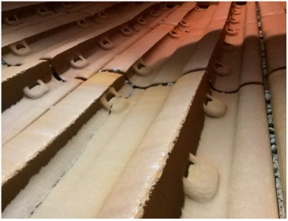
In March 2021, a 30-3 row “Hi-Lo” lifter with 27° face angle was installed. In March 2022, the SAG mill was shutdown initially due to the detection of full-sized grinding media escaping from the mill onto the pebble conveyor. During the internal inspection of the SAG, the deflector cone bolt failure had been identified and warranted immediate replacement. While in the process of the cone replacement, cracks and excessive wear on the discharge-end shell liners were also discovered (Figure 1). This initiated an emergency SAG liner replacement (all shell liners). This unplanned reline accounted for 217 hours, the original 60-3 row Hi-Hi lifter profile with 7° face angle was reinstated. Thus, a root cause analysis was initiated.
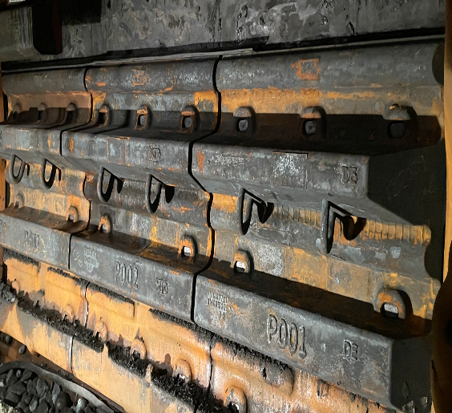

Figure 1 – Hi-Lo discharge-end shell liner plate cracked, installed in March 2021 and failed in March 2022.

Fault Tree Analysis, a reliability engineering method for failure investigations, identified the excessive wide space with inadequate profile between lifters in the shell liner design was the primary cause of the failure. The combination of insufficient lifter face angle (27°) and uncontrolled charge trajectories at the operating SAG speed of 10.8 rpm resulted in frequent high-energy liner impacts and exacerbated abrasive wear, leading to the liners operating beyond their design capacity and ultimately resulted in fatigue fractures on the shell liner plate. Several contributing factors prevented early detection and mitigation of the failure mechanism. These included inadequate liner wear monitoring, the absence of a systematic liner integrity inspection program and insufficient operational control of SAG speed and charge levels in relation to the liner design requirements. Collectively, these factors created failure modes that exceeded the liner mechanical strength leading to fatigue fractures.
The macro-fractography examination of the liner plate crack confirmed the failure mechanism. The affected liner plate exhibited significant wear with remaining thickness of 35 mm, below the manufacturer’s 40 mm minimum replacement threshold. Uneven liner plate wear profile contributed to localized stress concentration that promoted crack initiation. Additionally, fatigue cracking was also identified on a 50 mm thick liner plate (Figure 2), indicating that cycling impact can induce fatigue fractures even when thickness remained well above the recommended minimum.
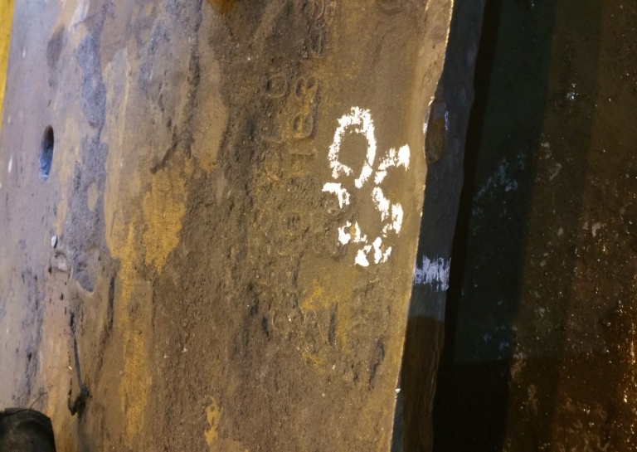
The liner thickness control was inadequate. The frequency of 3D laser scans performed prior to the failure contained too few sampling points, and lacked consistent cross-sectional coverage, leaving the critical wear condition undetected. Additionally, the absence of a systematic liner inspection program contributed to the lack of wear profile control.
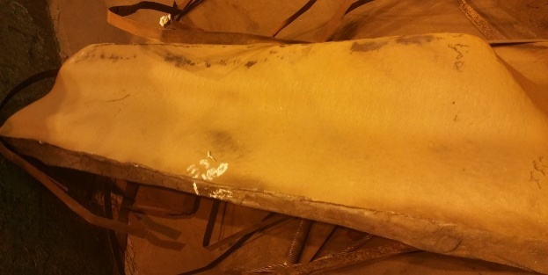

Figure 2 – Fatigue fracture at thinner 35 mm and thicker 50 mm liner plate.

The SAG Mill operational control philosophy was also insufficient in mitigating excessive grinding media impact onto the shell liners above the charge toe. The Hi-Lo shell liner was designed to start-up and operate at max rpm (10.8) to achieve maximum power draw and throughput, but trajectory simulations (Figure 3) indicate that under this speed condition, the 30% mill charge produced direct and repeated impacts on the shell liner surface. The grinding media trajectories were considered uncontrolled, which was later supported by the mill sound data (noise monitoring system) retrieved for this liner campaign. The mill charge level calibration (performed weekly) was based on thermal differentials (using a thermal gun) to identify charge levels and adjusted using internal mill distance references, as well, the grinding media addition rate was constant at 8.5 tons/day.
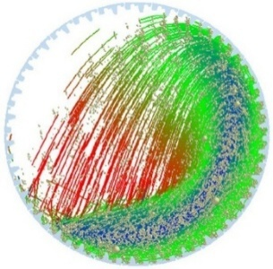
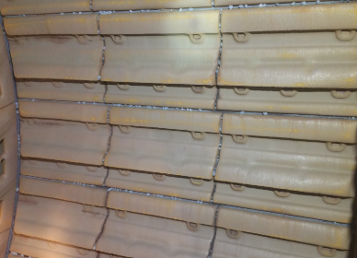
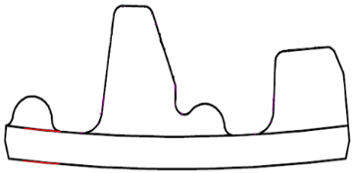

Figure 3 –Hi-Lo shell liner profile, harmful charge trajectory simulation above charge toe at 10.8 rpm @ 30% mill charge, DE shell liners breakage

Figure 4 illustrates severe peening, characterized by dimpled impact marks on the liner surface, which was prevalent on the Hi-Lo shell liner design (also present to a lesser extent on the original Hi-Hi design, though the impact was minor). Significant pegging was also observed on both the shell and feed-end liners (where grinding balls became trapped between ribs or lifting hooks and lifters). Peening failure mode from repeated high-energy media impacts induced cracks and accelerated wear onto the intermediate discharge-end liners. Pegging primarily impacts worker safety as trapped balls pose an overhead hazard and must be manually scaled out before personnel can enter the SAG mill. These routine scaling requirements activities not only increase exposure to safety hazards but also extend the scheduled maintenance downtime.

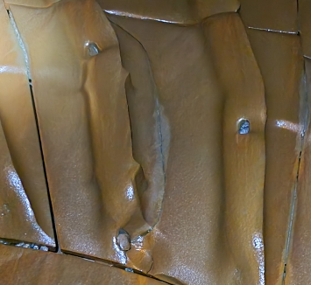
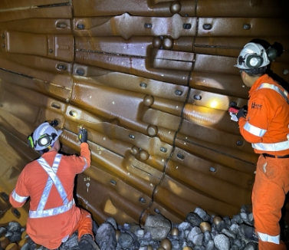
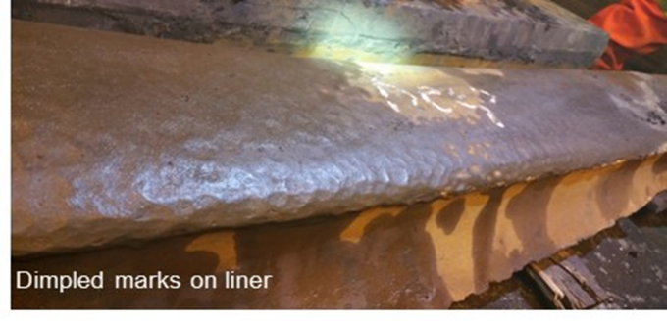

Figure 4 – Severe peening on shell liner lifter, pegging on FE liners and cracks on DE intermediate liners

2.2. Historical Liner Failure Modes

Historically, Clarabelle SAG mill has been experiencing several failure modes including intermediate discharge-end liner cracking, frequent failure of the discharge deflector cone bolts and undesirable shell liner packing—cemented rock-charge adhered within the space between the shell lifters (Royston, 2012). As well, severe peening—an impact induced deformation and work-hardening—on liners caused by frequent hammering from grinding media and ore are conditions that increase liner wear and may lead to breakage (Powel, 2006). Lastly, chronic presence of pegging—oversized particles and balls getting stuck between lifter bars, posed a safety risk for SAG entry during maintenance.

Original Hi-Hi Shell Liner Failure Modes

Figure 5 shows the original 60-3 row Hi-Hi liner with 7° face angle design and trajectory simulation at 10.8 max rpm (with no packing) with harmful media to liner impacts above charge toe. Also, this liner was designed to start-up and operate at max speed (10.8 rpm). This liner set was prone to significant packing which also depends on several factors such as ore types, slurry characteristics, liner design and wear profiles (Royston, 2012). Though packing benefits are to protect the liner plate from wear, it also affects the ore breakage mechanism and changes the trajectory of the grinding media and therefore reduces grinding efficiency. For liner inspections, to ensure safe SAG entry, extensive liner washing was commonly required to remove the packing which increased entry timeline.
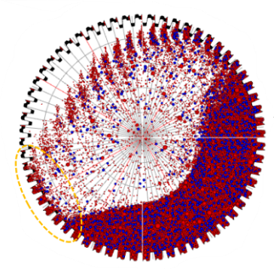
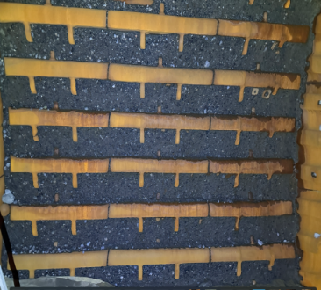
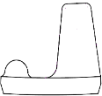

Figure 5 – Hi-Hi with 7° face angle, Bradken’s MILLSIM charge trajectory simulation at 10.8rpm, 30% mill charge and severe packing on shell liners.

2.3. Liner Wear Analysis

Liner wear profile was monitored using 3D laser scans and ultrasonic thickness (UT) measurements, enabling comprehensive mapping of liner thickness throughout the entire liner life. This data formed the foundation for predictive wear-rate models, which were used for forecasting liner thickness at any point in time, leading to significantly improved planning of liner replacement intervals. Condition-based maintenance tools were implemented, followed by monthly 3D scans and UT measurements with visual inspections. Finally, as a further supplement, drone-based integrity inspections were initiated for full coverage of liner condition and structural health. In 2023, a SAG shell liner wear study was initiated, comparing the wear characteristics between original Hi-Hi and Hi-Lo liner configuration. The study analyzed lifter height and plate thickness. As shown in Table 1, the Hi-Hi lifter height presented higher wear rate than Hi-Lo configuration (14 to 19 mm/Mt) when throughput was below 2 Mt, while at throughput above 2Mt, both designs demonstrated similar wear rates of approximately 100 mm/Mt.

Table 1 – Liner Lifter Wear Rate
Ore Milled  (Mt) | Hi-Lo (mm/Mt) | Hi-Hi (mm/Mt)
0 to 1 | 76 | 90
1 to 2 | 31 | 50
>2 | 98 | 101

Table 2 shows the liner plate wear rate, showing that the Hi-Hi design experiences a lower wear rate (12 mm/Mt) compared to the Hi-Lo design (15 mm/Mt) over the full liner life campaign.
The packing condition associated with the Hi-Hi configuration contributes to an accelerated abrasion wear mechanism on the lifters, as well peening caused by media impact when low packing loads occur. However, as a result of the packing, a protective layer adhered over the liner plate, reducing abrasive contact and resulting in lower overall wear on the plate surface, driving an accelerated abrasion wear mechanism on the lifters.

Table 2 – Liner Plate Wear Rate
Ore Milled  (Mt) | Hi-Lo (mm/Mt) | Hi-Hi (mm/Mt)
0 to 1 | 15 | 12
1 to 2 | 7 | 4
>2 | 15 | 7

Reliability analysis highlighted that the Hi-Lo shell liner bucket design—wider space between lifters, incorrect lifters face angle that disrupted charge trajectory, inadequate inter-lifter shape profiles, and a thin plate—collectively failed to protect the liner plate against abrasion and media impact, and no evidence of controlled packing formation was observed. In traditional Hi-Lo liner systems, packing can be controlled to the height of the “Lo” lifters to shield the plate against wear (Royston, 2006). In addition, asymmetric bolting-pad configuration contributed to uneven protection to the liner plate against peening. To address these issues, an in-house optimized shell liner concept design was developed with the following modifications: adjust lifter spacing and shape design (bucket volume) to reduce charge slippage and reduce wear rate on the liner plate. Balance lifter height and face angle to achieve an optimal charge trajectory while reducing liner impact, increase lifter width to improve resistance against peening deformation, increase liner plate thickness to increase overall lifespan and adoption of symmetric liner bolting pads to ensure even protection for the liner plate.

2.4. Liner Design Methodology

In 2024, Clarabelle Mill launched an in-house liner design optimization project. The multi-disciplinary team consisted of maintenance, operation, process technology, processing research innovation group, mill liner supplier, mill reline contractor, mill reline liner handler manufacturer and liner bolt manufacturer. The liner design approach incorporated detailed wear analysis from historical Hi-Lo and Hi-Hi liner campaigns and chronic failure modes. A comprehensive Failure Mode and Effects Analysis (FMEA) was developed to identify liner failure mechanisms and establish action plans to mitigate them.

In April 2024, with Vale’s procurement involvement, a ‘request for information’ process was initiated. Seven original liner manufacturers (OEM) were invited to participate in the liner design optimization project. After systematic technical evaluation of the concept design proposals, one OEM was selected in July 2024. Detailed engineering continued with the chosen OEM and was finalized by October 2024. The optimized liner design was installed in May 2025.
Guidelines from a general design VDI 2221(Jansch, 2006) were followed. One of the most crucial steps was to identify components of the liner such as lifter and plate. Functions of each component were defined and integrated with key operational variables such as SAG rotational speed and volumetric charge them into the design expectations. The design criteria expectations were as follows:

- Liner service life—the liner system shall be designed to achieve a minimum service life equivalent to 3.2 million metric tons of ore processed or (6 months), with aligned wear performance and synchronized replacement intervals for the discharge-end (DE), shell, and feed-end (FE) liners.
- Failure mode mitigation—the design shall prevent or minimize known failure mechanisms, including peening of liner plates, pegging of apertures or grates, liner cracking, deflector cone bolting failure and excessive packing between liner lifters.
- Grinding efficiency—the liner design shall improve throughput (tons per hour), support optimal charge motion and optimize power consumption.

The SAG mill operational control was also determined. Liner material compositions were reviewed, and it was decided to maintain the chromium-molybdenum steel alloy and same total liner weight in order to not compromise the SAG mill power and integrity capacity.

Optimized Hi-Hi Shell Liner

The new customized shell liner configuration was a 40-2 row Hi-Hi lifter with 35° face angle. As shown in Figure 6, mill charge trajectory simulations, designed for 30% of total volumetric charge (18% of ore and 12% grinding media), indicated that the SAG mill should be initially operated with an upper limit of 10.4 rpm (note: SAG operates at variable speed; min: 8 rpm / max: 10.8 rpm). To maintain the optimal charge lift and trajectory throughout the wear cycle, the operating speed should be incrementally increased to 10.8 rpm over the liner life cycle. In addition, the new liner set was designed with larger pieces, decreasing the number for shell liner pieces from 180 to 80. This reduction further decreased reline time (25 hours) and permitted safer installation.
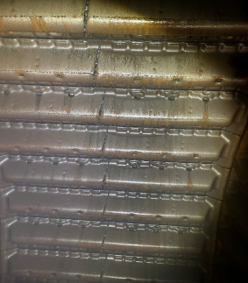

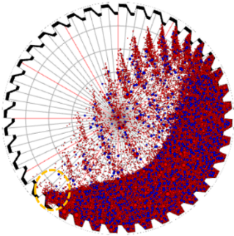
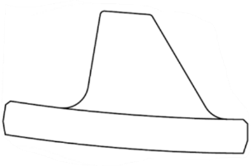

Figure 6 – 40-2 row Hi-Hi with 35° face angle, Bradken’s MILLSIM charge trajectory simulation @ 10.4 rpm, and liner packing mitigation.

Feed End Liner

To address the pegging, the pinch points between the top of the side rib and the main lifter were reduced by shortening the sides of the rib to eliminate gaps where balls were previously trapped. To extend liner life, the lifter height was increased by 38mm, and the leading face angle was modified from 4° to 25° to reduce peening thereby minimizing direct high-energy impact on the liner face. To reduce reline time, the total number of components was reduced from 42 to 36 by integrating two liner segments into a single larger casting, consolidating the wear zone and enabling replacement of one liner instead of multiple smaller pieces.

Discharge End Liner

During the shell liner failure investigation, it was determined that chronic breakage to the DE intermediate liners were related to the poor shell liner design (which promoted increased media/ore impact onto DE liners). Poor discharge-end liner face angles also can contribute to discharge end impacts by throwing material onto itself. To reduce peening, the face angle was increased from 1° to 10°. To extend liner life, the lifter height was increased by 31 mm. The grates were modified to curved ribs; slot size maintained at 2” as well as the total grate slot/open area. These dimensions were used to keep the mill’s overall volume consistent with the original design.

Discharge Deflector Cone

Original deflector cone chronic failures had caused significant mill downtime due to poor bolting design. The “Bullnose®” cone design was selected to mitigate multiple failure modes such as inner pulp lifter bolt and deflector cone bolt failures as well as accelerated wear on the inner pulp lifters. This cone design integrated the existing inner pulps and DE liner plates into one piece, and the number of components were also reduced from 20 to 9 pieces, which further reduced reline time.

Smart Liner Bolting

During installation of the new liners, the Load Monitoring Fastener (LMF+) BoltSense technology was commissioned to verify and improve bolting practices (Figure 7). The objective was to improve pre-load consistency, eliminate bolt loosening and breakages and leakage. LMF+ data was also used to assist in evaluating acceptable run-in and retorque timing.
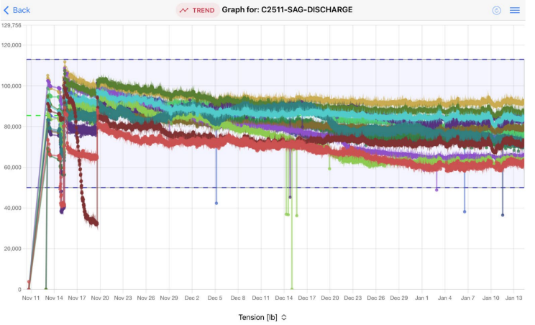
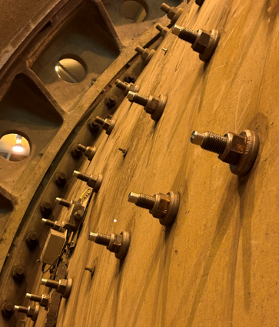

Figure 7 – Smart bolts installed and bolt tension in real-time.

Using LMF+, high variability of bolt tension was noted (30-40% variance from target tensions), which was significantly greater than expected, and an overall low bolt tension — 2250 ft-lbs. Throughout the reline procedure, improper bolt installation, bolt thread damage, and bolt yielding were observed (Breininger, 2025). Also, during pre-installation, bolt damage was detected due to inappropriate packaging and storage.

CLARABELLE SAG RELINE STRATEGY

Mill availability is one of the most important indicators for overall equipment effectiveness. Maximizing operating time is fundamental for achieving production targets. Both planned and unplanned maintenance reduce availability and, consequently, mill throughput. Therefore, strategies and tools that minimize the frequency and duration of mill downtime are vital. Enhancing reliability, optimizing liner and component life, and improving maintenance efficiency all play a central role in increasing mill availability. At Clarabelle Mill, the SAG mill has historically required on average 4 planned relines per year, which represented approximately 4% of the mill’s annual availability.

Synchronization of SAG Mill Wearable Components and Reline Intervals

Historically, SAG reline schedules were tonnage-based and followed a staggered replacement sequence; with the shell liners, discharge-end liners, and feed-end liners changed at different intervals throughout the year (Figure 8). The SAG reline was one of the largest contributors to the mill planned downtime. In 2023, to improve this, Clarabelle transitioned from tonnage-based to a thickness-based strategy, enabling all high wear liners to be replaced in a single shutdown, reducing from 4 to 3 relines.
By improving the liners design and aligning the lifespan of the feed chute, feed-end liners, shell liners, discharge-end and trommel panels (Figure 8), the reline frequency was successfully reduced to 2 relines per year in 2026.

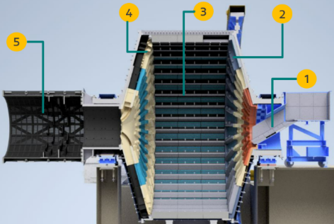

Figure 8 – SAG Mill reline strategy: one shutdown to align and replace all high wear components: (1) feed chute liner, (2) FE liners, (3) shell liners, (4) DE liners and (5) trommel panels

Feed Chute Liner Redesign – Root Cause and Upgrades

Chronic plugging events on the SAG mill feed chute was another major SAG availability detractor. Root cause analysis uncovered causes of problem:

- Oversized rock box design, massive ore bed provided protection against liner wear but failed to form a consistent slope for ore travel
- Poor ore slope conformation and inadequate compaction, preventing consistent ore flow through the spout
- Too sensitive to ore oversize and scrap metal from mines

To address these issues, Clarabelle’s engineering team developed the concept and detail engineering of the chute design. Rock box and liners were modified to optimize material flow, improve wear performance, and mitigate plugging.

Trommel Panel Life

In 2025, the trommel panel design was modified to increase its lifespan in order align with the SAG relines. Despite the high confidence in achieving the targeted lifespan, the new design exhibited a lower classification efficiency and as such, the plant decided to revert to the previous design to ensure operational stability. Clarabelle will continue to pursue panel lifespan improvements, while ensuring classification efficiency, to align with the SAG reline strategy.

Condition-Base Liner Maintenance

Since 2024, Clarabelle’s SAG mill has adopted an in-house Condition-Based Maintenance program for SAG liner integrity control. Routine inspections now include systematic 3D laser scans and liner ultrasonic thickness (UT) measurements to track wear. Figure 9 shows the drone-assisted inspections (Helliun, 2025) that eliminate the need to pull the feed chute for liner accessibility, reducing downtime, increasing plant personnel safety, and improving inspection quality.
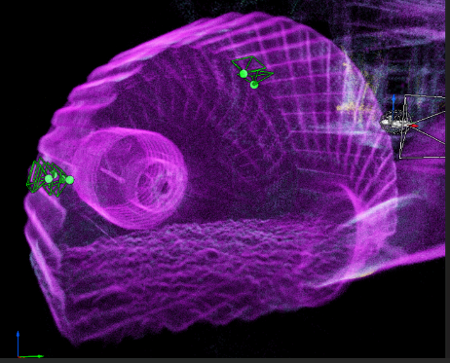

Figure 9 – Drone-based inspections, indicating drone location while performing UT thickness measurement

GRINDING EFFICIENCY

Clarabelle’s SAG mill is fed by at least 5 underground mines (with more mines coming online), with the ore consisting of 3 major sulfides: pentlandite, primary nickel mineral, chalcopyrite, primary copper mineral, and pyrrhotite, sulfide gangue mineral, with the balance being silicate gangue. The feed variability is significant; SAG specific energy ranging from 5 to 20 kWh/t. The feed size is also highly variable, typically F80 of 6” and product size of 2” (P80), though oversize material commonly enters the mill (sizes reaching up to 30”x6”) as well as variations in fines and coarse content are commonly observed, which further contribute to the challenges of maintaining a stable SAG mill operation. Pebble generation is typically between 10 and 30% (function of feed type/grade and state of liners), where it increases steadily over a given liner campaign. Under these conditions, the SAG mill operates at an average rate of 18,000 t/d.
Figure 10 shows the SAG mill performance after the new Hi-Hi liner reline, demonstrating SAG mill tons/hour increased by 9% (+66 tons/hour) compared to the original Hi-Hi liner design, and specific energy consumption decreased by 7% (-0.4 kWh/t). It signifies improved charge lift, optimized ore/media trajectory, and more energy conversion towards ore breakage. The SAG used more available power to generate more throughput, essentially what the new liner design was expected to achieve.
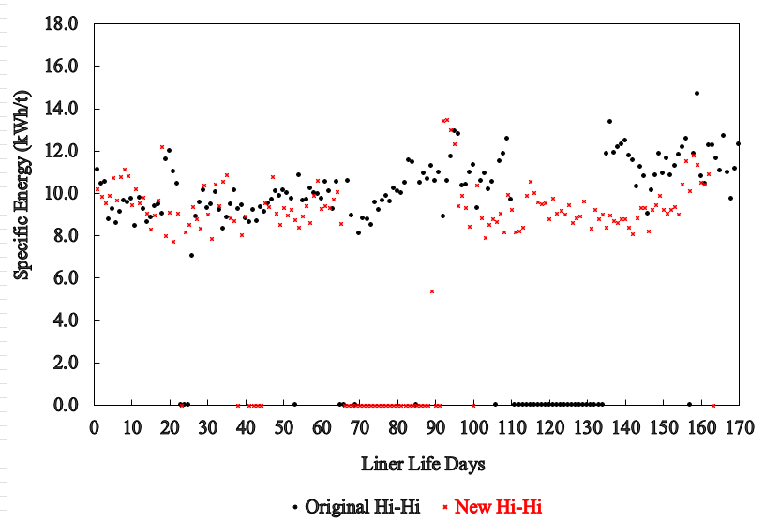
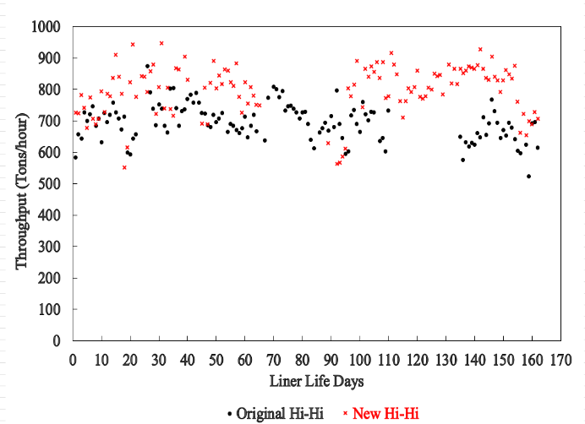

Figure 10 – SAG mill tons/hour and energy specific consumption kWh/t.

CONCLUSIONS

The Clarabelle Mill reliability and efficiency improvement transformation is progressing well. A key catalyst for this advancement has been the SAG liner failure event, consequently the liner design optimization, and the implementation of a revised SAG mill reline strategy.

- Worker safety risk for SAG entry was significantly reduced with the elimination of packing and pegging between the liners; risk of falling material from the liners was eliminated.
- Clarabelle SAG mill availability increased by 2%, driven by successfully implementing the new SAG reline strategy, resulting in a reduction from 4 to 2 relines per year.
- SAG mill high wear reline downtime decreased 25 hours as a result of the new liner configuration, which decreased the total number of shell liner pieces by 100.
- Unplanned SAG mill liners downtime was mitigated by the elimination of chronic liner failure events through improved reliability-centered liner design and condition-based monitoring practices
- Unscheduled shutdown due to broken bolts were mitigated via the optimization of bolting procedure, lubrication and implementation of smart bolt technology that enables real-time tension monitoring
- Grinding efficiency was significantly improved, resulting in a throughput increase of 66 tons/hour and a 7% reduction in specific energy consumption

FURTHER TRANSFORMATION

In 2026, in alignment with the SAG reline strategy roadmap focused on improving mill availability, a new iteration of this Hi-Hi shell liner design will be evaluated to achieve its full wear life potential. This trial will support ongoing continuous improvement initiatives and determine the feasibility of transitioning to a Hi-Lo liner configuration for future installs (long-term objective of achieving 1 SAG reline per year).

ACKNOWLEDGE

The authors acknowledge Vale’s Clarabelle Mill for permission to publish this paper. Also, Kaltech, Russel Mineral Equipment, Copper State Bolts, Unmanned Aerial Inc. for their support on SAG reline strategy

REFERENCES

Breininger, R. (2025). Clarabelle SAG Mill Bolting Report – LMF+ Installation Report, Copper State Bolt and Nut / BoltSense LMF+,
Hart, S., Nordell, L. and Faulkner, C. (2006). Development of a SAG mill shell liner design at Cadia DEM modelling, SAG Conference
Helluin, G. (2025). Clarabelle SAG Mill Drone-UT Inspection Report, Unmanned Aerial Services Inc.
Jansch, J., Birkhofer, H. (2006). The Development of The Guideline VDI 2221 – The Change Direction, International Design Conference – Design 2006
Orcon, N. (2022). Root Cause Analysis – SAG Shell Liner Failure, Clarabelle Mill Reliability Engineering
Orcon, N. (2023). Study of Shell Liner Wear Profile, Clarabelle Mill Reliability Engineering
Outkes, C. (2025). Clarabelle Mill SAG Mill Reline Service Report, Kaltech
Powel, M., Smit, I., Radziszewski, P., Cleary, P., Rattray, B., Eriksson, K., Schaeffer, L (2006) The Selection and Design of Mill Liners. SAG Conference
Royston, D. (2006). Current Development in SAG Liners Design, SAG Conference
Royston, D. (2012). Packing in SAG Mill Liners - Issues and Controls, CIM
Russel, J. (2006). Advanced Grinding Mill Relining for Process Metallurgists and Management, SAG Conference
Wadekar, A. (2025). Clarabelle SAG Mill Liner 3D Laser Scan Report, Bradken

