BIOLOGICAL DUST CONTROL AS A NATURE-POSITIVE ALTERNATIVE TO WATER, SALTS AND BITUMEN IN MINING: A CHILENIAN CASE STUDY

Jan-Philip Merk¹, M.K. Weinhold^{2*}, F.Wianski¹, P. Fuenzalida², L.Fried¹

¹Bind-X International GmbH, Am Klopferspitz 19, Planegg
²Geoeontrno SpA, Los Militares 5620 Of. 905, 7550135 Las Condes
(*presenting author: info@geoentrono.cl)

ABSTRACT

Unpaved haul roads in the hyper-arid Andean region generate severe dust emissions, impairing visibility, workers' health, and equipment lifespan while consuming scarce water resources through frequent suppression efforts. Conventional suppressants like magnesium chloride hexahydrate (bischofite), widely used in the mines in the region, require repeated applications due to hygroscopic salt migration and pose sustainability challenges through soil salinization and vegetation damage. This study evaluates a bio-based biocementation approach on copper mine soil from the Chuquicamata operation using the miniaturized laboratory test regime previously developed and validated.
Solidifying dust suppressants exhibits higher abrasion stability than the use of wetting agents indicating longer-term effects on roads. The reason for constant reapplication of magnesium chloride is discussed, and mechanical solidification of wettened soil is assessed – no abrasion stability was determined in the wettened state. Solidifying dust suppressants did yield higher resistance towards Material Loss in “Mini Open Pit” Tests than magnesium chloride-treated samples.
Water erosion stability and load-bearing wet stability were quantified, and >90 % mass retention after simulated heavy rainfall (> 10,000 L/m²) and retained structural integrity under 2.4 MPa load in saturated conditions was observed using biological solidification agents.
The results confirm that bio-based biocementation delivers long-lasting dust control with minimal water use and without salt accumulation, offering a sustainable alternative for arid-zone copper mining haul roads.

KEYWORDS

Dust suppressants, dust control, biocementation, haul roads, copper mining, arid climate, Sustainability World Mining Congress

1. INTRODUCTION

Unpaved haul roads in arid mining environments, such as the hyper-arid Atacama desert, generate large quantities of dust, impairing visibility, workers' health, and equipment life while consuming scarce water resources through frequent watering or suppressant application [Merkl et al., (2026)]. Effective dust control is critical not only for operational safety and efficiency but also for regulatory compliance and community health, as airborne particulates can lead to respiratory issues and environmental degradation. Conventional suppressants, including water, hygroscopic salts like magnesium chloride hexahydrate (bischofite, commonly used in mines in the region), lignosulfonates, and petroleum-based emulsions, are often short-lived or introduce environmental drawbacks. Magnesium chloride (“bischofite”), in particular, relies on hygroscopicity to bind atmospheric moisture but leads to salt migration through constant water flow, resulting in soil salinization, vegetation damage via osmotic stress and chloride accumulation, and potential contamination of groundwater and riparian ecosystems [Goodrich (2008)]. Besides the environmental drawback, the use of Magnesium chloride has an operational drawback, which is the frequent need for reapplication linked to operational costs (e.g. diesel, corrosive to equipment and high labour costs).
Usually overlooked, this frequent reapplication is directly linked to the hygroscopic mode of action and thus to the physicochemical properties of magnesium chloride (which also apply for calcium chloride). This metal chloride-based dust control agents adsorb water from the air. The amount and speed of adsorption is depending on the temperature, e.g. soil and air temperature, [Greenspan (1977), Guo et al (2019)], particle size [Wang (2024)] and further factors. The single steps of hydration, which involve various steps of phase transition, are still subject to scientific debate [Wang (2024)]. These single steps of phase transition will determine the kinetics of adsorption (the speed of adsorption). Based on the above, one can conclude that the speed of water adsorption to metal chloride treated soils in the context of mine-road dust control is subject to local variances, however, on “real live mining time scales” the thermodynamic aspect of use of hygroscopic metals salts (the adsorption of water) will always lead to migration of the metals salts and result constant reapplication: The equilibrium relative humidity of saturated magnesium chloride solutions is 33 RH% at 0 °C and 29 RH% at 60 °C [Greenspan (1977)]. Thus, it can be assumed that if the relative humidity exceeds the above-mentioned values, magnesium chloride applied to soil will adsorb water from air and start to migrate. As a comparison relative, humidity values around Chuquicamata are reported to be 40-45 RH% from January to March and below 25 RH% from May to November, whereas the annal average is 27 RH%. It is well known, that substantial fluctuation of the relative humidity exists in day/nigh changes (e.g. due to temperature change), so it can be assumed, that, even in very dry places, such as Atacama desert, there is constant water flow from the air to the soil, transporting magnesium chloride into deeper soil layers and, thus, reducing the dust reduction ability on the surface.
The constant transfer to deeper soil layer gives rise to further concerns in the context of future renaturation of mine sites: As metal salts are known to be harmful to plants [Goodrich (2008)], the accumulation of metal chlorides in the soil will have a negative influence on plant growth on this soil.
Emerging bio-based products induce biocementation, binding soil particles via hybrid mineral-organic bridges with minimal water and no petroleum-derived components [Stocks-Fischer et al. (1999), Kucharski et al. (2006), Fried et al. (2021)] increasing durability characteristics of the formed layer through carbonate precipitation. Metal carbonates are by a factor or approx.10 000 less soluble than corresponding metal chlorides, which contributes significantly to the long-term stability of the road and hinders wash out of binder from the top layer.
This paper applies the miniaturized laboratory protocol previously validated on iron ore soils from the Pilbara region [Merkl et al., (2026)] to copper mine material from Chuquicamata, Chile, to assess performance under local conditions and compare it with magnesium chloride.

2. MASTERIALS AND METHODS

2.1 Soil substrate
Road material was collected from active haul roads at Chuquicamata mine. Sieve analysis (DIN ISO 3310-1) revealed 33.5 % fines (<63 µm). Soil classification (in accordance with the United States Department of Agriculture (USDA) and the USDA Soil Texture Triangle) was loam. Based on these two values, the clay content (<2 µm) is 25-33.5 wt.-%, whereas the silt content is 0 - 8.5 wt.-%. Plastic limit: ~13.

Mineralogical composition (duplicate XRD-measurement and Rietveld refinement): Quartz 28.2 wt.-%, chamosite 10.6 wt.-%, 41.1 wt.-%, muscovite 13.7 wt.-%, calcite 4.4 wt.-%, gypsum 2.0 wt.-%.

2.2 Dust suppressants and application rates
Three powder-form bio-based biocementation agents and one liquid concentrate were tested against untreated soil and magnesium chloride (bischofite). Spray-On rates ranged 20–120 g/m² in 20 g/m² steps; Build-In rates were calculated for 12.5 cm incorporation depth following Merkl et al. (2026).

Table 1 – Build-In and Spray-On application rates in g/m²
Element | Spray-On | Build-In
 | (g/m²) |  | (g/m²)
Terrabind Ultimate | 20-120 |  | 400-600
Terrabind Max | 20-120
Terrabind Select | 20-120 |  | 300
Magnesium Chloride | 100-250 |  | 600-1000

2.3 Laboratory test regime
All tests followed the statistically robust, high-throughput protocol, which we have published recently [Merkl et al. (2026)]:
- Abrasion resistance was determined with increasing weight and the failure point was determined. The failure point is the point where 90% of the respective top layer of the soil was worn away. This test works for spray-on and build-in samples. However, it was just used for spray-on tests in this study.
- Water erosion stability (simulated heavy rainfall, 10 000 L/m²)

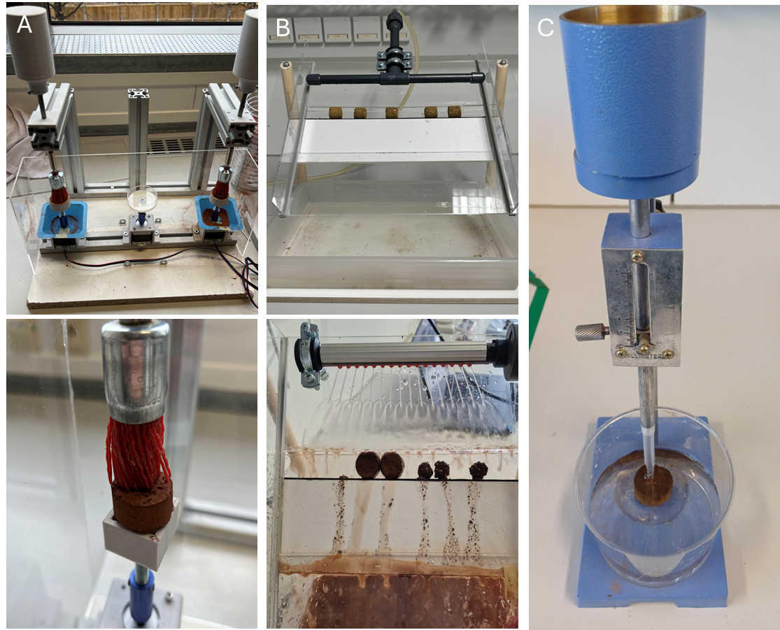
Figure 1 – Illustration of measurements on Build-In samples: A: Abrasion, B: Water erosion stress testing, C: Vicat slake testing.

Further tests include a Vicat slake test under 2.4 MPa load in saturated conditions sample preparation, curing (48 h, 23 °C, 50 % RH) and statistical evaluation (Bonferroni-adjusted) were identical to the reference study.

Vicat slake test: To qualitatively assess the water stability of the formed layer a sieve dipping processes (also known as slake test) was executed, adapted from DIN 19683-16:2015-12 and ISO 10930:2012 and combined with a Vicat test, adapted from EN 196-3, ASTM C191 and ISO 9597 mimicking load under water exposure. The pressure applied was approx. 2.4 MPa and the time until failure was determined when the tip reached the bottom of the test specimen. The standard deviation of this test is around 2 % of the failure time, thus, a difference of 1.3 min was considered to be a substantial difference (n=4).

Miniature open pit stability test: To qualitatively assess the solidification and dust control performance of the treated samples, miniaturized open pit samples were prepared using a 3D-printed negative form. The test specimen had a height of 31 mm, an upper diameter of 30 mm, and a lower diameter of 65 mm. The exposed surface is approx. 5,930 mm². Soil was mixed with water at the plastic limit and the test specimens were formed and let dry for at least one day while glued with super glue to a plastic plate. After this, the test specimens were treated with the respective dust suppressant and let to dry for at least one day. The test specimens were weighed, clamped into a vibrating plate and let to vibrate for 2 minutes. Loose material was cleaned off, and the mass of the lost material was determined. Water-treated samples were used as a reference when determining the lost material.

3. RESULTS

The aims of this study are to investigate the performance of biological solidifying dust control agents against a magnesium chloride treatment.

3.1 Magnesium chloride treated soil
The laboratory studies were carried out in summer, which corresponds to approximately 55 RH%. Therefore, the magnesium chloride samples stayed wet throughout the experiments. This resulted in no mechanical stability of the formed layer but a viscous soil behavior. As seen in Figure 1, the samples deformed during mechanical stress.

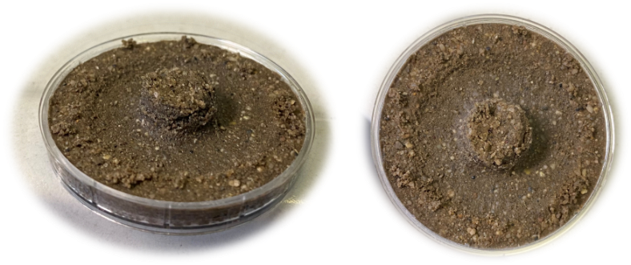
Figure 2 – Photographs of magnesium chloride treated soil samples after abrasion resistance tests.

3.2 Abrasion resistance
Untreated and magnesium chloride-treated samples disintegrated rapidly and exhibited plastic deformation (Figure 2 A left sample, Figure 2 B orange dot) in the abrasion resistance tests; thus, no breaking point could be determined.

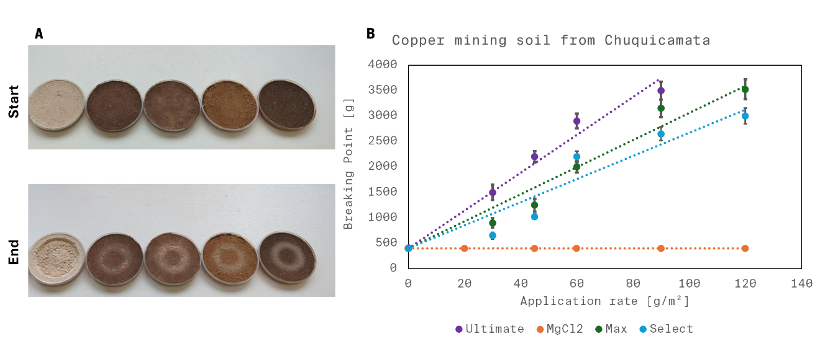
Figure 3 – Abrasion resistance test. A: Top row: Different specimens (untreated, 2x Terrabind Max, Terrabind Select, Terrabind Ultimate) before the abrasion test. Bottom row: Identical specimens after the abrasion test. B: Application rate dependent solidification of the Terrabind-products. The Breaking point of 2 500 g mimics the load of 700 t trucks. Dotted lines represent a linear fit with fixed intercept of 450 g (the breaking point of water treated soil).

All biocementation treatments formed a coherent crust. In the sample soil, the relation between the application rate and the respective breaking point in the abrasion test followed an upmost linear trend (Figure 2 B). It is a common behavior that at low dose rates the breaking point is below the fitted linear trend of the whole dataset (compare Terrabind Select and Terrabind Max in Figure 2B). This is due to the fact, that a minimum dose rate is needed to solidify the soil area.

To assess the stability the treated and untreated miniturazied open pit samples were produced and their stability against vibration was assessed. This test was used as a primer indication to solidification and stability enhancement of the dust suppressants. It was found that water treated samples lost material, whereas the samples treated with the biological dust control agents showed a solidified surface and approximately 99.5% reduces material loss though the vibration (compare Figure 4). Also, the treatment of Magnesium chloride did show a reduction of 85.3% due to wetting effect – no mechanical stability was achieved.

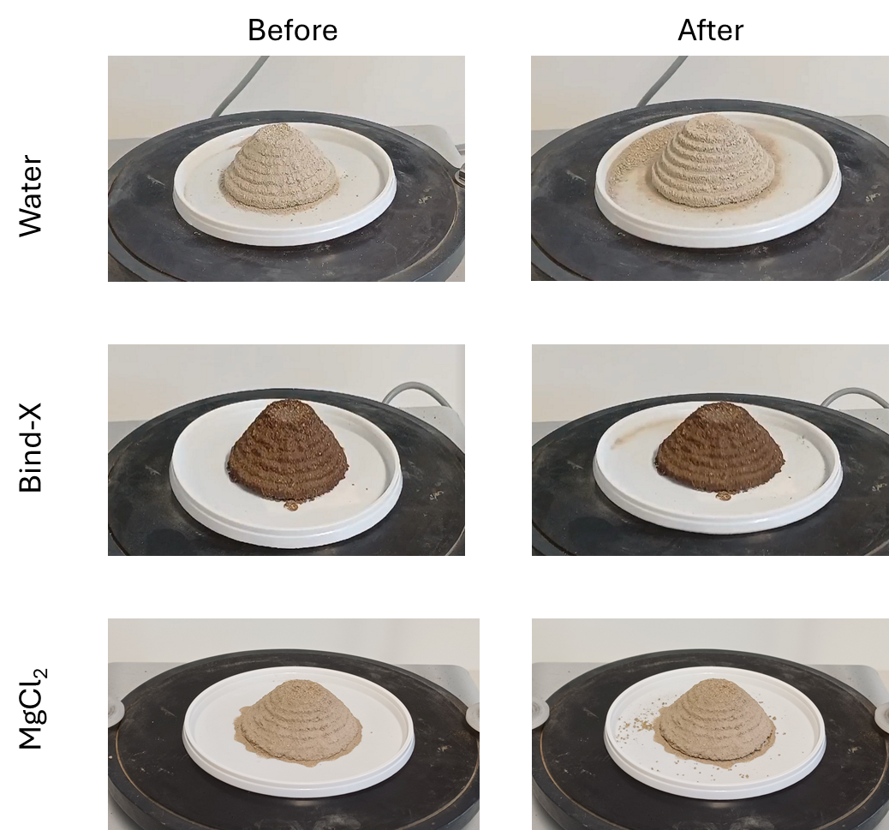

Figure 4 – Miniature open pit stability test: The photographs illustrate differently product-applied samples (above: water, middle: Terrabind Max, bottom: magnesium chloride (MgCl₂) before (left) and after (right) the mechanical stress.

3.3 Water Erosion Stability

Although the area of Chuquicamata is reported to be very dry, water erosion stability was assessed, as water erosion stability is in general an important parameter for dust suppressants [Austroads (2009)].

Water erosion stability and load-bearing wet performance After 60 min of simulated intense rainfall (>10 000 L/m²), build-in specimens treated with the premium biocementation variant retained 65–92 % of initial mass depending on dosage (400–600 g/m²). Under simultaneous 2.4 MPa compressive load in saturated conditions (Vicat slake test), failure time increased from <2 s (untreated or magnesium chloride) to >20 min at 600 g/m² application rate (Figure 4). This indicates, that the treatment with Terrabind Ultimate

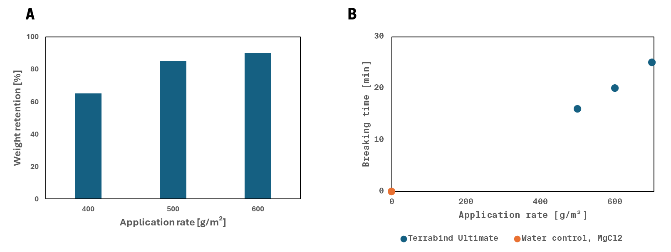
Figure 5 – Water resistance of Terrabind Ultimate-treated samples as a function of application rate. The corresponding untreated soil samples or magnesium chloride treated soil samples disintegrated completely upon contact with water. B: Water resistance quantification. Terrabind Ultimate during the Vicat Slake test on the copper soil.

4. DISCUSSION

Although the high-volume availability of magnesium chloride renders magnesium chloride a widely used dust repellant, its constant, use is an environmental concern, as it can be described as anthropogenic salinization. The mode of action of hygroscopic salts renders reapplication unavoidable and lead to constant drop in solidification and dust control performance of the treated area over time. The local extend of this deterioration is to be determined individually and will depend on factors such as soil mineralogy and local climate e.g. humidity, humidity variations and temperature, whereas higher humidity will likely yield faster deterioration. In addition, magnesium chloride solutions are highly corrosive and constantly damage water trucks and other equipment in contact with the dust suppressant solution.

Besides the deterioration, we have shown here that magnesium chloride treated soil in wettened state does not yield solidification of a surface. The cohesive forces of the soil-adsorbed water are enough, to reduce dust, but are not strong enough to physically stabilize against abrasion. Thus, mechanical properties of magnesium chloride treated roads will very strongly depend on the local climate conditions. Solidifying dust suppressants exhibit the benefit of reducing abrasion more than Magnesium Chloride treatment (compare Figure 5B): The formation of a non-plastic, load-bearing crust eliminates salt accumulation and increases stability on a longer time scale than the hygroscopic salts. This enhanced durability directly increases the environmental footprint of the biological dust control products, as the frequency of reapplication is reduced, which results in long term lower material consumptions and also lower maintenance diesel use.

As magnesium chloride is soluble in water, magnesium chloride treated samples did not exhibit any resistance against water erosion or against load when emerged in water. Terrabind Select and Terrabind Max showed slightly increased wash out resistance, as reported elsewhere [Merkl et al., (2026)]. Only Terrabind Ultimate treated samples show 90% weight retention after exposure to the equivalent of 10 000 liters water per square meter. Also, the load bearing capacity was increased significantly through the treatment of Terrabind Ultimate.

5. CONCLUSION

Biological dust control outperforms magnesium chloride-based dust control in mechanical and environmental performance. Time is right to make better choices when selecting dust suppressants.

Across all evaluated metrics, biological dust control consistently outperformed magnesium chloride in both mechanical effectiveness and environmental performance. These findings support a shift toward bio‑based suppressants as the preferred option in performance‑critical and sustainability‑constrained applications.

REFERENCES

ASTM International, (2021), ASTM C191, Standard test method for time of setting of hydraulic cement by Vicat needle, ASTM International, West Conshohocken, PA.
Austroads (2009) Guide to pavement technology part 6: Unsealed pavements (Edition 1.1). Sydney: Austroads. (Publication no. AGPT06-09).
Berwyn, B. (2007). Studies put mag chloride use in question. Aspen Times. https://www.aspentimes.com/news/studies-put-mag-chloride-use-in-question/ (assessed 10.12.25).
Deutsches Institut für Normung, (2015), DIN 19683-16:2015-12, Soil quality - Physical laboratory tests - Part 16: Determination of aggregate stability using the method of wet sieving, Deutsches Institut für Normung, Berlin, Germany.
European Committee for Standardization, (2005), EN 196-3 Methods of testing cement - Part 3: Determination of setting times and soundness. European Committee for Standardization, Brussels, Belgium.
Fried L, Spitznagel M, Pazur S, Merkl J, Hornung F, BIOCEMENTATION MIXTURE FOR DUST CONTROL AND RELATED APPLICATIONS, International Patent Application WO2021/239573A1.
International Organization for Standardization, (2012), ISO 10930:2012. Soil quality — Measurement of the stability of soil aggregates subjected to the action of water. International Organization for Standardization, Geneva, Switzerland.
International Organization for Standardization, (1989), ISO 9597 Cement - Test methods - Determination of setting time and soundness. International Organization for Standardization, Geneva, Switzerland.
Kucharski, E, Cord-Ruwisch R, Whiffin V, Al-Thawadi, S, Microbial Biocementation, International Patent Application WO2006/066326A1.
Greenspan, L., (1977) Humidity Fixed Points of Binary Saturated Aqueous Solutions, JOURNAL OF RESEARCH of the National Bureau of Standards - A. Physics and Chemistry Vol. 81 A, No.1.
Guo, L., Gu, W., Peng, C., Wang, W., Jie Li, Y., Zong, T., Tang, Y., Wu, Z., Lin, Q., Ge, M., Zhang,. G, Hu,. M., Bi., X., Wang, X., Tang, M., (2019). A comprehensive study of hygroscopic properties of calcium- and magnesium-containing salts: implication for hygroscopicity of mineral dust and sea salt aerosols. Atmospheric Chemistry and Physics, 19(4), 2115–2133.
Goodrich, B. A., Koski, R. D., & Jacobi, W. R. (2008). Roadside Vegetation Health Condition and Magnesium Chloride (MgCl2) Dust Suppressant Use in Two Colorado, U.S. Counties, Arboriculture & Urban Forestry 34(4), 252-259.
Merkl, J.-P., Wianski, F., & Fried, L. (2026). Bio-based dust suppression for haul roads in an arid Australian iron ore mine, Proceedings of the 2026 Resource Operators Conference.
Stocks-Fischer S, Galinat J and Bang S, 1999. Microbiological precipitation of CaCO3, Soil Biology and Biochemistry, 31:1563-1571.
Wang, W., Stahlbuhk, A., & Steiger, M. (2024). Hydration and deliquescence behavior of calcium chloride hydrates.Fluid Phase Equilibria, 600, Article 114171.

