STRATEGY FOR THE PROMOTION OF MINING INVESTMENTS AND THE SUSTAINABILITY OF THE MINING SECTOR, PERU – 2026

J. Pineda¹

¹Director of Projects and Research, Earth Institute, Perú (jose.pineda@earth-institute.net)

Scope / Topics: Critical Minerals, Strategic Materials & Mineral Policy

ABSTRACT

To achieve the global goal of Net Zero by 2050 and mitigate the serious environmental problem on the planet, minerals will be required for renewable and green energy technologies. Peru is a major mining country; however, in recent years, several mining investment projects have been severely affected by a lack of political will, obstacles and excessive permits imposed by the government, socio-environmental conflicts, and others. The objective is to analyze how the mining investment promotion strategy impacts the sustainability of the Peruvian mining sector; as materials and method, it is based on consolidating the lessons learned executed (1990-2025). and as a result, the assessment of the dimensions of the mining investment promotion strategy (international environment, governance and lessons learned or knowledge) is presented, together with the mining sector sustainability index (ISSM), which at the end of 2025 shows a value of 62% (medium and decreasing rating), giving rise to conclusions and recommendations to take advantage of the strengths and opportunities of higher international prices and demand for minerals that the world will require in the coming years to promote clean and renewable energy, resuming the promotion of mining investments and the sustainability of the Peruvian mining sector, with proactive participation of the state and the actors involved.

KEYWORDS

Sustainable development, investment promotion strategy, mining project portfolio, mining Peru

1. INTRODUCTION

This research is an update of the Author's Articles published in the Earth Institute Journal “Strategy for the Promotion of Mining Investments and the Sustainability of the Mining Sector, Peru-2025” (Pineda, 2025).

From a theoretical perspective, the Mining Investment Promotion Strategy focused on the sector's sustainability is based on lessons learned and proposals from Climate-Smart Mining (World Bank, 2020). This aims to contribute knowledge for current and future generations in the joint effort to promote responsible investments.

From a practical point of view, the strategy has been effectively applied in Peru, although there is a lack of documentation that allows for the extraction of lessons learned and facilitates continuous improvement, which is a significant contribution of this research.

In social and environmental terms, the strategy based on Climate-Smart Mining ensures responsible management of the environment and social dimensions, aligning with the objectives of sustainable development.

Economically, there is an urgent need to promote investment for Peru's economic recovery, especially considering the increase in poverty and the national economic recession that began in 2023, exacerbated by the global post-Covid-19 pandemic context. Therefore, it is essential to apply best practices and strategies derived from global and local experiences to effectively foster mining investment with a focus on sustainable development.

2. METHOD

The research follows the theory of strategic planning, specifically regarding investment promotion strategies, which integrate the diagnosis of dimensions, the evaluation and formulation of strategies and plans oriented toward achieving a vision—in this case, an agenda of “sustainable development.” This theory also suggests that every plan should include monitoring and control mechanisms for corrective measures and/or continuous improvement, precisely to measure the “sustainability of the mining sector” through its indicator (ISSM).
Figure 1 summarizes the overall picture of the theory and the scope of the research.

This is an applied research study; a descriptive method, a lesson-learned study; a documentary, non-experimental design. The population analyzed consists of the results of the mining investment promotion process implemented in Peru from 1990 to 2025, using a non-probability sample. Two successful cases of investment promotion in mining projects in Peru (Antamina and Las Bambas) were selected by convenience sampling.

The independent variable (x) is the Investment Promotion Strategy; and its dimensions are: x1: International Environment for Promoting Mining Investments (International Competitiveness) with a weight of 40%; x2: Governance (internal competitiveness) with a weight of 40%; and x3: Lessons learned and continuous improvement of the Promotion Strategy (Experience or Knowledge) with a weight of 20%.

The assessment of xij indicators is green when the range value varies from 70% to 100% (opportunity, strength); yellow when the range varies from 50% to 70% (medium, average); and red when the range is less than 50%, which signifies risk or weakness.

The sustainability of the mining sector is a dependent variable (y), and its indicator is the mining sector sustainability index (ISSM), which is a function of x: y = f(x) = 40%x1 + 40%x2 + 20%x3, as described in Figure 1.
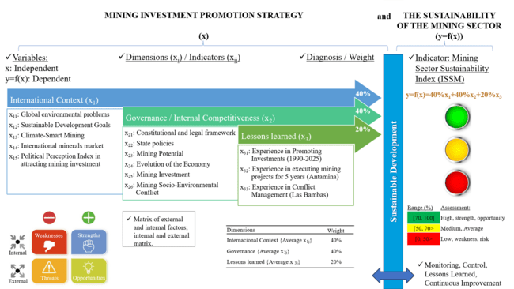
Figure 1 – Theory and the scope of the research
3. RESULT

As a result, the Mining Sector Sustainability Index (ISSM) is presented, which at the end of 2025 and with values ​​published during 2026 to date, shows an average value of 62% (Table 1).

Table 1 – Mining Sector Sustainability Index (ISSM).

x | INDEPENDENT VARIABLE: MINING INVESTMENT PROMOTION STRATEGY
 | Dimensions / Indicators |  |  | Criteria for evaluating indicators |  |  |  | Weight | Value
x₁ | International Context for Promoting Mining Investments (International Competitiveness) |  |  |  |  |  |  | 40% | 70%
x₁₁ | Global environmental problems |  |  | Is there an opportunity for increased demand for minerals in the future? |  |  |  |  | 80%
x₁₂ | Sustainable Development Goals |  |  | Global SDG Index Peru 2024 (United Nations) |  |  |  |  | 73%
x₁₃ | Climate-Smart Mining (CSM) |  |  | Is Peru referenced in the CSM's global strategy? |  |  |  |  | 75%
x₁₄ | International minerals market |  |  | Are there pricing opportunities? Is there market interest? |  |  |  |  | 74%
 |  |  |  | Copper and gold prices |  |  |  | 80%
 |  |  |  | Metal buyers |  |  |  | 75%
 |  |  |  | Mining Potential Index (Fraser, 2025) * |  |  |  | 66%
x₁₅ | Political Perceptions Index (Fraser, 2025) * |  |  | *5-year average; mining investment attraction index. |  |  |  |  | 51%
x₂ | Governance (Internal Competitiveness) |  |  |  |  |  |  | 40% | 56%
x₂₁ | Constitutional and legal framework |  |  | Is there a legal framework that promotes investment? |  |  |  |  | 60%
 |  |  |  |  | Legal Framework |  |  | 80%
 |  |  |  |  | Obstacles in granting licenses and permits |  |  | 40%
x₂₂ | State policies |  |  | Are there adequate policies? What is the vision? |  |  |  |  | 75%
x₂₃ | Mining Potential |  |  | Cost competitiveness, internal logistics? |  |  |  |  | 67%
 |  |  |  |  | Mining history and tradition |  |  | 79%
 |  |  |  |  | Internal logistics |  |  | 55%
x₂₄ | Evolution of the Economy |  |  | Are the indicators rising? Are they falling? |  |  |  |  | 45%
 |  |  |  |  | GDP per capita |  |  | 50%
 |  |  |  |  | Poverty Index |  |  | 40%
x₂₅ | Mining Investment (executed and projected) |  |  | Is the magnitude of mining investments adequate? |  |  |  |  | 52%
 |  |  |  |  | Investments made (1990-2025) |  |  | 75%
 |  |  |  |  | Currently under development |  |  | 40%
 |  |  |  |  | Future portfolio |  |  | 40%
x₂₆ | Social and Environmental Conflict in Mining |  |  | How do they affect mining investments? |  |  |  |  | 40%
x₃ | Lessons learned and continuous improvement of the Promotion Strategy |  |  |  |  |  |  | 20% | 58%
x₃₁ | Results of the Investment Promotion Process in the Antamina Mining Project (1996-2001) |  |  | Is it possible to develop mine in 5 years? |  |  |  |  | 58%
 |  |  |  |  | Experience (Antamina) |  |  | 75%
 |  |  |  |  | Current Experience |  |  | 40%
x₃₂ | Results of the Investment Promotion Process in the Las Bambas Mining Project (2003-2015) |  |  | Conflict management and state presence? |  |  |  |  | 58%
 |  |  |  |  | Experience (Las Bambas) |  |  | 75%
 |  |  |  |  | Current Experience |  |  | 40%
x₃₃ | Operationalization of the Promotion Strategy |  |  | Is there the infrastructure and experience to carry out the strategy? |  |  |  |  | 60%
 |  |  |  |  | Existing infrastructure and resources |  |  | 70%
 |  |  |  |  | Past experience |  |  | 70%
 |  |  |  |  | Current experience |  |  | 40%
y | DEPENDENT VARIABLE: SUSTAINABILITY OF THE MINING SECTOR
 | Indicator: |  |  |  |  |  |  | Weight | Value
 | ISSM | Mining sector sustainability index: y = f(x) = 40%x₁ + 40%x₂ + 20%x₃ |  |  |  |  |  | 100% | 62%
 | Range (%) | Assessment: |  |  | Dimensions:
 | [70, 100] | High, strength, opportunity |  |  | Internacional Context {Average x_{1j}} |  |  | 40% | 70%
 | [50, 70> | Medium, Average |  |  | Governance {Average x_{2j}} |  |  | 40% | 56%
 | [0, 50> | Low, weakness, risk |  |  | Lessons learned {Average x_{3j}} |  |  | 20% | 58%

4. DISCUSSION

4.1 Peru, a mining country

The Peruvian economy depends directly on mining; “Peru is a mining country,” as evidenced by the evolution of GDP per capita and copper production in the last 100 years in Peru, shown in Figure 2, where we clearly see three defined stages:
The first stage, up to 1967, shows constant economic and mining growth with private investment, and prior construction of large infrastructures such as the Central Railway, the Central Highway, hydroelectric plants, the La Oroya Metallurgical Complex and others, based on the mining potential, particularly in the center of the country, with the awakening of copper, with mining explorations in the north, center and south of the country.
As a second stage, this growth was unfortunately interrupted in 1968 by a statist and nationalist model, which led Peru to its greatest economic, social, environmental, and political crisis by the end of 1990, as detailed in the Central Reserve Bank of Peru's (BCRP) publication "The Great Depression of the Peruvian Economy." This publication highlighted the significant economic losses caused by public enterprises, corruption, bureaucracy, and a lack of investment (BCRP, 2015, p. 92). In other words, by 1990, Peru was on a completely different path, contrary to the Sustainable Development model promoted by the United Nations since 1987.
As a third stage, the new government that began in 1990 embraced the opportunity presented by the global agenda promoted by the United Nations. A change in policy was necessary, shifting towards a "Social Market Economy," including the free market and the promotion of private investment under the global agenda of risk management and sustainable development—principles consolidated in the new Political Constitution of Peru, in force since 1993.
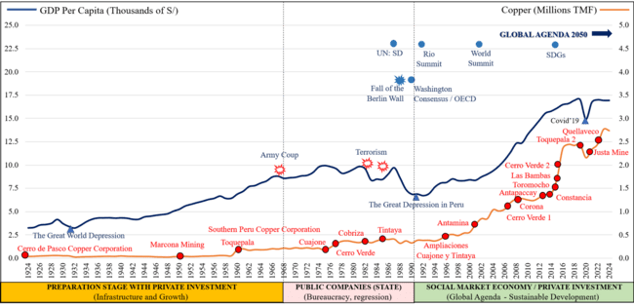
Figure 2 – Peru, a mining country
Three decades later, since 1990 we can see sustained growth in GDP per capita (increasing 7 times; from US$1,200 in 1990 to US$8,452 in 2024) according to the World Bank, supported by mining growth, in this case copper (increasing 8.6 times, from 0.32 million tons in 1990 to 2.74 million tons in 2024) according to the Ministry of Energy and Mines (MINEM, 2025).
The political polarization during the general elections and change of government in 2000 increased social conflicts and greatly affected the continuity of the privatization process and the granting of service concessions to the private sector, which had become the main drivers of investment and modernization in the country.
The Central Reserve Bank of Peru (BCRP), in its June 2017 report "Determinants of Social Conflicts in Mining Production Zones," mentions that social and environmental conflicts associated with mining projects in Peru have paralyzed US$18 billion in investment (10 percent of GDP) in recent years. Regarding copper, the suspension of major mining projects in Cajamarca (Michiquillay, Conga, La Granja), Piura (Río Blanco), Arequipa (Tía María), and others, has delayed the growth of copper production projected in the 1992 Annual Mining Reference Plan. This plan, which aimed to reach Chile's production levels within three decades, only achieved 50% of that target.
One of the direct consequences of mining conflicts, including the "Conga No Va" conflict, is evident in the drop in gold production from 208 to 107 tons between 2005 and 2024, as reported by the Ministry of Energy and Mines (MINEM) (see Figure 3).
This represents a 50% decrease in two decades, due to reduced production at Yanacocha, delays in the execution of the Conga mining project (gold and copper), which is currently suspended pending a more favorable social climate for mining investments, and other setbacks. The damage is twofold, coinciding with an increase in the price of gold. In other words, losses are not only incurred due to lower production, but also in missing out on the higher price of gold as an opportunity in the international market.
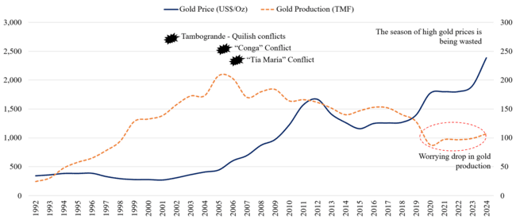

Figure 3 – The Missed Gold Opportunity: Lower Production During the Gold Price Season
Regarding poverty, at the end of 2023 the Central Reserve Bank registered a negative GDP of 0.6% (the beginning of an economic recession). Poverty has grown to 29% in 2023, regressing to a rate equivalent to that of 2010 (30.8%) (INEI, 2025).
This represents more than a lost decade, and poverty will continue to increase in the country if investments are not urgently promoted and the national economy is not reactivated. This will negatively impact on the country socially, environmentally, and economically, contrary to the vision of sustainable development referenced in the 1993 Constitution.

4.1 Peru's Mining Investment Attractiveness Index
Table 2 shows a drop in the mining investment attractiveness index in Peru from 81.6% in 2018 to 44% in 2023 and 61.2% in 2024, mainly affected by the drop in the rating of political perception, even reaching the lowest historical level (34%) in 2022, and as a consequence the drop in the mining potential index to 44.4% in 2023 although it recovers its rating of 65.9% in 2024 (Fraser, 2025, p.14).
This decline in the mining investment attractiveness index in Peru should be interpreted as reflecting how our country has fallen in its Mining Potential ranking, from 8th place in 2018 to 42nd in 2023 (its lowest position ever). Even after recovering to 25th place in 2024, it has been overtaken by other countries where exploration is underway and large copper and cobalt deposits are being discovered, such as Congo (an African country), which in 2024 surpassed Peru as the second largest copper producer, attracting the world's largest mining investors.
Table 2 – Mining Investment Attractiveness Index – Peru / Average 2020 - 2024

Index (%) | 2018 | 2019 | 2020 | 2021 | 2022 | 2023 | 2024 | Average
Attracting mining investment | 81.6 | 75.1 | 70.4 | 61.6 | 60.7 | 44.0 | 61.2 | 60
Political perception (40%) | 79.7 | 67.0 | 75.2 | 46.3 | 33.8 | 43.4 | 54.2 | 51
Mining Potential (60%) | 82.8 | 80.6 | 67.2 | 71.9 | 78.6 | 44.4 | 65.9 | 66
Position in Mining Potential | 8 | 12 | 30 | 24 | 17 | 42 | 25

4.3 Strategies for promoting mining investments
“From Problem to Opportunity” described in Figure 4, attempts to outline the global context of the research area aimed at understanding the problem and the opportunity to propose strategies for promoting mining investments and their impact on the sustainability of the mining sector.
In other words, when a country's economy enters a recession (red), it has direct consequences on the social dimension (more unemployment, informality, crime, poverty, etc.) and the environmental dimension (for example, a lack of resources to promote energy transition or renewable energy technologies to achieve the Net Zero goal). Conversely, when the economy is growing (green), it has a positive impact on the social and environmental dimensions, based on global policies such as those proposed in the World Bank's Climate Smart Mining initiative.
This dynamic of migrating from red (negative) indicators to green (positive) indicators allows for growth and a trend towards achieving the Sustainable Development Goals (SDGs), as promoted by the United Nations, of which Peru is a member country.
Therefore, from the perspective of the problems (social, economic, and environmental), Peru can take advantage of the great opportunities that the international environment offers (models of good governance; the global climate change agenda; the climate-smart mining strategy, among others), decisively promoting investments in all productive sectors, including, of course, mining.
For this purpose, there is a portfolio of mining projects that can be developed with a vision of sustainable development, capitalizing on the opportunity presented by higher mineral prices due to the high demand for metals in the coming years to meet the energy transition. To achieve this, all stakeholders must work together, including the government, investors, civil society, and academia.
Figure 5 shows the mining investment promotion strategy, which is influenced by three dimensions, including i) International context for promoting mining investments; ii) Governance (internal competitiveness) and iii) Lessons learned and continuous improvement of the promotion strategy.

Figure 4 – From Problem to Opportunity

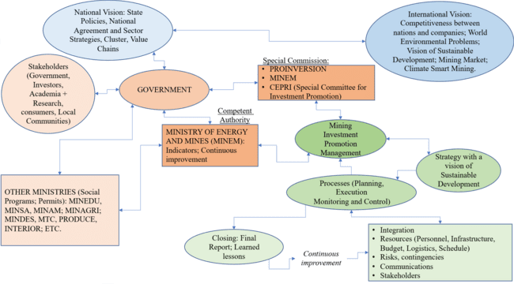
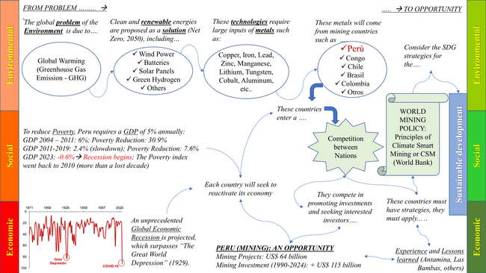
Figure 5 – Components of the mining investment promotion strategy

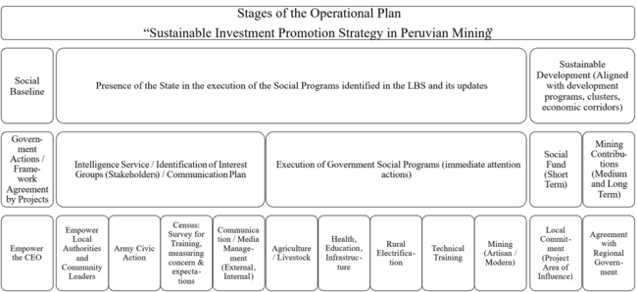
Figure 6 illustrates the strategy for implementing the promotion plan. In other words, there is sufficient experience to resume investment promotion efforts, but this requires the government's firm political will to unblock investments and assign personnel with experience in these processes.

Figure 6 – Operational phases of the promotion strategy
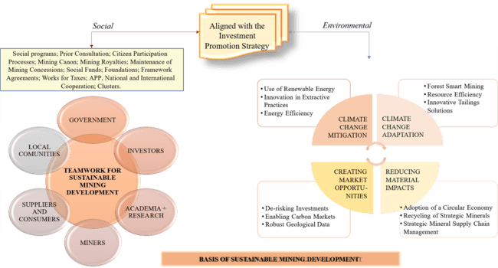
Figure 7, adapted from the Climate-Smart Mining initiative (World Bank, 2020), shows the components of social and environmental programs to be included in the promotion of investments in mining projects, including the social strategies or programs that are currently being implemented (mining canon, mining royalties, works for taxes, public-private partnership and others) and environmental programs that are in progress (Environmental Management Plan, Citizen Participation Processes, others).

Figure 7 – Social and environmental program for the promotion of mining investments
5. CONCLUSIONS
The Mining Investment Promotion Strategy has a significant impact on the sustainability of the mining sector in Peru. The proposed strategy, based on successful case studies implemented in Peru since 1990, is available to the authorities for implementation and consolidation. This is one of the main contributions and objectives of this research, with a vision aligned with the global agenda for 2050.
The international context for promoting mining investments significantly impacts the sustainability of the mining sector. The United Nations' Net Zero by 2050 goal, as a solution to the global environmental problem, and the World Bank's Climate-Smart Mining initiative, both of which contribute to achieving the Sustainable Development Goals, represent a historic opportunity for emerging mining countries like Peru, given the projected increase in consumption of key minerals such as copper and others, coupled with higher prices.
Governance (internal competitiveness) significantly influences the sustainability of the mining sector. While the legal framework, state policies, mining potential, procedures, infrastructure, and experience exist to promote investment, these investments have been declining in recent years due to socio-environmental conflicts, obstacles in permitting, and the current government's lack of knowledge and political will.
Lessons learned and continuous improvement of the promotion strategy significantly impact on the sustainability of the mining sector. All the experience gained from promoting over US$115 billion in mining investments in Peru since 1990 should be leveraged and used to realize Peru's US$64 billion mining investment portfolio.
Antamina offers us a valuable lesson, a success story, demonstrating that it's possible to develop a large-scale mining project in just five years—from exploration and permit approval to construction, testing, and commissioning. Unfortunately, today's mining projects typically take an average of 15 years to become a reality. Antamina symbolizes the remarkable teamwork undertaken between 1996 and 2001 (government, investors, and civil society) to promote this large-scale mining project with a vision of sustainable development.
The "Sustainable Development Model for Promoting Private Investment in the Las Bambas Mining Project" has been duly recognized for its successes in various forums, including the Congress of the Republic and events such as the Mining Convention. It received the winning award in the 2004 Business Creativity Competition. This process demonstrates that it is possible to reverse major social conflicts through a proactive state presence and by achieving social agreements for the common good of all parties involved.
The Mining Sector Sustainability Index (ISSM) of this research (62%) is like the 2020-2024 average value of the Fraser Mining Investment Attractiveness Index (60%), a rating with a downward trend that should be reversed with the annotations indicated in this research.
As a general recommendation, the global sustainable development agenda with a vision to 2050 should be followed (risk management, sustainable development, net-zero, land-use planning and governance), along with the opportunities of the energy transition, which anticipates high demand for minerals and higher international prices that can be leveraged by mining countries like Peru.
This requires a renewed strong political will from the government to promote investments in mining in particular, eliminating all bureaucratic obstacles, reversing socio-environmental conflicts with local and regional development strategies and plans based on large investment projects, making good use of past experiences, and appointing officials with the necessary knowledge for effective management, continuous improvement, and collaborative work among stakeholders, including the government, investors, civil society and academia, contributing knowledge, strategies, and initiatives for the common good, for the benefit of the country.
References
Private Investment Promotion Agency [PROINVERSIÓN, Perú]. (1996-2014). Privatization of the Antamina and Las Bambas Mining Projects.
Private Investment Promotion Agency [PROINVERSIÓN, Perú]. (September 2005). LAS BAMBAS, A model of sustainable development.
Central Reserve Bank of Peru [BCRP]. (December 2015). The great depression of the Peruvian economy.
World Bank [World Bank]. (2020). Climate-Smart Mining: Minerals for Climate Action.
World Bank [World Bank]. (2021). Diagnosis of the Mining Sector - Peru.
Ombudsman's Office - Peru. (2007). Extraordinary Report on socio-environmental conflicts due to extractive activities.
Fraser Institute [Fraser]. (2025). Survey of Mining Companies 2024.
National Institute of Statistics and Informatics [INEI, Perú]. (May 2024). Peru: Evolution of Monetary Poverty 2014-2023.
Ministry of Economy and Finance [MEF, Perú]. (2020). Multiannual Macroeconomic Framework 2021-2024.
Ministry of Energy and Mines [MINEM, Perú]. (2019). Vision for Mining to 2030. Center for Convergence and Good Mining and Energy Practices.
Ministry of Energy and Mines [MINEM, Perú]. (May 2025). General Directorate of Mining Promotion and Sustainability. Mining Yearbook 2024.
Ministry of Energy and Mines [MINEM]. (April 2025). Portfolio of Mining Investment Projects.
United Nations (1987): Report of the World Commission on Environment and Development (Brundtland Report).
United Nations (2025). Sustainable Development Report.
United Nations (2024). Office for Disaster Risk Reduction - Regional assessment report on disaster risk in Latin America and the Caribbean (RAR24).
Pineda, J. (2025). Strategy for the Promotion of Mining Investments and the Sustainability of the Mining Sector, Peru-2025. Earth Institute Journal 2025(2), pp. 13-33.
Porter, M. (1989). Competitive Advantage of Nations.
Office of the Prime Minister [PCM, Perú] - Commission for Sustainable Mining Development. (February 2020). Final Report "Proposals for regulatory, management and public policy measures to strengthen the sustainability of the mining sector

