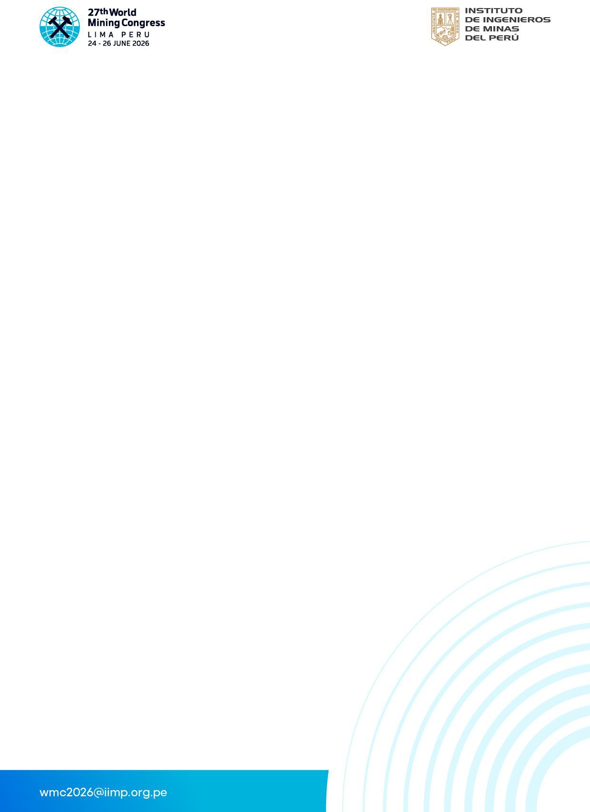
27th WORLD MINING CONGRESS – PERU 2026

PRIVACY POLICY

INTRODUCTION
The World Mining Congress 2026 (“WMC 2026”) participant registration platform is operated by the Instituto de Ingenieros de Minas del Perú (IIMP).We are committed to protecting the privacy and personal data of individuals registering as participants for WMC 2026.
This Privacy Policy explains how personal information is collected, used, stored, and protected exclusively for participant registration and event administration purposes.

DATA CONTROLLER
The Data Controller responsible for the processing of personal data is:
Instituto de Ingenieros de Minas del Perú (IIMP) As Data Controller, IIMP determines the purposes and means of processing personal data collected through the WMC 2026 registration platform.

PARTICIPANTS
When registering as a participant, we may collect the following personal data:
- Full name
- Nationality
- Passport or national identification document (required for legal and tax purposes)
- Email address
- Phone number
- Company/organization name
- Billing information
- Payment confirmation details
Only data strictly necessary for participant registration, accreditation, payment processing, and legal compliance is collected.

PERSONAL DATA WE COLLECT

Personal data is processed exclusively for:
* Participant registration and confirmation
* Issuance of invoices and compliance with applicable tax regulations
* Payment processing
* Event accreditation and access control
* Administrative communication related to participation
* Fraud prevention and registration validation
Personal data is not used for unrelated marketing or commercial purposes.

- LEGAL BASIS FOR PROCESSING (INCLUDING EU PARTICIPANTS)

For participants located in the European Union (EU) or European Economic Area (EEA), personal data is processed in alignment with the principles established under the General Data Protection Regulation (GDPR – EU Regulation 2016/679).
Processing is based on:
- Contractual necessity (registration and participation in WMC 2026)
- Legal obligations (tax and accounting regulations applicable in Peru)
- Legitimate interest (event administration and security)

- PAYMENT PROCESSING

All payments are securely processed through Niubiz, a certified payment gateway compliant with international payment security standards.
Important:
- Credit card information is processed directly by the payment gateway
- WMC 2026 and IIMP do not store credit card data on their servers
- Payment data transmission is encrypted

- DATA STORAGE AND SECURITY

The registration platform is hosted on secure cloud infrastructure provided by Amazon Web Services (AWS).
Security measures include:
- SSL/TLS encryption
- Web Application Firewall (WAF) protection
- Restricted administrative access
- Continuous monitoring and security controls
Appropriate technical and organizational safeguards are implemented to protect personal data against unauthorized access, disclosure, alteration, or destruction.

- DATA RETENTION

Personal data is retained only for the period necessary to:
- Manage participant registration and accreditation
- Comply with legal, tax, and accounting obligations
- Address contractual or administrative matters
After the applicable retention period, data is securely deleted or anonymized.

- UPDATES TO THIS POLICY


This Privacy Policy may be updated to reflect operational, legal, or regulatory changes. The updated version will be published on the official registration platform

