COMP3100

**Simulated Distributed System Job Scheduler**

Cheap-Fit resource utilisation algorithm

horizontal line

|  |  |
| --- | --- |
| **Name** | **Student ID** |
| Max Williams | 45200556 |

# Introduction

This project (Stage 2) is focusing on a very relevant subject which is creating and analysing scheduling algorithms by strict performance metrics. Job scheduling revolves around assigning a specific job to a server that has the required resources to complete the work. Many algorithms exist to do this that have different positives and negatives such as First-fit which is fast but inefficient, Best-fit which is memory efficient but slow and Worst-fit which is slow but can put small jobs in the fragmentation gaps on the server.

A scheduler is usually created to load balance resources efficiently, allow multiple users to share resources and to achieve a target quality of service. Scheduling is fundamental to computation as it is a key concept of multitasking.

The overall goal of Stage 2 is to code a new Scheduling algorithm that will optimise one or more of the provided metrics and to create a report that will outline the algorithm, justify why I chose to create it how I did, clearly indicate the performance objectives, and compare the results to the three baseline algorithms (FF, BF, WF). This algorithm must also work with any provided simulation configuration.

# Problem Definition

For Stage 2, we will be creating our own custom algorithm that must optimise one of more of the following objectives:

* Minimise average turnaround time
* Maximise average resource utilisation
* Minimise total server rental cost

These objectives are often conflicting so therefore, optimising in one area may lead to sacrificing performance in another metric.

The two metrics I focused my algorithm on was to **minimise the total server rental cost** and to **maximise average resource utilisation**. These two metrics came at the cost of having a increase in average turnaround time.

I chose to create my algorithm in this way as many individuals and companies prefer to keeps costs (overhead) as low as possible even if it results in a longer turn-around time. This algorithm would also be useful if the jobs were not on a strict time-schedule to be allocated such as making system backups.

# Algorithm Description

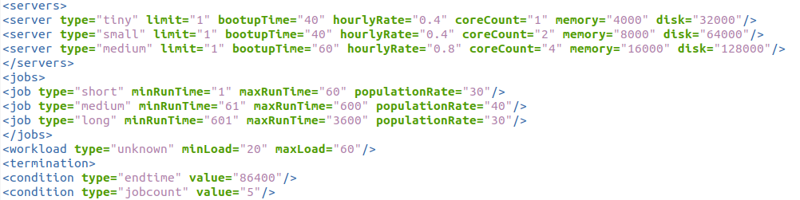**Configuration file used:** ds-config01—wk9.xml

Figure A- Configuration file

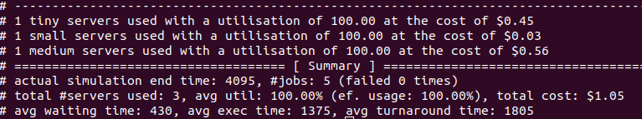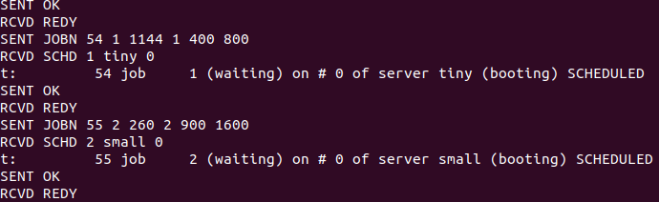

Figure B- Example Scheduling

Figure C- Final Schedule Results

**Description & Discussion:**

My algorithm works off a very simple principle: If the job requires **X** number of cores, **Y** amount of memory and **Z** amount of disk then it will be sent to a server that has the same **X** cores as long as the jobs **Y** (mem) and **Z** (disk) are lower than the servers **Y** and **Z**. If the job does not fit the above specifications it will be compared to the next largest server.

In Figure B you can see that JOBN 1 was assigned to the server “tiny” as that server has the same Core-count and larger memory and disk than the job requires (Figure A).

I went with this algorithm design because I noticed that the default “all-to-largest” algorithm was often the cheapest, but it could be even cheaper if I assigned jobs to smaller servers that had same amount of cores, mem and disk.

This overall results in a **cheap total cost** and **high average utilisation** at the cost of high turnaround time.

# Implementation Details

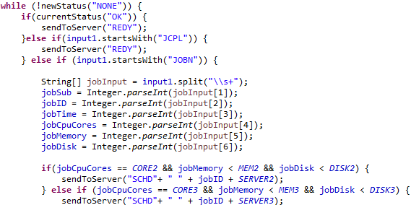

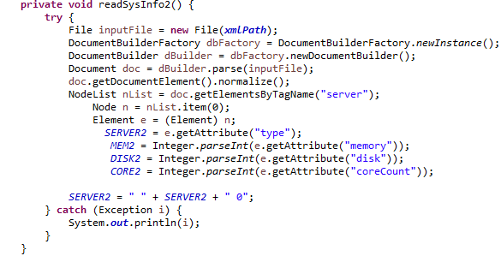

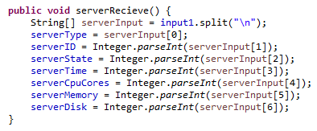

# Evaluation

**Setup test cases and configurations:**

**Results and Comparisons with FF, BF and WF:**

**Pro’s and Con’s of my algorithm:**

# Conclusion

# References

Github Repository:

https://en.wikipedia.org/wiki/Scheduling_(computing)