**Progress Report 1**

**Project ID: DERIV2D**

**Name: Manasvi Thakkar, Maksim Egorov**

**PSID: 1544259, 1664566**

1. **Overview:**

* The aim of the project is to extract partial derivatives of 2D function and compare them.
* The input is the dataset containing the X and Y points of a function A and Function B in 2D
* The output is to compare the derivates of function A with B

**Tools**

Following are the tools that we used for our project:

* Operating System: Windows
* Version control: Git
* Programming Language: Python 3.5

1. **Implementation**

We followed the following steps:

1. First, we calculated the partial derivate for X and Y points in function A by taking difference between point *i* point *i+1*
2. As the number of points in function B is greater than A, we tried to reduce the number of points in Function B. The number of points in function B is 9327 whereas the number of points in function A is 1738. So to reduce the number of points we took average of every 5 points, because number_of_pointsA / number_of_pointsB = 5.36, but since fraction not exactly 5 we ended up with still more points in function B (1865 data points) then in A (1738 data points).
3. Then we normalized the points in function A and B by using the formula

Z = (a-min)/(max-min). Where ‘a’ is a point in the function and min is min( min(A’), min(B)) and max is max(max(A’),max(B)) respectively. We did this so that the range for both would be between 0 and 1 and it would be easy to compare and plot the points.

1. **Results:**

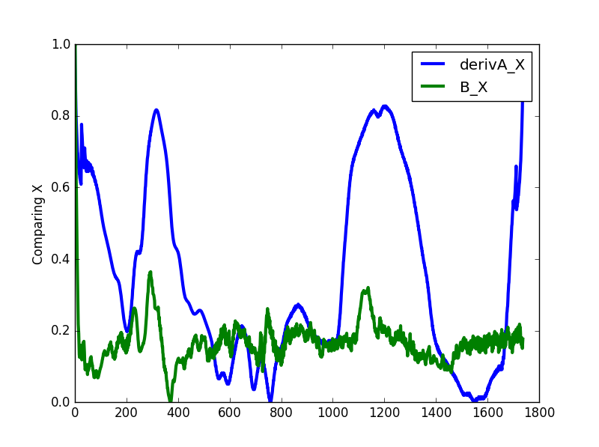We have successfully calculated the partial derivative for the points in function A. After that we tried to reduce the number of points in function B by taking the average of 5 points. But we still end up having more points in function B than in function A. We will work on reduction of points in function B in our next steps. Then we normalized the dataset for function A and function B. On the *Figure 1* we plot partial derivative X of function A and function B for points X. On *Figure 2* you can see results for Y data points.

Figure

Figure

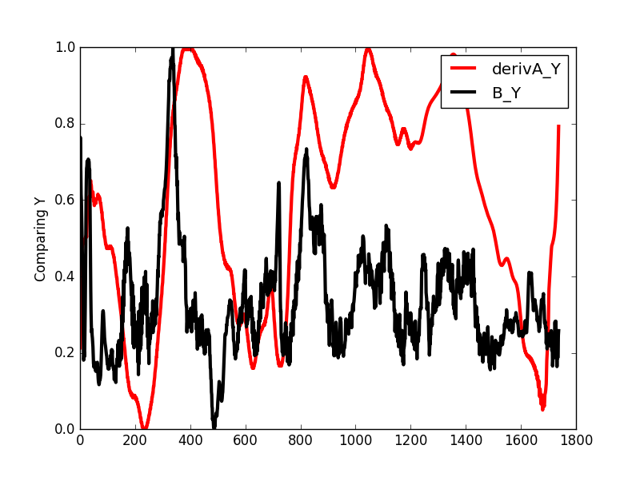

Even with presents of noise and not smooth graph for function B, we can notice that graphs of partial derivatives of function A approximately follows the same pattern as graph of function B.

1. **Future Work:**

The next step of our development involves doing critical analysis of the datasets and coming up with a solution to deal with noise. As first few points of function B are high and there can be seen lot of spikes in the graph. Once we figure out this, it will facilitate us to effectively do the comparison of derivatives of function A with function B. Also, after reducing the datasets we end up having more points in function B as compared to the number of points in function A. We will be working on this too in our next steps.