**MEMO**

**From:** Chief Technology Officer

**To:** Chief Financial Officer

**Date**: March 22, 2019

**Subject: REQUEST FOR APPROVAL FOR USSD IMPLEMENTATION AS A MEANS OF PREMIUM COLLECTION**

The above subject and attached document refers.

**Introduction:**

Unstructured Supplementary Service Data (USSD), sometimes referred to as "Quick Codes" or "Feature codes", is a protocol used by GSM cellular telephones to communicate with the service provider's computers. Essentially, USSD is an electronic means of conducting transaction via Telecommunication companies. This method does not require internet access and is accessible on any mobile phone with an active SIM card. We are proposing that FBNInsurance use this means as one of her channels of premium collection since majority, if not all our customers have a mobile phone for communication purposes.

**Project Commercials:**

The table below shows the proposed commercial per transaction

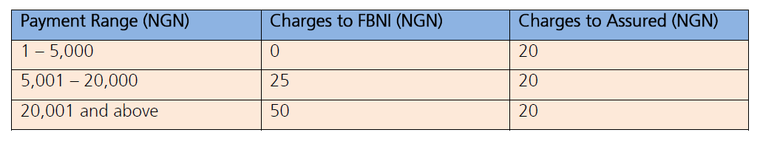

We have made enquires on what obtains elsewhere. A quote received by FBN General Insurance indicated an implementation fee of N11,000,000 (excluding VAT and maintenance fee) with a 3% transaction cost. The schedule of the commercial from this Vendor (Sifahn) is attached. The assureds’ USSD transfer charge of N20 is the normal applicable charge across banks for transfers within the bank for their customers.

**Justification:**

1. By accepting FirstBank’s offer, we will be leveraging on their existing relationship with their Service Provider (Qrios) with an Integration and implementation cost of **N5,775,000** VAT inclusive and we will ride on the *894 code thereby reducing cost on publicity if an entirely new code is generated.
2. The cost of **N5,775,000** per company was later renegotiated and discounted to **N5,197,500**. Therefore, the total implementation cost for both companies is **N10,395,000**
3. This comes with a much reduced cost to us in comparison with other electronic means of premium collection.
4. Further, most of our customers fall within the category that attracts no charges for payment of first premiums. See below our assured’s segmentation analysis based on First Premium collected:

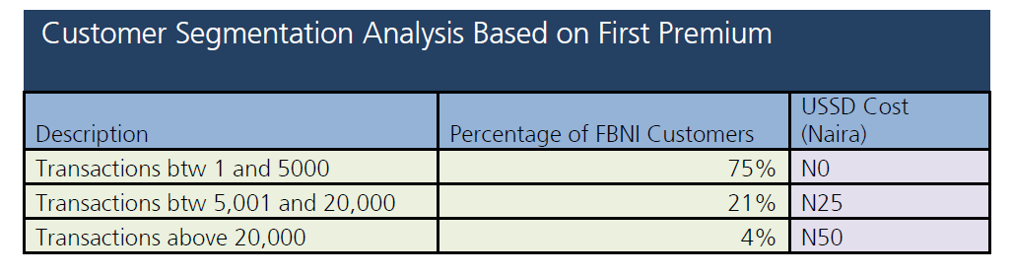

Based on the above table, 75% of First premium collected will come at no cost to us and FBNI will pay N25 per transaction on every payment above N5,000 and within N20,000.

**Conclusion/Request:**

I hereby request executive Management consideration and approval of **N5,775,000** VAT inclusive for the implementation of the USSD channel as a means of premium collection for FBNInsurance. Note that only successful transactions are charged.

Thank you.

**Rivers Khumalo**