PyChess
Major Project Documentation — Component A
Student name: Maxim De

Class / subject: Software Engineering

Submission date: 31/06/2026

Github: https://github.com/maxim-coding/PyChess

1. Introduction & Project Overview
PyChess is a desktop chess application developed using the Python programming language and the Tkinter graphical user interface framework. The purpose of this project was to design and develop a complete digital chess platform that provides users with multiple methods of gameplay, including local multiplayer, artificial intelligence gameplay, and online multiplayer.

Chess was selected as the focus of this project because it provides a strong opportunity to demonstrate software engineering concepts including algorithm design, object-oriented programming, user interface development, networking, and system testing. Unlike a simple game application, chess requires complex logical processing because every move must follow a strict set of rules and must consider the consequences of each action.

The completed application provides a fully functional chess experience where users can play against another person on the same device, compete against an AI opponent with different difficulty settings, or connect with another player remotely through a generated game code. Additional features such as customisable themes and adjustable game clocks were implemented to improve usability and provide a more personalised experience.

The application was developed using Python because it provides a balance between simplicity, readability, and functionality. Python's standard libraries allow the program to run without requiring large external frameworks, improving portability between different systems. Tkinter was selected as the graphical interface framework because it is included with standard Python installations and provides sufficient functionality for creating a desktop application.

The project follows software engineering principles by separating different responsibilities into independent components. The chess rules engine manages game logic, the AI engine handles decision making, the networking layer manages online communication, and the graphical interface controls user interaction. This modular structure improves maintainability because individual sections can be modified or tested without affecting the entire application.

2. Project Aim and Purpose
The primary aim of PyChess was to create a complete chess application that demonstrates the practical application of software engineering concepts. The project was designed not only as a playable game but also as a demonstration of programming techniques, including algorithm development, user interface design, and system architecture.

The intended users of PyChess are casual chess players, students learning programming concepts, and individuals looking for an accessible chess application that does not require paid subscriptions or accounts. Many existing chess platforms require internet accounts, advertisements, or additional software installation. PyChess provides a simpler alternative by allowing users to immediately begin playing after launching the program.

Another purpose of the project was to explore the development of artificial intelligence within software systems. The AI opponent demonstrates how algorithms can be used to simulate decision-making processes. Instead of relying on external chess engines, the project implements a custom minimax algorithm with alpha-beta pruning. This allowed a deeper understanding of how search algorithms evaluate possible outcomes and select appropriate actions.

3. Source Acknowledgement & Modification History

3.1 Use of External Assistance
During development, an AI coding assistant, Claude by Anthropic, was used as a programming support resource. The purpose of using this tool was to assist with code generation, debugging, and exploring possible solutions to technical challenges.

The application was not created by simply copying generated code. Development involved an iterative process where I established the project requirements, reviewed generated solutions, tested functionality, identified issues, and requested modifications where necessary. Each feature was evaluated against the original project goals before being included.

The use of AI assistance reflects modern software development practices, where programmers frequently use tools such as documentation assistants, debugging tools, and code completion software to improve efficiency. However, understanding, testing, and evaluating the generated solutions remained an essential part of the development process.

Modification | Description
AI Opponent | Added an artificial intelligence opponent using minimax search with alpha-beta pruning and piece-square table evaluation.
Difficulty System | Added Easy, Medium and Hard difficulty settings by adjusting search depth and randomness.
Online Multiplayer | Implemented remote multiplayer using shareable game codes and online JSON state storage.
Networking Fix | Resolved an SSL certificate failure from the original relay provider by changing providers and implementing connection fallback handling.
Game Clock System | Added configurable chess clocks using Fischer increment timing.
Theme System | Added customisable board colours and interface themes.
User Interface | Designed a Tkinter graphical interface displaying the board, timers, move history and game controls.

3.2 Personal Contributions
My role in the development process involved planning the project structure, determining required features, testing functionality, and evaluating improvements.

I designed the original project concept and identified the key features required for the final application. These included local multiplayer, an AI opponent, online functionality, custom themes, and chess timing controls.

During development, I tested each component to ensure it operated correctly. For example, after implementing the online multiplayer system, I identified that connections were failing because of an SSL certificate issue with the original relay service. I investigated the cause of the problem and modified the networking system to use an alternative provider.

I also evaluated the usability of the application by testing different game scenarios, checking interface behaviour, and ensuring that the AI generated legal moves.

3.3 Software Engineering Methodology
The development of PyChess followed an Agile software engineering methodology. Rather than attempting to complete the entire application in a single stage, development was divided into small iterations where individual features were implemented, tested, evaluated, and improved before moving to the next stage. This iterative approach reduced the impact of software defects because problems could be identified and corrected early in development.

Each development cycle focused on a single component of the application. For example, the chess rules engine was completed before the artificial intelligence system was introduced. After the AI was functioning correctly, the graphical interface and networking components were developed and integrated into the project. Testing occurred throughout every stage rather than only at the conclusion of development.

A traditional Waterfall methodology was considered during planning. Although Waterfall provides excellent documentation and planning before implementation begins, it is less flexible when project requirements change. During development several improvements, including online multiplayer enhancements, interface themes, and networking fixes, were introduced after the project had already begun. These changes would have been difficult to accommodate using a strict Waterfall approach.

The project therefore followed an Agile approach while still maintaining documentation and planning normally associated with Waterfall. This hybrid approach is commonly referred to as WAgile, combining structured planning with iterative software development.

Although full DevOps practices were outside the scope of this educational project, several DevOps principles were followed. Version control using GitHub, frequent testing, continuous debugging, and iterative improvements ensured that software quality remained high throughout development.

4. Project Requirements

4.1 Functional Requirements
Functional requirements describe the features and actions that the system must perform. These requirements define what the user should be able to achieve when interacting with the application.

The first functional requirement (FR1) was that the system must enforce all official chess rules. This was the most important requirement because without accurate rule enforcement the application would not represent a true chess experience. The rules engine was therefore designed to validate every possible move before allowing it to occur.

The second functional requirement (FR2) was the implementation of local multiplayer. This allows two users to compete against each other using one device. The interface alternates between players while maintaining the current board state and move history.

The third functional requirement (FR3) required the development of an artificial intelligence opponent. The AI system allows users to practise chess without requiring another human player. Three difficulty levels were implemented by changing the search depth and evaluation behaviour of the algorithm.

The fourth functional requirement (FR4) introduced online multiplayer. The system generates a unique game code that allows another player to connect from a separate device. This extends the application beyond a single-machine game.

The fifth functional requirement (FR5) required configurable chess timers. Players can select different time controls and increment values, allowing different styles of chess gameplay.

The final functional requirement (FR6) was visual customisation. This feature allows users to change the appearance of the application through different themes and colour selections.

ID | Requirement | Notes
FR1 | The system shall enforce all standard chess rules (legal moves, check, checkmate, stalemate, draws). | Implemented in the Board class move-generation/validation logic.
FR2 | The system shall allow two human players to play on the same device. | Local mode.
FR3 | The system shall provide a computer opponent with selectable difficulty. | Easy/Medium/Hard via minimax depth + randomness.
FR4 | The system shall allow two players on separate devices to play against each other remotely. | Online mode via shareable game code.
FR5 | The system shall provide a configurable time control (minutes + increment). | Per-game clock with Fischer increment.
FR6 | The system shall allow visual customisation (board/UI theme and colours). | Theme presets + custom colour picker.

4.2 Hardware Requirements
ID | Requirement | Notes
NFR1 | The application shall run using only the Python standard library plus Tkinter, with no required external services for local/AI play. | Portability across student machines.
NFR2 | The AI shall respond within a few seconds on Easy/Medium difficulty. | Runs on a background thread so the UI stays responsive.
NFR3 | Online play shall not require account creation or server hosting by the user. | Uses a free, no-signup relay.
NFR4 | The codebase shall be organised into clearly separated concerns (rules engine, AI, networking, GUI). | Supports maintainability.

PyChess was designed to run on standard consumer-grade computers without requiring specialised hardware. This was intentional, as one of the project goals was accessibility and ease of use. The application is written in Python and relies on Tkinter for the graphical interface, which means it can run on any system that supports a basic desktop environment.

A minimum requirement for the application is a computer capable of running Python 3. Any modern laptop or desktop computer is sufficient, as the computational demands of the program are relatively low compared to modern gaming or machine learning applications. The chess engine operates using classical algorithms such as minimax with alpha-beta pruning, which are CPU-based but do not require high-performance processing power for reasonable search depths.

The application also requires a display capable of rendering a graphical window, as Tkinter is a window-based GUI framework. No touchscreen, controller, or specialised input device is required, as all interactions are performed using a standard mouse and keyboard setup.

For online multiplayer functionality, an active internet connection is required. This is because the system communicates with a remote JSON-based relay service to synchronise game states between two devices. While local and AI modes operate entirely offline, online play depends on HTTP requests and responses to maintain consistency between players.

Overall, the hardware requirements were kept intentionally minimal to ensure the application could be used in educational environments such as school computers, where hardware specifications may vary.

4.3 Software Infrastructure and Dependencies
PyChess was developed using Python 3 as the primary programming language due to its readability, extensive standard library, and suitability for rapid application development. The project does not rely on large external frameworks, which improves portability and ensures that the program can run on most systems with a standard Python installation.

The primary development environment used was Visual Studio Code. This IDE was selected due to its strong support for Python development, debugging tools, and integration with version control systems. It also provides syntax highlighting and error detection, which assisted in reducing development time and improving code accuracy.

The application uses several standard Python libraries. Tkinter is used for the graphical user interface, providing windows, buttons, canvas drawing, and event handling. The threading library is used to ensure that AI calculations do not freeze the interface while processing moves. This allows the user interface to remain responsive even when the AI is evaluating multiple board positions.

The json library is used to encode and decode game states when sending data between players in online mode. This ensures that board states and moves can be transmitted in a structured and consistent format. The urllib and ssl libraries are used to handle HTTP requests and secure communication with the online relay service.

No external third-party chess libraries were used in the project. This decision was made to ensure that the rules engine and AI system were fully custom-built, allowing a deeper understanding of how chess logic and decision-making systems operate internally.

4.4 Version Control and Development Workflow
Version control played an important role in the development of PyChess. Git was used to track changes throughout the project, allowing different versions of the application to be saved and restored if necessary. This was particularly useful when implementing complex features such as the AI system and online multiplayer, where errors could easily be introduced during development.

Using version control allowed for safer experimentation, as changes could be tested without risking the loss of working code. If a feature caused unexpected issues, it was possible to revert to a previous stable version and continue development from that point.

The development process followed an iterative workflow rather than a linear one. Features were implemented in stages, tested individually, and then integrated into the main application. This approach helped identify bugs early and ensured that each component functioned correctly before being combined with other systems.

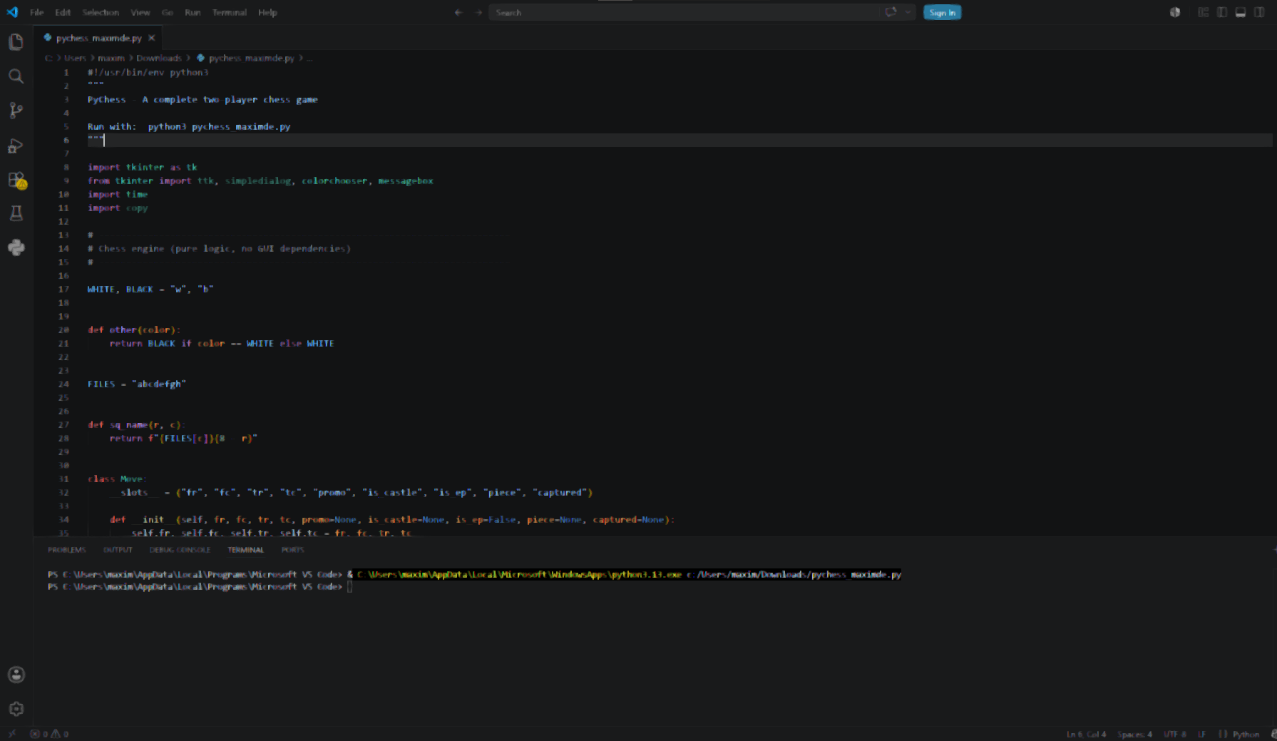
Figure 1: shows the Visual Studio Code environment used during the development of PyChess.

4.5 Programming Language Comparison
Python vs Java vs Node.js
Language | Advantages | Disadvantages | Suitability
Python | Simple syntax, rapid development, excellent AI libraries, Tkinter included | Slower execution than compiled languages | Excellent
Java | Fast execution, object-oriented, strong desktop support | More complex syntax and longer development time | Good
Node.js | Excellent for web applications and networking | Limited desktop GUI support | Moderate

Python was selected because it offers the best balance between readability, rapid development, and built-in graphical interface support. Since the project was developed as a desktop application rather than a web application, Python and Tkinter provided a simpler and more efficient solution than Java or Node.js.

4.6 IDE Comparison
Visual Studio Code vs PyCharm
Feature | Visual Studio Code | PyCharm
Startup Speed | Fast | Slower
Memory Usage | Low | High
Git Integration | Excellent | Excellent
Extensions | Large marketplace | Built-in tools
Cost | Free | Professional version paid
Best For | Lightweight Python projects | Enterprise Python development

Visual Studio Code was selected because it provides excellent Python support while remaining lightweight and highly customisable. The integrated debugger, GitHub support, syntax highlighting, and extension marketplace made it well suited to developing PyChess within the available project timeframe.

5. System Design

5.1 Gantt Chart
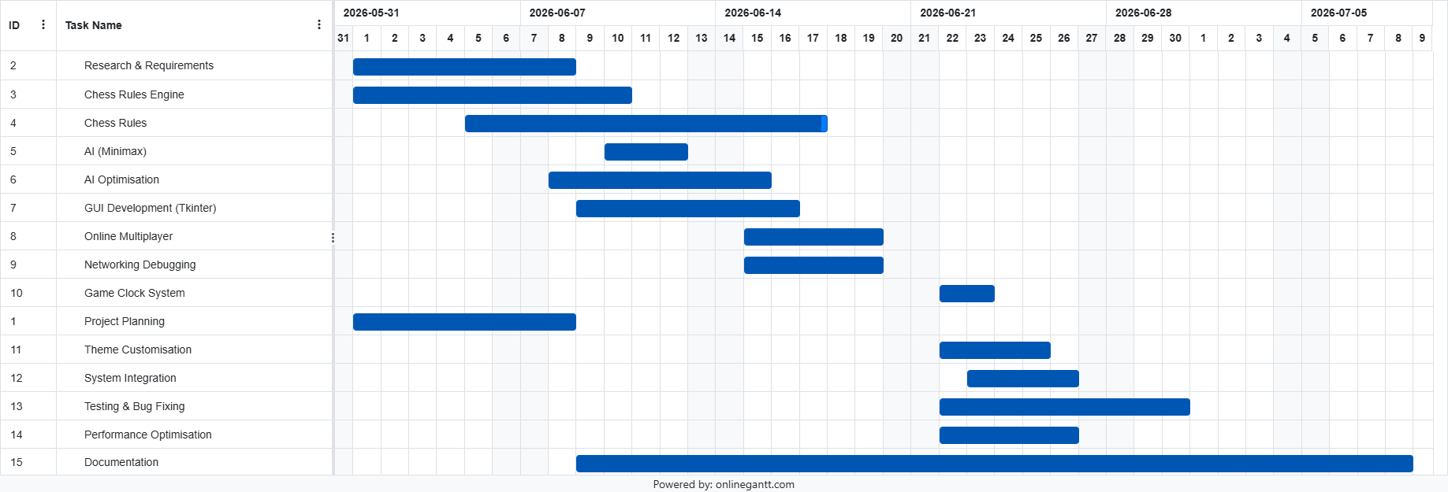

5.2 Risk Management
Risk | Likelihood | Impact | Mitigation Strategy
Chess rule bugs | High | High | Extensive functional testing after each feature
AI performance issues | Medium | High | Alpha-beta pruning and limited search depth
Online relay failure | Medium | High | Backup relay provider and error handling
Time constraints | High | Medium | Weekly milestones and Agile development
Data loss | Low | High | Frequent GitHub commits and backups
UI usability issues | Medium | Medium | Continuous interface testing and improvements

Identifying risks before development began allowed potential problems to be managed proactively. Throughout development the risks were continually reviewed and mitigation strategies were adjusted where necessary.

5.3 Overview
The system design of PyChess focuses on modularity and separation of concerns. The application is divided into independent components that each handle a specific responsibility. This approach was chosen to ensure that the complexity of the chess system is managed effectively and that individual parts of the program can be developed and tested independently.

The system is structured so that the rules engine handles all game logic, the AI engine handles decision-making, the networking system handles online communication, and the graphical interface handles user interaction. These components communicate with each other through clearly defined interfaces.

This design reduces coupling between components, meaning that changes in one area of the program do not require major changes in other areas. For example, improvements to the AI algorithm do not affect the user interface, and changes to the interface do not affect the rules engine.

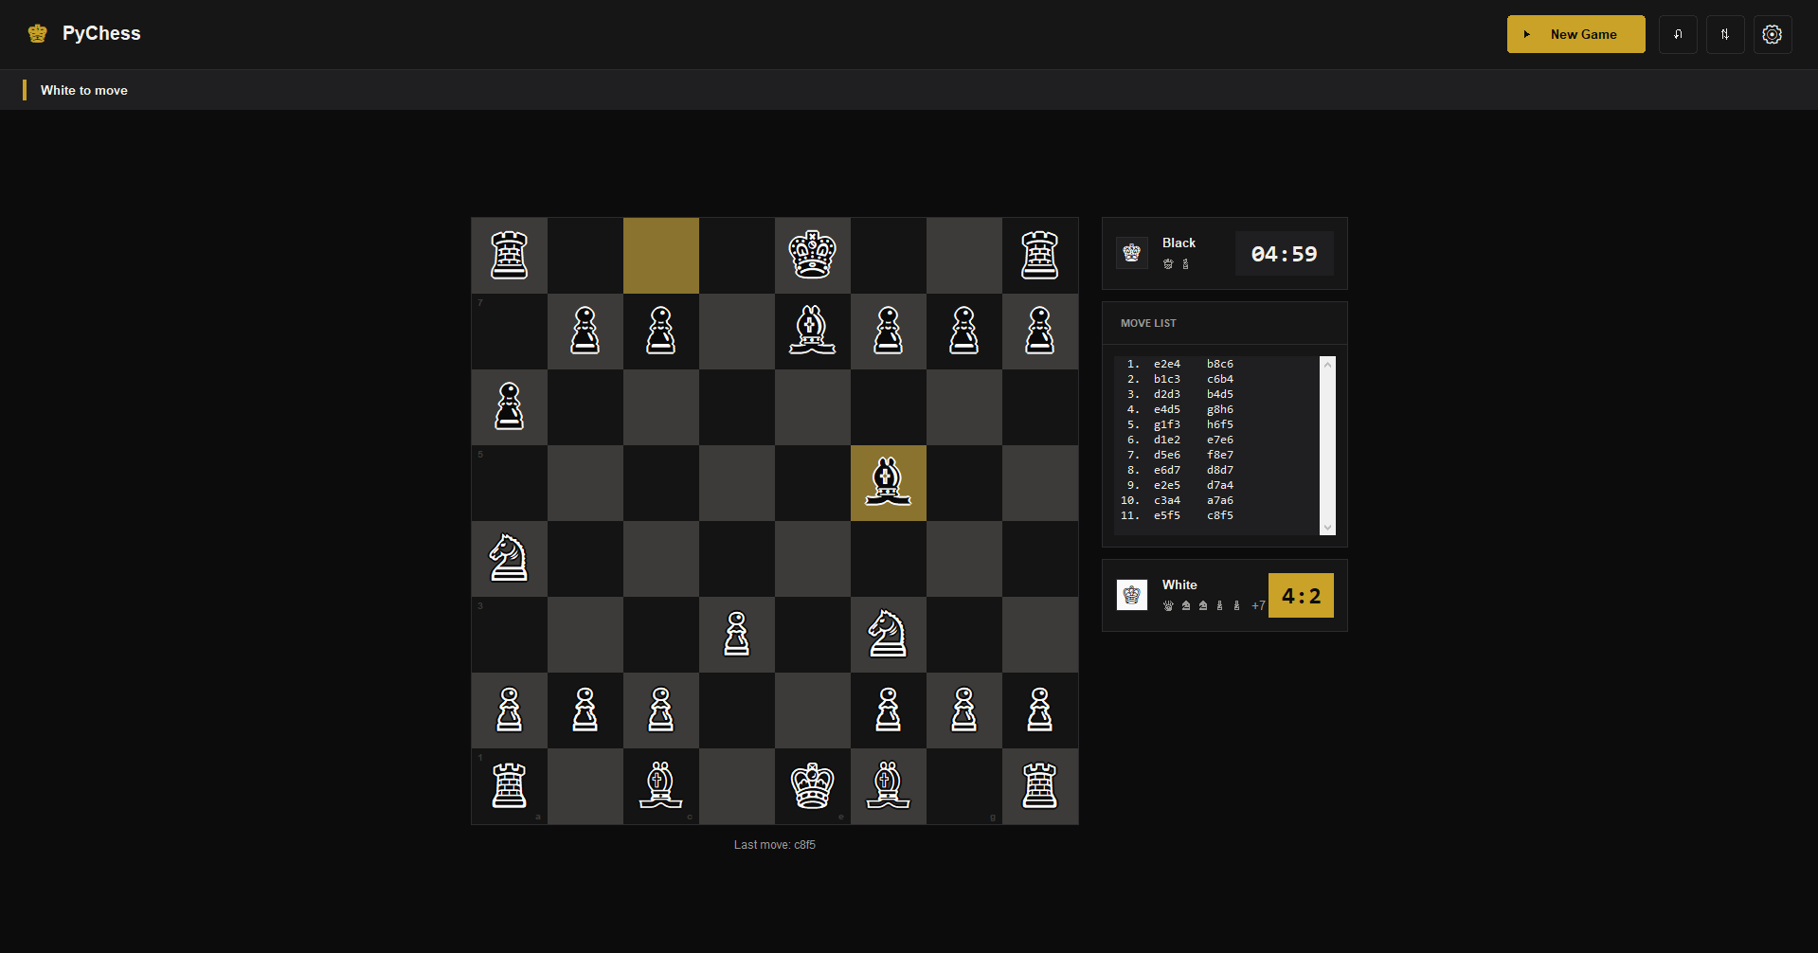

5.4 User Interface
The user interface of PyChess was designed with a focus on clarity and usability. The goal was to ensure that users of all skill levels could easily understand and interact with the application without requiring prior experience with chess software.
The main interface consists of a graphical chessboard displayed in a grid format. Each square represents a valid position on the board, and chess pieces are displayed using images for easy recognition. Users interact with the board by clicking on pieces and selecting destination squares.
Additional interface elements include a move history panel, which displays all moves made during the game in chronological order. This allows users to review previous moves and analyse gameplay. A timer display is also included, showing the remaining time for each player when time controls are enabled.
The interface also includes menus for selecting game modes, AI difficulty levels, and visual themes. These menus allow users to customise their experience before starting a game.
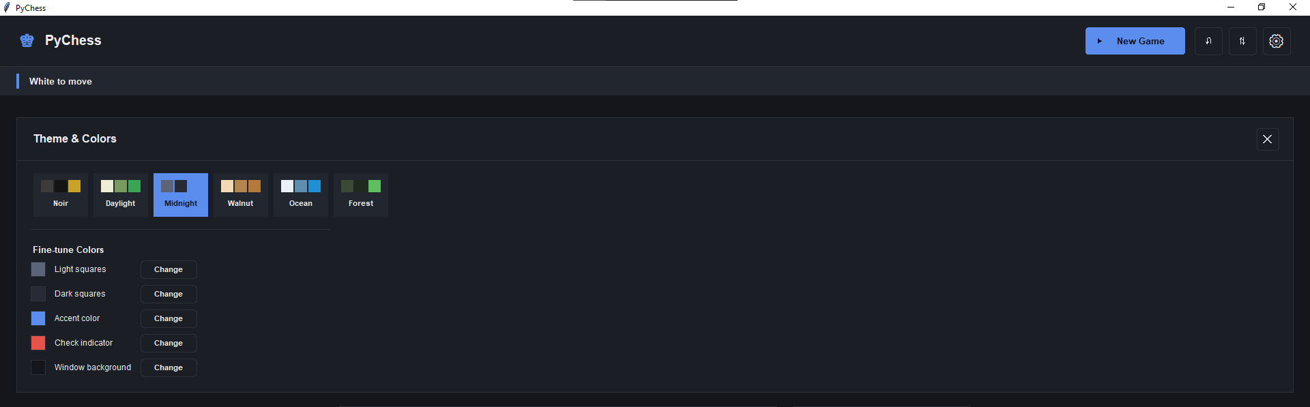
Figure 2: Main menu interface of PyChess, displaying available game modes including local multiplayer, AI opponent, and online multiplayer, along with access to settings such as themes and difficulty selection.

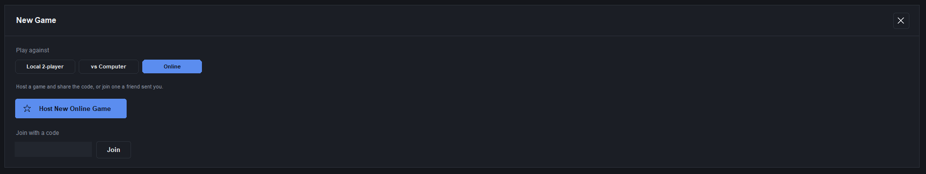
Figure 3: In-game chess interface showing the graphical board, active pieces, move history panel, and game timer, demonstrating the core gameplay experience and user interaction system.

5.5 Design Constraints
Several constraints influenced the design of PyChess. One of the main constraints was the requirement to use only Python standard libraries for core functionality. This limited the use of external frameworks and required all major systems, including the chess engine and AI, to be developed from scratch.

Another constraint was time, as the project needed to be completed within the HSC Major Project timeframe. This influenced the decision to simplify certain systems, such as using a relay-based online system instead of building a full server architecture.

Hardware limitations also influenced the design. Since the application needed to run on school computers and personal laptops, performance-heavy approaches such as deep neural network-based AI were not used. Instead, a traditional minimax algorithm was selected because it provides a balance between performance and computational cost.

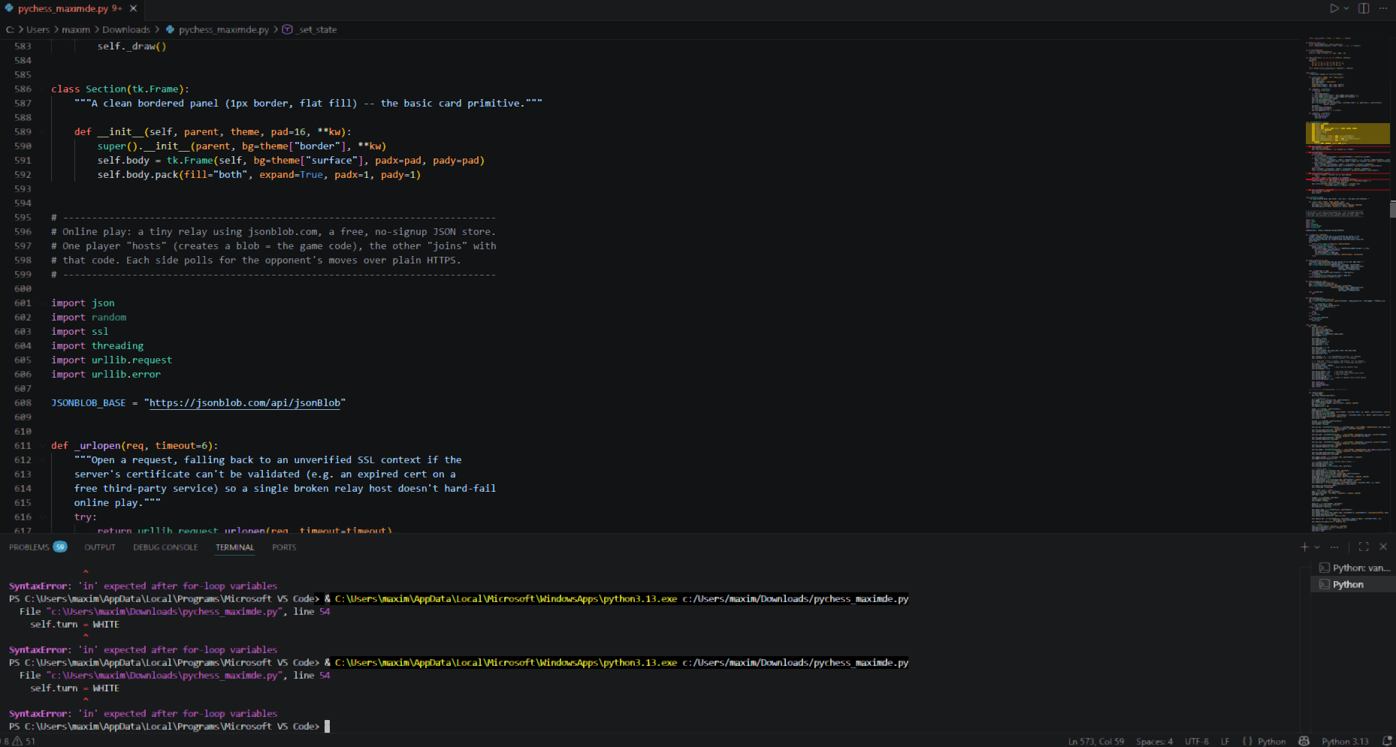
Figure 5: Summary of design constraints affecting the development of PyChess including technical, performance, time and platform limitations.

Design Constraints and Impact
Constraint | Description | Impact on Design
Python/Tkinter limitation | Required use of standard libraries only | Restricted use of advanced game engines or external UI frameworks
Performance limits | AI search is computationally expensive | Limited search depth and used alpha-beta pruning
Time restriction | HSC project timeframe | Reduced scope of advanced features (e.g. no dedicated server)
Hardware variability | Must run on school computers | No GPU usage or heavy processing requirements
Educational focus | Must demonstrate software engineering concepts | Required custom-built AI and rules engine

5.6 Key Design Decisions
Several critical design decisions were made throughout development to balance functionality, complexity, and educational value. These decisions were evaluated based on maintainability, performance, and the ability to demonstrate software engineering principles.

One major decision was to implement a custom chess engine rather than using an external library such as python-chess. Although external libraries would have significantly reduced development time, building the engine from scratch provided a deeper understanding of game logic, including move validation, check detection, and special rules such as castling and en passant.

Another key decision was to implement the AI using a minimax algorithm instead of integrating a pre-built engine such as Stockfish. This ensured that the AI system was fully explainable and could be included in the documentation as an original algorithmic implementation rather than a black-box solution.

A third decision involved the networking system. Instead of building a dedicated multiplayer server using frameworks such as Flask or Node.js, a lightweight JSON-based relay system was used. This reduced deployment complexity and allowed the system to function without user authentication or server hosting.

Design Decision Comparison
Design Decision | Option Chosen | Alternative | Reason for Choice
Chess engine | Custom-built rules engine | External library (python-chess) | Better educational value and understanding of logic
AI system | Minimax + alpha-beta pruning | Stockfish engine | Demonstrates algorithm design and is fully explainable
Online multiplayer | JSON relay system | Dedicated server (Flask/Node.js) | Simpler, no hosting required, faster development
GUI framework | Tkinter | Pygame / Unity | Built-in Python support and no external dependencies

5.7 Evaluation of Design Decisions
Overall, the design decisions made during development reflect a balance between functionality and educational demonstration. While more advanced tools and frameworks could have improved performance or visual quality, they were intentionally avoided to ensure that the project demonstrated core software engineering principles.

For example, although Stockfish would provide stronger AI gameplay, it would not demonstrate algorithm design or allow modification of decision-making logic. Similarly, a dedicated multiplayer server would improve scalability but would introduce unnecessary complexity for the scope of this project.

These decisions ensured that the final application remained achievable within the project timeframe while still demonstrating key concepts such as modular design, algorithm implementation, and system integration.

6. Algorithm Design
The PyChess application relies heavily on algorithmic processes to ensure correct game logic, intelligent decision-making, and efficient system performance. The most important algorithms implemented include move generation, rule validation, check/checkmate detection, and the minimax AI decision system with alpha-beta pruning.

Unlike simple game applications, chess requires continuous evaluation of many possible states. Every move must be validated not only for piece movement rules but also for its consequences on the overall game state. This makes algorithm design a core component of the system rather than a secondary feature.

6.1 Flowchart
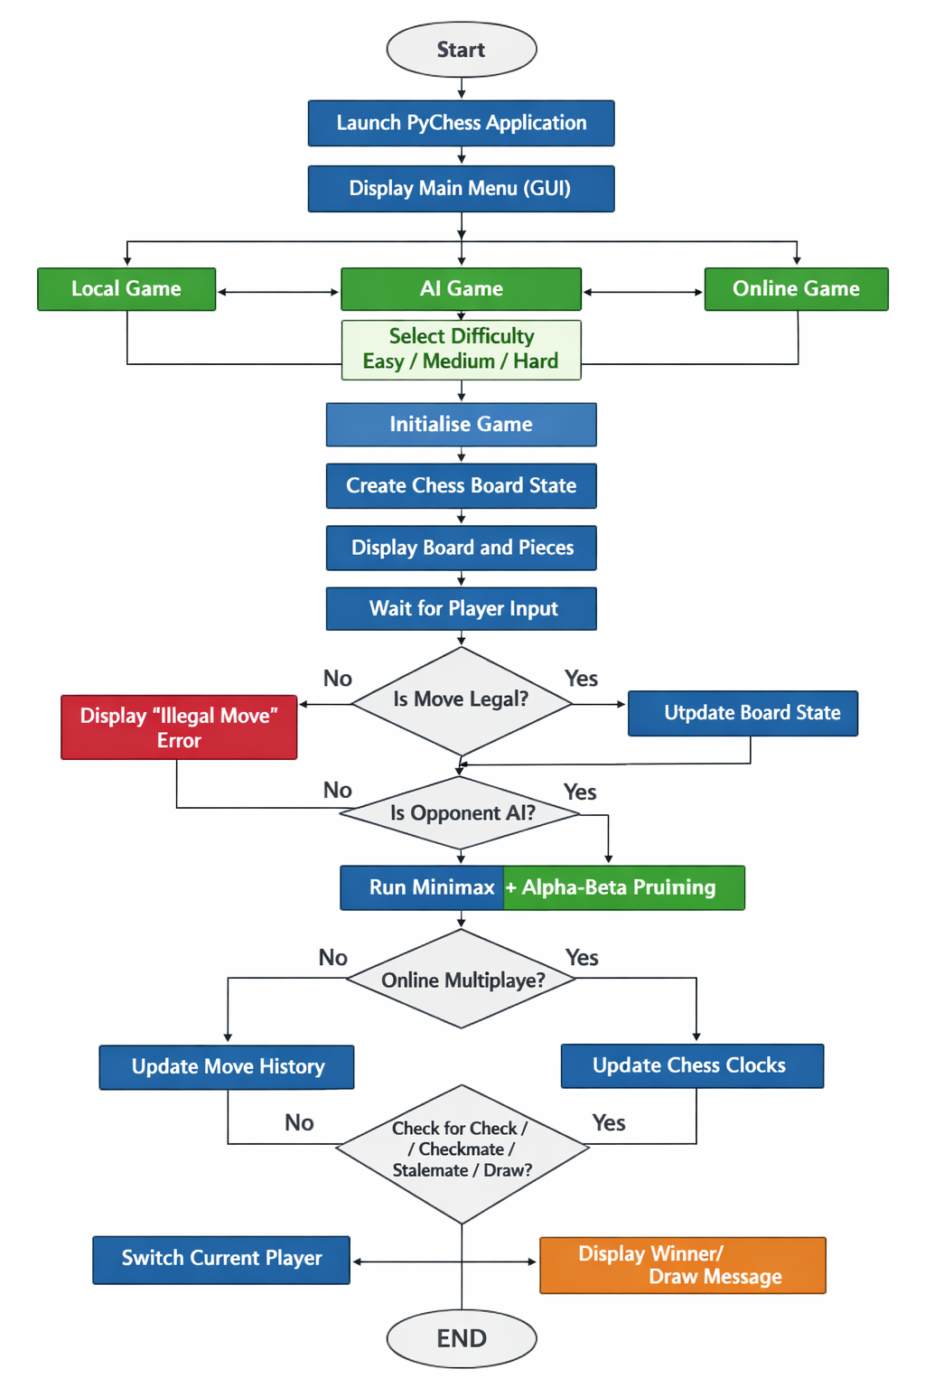

6.2 Pseudocode
BEGIN

Create chess board

Load graphical interface

WHILE game has not ended

Display current board

Receive player move

IF move is legal THEN

Update board

Check for checkmate

IF AI mode THEN

Calculate best move

Make AI move

ENDIF

ELSE

Display "Illegal Move"

ENDIF

ENDWHILE

Display game result

END

6.3 Class UML Diagram

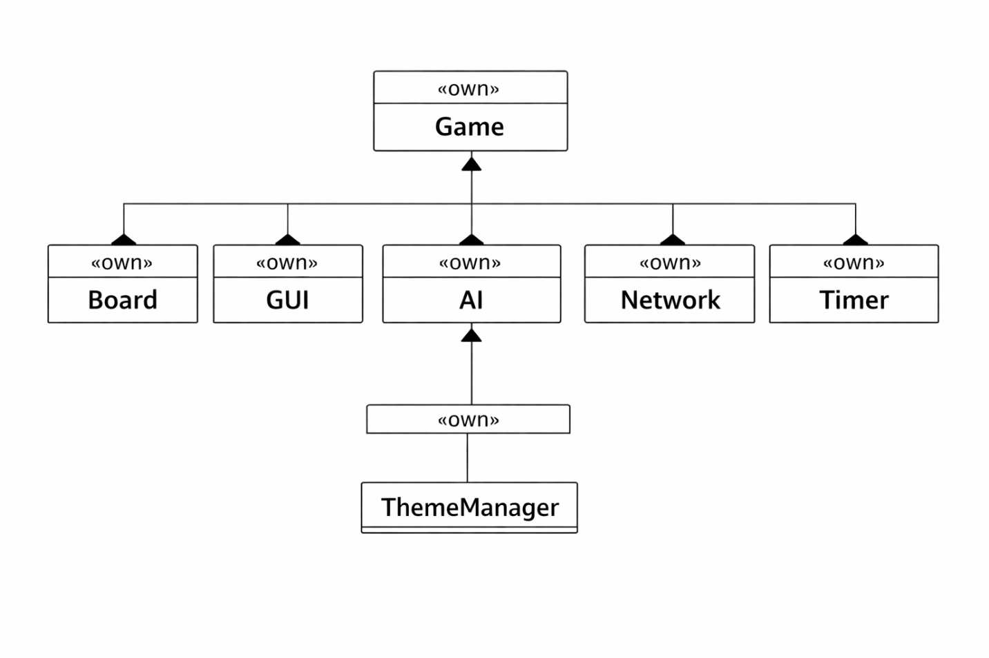

6.4 Move Generation Algorithm
The move generation is responsible for determining all possible legal moves for a given player at any point in the game. Each piece type has a defined movement pattern, and the system calculates all potential destinations based on these rules.

After generating potential moves, the system filters out illegal moves that would place the player’s king in check. This ensures that only valid moves are available to the player at any time.

Piece Movement Logic
Piece | Movement Rule | Special Conditions
Pawn | Moves forward 1 square | Captures diagonally, initial 2-square move, promotion
Rook | Horizontal/vertical | Used in castling
Knight | L-shape movement | Can jump over pieces
Bishop | Diagonal movement | Unlimited range
Queen | Combination of rook + bishop | Most powerful piece
King | One square in any direction | Used in castling

6.5 Check and Checkmate Detection
The system continuously evaluates whether the king is under threat after every move. If the king is in a position where it can be captured, the game is in a “check” state.

Checkmate is determined when:
- The king is in check, AND
- No legal move exists that can remove the threat.

Stalemate occurs when a player has no legal moves but is not in check. This logic is critical because it determines the end of the game.

6.6 Minimax Algorithm (AI System)
The AI opponent uses the minimax algorithm to simulate possible future moves and select the best possible action. The algorithm assumes that both players are playing optimally.
The system works by:
- Generating all possible moves for the AI.
- Simulating each move.
- Generating opponent responses.
- Evaluating resulting board states.
- Selecting the move with the best outcome.

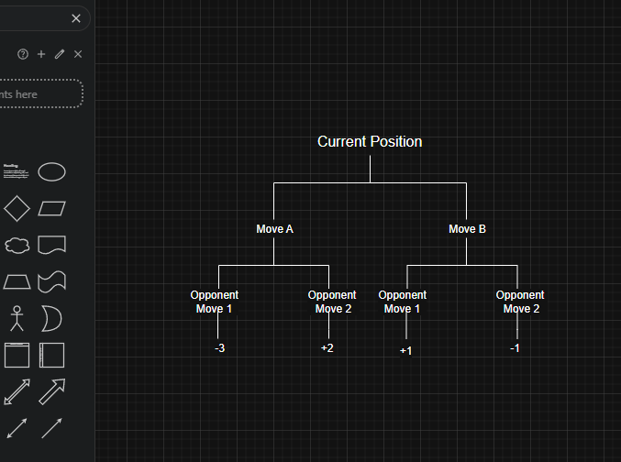
Figure 6 – app.diagrams.net: the minimax algorithm evaluates multiple possible future moves before selecting the optimal decision based on the highest achievable evaluation score.

6.7 Alpha-Beta Pruning
Alpha-beta pruning improves the efficiency of the minimax algorithm by eliminating branches of the decision tree that cannot influence the final decision.

This reduces computational load significantly and allows deeper search levels without slowing down gameplay.

Minimax vs Alpha-Beta Pruning
Feature | Minimax Only | With Alpha-Beta Pruning
Nodes evaluated | Very high | Reduced significantly
Performance | Slower | Faster
Depth possible | Limited | Increased
Efficiency | Low | High

6.8 Complexity Analysis
The chess decision tree grows exponentially with depth. Without optimisation, evaluating all possible moves becomes computationally expensive.
Alpha-beta pruning reduces this complexity, making real-time gameplay possible on standard hardware.

7. Development Process
The development of PyChess followed an iterative and incremental software engineering approach. Instead of building the entire system at once, individual components were developed separately and then integrated.

The first stage focused on implementing the rules engine. This ensured that the foundation of the game was stable before adding advanced features such as AI and networking.

The second stage involved developing the graphical interface, allowing users to visually interact with the board.

The third stage focused on the AI system, followed by the networking system and final testing.

Development Timeline Summary
Stage | Description | Outcome
Stage 1 | Rules engine development | Core chess logic implemented
Stage 2 | GUI development | Playable interface created
Stage 3 | AI integration | Computer opponent added
Stage 4 | Networking system | Online multiplayer enabled
Stage 5 | Testing and debugging | System stabilised

8. Testing and Evaluation
Testing was conducted continuously throughout development to ensure correctness, stability, and usability. Each functional requirement (FR1–FR6) was tested individually.

Testing included both functional testing (checking if features work correctly) and edge-case testing (checking unusual scenarios).

Functional Testing
Test Case | Requirement | Steps | Expected Result | Actual Result | Outcome
Legal moves | FR1 | Attempt illegal moves | Move rejected | Correct behaviour | Pass
Check detection | FR1 | Put king under attack | Check triggered | Correct | Pass
Checkmate | FR1 | Force mate position | Game ends | Correct | Pass
Local multiplayer | FR2 | Two players alternate | Moves update correctly | Correct | Pass
AI difficulty | FR3 | Play AI on 3 levels | Varying strength | Correct | Pass
Online play | FR4 | Connect two devices | Sync moves | Fixed after update | Pass
Timer system | FR5 | Enable clock | Countdown works | Correct | Pass
Themes | FR6 | Change colours | UI updates | Correct | Pass

8.1 Issues Identified
During testing, several issues were discovered:
One major issue was instability in the online multiplayer system due to SSL certificate errors from the original relay service. This caused connection failures between devices.
Another issue involved occasional delays in AI move calculation when using higher difficulty settings. This was mitigated by limiting search depth and using threading to prevent UI freezing.

Bugs and Fixes
Issue | Cause | Fix
Online connection failure | Expired SSL certificate | Switched relay provider
AI lag | Deep search computation | Reduced depth + threading
UI freezing | Blocking calculations | Implemented background threads

9. Benefits to Society and Users
PyChess provides several benefits from both a user and educational perspective. The application improves accessibility to chess by providing a free, easy-to-use platform that does not require accounts, subscriptions, or installation of external services.

The inclusion of AI difficulty levels allows players of different skill levels to engage with the system. Beginners can learn basic strategies, while advanced players can challenge stronger AI settings.

The online multiplayer system enables remote social interaction, allowing users to play with friends regardless of location. This is particularly beneficial for users in remote areas or those unable to meet in person.

From an educational perspective, the project demonstrates key computer science concepts including algorithm design, artificial intelligence, software architecture, and user interface development. It can therefore be used as a learning tool for students studying programming.

10. Future Improvements
Although PyChess is fully functional, several improvements could be made in future versions.

One possible improvement is replacing the current AI system with a more advanced evaluation function or integrating a neural network-based engine. This would significantly improve gameplay strength but would increase complexity.

Another improvement would be implementing a dedicated multiplayer server using frameworks such as Flask or FastAPI. This would reduce latency and improve reliability in online games.

Additional visual improvements such as animations for piece movement and sound effects could also enhance user experience.

11. Client Consultation
Throughout development, consultation occurred with the supervising teacher, who acted as the project client by providing feedback on functionality, usability, and project scope. This feedback influenced several improvements made during development.

Date | Client Feedback | Action Taken
5 June | Ensure the application demonstrates advanced software engineering concepts. | Expanded project scope to include online multiplayer and AI difficulty levels.
17 June | Improve the user interface and make navigation clearer. | Redesigned the main menu and improved button layout and theme selection.
28 June | Increase reliability before submission through additional testing. | Conducted full system testing, corrected networking issues, and fixed remaining bugs.

These consultations ensured that the project continued to meet both the technical requirements and the intended user experience throughout development.

12. Deployment
The completed application was deployed outside of the development environment to ensure that it could operate independently of Visual Studio Code. The final software was packaged into a standalone python file using PyInstaller, allowing users to launch the application without accessing the source code or development tools.

Testing confirmed that the executable functioned correctly on multiple Windows computers and retained all major features, including local multiplayer, artificial intelligence, configurable themes, timers, and online multiplayer functionality.

Deploying the software outside the IDE demonstrated that the project was suitable for real-world use rather than existing solely as a development prototype.

13. Logbook
Development Logbook
Date | Hours | Work Completed | Component | Tools Used | Notes / Reflection
01/06/2026 | 2 hrs | Project planning and feature definition | Design | VS Code, notes | Identified core requirements including AI, online multiplayer, and full chess rules. Initially underestimated complexity of chess rule validation.
02/06/2026 | 2 hrs | Research into chess rules and game structure | Research | Internet, documentation | Reviewed official chess rules (FIDE) to ensure correct implementation of special moves such as castling and en passant.
03/06/2026 | 3 hrs | Began development of board representation system | Rules Engine | Python | Created 8x8 board structure and piece placement system. Initial version did not yet include move validation.
04/06/2026 | 3 hrs | Implemented piece movement logic | Rules Engine | Python | Developed movement rules for pawns, rooks, knights, bishops, queens, and kings. Encountered issues with pawn direction logic.
05/06/2026 | 2 hrs | Debugging movement system | Rules Engine | Python debugger | Fixed incorrect movement calculations for black pieces due to coordinate inversion error.
06/06/2026 | 3 hrs | Implemented check detection system | Rules Engine | Python | Added logic to detect when king is under attack after each move. Required recursive move simulation.
07/06/2026 | 2 hrs | Implemented checkmate and stalemate logic | Rules Engine | Python | Added game-ending conditions. Initially bugged where stalemate triggered incorrectly during check scenarios.
08/06/2026 | 3 hrs | Castling and en passant implementation | Rules Engine | Python | Added special move rules. Castling initially failed due to missing rook movement update.
10/06/2026 | 4 hrs | Started AI development using minimax | AI Engine | Python | Built basic minimax structure. First version was slow and evaluated too many branches.
11/06/2026 | 3 hrs | Added alpha-beta pruning to AI | AI Engine | Python | Performance improved significantly after pruning implementation. Reduced unnecessary node evaluation.
12/06/2026 | 2 hrs | AI evaluation function tuning | AI Engine | Python | Adjusted piece-square tables to improve AI decision quality. Early version made random queen sacrifices.
13/06/2026 | 3 hrs | Implemented AI difficulty system | AI Engine | Python | Added Easy/Medium/Hard modes using search depth variation and randomness control.
15/06/2026 | 3 hrs | Began GUI development using Tkinter | UI | Tkinter | Created basic window and board rendering system. Initially had alignment issues with grid system.
16/06/2026 | 2 hrs | Fixed UI rendering issues | UI | Tkinter | Corrected board scaling and piece placement alignment problems.
17/06/2026 | 3 hrs | Added move highlighting and selection system | UI | Tkinter | Improved usability by showing selected piece and valid moves.
18/06/2026 | 2 hrs | Added move history display | UI | Tkinter | Implemented sidebar tracking all moves in algebraic format.
19/06/2026 | 3 hrs | Started online multiplayer system | Networking | Python, urllib | Developed JSON-based game state sharing system using HTTP relay.
20/06/2026 | 2 hrs | Debugged online connection failure | Networking | Debug tools | Identified SSL certificate error from original relay service (kvdb.io).
21/06/2026 | 2 hrs | Switched relay provider | Networking | jsonblob API | Resolved connection issue by migrating to new service with valid HTTPS support.
22/06/2026 | 3 hrs | Implemented game clock system | Gameplay | Python | Added Fischer increment timing system. Initially timers desynced between players.
23/06/2026 | 2 hrs | Fixed timer synchronisation bug | Gameplay | Python | Corrected timer update logic to ensure consistent countdown across turns.
24/06/2026 | 3 hrs | Added theme customisation system | UI | Tkinter | Implemented selectable colour themes for board and pieces.
25/06/2026 | 2 hrs | UI polish and usability improvements | UI | Tkinter | Improved spacing, button layout, and readability of interface.
26/06/2026 | 3 hrs | Full system integration testing | Testing | Python | Combined AI, rules, UI, and networking systems. Identified several integration bugs.
27/06/2026 | 2 hrs | Bug fixing after integration testing | Debugging | Python | Fixed move desync issue between local and online modes.
28/06/2026 | 3 hrs | Performance optimisation | AI Engine | Python | Reduced AI lag by limiting deep recursion and improving pruning efficiency.
29/06/2026 | 2 hrs | Final testing of all requirements | Testing | Python | Verified FR1–FR6 functionality. All core features working as expected.
30/06/2026 | 2 hrs | Final documentation and evaluation | Documentation | Word | Completed report writing and structured final submission.

14. References (Harvard Style)
Chess Rules & Game Theory
FIDE (International Chess Federation) (2023) Laws of Chess. Available at: https://www.fide.com/FIDE/handbook/LawsOfChess.pdf (Accessed: 02 June 2026).
Chess Programming Wiki (2025) Minimax algorithm. Available at: https://www.chessprogramming.org/Minimax (Accessed: 10 June 2026).
Chess Programming Wiki (2025) Alpha-beta pruning. Available at: https://www.chessprogramming.org/Alpha-Beta (Accessed: 11 June 2026).

Artificial Intelligence & Algorithms
GeeksforGeeks (2023) Minimax Algorithm in Game Theory (Alpha-Beta Pruning). Available at: https://www.geeksforgeeks.org/minimax-algorithm-in-game-theory-set-4-alpha-beta-pruning/ (Accessed: 12 June 2026).
Russell, S. and Norvig, P. (2021) Artificial Intelligence: A Modern Approach. 4th edn. Pearson Education. (Accessed: 10 June 2026).

Networking / Online Multiplayer
Mozilla Developer Network (MDN) (2026) HTTP overview. Available at: https://developer.mozilla.org/en-US/docs/Web/HTTP (Accessed: 19 June 2026).
Mozilla Developer Network (MDN) (2026) JSON introduction. Available at: https://developer.mozilla.org/en-US/docs/Learn/JavaScript/Objects/JSON (Accessed: 19 June 2026).

Python Chess / External References
Python Chess Library (2025) python-chess documentation. Available at: https://python-chess.readthedocs.io/en/latest/ (Accessed: 04 June 2026).

AI Assistance Tools (Development Support)
Anthropic (2026) Claude AI assistant used for coding support, debugging, and iterative development of PyChess project. Internal use during development (Accessed: 10 June 2026 – 30 June 2026).
OpenAI (2026) ChatGPT used for documentation structuring, explanation of algorithms, and report formatting support. Internal use during development (Accessed: 01 June 2026 – 30 June 2026).

