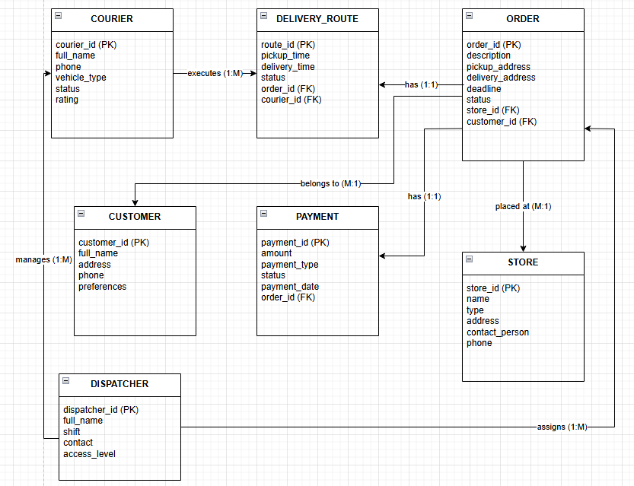
Связи:
COURIER → executes → DELIVERY_ROUTE (1:M)
ORDER → has → DELIVERY_ROUTE (1:1)
ORDER → placed at → STORE (M:1)
ORDER → belongs to → CUSTOMER (M:1)
ORDER → has → PAYMENT (1:1)
DISPATCHER → manages → COURIER (1:M)
DISPATCHER → assigns → ORDER (1:M)

