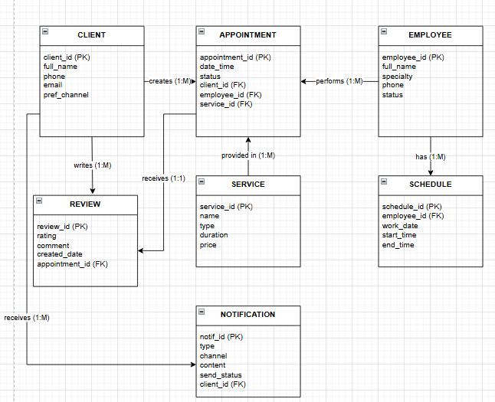
Связи:
CLIENT → creates → APPOINTMENT (1:M)
EMPLOYEE → performs → APPOINTMENT (1:M)
SERVICE → provided in → APPOINTMENT (1: M)
CLIENT → writes → REVIEW (1:M)
APPOINTMENT → receives → REVIEW (1:1)
EMPLOYEE → has → SCHEDULE (1:M)
CLIENT → receives → NOTIFICATION (1:M)
SERVICE → triggers → NOTIFICATION (1:M)

