VGA_Timer

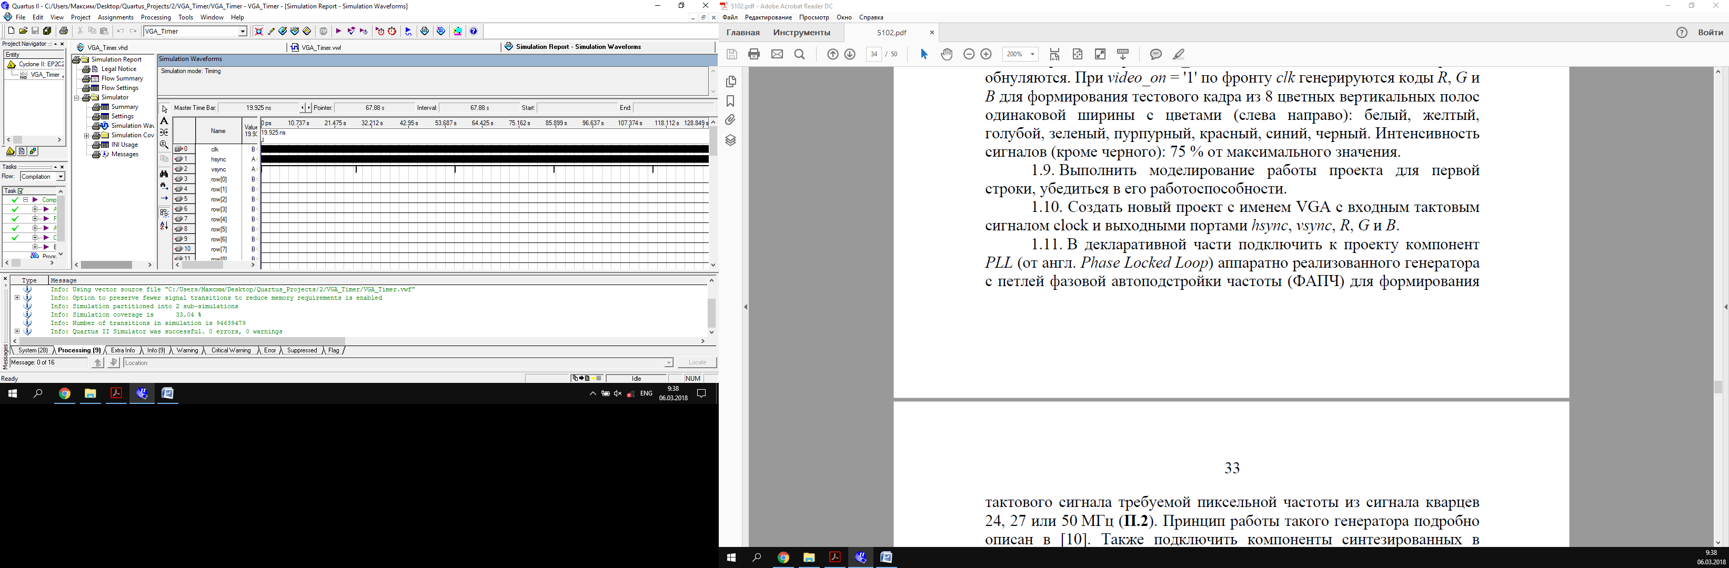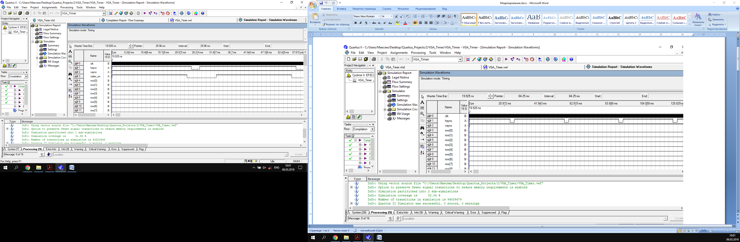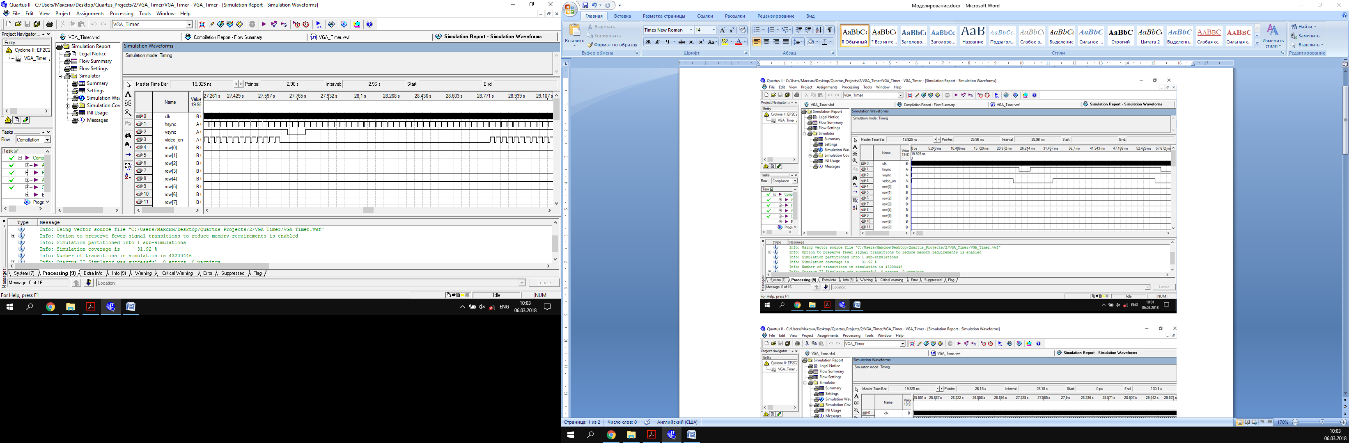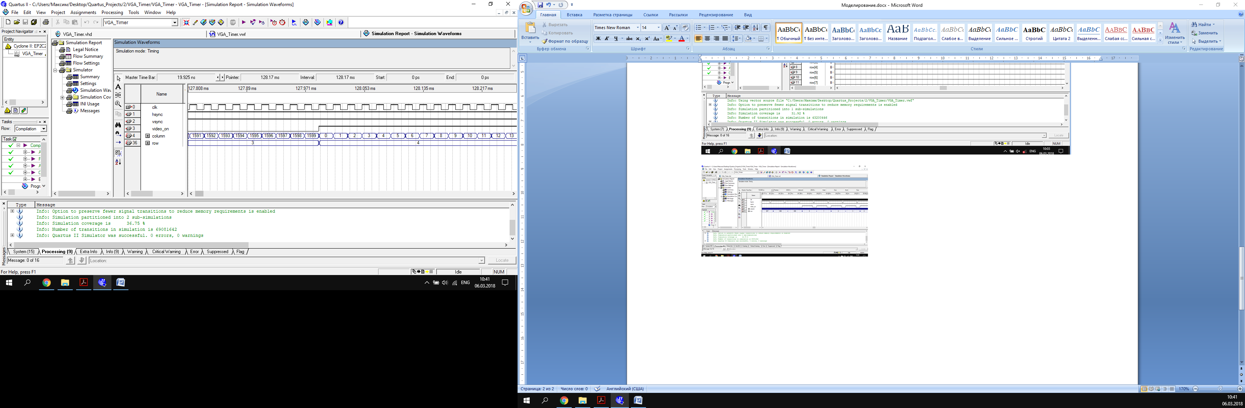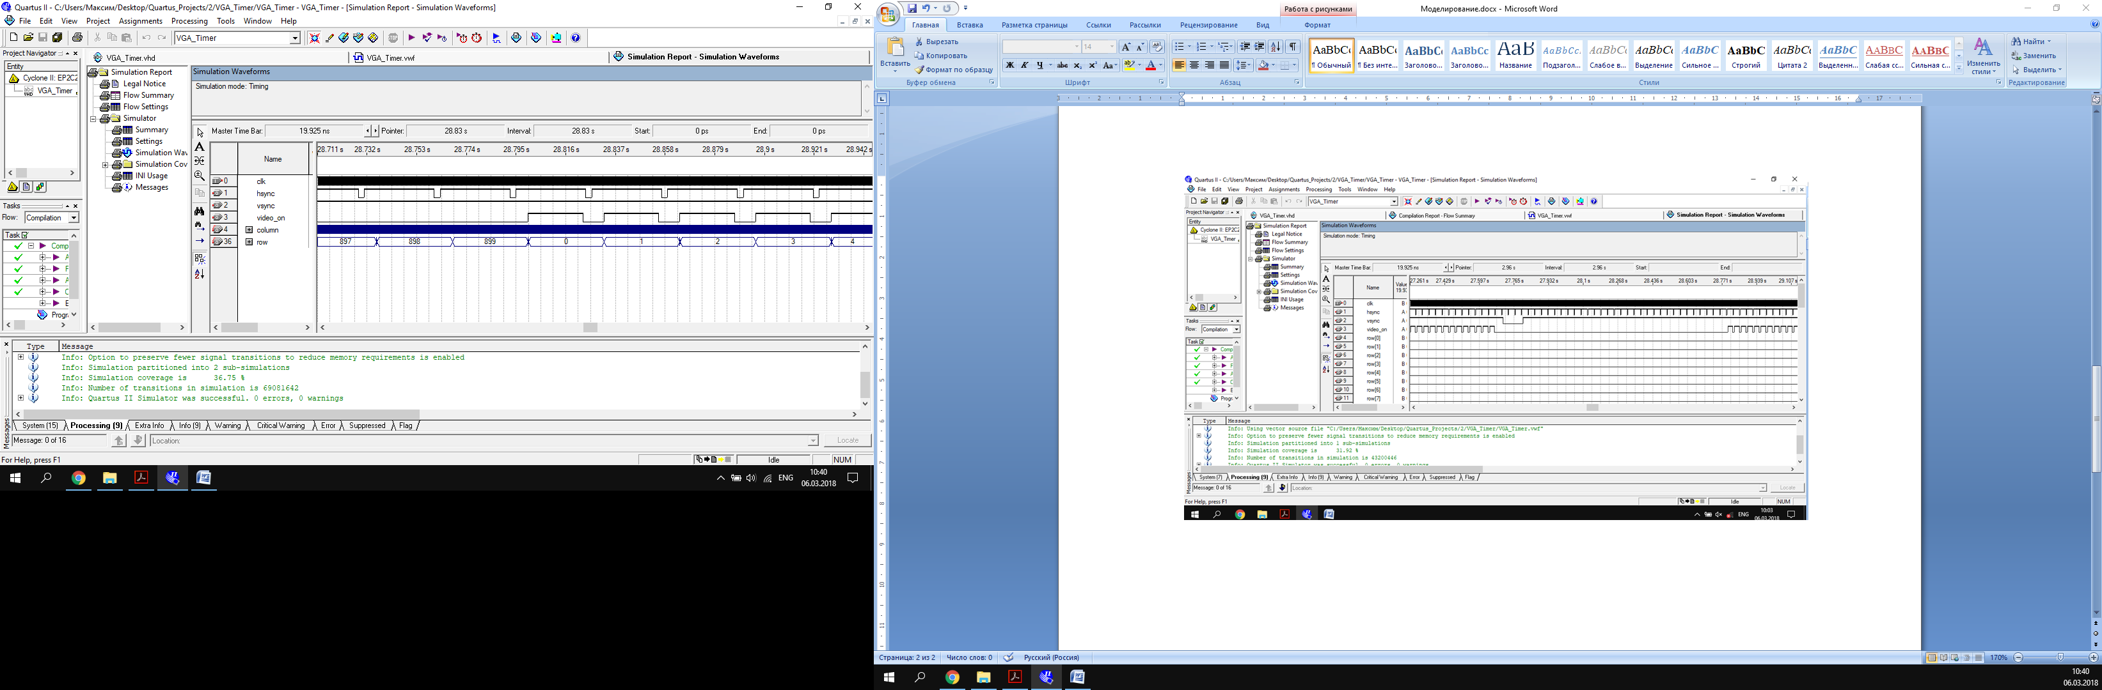

VGA_Video_Generator

