**CI/CD Pipeline Using Git, GitHub, Docker and Jenkins**

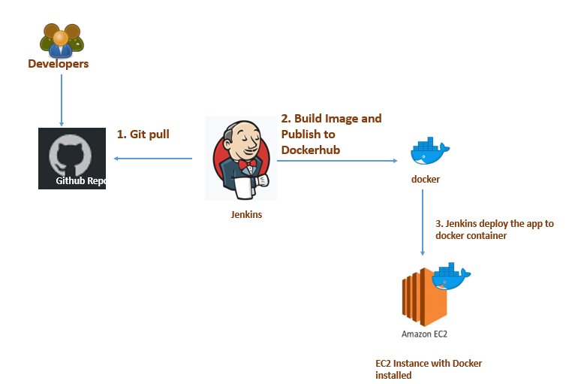

The CI/CD Pipeline I have chosen - which involves using Git, GitHub, Docker, Jenkins, Maven, and AWS - is important for several reasons.

1. Collaborative development:
   * Enables developers to work collaboratively on a codebase while ensuring seamless and continuous integration of changes.
   * Reduces time and effort required to resolve integration conflicts.
   * Promotes faster release cycles.
2. Consistent and portable development environment with Docker:
   * Allows for the creation of a consistent and portable development environment.
   * Can be replicated across different stages of the pipeline (development, testing, production).
   * Ensures that code is tested in an environment as close as possible to production, reducing runtime issues.
3. Automation with Jenkins:
   * Orchestrates the pipeline and automates tasks such as code building, testing, and deployment.
   * Reduces manual effort required.
   * Promotes consistency and reproducibility across different stages of the pipeline.
4. Scalable and secure infrastructure with AWS:
   * Enables the scaling of resources and deployment of the application.
   * Provides secure and reliable infrastructure for the pipeline.
   * Ensures application is available to end-users with minimal downtime.
5. Java app building and testing with Maven:
   * Uses Maven to build and test the Java app.
   * Promotes consistency in building and testing Java apps within the pipeline.

The goal of my CI/CD Pipeline is to automate the software development lifecycle and ensure faster, more efficient, and higher quality delivery of the Java application. This is achieved through a series of automated stages that include receiving the application code from GitHub, building and testing it, creating a Docker image, publishing the image to Docker Hub, and deploying the image to your deployment server. The ultimate goal of this process is to make the application development and deployment process more streamlined, reduce errors and ensure that the application can be deployed quickly, reliably and with minimal manual intervention.

This CI/CD Pipeline is good because it provides numerous benefits that improve the software development process. Some of these benefits include:

* Automation: CI/CD Pipeline automates the process of building, testing, and deploying your Java application, which saves time and reduces errors.
* Quality: By automating the testing process, CI/CD Pipeline ensures that the application is of higher quality and more reliable, as issues can be detected and resolved earlier in the development process.
* Collaboration: CI/CD Pipeline promotes better collaboration among team members by automating the workflow and providing a shared understanding of the development and deployment process.
* Speed: CI/CD Pipeline speeds up the delivery of the application, enabling faster releases and allowing the team to respond more quickly to customer needs.
* Consistency: CI/CD Pipeline ensures that the application is deployed consistently across different environments, which reduces the likelihood of errors and improves the reliability of the application.

Overall, the CI/CD Pipeline is good because it streamlines the software development and deployment process, reduces errors, and improves the quality and reliability of the application.

Summary

CI/CD Pipeline is a tool used to automate the software development and deployment process of a Java application. The pipeline comprises various stages, including receiving the application code from GitHub, building and testing the code, creating a Docker image, publishing the image to Docker Hub, and deploying the image to the deployment server. The pipeline's goal is to streamline the software development and deployment process, reducing errors, improving software quality, promoting better collaboration among team members, and speeding up the delivery of the application. The CI/CD Pipeline is considered a good tool because it provides numerous benefits that enhance the software development process, including automation, consistency, quality, collaboration, and speed.

In summary, my CI/CD Pipeline is an effective tool for automating the software development process and ensuring faster and more efficient delivery of my Java application. However, there is always room for improvement. One improvement I could make is to use Jenkins nodes on separate AWS instances for testing, which could be provisioned using Ansible. This would enable me to run multiple tests concurrently, improving the speed of the pipeline, reducing the time it takes to build and test the application, and making the testing process more scalable, efficient, and cost-effective. By continuously improving my CI/CD Pipeline, I can ensure that it remains effective and relevant in the ever-changing landscape of software development.