Abstract :

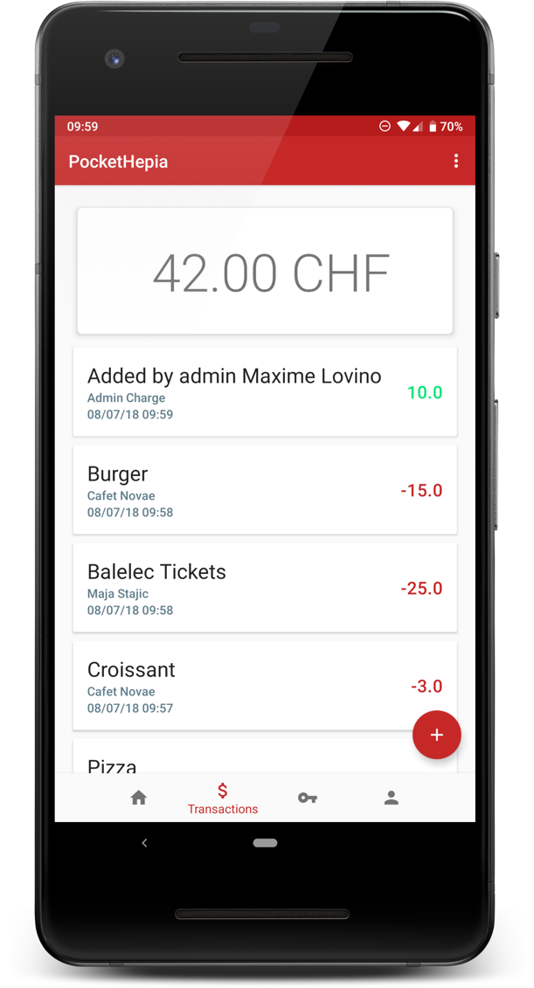
PocketHepia is a NFC student card platform for hepia. This student card will initially integrate two features: handling of accesses to classrooms and payments between students or at the canteen. This platform has two companion clients, a mobile application and a web client, that allow students to have read access to their payments and accesses and administrators to manage the students’ data.

This platform is extensible and has been specified to integrate additional features, with the school library for example, or even hooking it to the existing authentication infrastructure at hepia.

The project is built around the MEAN development stack with a MongoDB database, a NodeJS+Express backend and an Angular web frontend. The mobile application has been built natively on Android to take advantage of platform-specific NFC features and takes full profit from the latest and greatest Android libraries designed to improve and simplify app development on Android.

On the infrastructure side of things, deployment is done using Docker containers and we are using Docker Compose to orchestrate the deployment of the individual module containers and handle communication between them.

Student : Professor in charge :

Lovino Maxime Alexandre Hoerdt Mickaël

Study Program:

In collaboration with: ------------

Bachelor Thesis linked to a company internship: no

Confidential Bachelor Thesis : no

