Mensa App



**Submitted by**

Maxime Thébault

Md. Marufur Rahman

The Mensa App is a mobile application that was developed to provide useful information about German Mensas to students, teachers and staff as well as any other possible Mensa user. It provides a list of Mensas in an area based on the user location, a way to display them on a map, access to the Mensa menus, etc.

**Purpose of the developed app**

We can imagine several use cases for this application. As a student, it could be used to check if a Mensa is open on a given day, or to compare menus between different Mensas to decide which Mensa the student is going to use. If the user were a guest, it could be used to determine which Mensa is the closest to its current position.

**Target group**

Any institutes or organization can use it by certain customization. This app particularly developed for educational institutes in Dresden. Users will be students, teachers, and staff members as well their guests

**Using Mensa App – Walkthrough**

After installing the application, it appears in the application drawer of the user’s device (screenshot 1).

Upon loading, the user is welcomed by the list of all the nearby Mensas (screenshot 2). If the location service is not enabled on the user’s device, the user is prompted to do so thanks to a dialog. An additional dialog is also shown if the user is running Android Marshmallow (or above), for which an application has to explicitly ask for permissions (in this case, the location permission) at runtime.

Instead of displaying the Mensas as a list, the user can also decide to display them on a map (screenshot 3). This more visual experience might be more attractive to users, and definitely helps when looking for the exact location of a Mensa.

When clicking on a map marker, a bottom sheet is opened and can be expanded to show the opening dates of the selected Mensa (screenshot 4).

Additionally, by clicking on the Floating Action Button, the user can access the Mensa details (screenshot 5 and 6). This screen can also be accessed by clicking on any item of the list from screenshot 2. It offers further information about the Mensa, including the menu for the upcoming days.

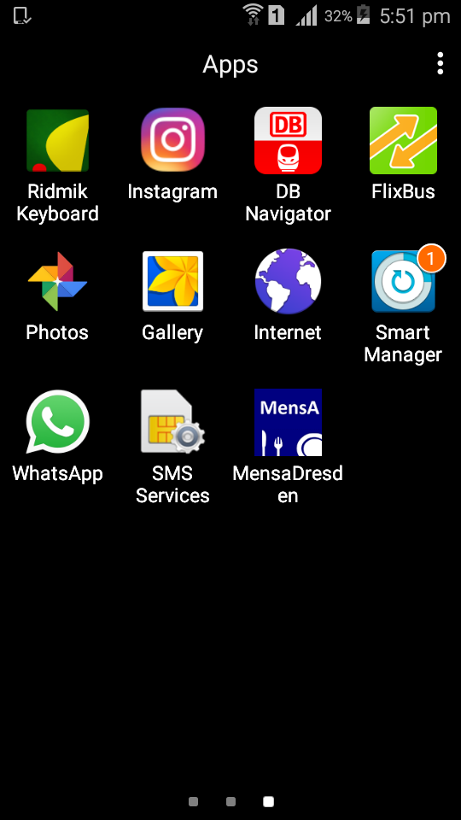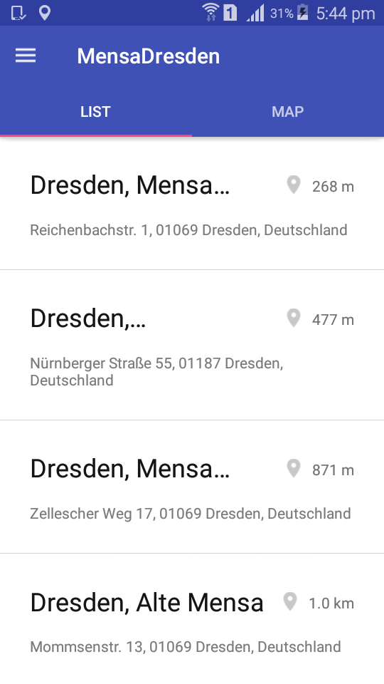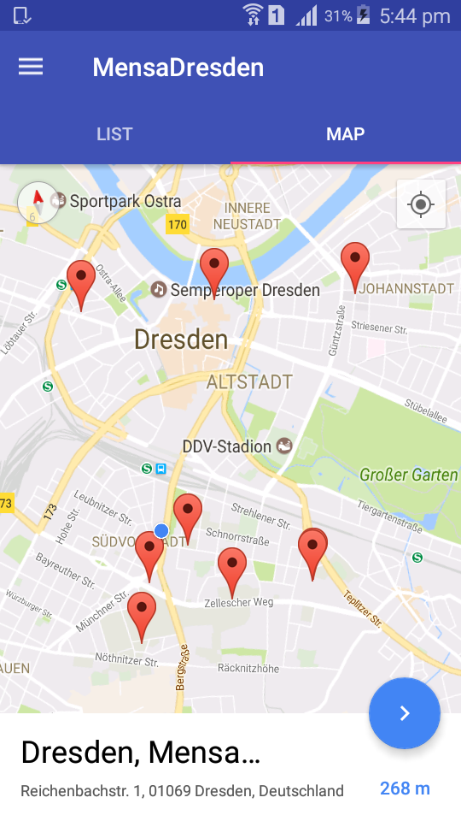

1 2 3

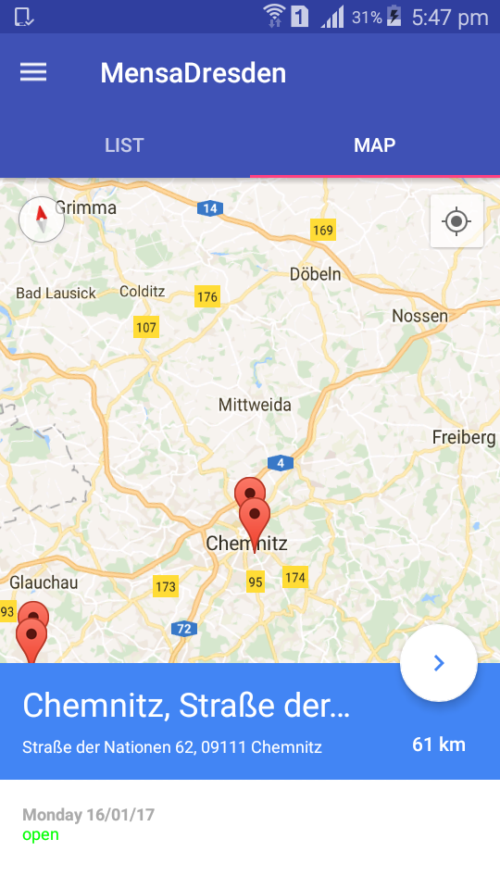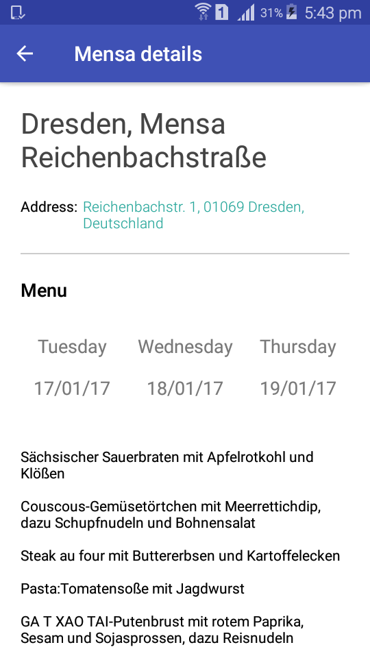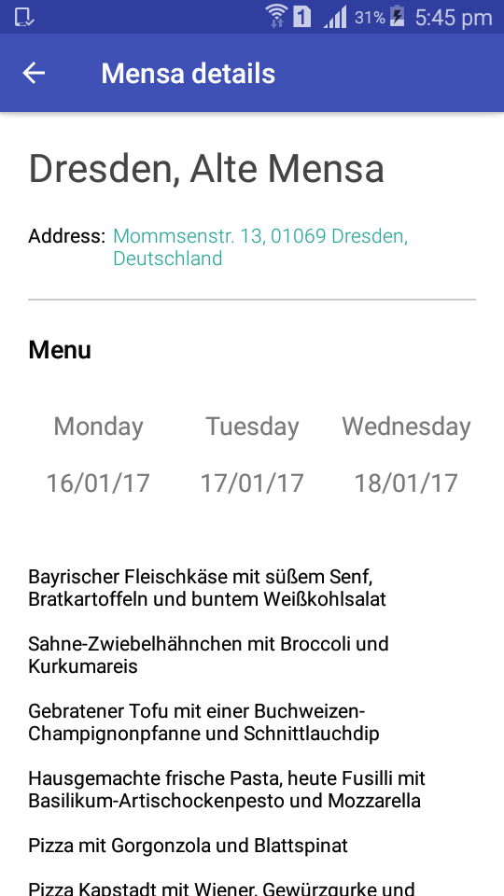

4 5 6