Maksimilian Golovach J4133c

**Schemas**

**Transactions**:

mgolovach_370819.transactions

and

mgolovach_370819.distr_transactions

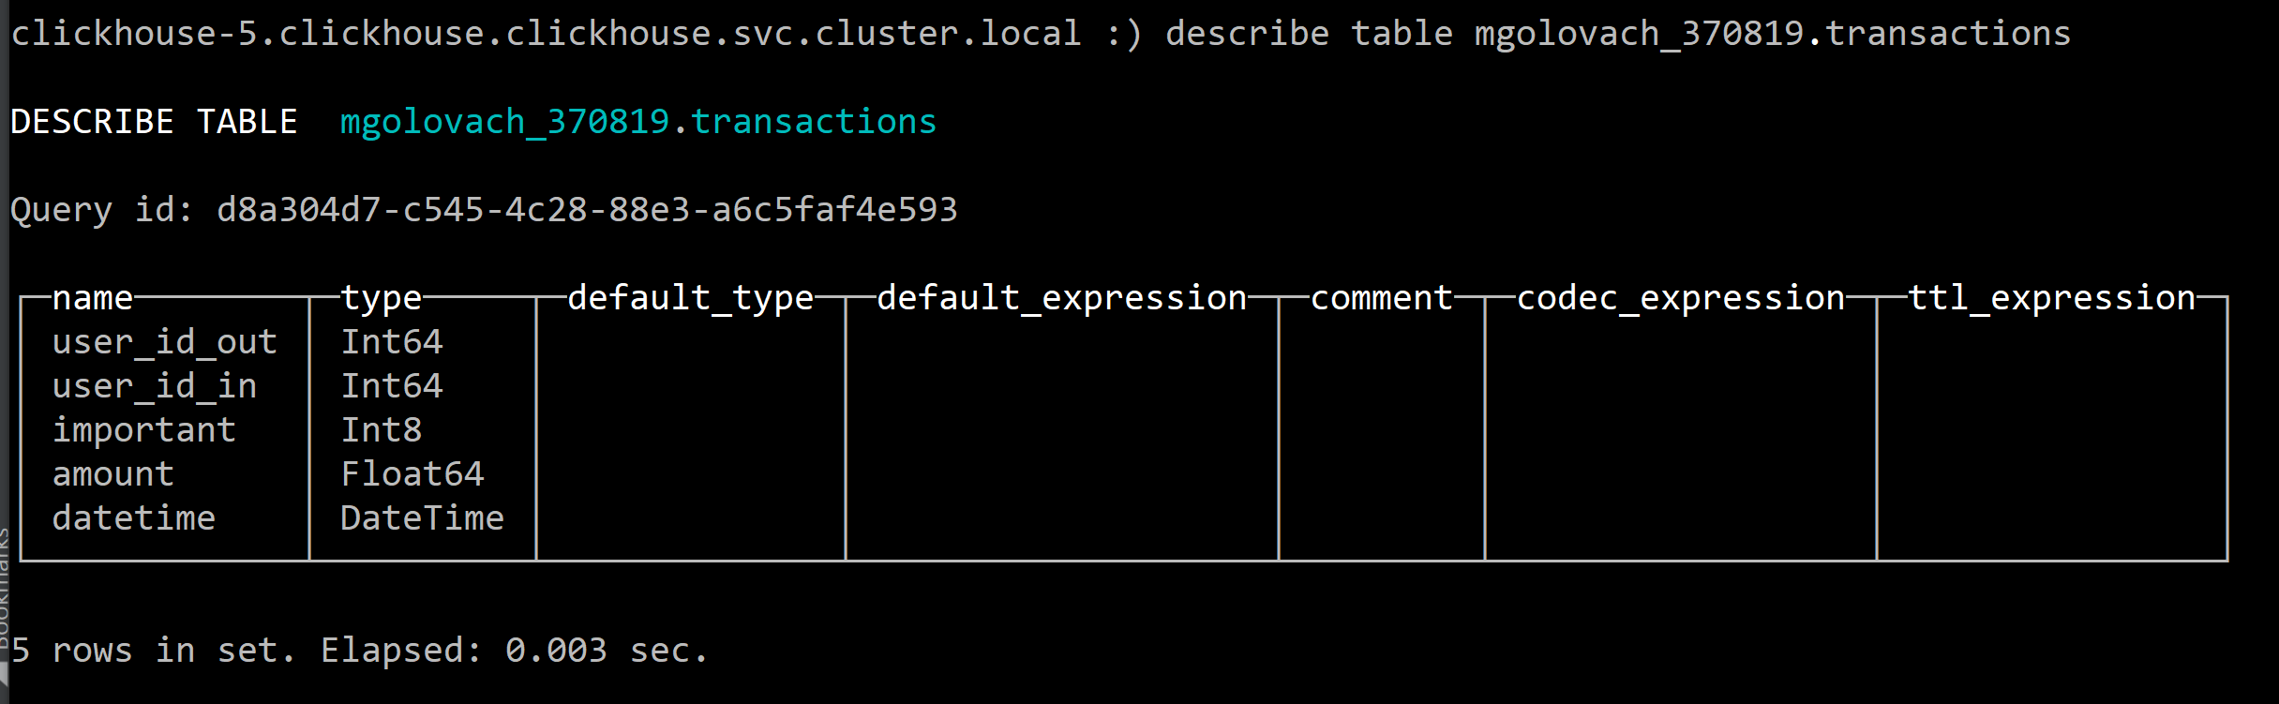

**Users saldo for the current moment**:

mgolovach_370819.saldo_for_each_user

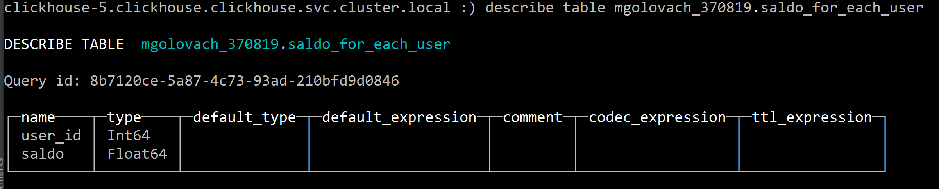

**The sums for incoming and outcoming transactions by months for each user**:

mgolovach_370819.transaction_sum_for_each_user

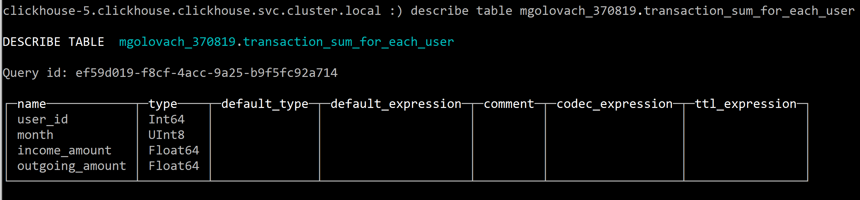

**Sharding expression clarification**

I’ve chosen sharding expression as 32 bit hash of expression “toYYYYMM(datetime)” for shards to be split by years and months of years.

In transaction dataset I saw that there is only 2018 year, so dataset will be split by 12 shards, 1 shard for each month in this case, so transactions will be +- equally distributed cluster, ~1 million per clickhouse-N.clickhouse.

**MV’s choice**

I’ve chosen 3, 4 views:

3 – **The sums for incoming and outcoming transactions by months for each user.**

-- The sums for incoming and outcoming transactions by months for each user.  
-- 1 - getting incomes(out), outcomes(in_table),  
-- 2 - matching out, in_table by user ids,  
-- 3 - grouping by user id and month, getting sum of amounts  
CREATE MATERIALIZED VIEW mgolovach_370819.transaction_sum_for_each_user ON CLUSTER kube_clickhouse_cluster  
 ENGINE = *AggregatingMergeTree* ORDER BY (user_id, month) POPULATE  
AS  
select  
 out.user_id_out as user_id,  
 out.month as month,  
 *sum*(out.amount) as income_amount,  
 *sum*(in_table.amount) as outgoing_amount  
from (select out.user_id_out,  
 *toMonth*(out.datetime) as month,  
 *count*(out.user_id_out) as incoming,  
 *sum*(out.amount) as amount  
-- from mgolovach_370819.transactions out  
 from mgolovach_370819.distr_transactions out  
 group by out.user_id_out, *toMonth*(out.datetime)) out inner join  
 (select in_table.user_id_in,  
 *toMonth*(in_table.datetime) as month,  
 *count*(in_table.user_id_in) as outcoming,  
 *sum*(in_table.amount) as amount  
-- from mgolovach_370819.transactions in_table  
 from mgolovach_370819.distr_transactions in_table  
 group by in_table.user_id_in, *toMonth*(in_table.datetime)) in_table  
 on user_id_in = user_id_out and out.month = in_table.month  
group by out.user_id_out, out.month;

Output:

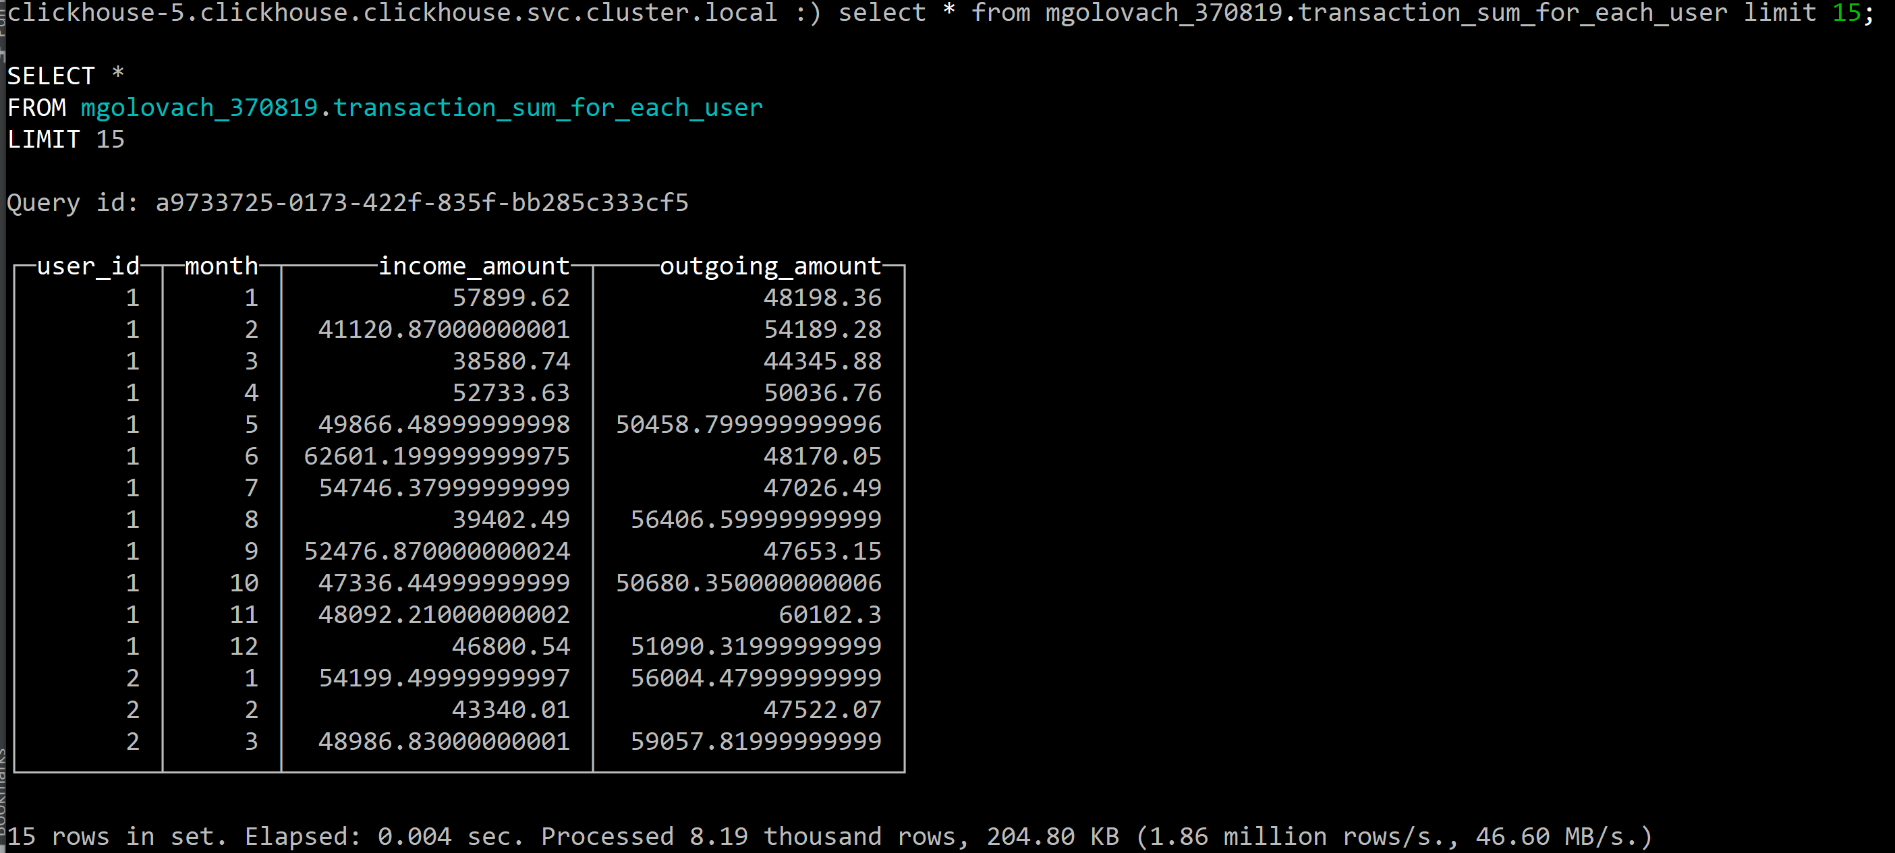

4 - **Users saldo for the current moment.**

-- Users saldo for the current moment.  
CREATE MATERIALIZED VIEW mgolovach_370819.saldo_for_each_user  
 ON CLUSTER kube_clickhouse_cluster  
 ENGINE = *AggregatingMergeTree* ORDER BY (user_id, saldo) POPULATE  
AS  
select out.user_id_out as user_id, (out.amount - in_table.amount) as saldo  
from (select out.user_id_out,  
 *count*(out.user_id_out) as incoming,  
 *sum*(out.amount) as amount  
 from mgolovach_370819.transactions out  
 group by out.user_id_out) out inner join  
 (select in_table.user_id_in,  
 *count*(in_table.user_id_in) as outcoming,  
 *sum*(in_table.amount) as amount  
 from mgolovach_370819.transactions in_table  
 group by in_table.user_id_in) in_table  
 on user_id_in = user_id_out;

Output:

