NJORD GraphEFM Baseline and Parallelization Analysis
  - ETH Student Cluster GTX 1080 Ti measurements and evidence-based project decisions
Main result The measurements establish a reproducible single-GPU baseline and a clear memory ceiling. The realistic training workload reaches a median 1.401 samples/s. Hidden dimension 192 barely fits with checkpointing, while hidden dimension 256 fails. Model weights are small; graph activations and intermediate states dominate memory. The central project objective should therefore be to distribute one complete global prediction step across multiple GPUs.
Metric | Measured value | Meaning
Baseline throughput | 1.401 samples/s | Median of three uninstrumented runs
Baseline step time | 1427.35 ms | Median for batch 2 and AR4
Peak memory at h64 | 3.408 GiB | CUDA allocator peak with checkpointing
Largest fitting hidden size | h192 | 9.49 GiB peak allocation
First non-fitting size | h256 | OOM despite checkpointing
GPU utilization | 92.2% | Mean during the diagnostic measurement window

Recommended project decision
The team should first distribute the existing Interaction Network implementation. MLP weights can be replicated, while nodes, edges, and activations must be sharded. Grid-to-mesh, the hierarchical mesh processor, and mesh-to-grid must share one ownership and communication scheme. A graph transformer should remain a later extension.

Contents
- Ten statements for the project meeting
- Measurement design and run comparability
- Reproducible baseline and capacity ceiling
- Runtime breakdown and GPU telemetry
- Model paths and communication requirements
- Prioritized parallelization areas and team split
- Next experiments and success criteria

Ten statements for the project meeting
1. The robust single-GPU baseline is 1.401 samples/s and 1427 ms per batch. Three independent runs vary by only about 2%.
2. Gradient checkpointing is already required at hidden dimension 64. Without checkpointing, batch 2 with four autoregressive steps runs out of memory.
3. With checkpointing, hidden dimension 192 barely fits at 9.49 GiB on the 10.90 GiB GPU. Hidden dimension 256 does not fit.
4. Weights do not cause the memory bottleneck. At h64, trainable parameters occupy 2.46 MiB, while the measured allocation peak is 3.41 GiB.
5. Backward, including checkpoint recomputation, consumes roughly two thirds of end-to-end time. Forward consumes roughly one third.
6. The physically enlarged Zarr dataset removes the old periodic input stalls. Data wait is now only 37–44 ms per approximately 1.4 s batch.
7. Run 1634 shows 92.2% mean GPU utilization, a stable 1822 MHz clock, and a 54 °C peak. There is no thermal throttling.
8. Standard DDP does not solve the capacity limit because every GPU still holds the full graph activations.
9. The complete global graph must be distributed. Halo communication occurs across cut message-passing edges; the final scalar loss is not the communication problem.
10. The first decisive multi-GPU success criterion is to execute h256 across several GTX 1080 Ti GPUs while measuring per-GPU memory, communication time, and parallel efficiency.

What the current evidence does not establish
- There is no multi-GPU measurement yet, so no measured speedup or halo overhead can be claimed.
- The physically repeated dataset is an I/O proxy, not a new scientific training distribution.
- The periodic compute outliers have not yet been explained. Telemetry rules out storage wait and thermal throttling, but not runtime, allocator, or kernel-launch effects.
- CUDA and Apple MPS results are not directly comparable.

Measurement design and comparability
All official values were measured on NVIDIA GeForce GTX 1080 Ti GPUs in the ETH Student Cluster. The software environment used Python 3.12.3, PyTorch 2.14.1 with CUDA 12.6, and PyTorch Lightning 2.6.6. Each job received four CPUs and 24 GiB host memory. Graph data and datasets were stored on scratch; repository code remained in the home directory.

Realistic training workload
Property | Value
Model | GraphEFM
Grid and mesh | 42,348 grid nodes and 10,553 mesh nodes
Edges | 273,845 across G2M, M2M, M2G, mesh-up, and mesh-down
Hidden dimension | 64 for the baseline
Processor layers | 2
Batch and unroll | Batch 2 and 4 autoregressive training steps
Precision | FP32
Checkpointing | Automatically enabled for AR4
Data loader | 3 workers
Dataset | 473 samples, 237 batches, approximately 2.19 GiB

Three separated measurement modes
Mode | Purpose | Protocol | Use
Aggregate, no telemetry | Headline performance | 20 warmups + 200 steps; no per-batch synchronization | Median of jobs 1627, 1628, 1629
Phase timing | Forward, backward, data wait | CUDA events and per-batch synchronization | Bottleneck diagnosis and hidden-size sweep
Phase + telemetry | GPU activity, power, clock, energy | 200 steps + about 1 s nvidia-smi sampling | Job 1634; diagnostic only

This separation prevents a common benchmark error. Per-batch synchronization and telemetry provide better diagnostics but can perturb throughput. The three aggregate runs therefore define the performance baseline, while phase-timed runs explain it.

Memory and input measurement
- CUDA allocator peak measures activations and tensors allocated by PyTorch.
- nvidia-smi device memory additionally includes reserved and process-related GPU memory.
- Data wait is measured from the end of the preceding training step until the next batch is available.
- The first 20 steps are discarded so initialization and cold-start effects do not dominate.
- Validation, external loggers, and model checkpoint saving are disabled during benchmark windows.

Reproducible single-GPU baseline
Job | Step time | Throughput | Peak allocation
1627 | 1380.76 ms | 1.4485 samples/s | 3.408 GiB
1628 | 1428.88 ms | 1.3997 samples/s | 3.408 GiB
1629 | 1427.35 ms | 1.4012 samples/s | 3.408 GiB
Median | 1427.35 ms | 1.4012 Samples/s | 3.408 GiB
Mean ± SD | 1412.33 ± 27.35 ms | 1.4165 ± 0.0277 | 3.408 ± 0.000 GiB

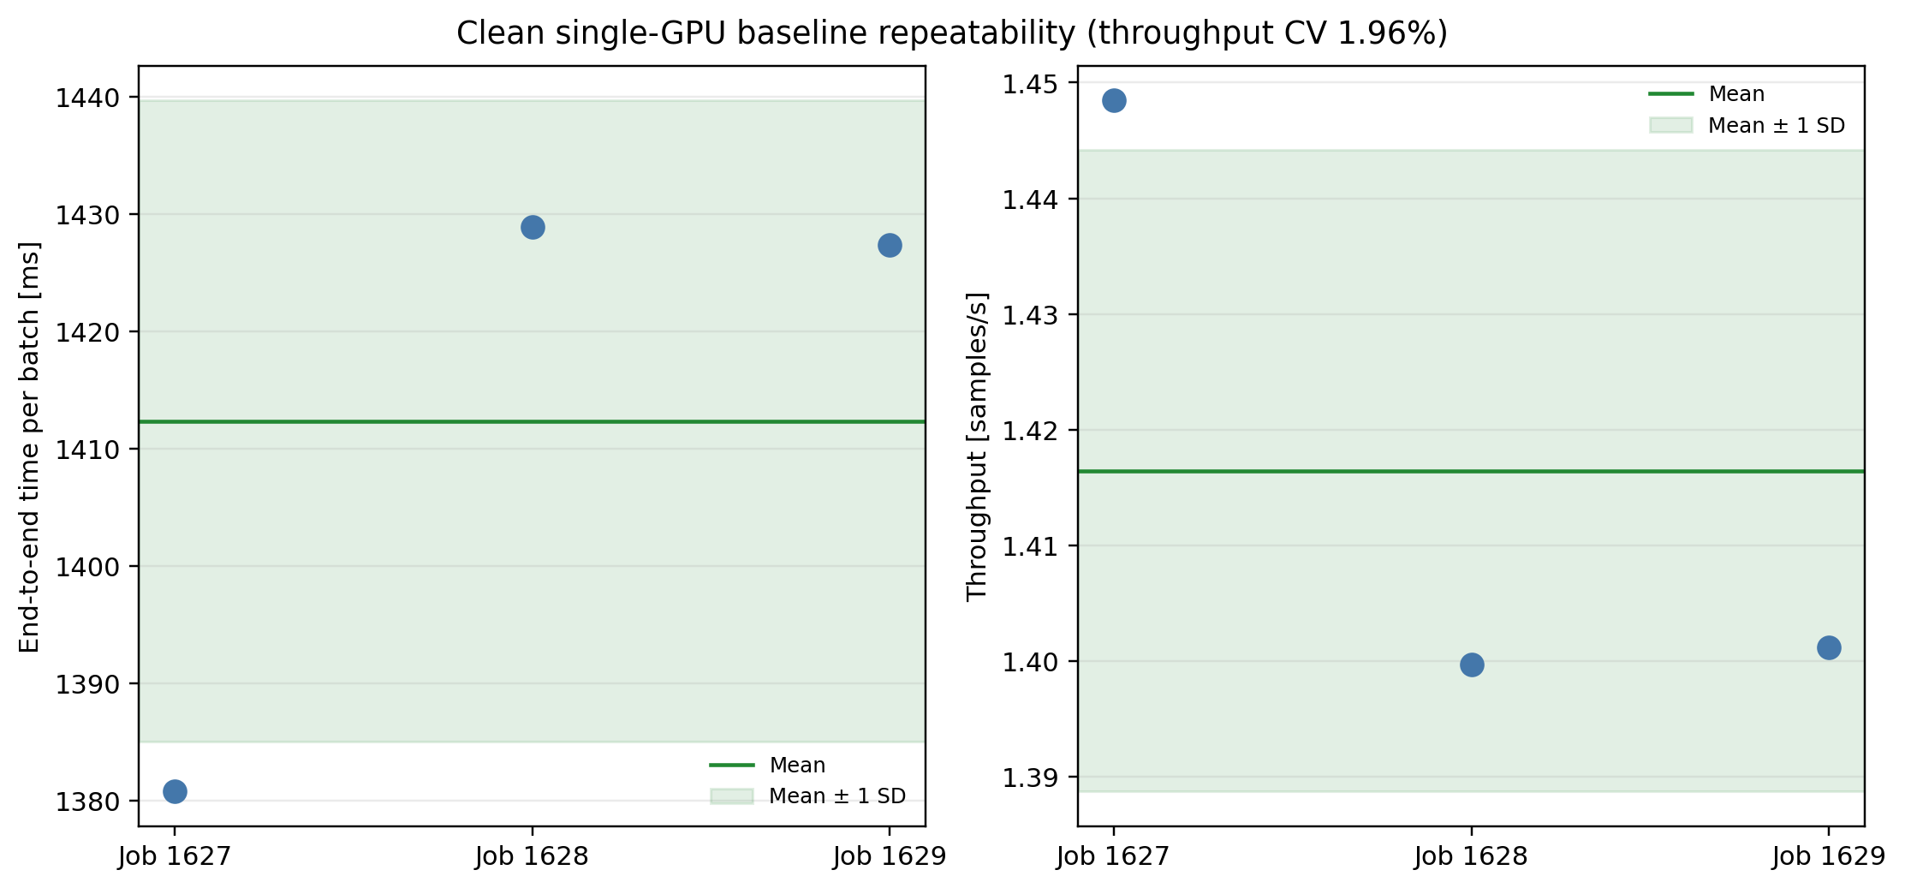
Figure 1. The three uninstrumented baseline runs show 1.96% throughput variation. Jobs 1628 and 1629 are nearly identical; job 1627 is about 3.4% faster than the slowest run.

Interpretation
The median 1.401 samples/s is the reference for later improvements. A claimed acceleration should be clearly larger than 3–4% and persist across repeated runs. The identical memory peak in all three runs confirms that the configurations match.

Memory ceiling and hidden dimension
Hidden | Checkpointing | Outcome | Step | Throughput | Peak or OOM
64 | on | completed | 1369 ms | 1.422/s | 3.41 GiB
64 | off | OOM | – | – | 10.88 GiB process memory
128 | on | completed | 2314 ms | 0.849/s | 6.44 GiB
192 | on | completed | 3361 ms | 0.589/s | 9.49 GiB
256 | on | OOM | – | – | 10.77 GiB process memory

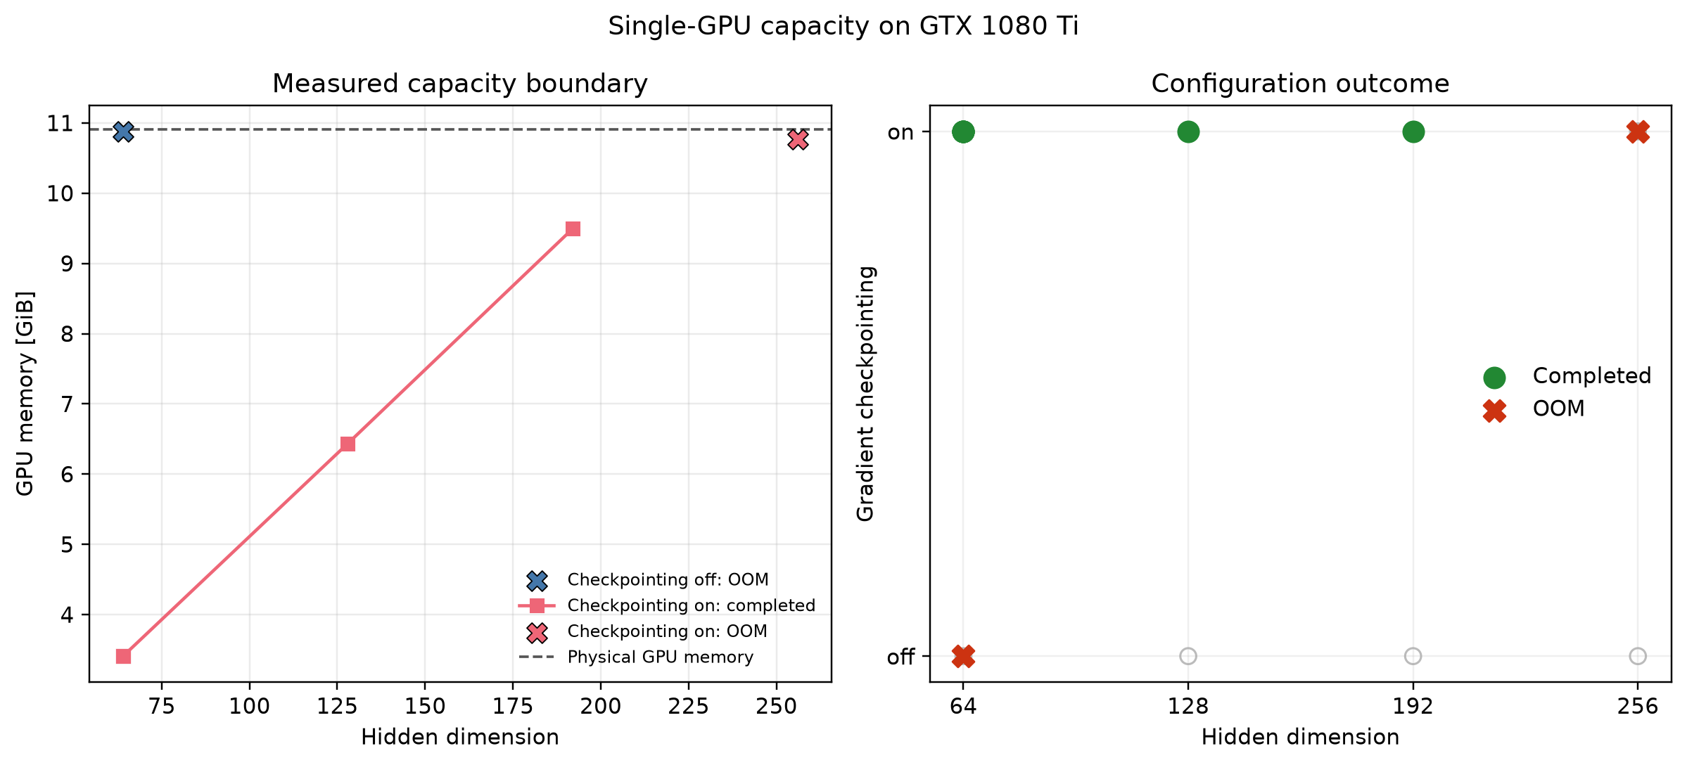
Figure 2. Measured capacity boundary. Checkpointing is required even for h64. With checkpointing, the boundary lies between h192 and h256.

What the memory curve shows
- From h64 to h192, parameter count grows by 8.72×, while peak memory grows by 2.79×.
- At h64, parameters and their FP32 gradient payload occupy only 2.46 MiB versus 3.41 GiB peak allocation.
- One batched representation of all 273,845 edges requires about 134 MiB at h64 and 401 MiB at h192.
- Multiple node and edge representations coexist in the encoder, prior, decoder, MLP activations, and backward pass.

Runtime and memory scale with hidden dimension
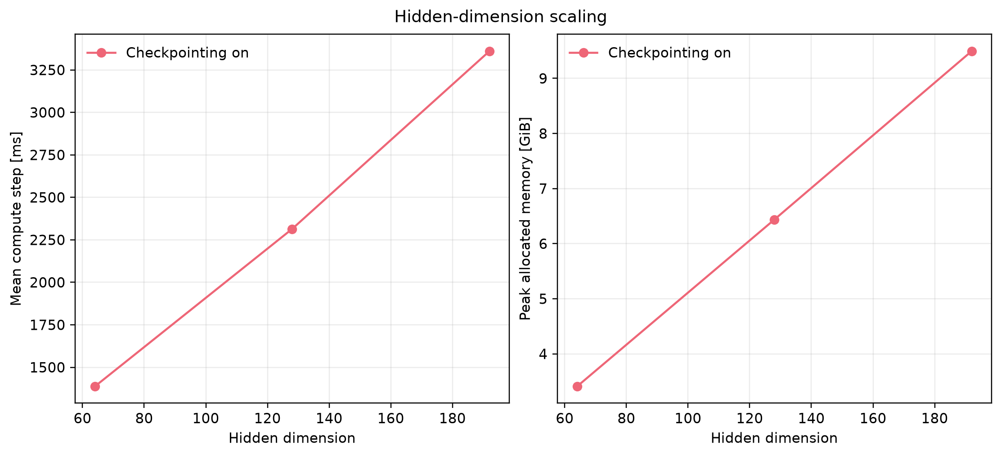
Figure 3. Compute time and peak allocation rise steeply with hidden dimension. Memory is nearly linear over the measured range even though parameter count grows approximately quadratically.
Hidden | Parameter factor | Memory factor | Step factor | Relative throughput
64 | 1.00 | 1.00 | 1.00 | 1.00
128 | 3.91 | 1.89 | 1.69 | 0.60
192 | 8.72 | 2.79 | 2.45 | 0.41

This measurement directly matches the supervisor's project objective. One global prediction step currently has to fit on one GPU. A distributed solution should use the memory and compute of several GPUs for that same step. The immediate capacity test is h256 because it demonstrably fails on one GPU.

Backward and checkpoint recomputation dominate
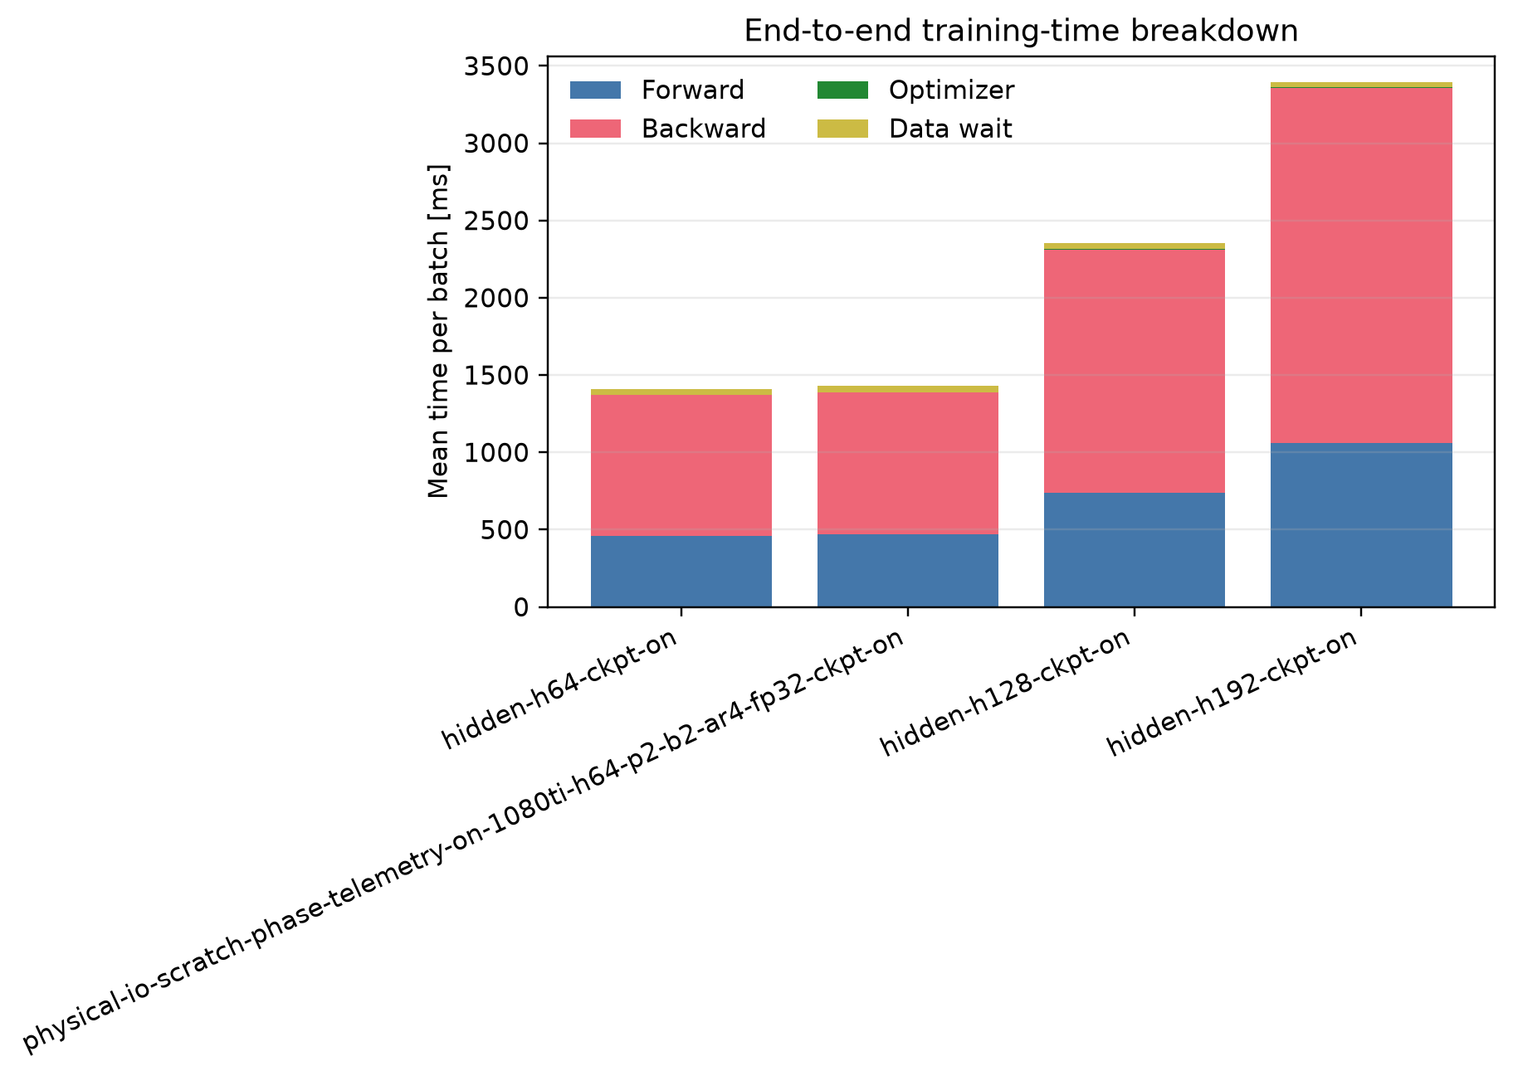
Figure 4. End-to-end breakdown of synchronized phase-timed runs. Backward is the largest component in all configurations; data wait and optimizer time remain small.
Hidden | Forward share | Backward share | Data-wait share | Optimizer share
64 | 32.80% | 64.50% | 2.64% | 0.05%
128 | 31.33% | 66.91% | 1.70% | 0.05%
192 | 31.29% | 67.70% | 0.95% | 0.05%

Checkpointing discards intermediate activations from each autoregressive step and re-executes the full compute-step/loss block during backward. The measured backward share therefore includes both gradient evaluation and repeated forward compute. Additional checkpointing levels can save memory but increase exactly this dominant component.

GPU telemetry and periodic compute outliers
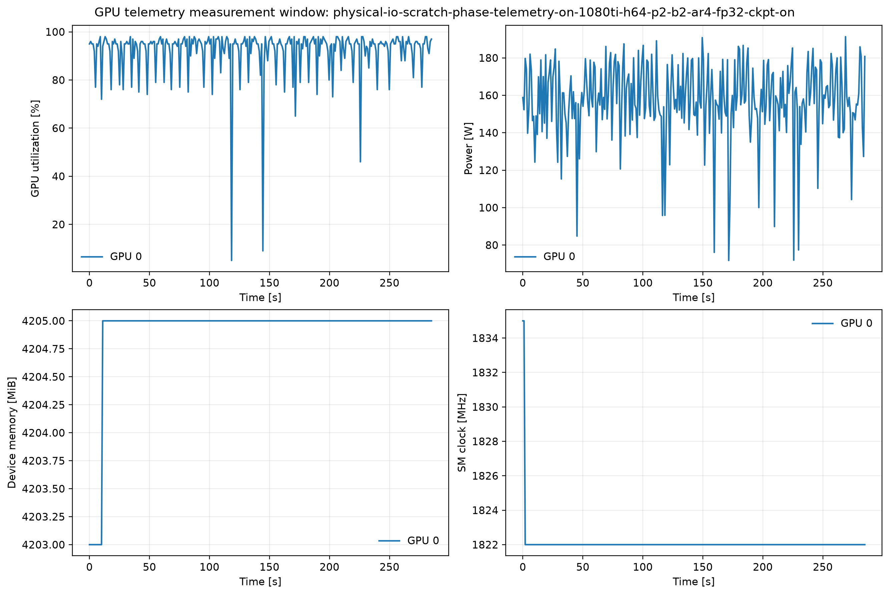
Figure 5. Telemetry during the 200-step measurement window. The GPU usually operates at 90–98% utilization with stable clocks and memory. Brief utilization and power drops remain visible.
Telemetry metric | Measured value | Interpretation
GPU utilization | 92.19% mean; 98% P95 | GPU usually active, with brief idle periods
Power | 157.17 W mean; 191.32 W peak | Below the 250 W limit
SM clock | Approximately constant at 1822 MHz | No clock throttling
Temperature | 54 °C peak | No thermal limitation
Device memory | 4205 MiB | Constant after initialization
Energy | 111.94 J per sample | Reference for later comparisons

Eleven batches take about 1.62–1.68 s instead of the 1.372 s median. They appear roughly every 18–20 steps and alternately extend forward or backward. Data wait remains normal. The same pattern appeared in an earlier run without telemetry. A short profiler run should investigate kernel-launch gaps, Python or allocator periodicity, and GPU kernel sequences. Current evidence does not identify a unique cause.

The earlier input bottleneck was a dataset artifact
Metric | Old short dataset, job 1453 | Physical-repeat dataset | Change
Compute step | 1338.32 ms | 1369.43 ms | +2.3%
Data wait | 533.64 ms | 37.16 ms | −93.0%
End to end | 1872.14 ms | 1406.77 ms | −24.9%
Throughput | 1.068 samples/s | 1.422 samples/s | +33.1%

The old run showed exactly 50 large waits in 200 steps—one every four batches. After physical replication, the dataset contains 473 valid samples and 237 batches. Compute time remains similar while the input component almost disappears. Storage I/O is therefore not a priority optimization area for the current configuration.

Limitation of this conclusion
The Zarr chunks physically exist and represent real filesystem behavior better than repeatedly iterating over a few samples. However, the scientific values repeat the same period. This dataset is therefore a compute and I/O proxy, not evidence about model quality.

Model paths and required communication
A GraphEFM training step contains more than one mesh processor. For each of four autoregressive steps, the model constructs grid and graph embeddings, evaluates the variational encoder, runs the decoder, evaluates a prior, and reduces likelihood and KL terms. Checkpointing wraps the full step and repeats it during backward.
Model area | Current computation | Distributed requirement | Priority
Grid-to-mesh | Bipartite message passing over 70,640 edges | Align grid/mesh ownership; exchange remote senders | Required
Mesh processor | M2M plus up/down processing over levels | Halo nodes and edge ownership per level | Required
Mesh-to-grid | Bipartite mapping over 126,107 edges | Produce local grid outputs without global shuffle | Required
Shared MLPs | Same weights for all nodes and edges | Replicate weights; reduce gradients | Simple
Loss | Sum over grid variables, batch, and time | Local sums plus a small global reduction | Simple
Autoregressive steps | Four serial predictions | Keep state sharded across steps | Required

Why the loss does not require a full gather
Each GPU can compute loss sums and active counts for its grid shard. A small global reduction produces the same mean loss. Large transfers occur earlier at cut message-passing edges. Forward requires remote neighbor representations; backward requires the corresponding gradients. This halo communication must be minimized and, where possible, overlapped with local computation.

Prioritized parallelization areas
Area | Why it matters | What to measure | Rank
Graph activation sharding | Solves the measured h256 memory ceiling | Peak VRAM and maximum hidden size | 1
Multi-level partitioning | Determines halo volume and load balance | Cut edges, halo nodes, bytes, rank imbalance | 2
G2M/M2G data placement | Avoids global layout shuffles | Transferred bytes and mapping runtime | 3
Communication/compute overlap | Reduces exposed halo overhead | Exposed communication and GPU idle time | 4
Checkpointing comparison | Trades memory for dominant recomputation | Time-memory frontier | 5
Graph transformer | May reduce explicit edge states | Memory, compute, equivalence | Optional
Inference parallelism | Relevant for latency; less capacity-critical | Latency and ensemble members/s | Later
Storage and data loader | Currently only about 3% | Data wait | Monitor
Pure DDP | Replicates the large activations | Control baseline | Not solution

Properties of a good partition
- Similar owned-node and owned-edge load on each GPU
- Few cut edges and few distinct communication partners
- Low halo bytes as a function of batch size and hidden dimension
- Enough memory for local activations and temporary send/receive buffers
- Consistent ownership across G2M, M2M, mesh-up/down, and M2G
- Stable assignment across all four autoregressive steps

Work split for five people
Track | Responsibility | Deliverable | Dependency
1 Baseline and evaluation | Jobs, measurement design, profiler, equivalence, plots | Reference metrics and scaling report | Independent and continuous
2 Partitioning | Ownership, halo metrics, balance strategies | Partitions plus communication estimates | Graph analysis
3 Distributed processor | Interaction Network M2M/up/down forward and backward | Functional sharded mesh processor | Track 2 ownership
4 G2M/M2G and data movement | Grid shards, bipartite edges, layout transitions | End-to-end sharded mapping | Track 2 ownership
5 Distributed runtime | P2P, collectives, buffers, overlap, rank telemetry | Communication layer and scaling | Tracks 3/4 interfaces

The graph transformer should be added only after ownership and halo runtime work for Interaction Networks. Neighborhood dependency remains in a transformer; only edge states and local compute change. Pipeline parallelism is also lower priority because encoder, prior, decoder, and autoregressive steps are serially coupled and are unlikely to be well balanced.

Next experiments
1. Run a short profiler experiment to identify the periodic forward/backward outliers.
2. Run a communication microbenchmark on 2 and 4 GTX 1080 Ti GPUs using realistic halo payloads at h64, h128, and h192.
3. Build a functional 2-GPU prototype with identical inputs and compare outputs, loss, and gradients against single GPU.
4. Measure strong scaling at h64 on 1, 2, and 4 GPUs: step time, speedup, efficiency, communication, and peak VRAM.
5. Measure capacity scaling at h192 and h256. The first hard success is one complete h256 training step without OOM.
6. Measure weak scaling over hidden dimension or graph size while holding memory and work per GPU approximately constant.

Success criteria and limitations

Success criteria
Question | Metric | Required evidence
Does a larger model fit? | Maximum hidden dimension | h256 runs distributed although single GPU OOMs
Is memory distributed? | Peak VRAM per rank | Decreases with GPU count at fixed work
Does it accelerate? | Strong-scaling speedup | Step time decreases on 2 and 4 GPUs
Is communication acceptable? | Exposed communication | Halo time does not dominate the step
Is work balanced? | Per-rank compute and idle | Small variation across ranks
Is the result correct? | Output/loss/gradient error | Only expected floating-point differences

Limitations of the current evidence
- No multi-GPU measurement yet for speedup, efficiency, or real halo overhead
- h128 and h192 use fewer measured steps than h64 and do not provide robust tail distributions
- GTX 1080 Ti absolute runtimes cannot be transferred directly to H200-class hardware
- The physical-repeat dataset represents I/O behavior but not scientific data diversity
- nvidia-smi samples roughly once per second and cannot resolve individual kernels
- Periodic compute outliers still require a dedicated profiler run

Recommended decision for the meeting
Freeze the three uninstrumented runs as the single-GPU reference. Then begin with one shared multi-level ownership scheme and a functional distributed Interaction Network. Develop G2M, processor, M2G, and runtime as separate tracks, but synchronize them through shared tensor layouts and equivalence tests. Transformer and inference remain extensions once the distributed core path works.

Evidence used
- Cluster jobs 1614, 1627, 1628, 1629, and 1634
- Benchmark JSON files and nvidia-smi telemetry under benchmark_archive
- Meeting notes and supervisor transcript containing project objectives
- GraphEFM, InteractionNet, HiGraphLatentEncoder, HiGraphLatentDecoder, and AR checkpointing code paths

