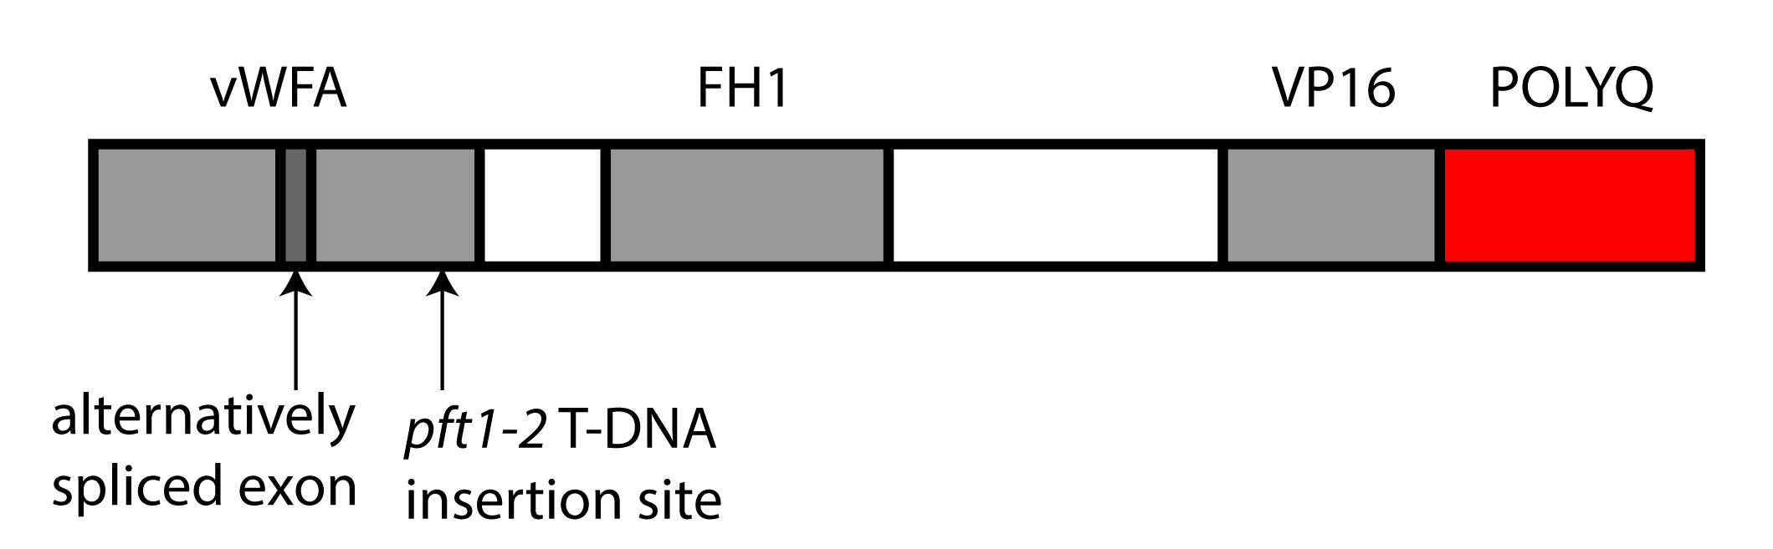
Figure S1. Structure of the PFT1 protein. Important features and domains are indicated. vWFA: van Willebrand Factor A domain, FH1: Formin homology 1 domain, VP16: VP16-like interaction domain, POLYQ: glutamine-rich domain including the polyglutamine encoded by the PFT1 STR. Also indicated is the difference between the two splice forms of PFT1 (minor splice form, PFT1.2, lacks a small exon), and the site of the T-DNA insertion in the pft1-2 mutant.
Table S1: Number of repeat units in two polyglutamine regions encoded by trinucleotide repeats across eight A. thaliana strains.
A. thaliana strain | Number of PFT1 trinucleotide repeats | Number of ELF3 trinucleotide repeats
C24 | 90 | 9
Can-0 | 90 | 20
Col-0 | 88 | 7
Cvi-0 | 89 | 9
Ler-1 | 90 | 17
Mt-0 | 88 | 21
Tamm-2 | 88 | 9
Ws-2 | 88 | 16

Table S2. Encoded amino acid sequence of the repeat regions across PFT1 constructs used in this study, named for their approximate proportion of the length of the endogenous repeat.
Allele name | Protein sequence in repeat region
0R | NLQ
0.34R | NLQQQQQQQQQQQQQQHQLTQLQHHHQQQQQ
0.5R | NQQQQQQQQLHQQQQQQQQIQQQQQQQQHLQQQQMPQLQHHHQQQQQ
0.75R | NQQQQQQQQLHQQQQQQQQIQQQQQQQQHLQQQQMPQLQQQQQQHQQQQQQQHQLTQLQHHHQQQQQ
1R* | NQQQQQQQQLHQQQQQQQQIQQQQQQQQHLQQQQMPQLQQQQQQHQQQQQQQHQLSQLQHHQQQQQQQQQQQQQHQLTQLQHHHQQQQQ
1.27R | NQQQQQQQQLHQQQQQQQQIQQQQQQQQHLQQQQMPQLQQQQQQHQQQQQQQHQLTQLQHHHQQQQQQQQQQQQQHQLTQLQHHHQQQQQQQQQQQQQHQLTQLQHHHQQQQQ
1.5R | NLQHHHQQQLQQQQQQQLHQQQQQQQQIQQQQQQQQHLQQQQMPQLQQQQQQQLHQQQQQQQQIQQQQQQQQHLQQQQMPQLQQQQQQHQQQQQQQHQLSQLQHHQQQQQQQQQQQQQHQLTQLQHHHQQQQQ
*: endogenous PFT1 polyglutamine sequence. All other sequences are synthetic (not observed in A. thaliana).

Table S3. Transgenic T₃ and T₄ A. thaliana lines used in this study.
Repeat Unit | Line Name | Repeat Region PCR Confirmed | Expression Relative to Col-0* | Standard Error*
1.5 | 1.5R3-3 | Yes | 0.96 | 0.12
1.5 | 1.5R4-4 | Yes | 3.21 | 0.07
1.5 | 1.5R8-1 | Yes | 2.32 | 0.19
1.27 | 1.27R6-2 | Yes | 1.78 | 0.10
1.27 | 1.27R13-2 | Yes | 0.89 | 0.05
1.27 | 1.27R14-2 | Yes | 1.49 | 0.46
1 | 1R1-2 | Yes | 0.90 | 0.05
1 | 1R8-3 | Yes | 1.10 | 0.22
0.75 | 0.75R1-4 | Yes | 1.92 | 0.19
0.75 | 0.75R2-1 | Yes | 0.69 | 0.21
0.75 | 0.75R10-2 | Yes | 0.92 | 0.27
0.5 | 0.5R5-1 | Yes | 2.70 | 0.09
0.5 | 0.5R6-4 | Yes | 0.66 | 0.29
0.5 | 0.5R7-3 | Yes | 0.98 | 0.13
0.34 | 0.34R1-2 | Yes | 0.63 | 0.05
0.34 | 0.34R2-2 | Yes | 0.82 | 0.02
0.34 | 0.34R9-1 | Yes | 2.85 | 0.49
0 | 0R4-2 | Yes | 1.33 | 0.01
0 | 0R8-2 | Yes | 0.94 | 0.06
V | V3-1 | NA | 0.36 | 0.04
*: Expression level estimate and standard error for each line are estimated from three biological replicates.

Table S4. Primers used in this study.
Target | Forward primer | Reverse primer
pft1-2 allele | ATTATTTGGGTGCTTTCTCATGGCC | TGGGCTTTCCCTGCATTTAAAACAG
UBC | GACCAAGATATTCCATCCTA | GTTAAGAGGACTGTCCG
PFT1 (cloning) | ATCAACAGGAATGGCTACATC | TTGTTTGAGGACTAAAGGCATTAT
PFT1 (both splice forms) | GCAAACCATCGTCTCCGACTATC | ccactccgttgtaccaagcaa
PFT1.1 (large splice form only) | CAGGTCTTTCTGTGGCAGTGA | ccactccgttgtaccaagcaa
PFT1.2 (small splice form only) | CAGAGGAACCCTGTTTCTACT | ccactccgttgtaccaagcaa

File S1. Alignment of PFT1 and MED25 amino acid sequences from diverse eukaryotes. See accompanying .pdf file.

File S2. Sanger sequencing data for 8 A. thaliana strains. See accompanying .zip file.

File S3. Phenotype data from experiments with transgenic lines. See accompanying .xls file (3 sheets).

