
TASK
4

UNIVERSITY OF BUEA
FACULTY OF ENGINEERING AND TECHNOLOGY
DEPARTMENT OF COMPUTERENGINEERING
CEF 440: INTERNET PROGRAMMING AND MOBILE PRORAMMING
Task 4: System Modelling and Design

GROUP 19
GROUP MEMBER | MATRICULATION NUMBER
DJEUGWA WEAH MAXIMILIENNE | FE23A036
TCHOUANMOU TOUONANG WHITNEY ELSA | FE23A165
LOREL EKAMBA AKO-TABE | FE23A083
ESSOH RODDICK ESSOH | FE23A048
BEZIA PRECIOUS | FE23A026

COURSE INSTRUCTOR: Dr NKEMENI VALERY
Contents
General Introduction 5
1. Context Diagram 5
1.1. Introduction 5
1.2. Purpose of the Context Diagram 6
1.3. Overview of the System 6
1.4. External Entities and Their Roles 8
1.4.1. Mobile Network Subscribers (Users) 8
1.4.2. Android Device 8
1.4.3. Backend Server 9
1.4.4. Network Analysts and System Administrators 9
1.4.5. Mobile Network Operators 9
1.5. Data Flow Description 10
1.6. System Boundary Definition 10
1.7. Conclusion 11
2. Data Flow Diagram 11
2.1. Introduction to Data Flow Diagrams 11
2.2. Level 0 :Context Diagram 12
2.2.1. Purpose 12
2.3. Level 1 : System Processes 12
2.4. Conclusion 13
3. USE CASE DIAGRAM 15
3.1. Introduction 15
3.2. Purpose of the Use Case Diagram 15
3.3. Actors Identified 15
3.4. Main Use Cases 15
3.5. Relationships Between Use Cases 16
3.6. Explanation of System Flow 16
3.7. Diagram 16
3.8. Conclusion 16
4. SEQUENCE DIAGRAM 17
4.1. Introduction 17
4.2. Scenarios 17
4.2.1. Scenario 1 : App Launch and Background Monitoring Start 17
4.2.2. Scenario 2 :Network Metrics Collection and Offline Storage 18
4.2.3. Scenario 3 : Offline to Online Data Synchronization 20
4.2.4. Scenario 4 : User Feedback Prompt and QoE Rating Collection 22
4.2.5. Scenario 5 :Manual Network Problem Report Submission 24
5. Class Diagram 26
5.1. Introduction 26
5.2. Purpose of the Diagram 26
5.3. Overview of the Diagram 26
5.4. Relationships and UML Principles 27
5.5. Key Design Features 28
5.6. Design Reasoning 28
5.7. Conclusion 28
6.Deployment Diagram 29
6.1. Introduction 29
6.2. Purpose of the Deployment Diagram 30
6.3. Overview of the System Architecture 30
6.4. Description of Deployment Nodes 31
6.4.1. Mobile Devices (Multi-Platform) 31
6.4.2. Internet Network 32
6.4.3. Application Server 33
6.4.4. Database Server 34
6.4.5. Analyst and Administrator Workstation 34
6.4.6. Mobile Network Operators 35
6.5. Communication Between Nodes 36
6.6. Cross-Platform Architecture Considerations 36
6.7. Security Considerations 37
6.8. Advantages of the Deployment Architecture 37
6.9. Conclusion 38
7.CONCLUSION 38

General Introduction
Mobile networks are a critical backbone of modern communication, yet subscribers in developing regions such as Cameroon often face fluctuating service quality, delays, and outages. To address these challenges, our project focuses on the design and implementation of a mobile application that collects both subjective user feedback and objective network performance metrics in real time. By combining active user input with passive monitoring of device and network parameters, the application enables mobile operators to gain deeper insights into subscribers’ Quality of Experience (QoE) and make informed decisions for network optimization.
In order to successfully design such a system, system modeling and design techniques are essential. System modeling provides a structured way to represent the application’s architecture, processes, and interactions before actual implementation. It helps identify requirements, visualize workflows, and ensure that all stakeholders share a common understanding of how the system will function.
For this project, six key diagrams are used to capture different perspectives of the system
Which are:

Context Diagram

Introduction
A context diagram is a high-level system model that illustrates the boundaries of a system and its interactions with external entities. It provides an overall view of how the system communicates with users, external systems, and stakeholders without exposing internal implementation details.
This report presents and explains the context diagram for the Mobile Quality of Experience (QoE) Data Collection System, a mobile application designed to collect, store, and analyze both subjective and objective network experience data from mobile network subscribers in Cameroon.

Purpose of the Context Diagram

The purpose of this context diagram is to:

- Define the system boundary of the QoE Mobile App System.
- Identify all external actors and systems interacting with the application.
- Illustrate the flow of data between the system and its environment.
- Provide stakeholders with a clear and simple understanding of system interactions.

This diagram serves as a foundation for further system modeling, including use case diagrams, sequence diagrams, and data flow diagrams.

Overview of the System

The QoE Mobile App System is the central system represented in the context diagram. It is responsible for:
- Collecting network performance metrics automatically.
- Gathering user satisfaction feedback and ratings.
- Storing and synchronizing data with a backend server.
- Generating QoE analytics and reports.

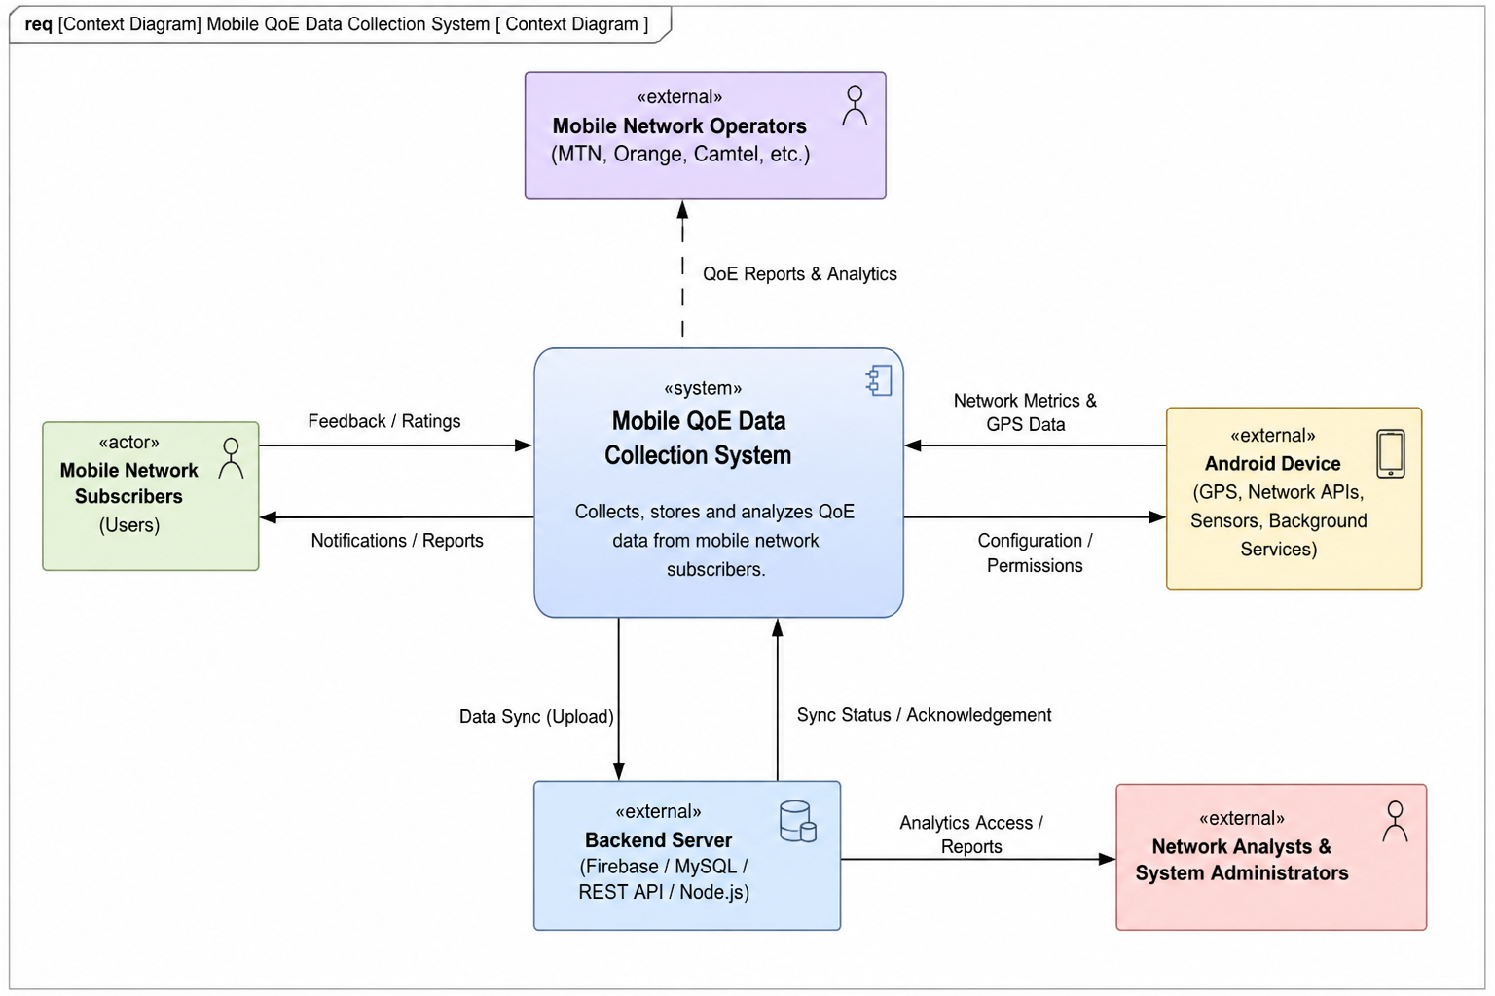

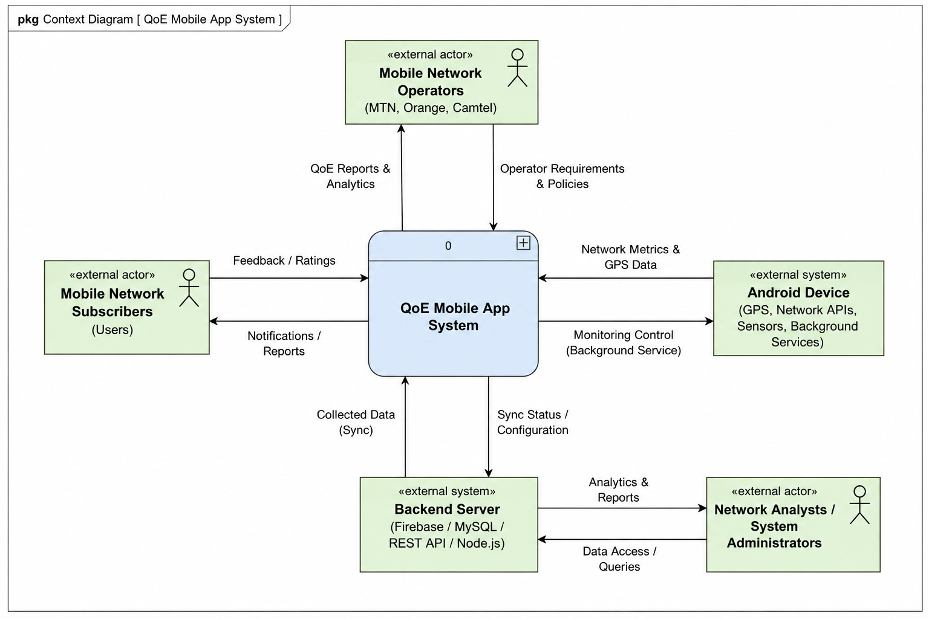

External Entities and Their Roles

Mobile Network Subscribers (Users)
Mobile Network Subscribers are the primary users of the system. They interact with the QoE Mobile App by:
- Providing feedback and satisfaction ratings
- Allowing background monitoring of network performance
- Receiving notifications and summarized reports
Their input represents the subjective Quality of Experience (QoE), which complements objective network measurements.

Android Device
The Android Device represents the mobile platform and hardware environment on which the application runs. It provides:
- Access to GPS location data.
- Network and telephony APIs.
- Signal strength and network type information.
- Background services required for continuous monitoring.

The QoE Mobile App relies on these system resources to collect accurate and real-time network metrics.

Backend Server
The Backend Server is an external system responsible for data storage and processing.
- Receiving synchronized data from the mobile application.
- Storing large volumes of QoE data securely.
- Supporting analytics, reporting, and dashboard services.
- Managing authentication and access control.

Network Analysts and System Administrators

Network Analysts and System Administrators access the system indirectly through the backend server. Their responsibilities include:

- Viewing QoE reports and analytics dashboards.
- Analyzing network performance trends.
- Managing system configurations and user access.
- Supporting decision-making for network optimization.

Mobile Network Operators

Mobile Network Operators such as MTN Cameroon, Orange Cameroon, and Camtel are key stakeholders. They:
- Receive aggregated QoE reports and analytics.
- Use insights to improve network coverage and quality.
- Provide policies and operational requirements that influence system design.

Although they do not interact directly with mobile application, they are major beneficiaries of the collected data.

Data Flow Description

- The context diagram illustrates several key data flows:
- Feedback / Ratings: From Mobile Network Subscribers to the QoE Mobile App.
- Notifications / Reports: From the QoE Mobile App to Subscribers.
- Network Metrics & GPS Data: From the Android Device to the QoE Mobile App.
- Collected Data (Synchronization): From the QoE Mobile App to the Backend Server.
- Analytics & Reports: From the Backend Server to Network Analysts and Administrators.
- QoE Reports & Analytics: From the QoE Mobile App System to Mobile Network Operators.
These flows show how subjective and objective data are collected, processed, and utilized by different stakeholders.

System Boundary Definition

The context diagram clearly defines the system boundary by placing the QoE Mobile App System at the center. All other entities lie outside this boundary and interact with the system through well-defined interfaces.
This separation ensures:
- Better understanding of system responsibilities.
- Clear distinction between internal processing and external interactions.
- Improved system security and maintainability.

Conclusion

The context diagram provides a comprehensive high-level representation of the Mobile QoE Data Collection System and its interaction with external actors and systems. It highlights the central role of the mobile application in collecting user experience data, the importance of backend services for storage and analysis, and the value of the system to network operators and analysts.

This diagram establishes a solid conceptual foundation for detailed system design and supports effective communication between developers, stakeholders, and project evaluators.

Data Flow Diagram

Introduction to Data Flow Diagrams
A Data Flow Diagram (DFD) is a structured analysis tool that shows how data moves through a system. It uses:
- Processes (functions that transform data)
- External Entities (actors outside the system)
- Data Stores (repositories of data)
- Data Flows (arrows showing direction and labels of data movement)
The QoE System is designed to collect, process, and analyze user feedback and network metrics to generate Quality of Experience reports for multiple stakeholders.
DFDs are drawn at different levels. In this project, only Level 0 (Context) and Level 1 (System Processes) were implemented.
Tools used : Gane & Sarson notation in Draw.io

Level 0 :Context Diagram
- Central Process
- QoE System
- External Entities & Data Flows
User
- Submit Feedback, Request Metrics --> QoE System
- Received/View Metrics, Notification <-- QoE System
Mobile Operator
- Request Data --> QoE System
- QoE Reports <-- QoE System
Researcher
- Request Data --> QoE System
- QoE Reports <-- QoE System

2.2.1. Purpose
Defines the system boundary and shows how external actors exchange feedback, metrics, and reports with the QoE System.

Level 1 : System Processes
Processes
- User Interaction / Interface
- Network Monitoring
- Feedback Collection
- QoE Report Analysis
Data Stores
- Metrics Data
- Feedback Data
- QoE Report Data
Data Flows
- User --> User Interaction / Interface: Submit Feedback, Request Metrics
- QoE System --> User: Received/View Metrics, Notification
- Mobile Operator --> Network Monitoring: Request
- Researcher --> Feedback Collection: Request Data
- QoE Report Analysis --> Mobile Operator & Researcher: QoE Report
- Network Monitoring --> Feedback Collection: Synchronize Metrics and Feedback
- Network Monitoring --> Metrics Data: Network Metrics
- Feedback Collection --> Feedback Data: Feedback
- QoE Report Analysis --> QoE Report Data: Metrics, QoE Report
Purpose
Shows the internal subsystems of the QoE System, their interactions, and how data is stored and synchronized to produce reports.

2.4. Conclusion
- The QoE System DFDs (Levels 0 and 1) provide a clear view of:
- How users, operators, and researchers interact with the system.
- How feedback and metrics are collected and synchronized.
- How reports are generated and distributed.
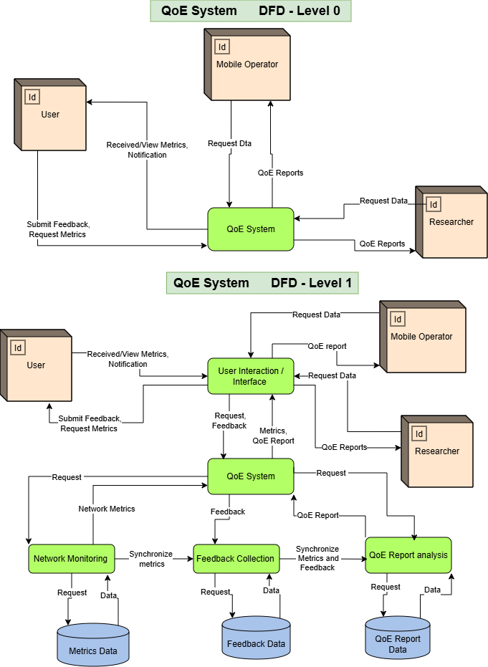

USE CASE DIAGRAM

Introduction
A Use Case Diagram is a UML diagram used to show how users interact with a system. It identifies the actors involved and the services or functions provided by the system. For this project, the use case diagram represents how mobile subscribers, network operators, and the backend server interact with the mobile application designed to collect Quality of Experience (QoE) data from users.

3.2. Purpose of the Use Case Diagram
The purpose of this diagram is to show interactions between users and the system, identify the main functionalities of the application, define the responsibilities of each actor, and provide a clear overview of system behavior.

Actors Identified
- Mobile Subscriber: Main user of the application who views network statistics, submits feedback, receives notifications, and manages settings.
- Network Operator: Accesses synchronized data to analyze network performance and user experience.
- Backend System: Stores, processes, and synchronizes collected network data.

Main Use Cases
- Background Monitoring
- View Real-Time Statistics
- Receive Notifications
- Collect Signal Strength
- Measure Latency & Ping
- Measure Download/Upload Speed
- GPS Location Tagging
- Offline Data Storage
- Backend Synchronization
- Provide QoE Feedback
- Submit Manual Reports
- Generate Weekly Reports
- Bilingual Support
- Manage Data Sharing

Relationships Between Use Cases
The diagram uses relationships where some use cases depend on others. For example, Background Monitoring includes Signal Strength Collection, Latency & Ping Measurement, Download/Upload Speed Measurement, and GPS Location Tagging.

Explanation of System Flow
The mobile subscriber interacts with the application to monitor network quality and provide feedback. The app continuously collects network metrics such as signal strength, speed, and latency. If internet connectivity is unavailable, data is stored locally and synchronized once connectivity is restored. The network operator then analyzes the synchronized data for performance evaluation.

Diagram

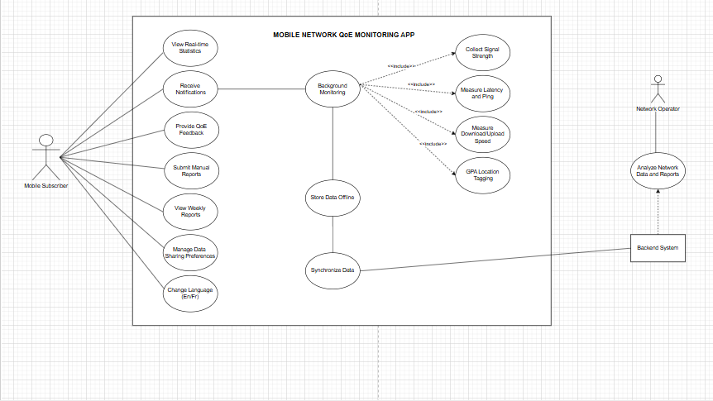

Conclusion
The use case diagram provides a high-level representation of system functionality and interactions. It helps stakeholders and developers understand the core services offered by the application and supports the design and implementation phases.

SEQUENCE DIAGRAM

4.1. Introduction
Sequence diagrams describe dynamic interactions between system components over time.
To complement the static view, we analyze the dynamic behavior of the system. In our project, we identified five main scenarios that are most relevant to QoE data collection and user interaction. Each scenario is represented by a sequence diagram that shows step-by-step interactions among components.

4.2. Scenarios

4.2.1. Scenario 1 : App Launch and Background Monitoring Start
Scenario: The user opens the QoE application for the first time and the background service is initiated.
Actors/Components: Mobile Subscriber, Mobile App UI, Background Service, Device APIs, Local Database.
Flow Description:
The sequence begins when the Mobile Subscriber taps the app icon to open the application. The Mobile App UI responds by displaying a splash screen, then immediately requests permissions from the Device APIs, specifically GPS and network access permissions. If permissions are granted, the app proceeds to display the home dashboard. If permissions are denied, a permission request dialog is shown to the user (alternative flow).
Once the home dashboard is displayed, the Mobile App UI starts the Background Service. The Background Service then performs three initialization steps: it registers with Android WorkManager to ensure persistence, initializes the telephony listener, and initializes the GPS location listener. Once all listeners are ready, the Background Service initializes the SQLite tables in the Local Database, which confirms that the database is ready.
The Background Service then reports back to the Mobile App UI that it is running, and the UI displays a "monitoring active" indicator to the user.
A loop begins, executing every 60 seconds while the app is running: the Background Service requests network metrics from the Device APIs, which return both metrics and GPS data.
Note: The background service continues running silently even when the user closes the app. Android Work Manager ensures persistence. The service respects Android Doze mode and battery optimization policies.
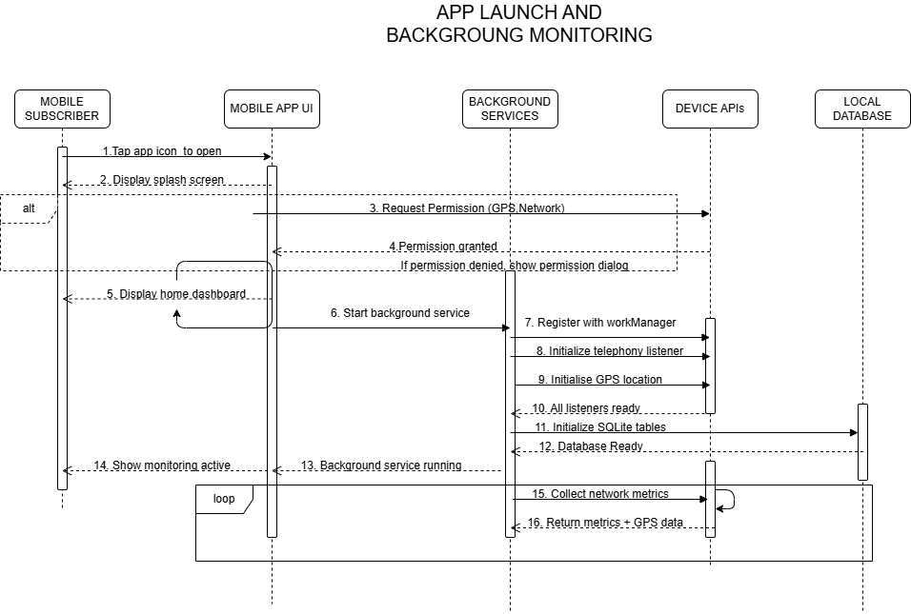

4.2.2. Scenario 2 :Network Metrics Collection and Offline Storage
Scenario: The background service periodically collects network metrics, tags them with GPS coordinates, and stores them locally when the device is offline.
Actors/Components: Background Service, Telephony Manager API, GPS Location API, Network Manager API, Local SQLite Database.
Flow Description:
This diagram operates within a continuous loop that fires every 60 seconds as part of the periodic data collection cycle.
At the start of each cycle, the Background Service requests signal strength data (RSRP/RSSI) from the Telephony Manager API, which returns RSRP, RSSI, and cell ID values. The Background Service then measures latency via a ping request to the Network Manager API, which returns the latency value in milliseconds.
Next, the Background Service requests GPS coordinates from the GPS Location API, which returns latitude, longitude, and accuracy values. The Background Service then instructs the Network Manager API to measure download and upload speed, which returns speed in Mbps along with the network type.
The Background Service then checks internet connectivity via the Network Manager API. If there is no internet — meaning the device is in offline mode — an alternative flow is triggered: the Background Service inserts a record containing signal strength, speed, latency, GPS coordinates, and a timestamp into the Local SQLite Database. The database confirms the record is stored successfully with a pending sync flag set to true. The Background Service then updates the sync status to PENDING.
Note: Every record is tagged with GPS coordinates, timestamp, network operator name, and device model. Data is stored in SQLite with a pending sync flag — data is never lost even without connectivity.
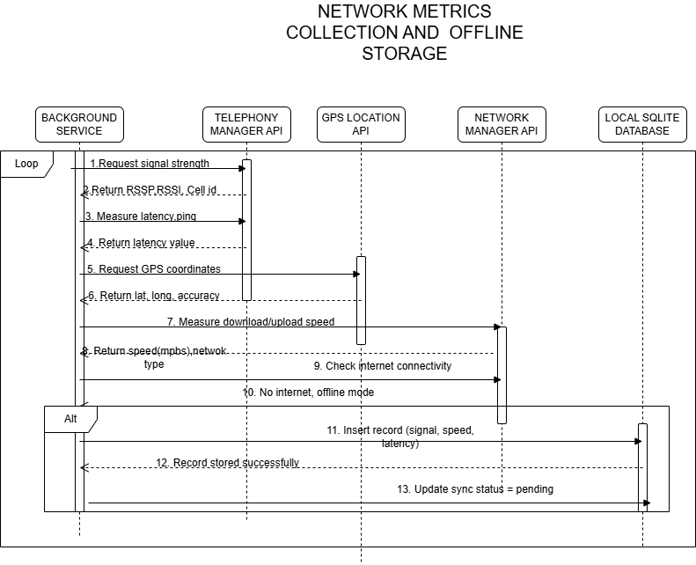

4.2.3. Scenario 3 : Offline to Online Data Synchronization
Scenario: Internet connectivity is restored and the application syncs all pending local data to the backend server.
Actors/Components: Background Service, Network Manager API, Local SQLite Database, Encryption Module, Backend Server API.
Flow Description:
The sequence is triggered when a connectivity changed event fires. The Background Service checks internet connectivity via the Network Manager API. Once internet availability is confirmed (online state), the Background Service queries the Local SQLite Database by selecting all records where sync_status = PENDING. The database returns the count of N pending records.
A loop then begins, processing each pending record in batch:
For each record, the Background Service fetches the next record from the local database, which returns the record as a JSON payload. The Background Service then sends this payload to the Encryption Module, which applies AES-256 encryption and returns the encrypted payload. The Background Service then transmits the encrypted payload to the Backend Server API via a POST request to /api/qoe-data using HTTPS with a JSON payload. The server responds with HTTP 200 OK, confirming the record was received. The Background Service then updates the sync_status of that record to SYNCED in the Local SQLite Database.
Once all records have been synced, the Background Service performs a cleanup of the local database.
Note: Data is transmitted in batches using HTTPS with TLS 1.2+ for security. AES-256 encryption is applied before transmission. If the sync fails mid-way, records remain in PENDING status and a retry occurs on the next connectivity event.
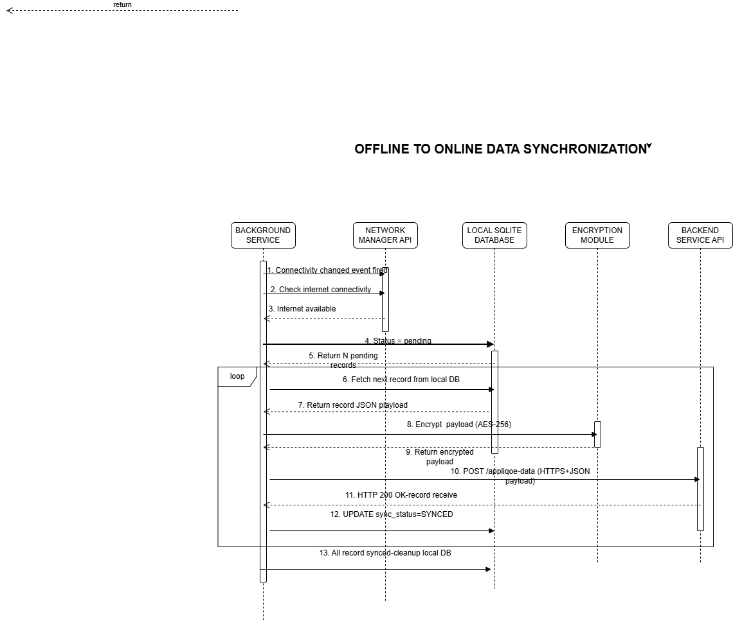

4.2.4. Scenario 4 : User Feedback Prompt and QoE Rating Collection
Scenario: The app prompts the user once per day to rate their network experience and stores the QoE feedback.
Actors/Components: Background Service, Mobile App UI, Mobile Subscriber, GPS Location API, Local SQLite Database.
Flow Description:
The sequence begins when a daily timer fires and the Background Service checks whether feedback has already been collected. It queries the Local SQLite Database for the last feedback timestamp.
If the last feedback was less than 24 hours ago, the prompt is skipped. If 24 hours or more have elapsed, the app proceeds to show the prompt (alternative flow).
The Mobile App UI displays a feedback dialog to the Mobile Subscriber, offering a rating scale from 1 to 5 stars. The user then has two choices (user interaction alternative flow):
- 5 -Submit rating: The user submits a rating (e.g., 3 out of 5 stars). The Mobile App UI requests the current GPS coordinates from the GPS Location API, which returns latitude, longitude, and accuracy. The app then inserts a record containing the rating, GPS data, timestamp, and current network metrics into the Local SQLite Database. The database confirms the feedback is saved, and a thank-you message is shown to the user.
- 6- Dismiss prompt: The user dismisses the dialog without providing a rating. No record is inserted.
Note: The feedback prompt is dismissible and appears at a maximum of once per day to avoid disturbing the user. The rating is linked to current network metrics and GPS location, providing a full subjective and objective QoE record.
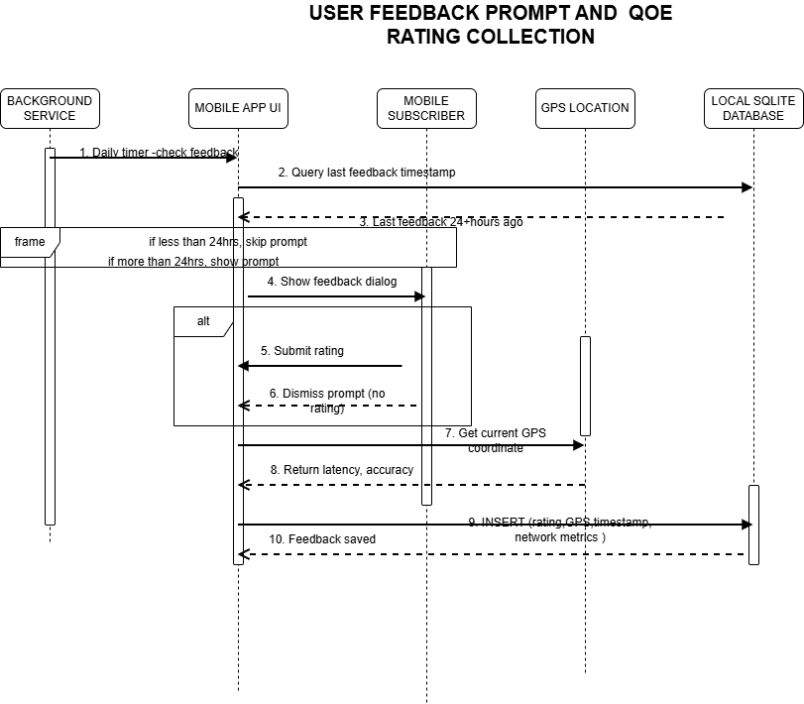

4.2.5. Scenario 5 :Manual Network Problem Report Submission
Scenario: The user manually reports a network problem with a description, location, and severity level.
Actors/Components: Mobile Subscriber, Mobile App UI, GPS Location API, Local SQLite Database, Backend Server API.
Flow Description:
The sequence begins when the Mobile Subscriber taps the "Report Problem" button. The Mobile App UI displays the report form screen. The user then fills in the required fields: entering a problem description, selecting a severity level (Low, Medium, or High), and selecting a problem type (e.g., no signal). The user then taps the "Submit Report" button.
Upon submission, the Mobile App UI requests the current GPS coordinates from the GPS Location API, which returns the GPS coordinates. The app then saves the report locally to the Local SQLite Database with a pending sync status. The database confirms the report is saved and returns a report ID.
An alternative flow is then evaluated based on connectivity:
- If internet is available: The app immediately posts the report to the Backend Server API via POST /Api/problem-report using HTTPS. The server responds with HTTP 201 Created, confirming the report was received. The app then updates the sync_status to SYNCED in the Local SQLite Database.
Finally, the Mobile App UI shows a "Report submitted" message to the Mobile Subscriber.

Note: If there is no internet, the report is stored locally with PENDING status and synced automatically when connectivity is restored. Each report includes the description, severity, problem type, GPS location, timestamp, device model, and current signal strength.
These diagrams highlight both automated and user-driven interactions, ensuring comprehensive QoE data collection.

Class Diagram

5.1. Introduction
A class diagram is a UML diagram used to represent the static structure of a system. It defines classes, their attributes and methods, and the relationships among them. This report describes the class diagram developed for a Network Analysis and Quality of Experience (QoE) system, which collects user feedback and network performance data, analyzes results, and generates reports for stakeholders such as mobile operators, researchers, administrators, and regulatory bodies.

5.2. Purpose of the Diagram
The purpose of this class diagram is to
- Model the logical structure of the QoE system.
- Define how data flows between users, metrics, and reports.
- Serve as a blueprint for implementation and database design.
- Ensure modularity and scalability for future system extensions.

Overview of the Diagram
The diagram consists of several interconnected classes
Class | Description
User | Represents individuals using the app to test network performance and submit feedback
Feedback | Stores user ratings and comments about network quality
NetworkMetrics | Captures technical parameters such as signal strength, latency, jitter, and speed
QoEReport | Aggregates feedback and metrics to produce analytical reports
Notification | Manages prompts and alerts for users to provide feedback
MobileOperator | Accesses reports and optimizes network performance.
Researcher | Requests data and publishes findings based on QoE analysis.
SystemBackend | Handles data storage, synchronization, authentication, and analytics
RegulatorBody | Enforces compliance and standards for network quality.
Admin | Manages users and reviews reports
Stakeholder | Abstract superclass for Admin, Operator, Researcher, and Regulator, defining shared attributes and methods

Relationships and UML Principles
The diagram applies UML relationships with labels and cardinalities (found on the diagram below)
Relationship Type | Example | Label | Description
Association | User - Feedback | submits | A user can submit many feedback entries
Association | User - NetworkMetrics | generates/views | A user initiates tests and views multiple metrics and the metrics can be reused in reports
Association | Researcher - QoEReport | requests data/uses/analyzes reports | Researchers analyze multiple reports; reports can be studied by multiple researchers
Association | Notification - User | prompts | Each notification prompts one user, and each user receives one notification instance
Association | MobileOperator - QoEReport | requests data/uses/analyzes reports | Operators access multiple reports; reports can be analyzed by multiple operators
Aggregation | QoEReport - Feedback | contains/summarizes | Reports summarize multiple feedback entries; feedback can contribute to multiple reports
Aggregation | QoEReport - NetworkMetrics | contains/summarizes | Reports summarize multiple metrics; metrics can be included in multiple reports
Generalization | Stakeholder - Admin, Operator, Researcher, Regulator | inherits stakeholder role | Common attributes and methods are inherited by all stakeholder classes.

Key Design Features
Visibility markers (+ public, - private, # protected) ensure encapsulation.
Anonymous user mode allows privacy in data collection.
Periodic notifications encourage consistent feedback submission.
Stakeholder hierarchy reduces redundancy and supports different access levels to reports.
Integration of metrics and feedback enables both subjective and objective QoE evaluation.
Scalable backend supports data synchronization, authentication, and analytics.

Design Reasoning
The design mirrors real-world QoE systems such as Speedtest Master and OpenSignal, where users initiate tests, view results, and contribute data for analysis. The User - NetworkMetrics connection ensures interactive measurement, while QoEReport centralizes analytics for stakeholders. The use of aggregation for Feedback and NetworkMetrics ensures flexibility: reports can summarize multiple entries, and the same data can be reused across reports.

Conclusion
The class diagram provides a comprehensive blueprint for implementing the QoE system. It captures both technical measurements and user perceptions, ensuring a holistic view of network performance.
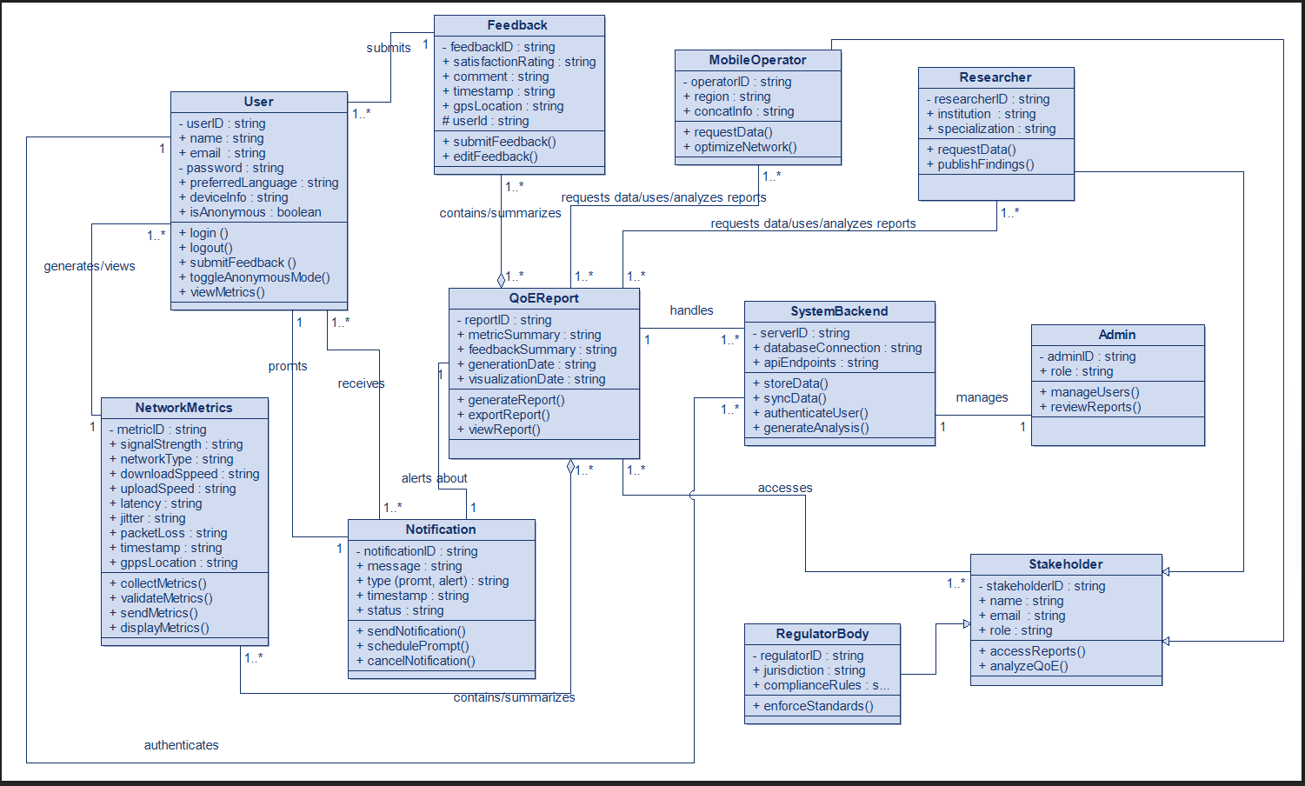

6.Deployment Diagram

6.1. Introduction
A deployment diagram is a Unified Modeling Language (UML) structural diagram used to represent the physical architecture of a software system. It illustrates the hardware devices, software artifacts, execution environments, and communication links involved in the deployment and operation of the system.
This report presents the deployment diagram of the Mobile Quality of Experience (QoE) Data Collection System, a multi-platform mobile application designed to collect and analyze network performance and user experience data from mobile network subscribers in Cameroon.
The deployment model supports multiple mobile operating systems including Android, iOS, HarmonyOS, Windows Mobile platforms, and other compatible mobile operating systems. This enhancement improves accessibility, scalability, and usability across a wider range of devices.

6.2. Purpose of the Deployment Diagram
The deployment diagram was developed to:
- Illustrate the physical architecture of the QoE system
- Show how software components are distributed across hardware nodes
- Identify communication links between devices and servers
- Describe execution environments and deployed software artifacts
- Demonstrate cross-platform mobile support
- Provide a clear understanding of the runtime infrastructure of the system

The diagram helps developers, stakeholders, and evaluators understand how the application operates within a distributed network environment.

6.3. Overview of the System Architecture
The Mobile QoE Data Collection System follows a distributed client-server architecture composed of:
- Multi-platform mobile devices running the QoE mobile application
- Internet communication infrastructure
- Backend application server
- Database server
- Analyst and administrator workstations
- Mobile network operator dashboards

The architecture supports secure communication and centralized processing of QoE data collected from users operating different mobile devices and operating systems.

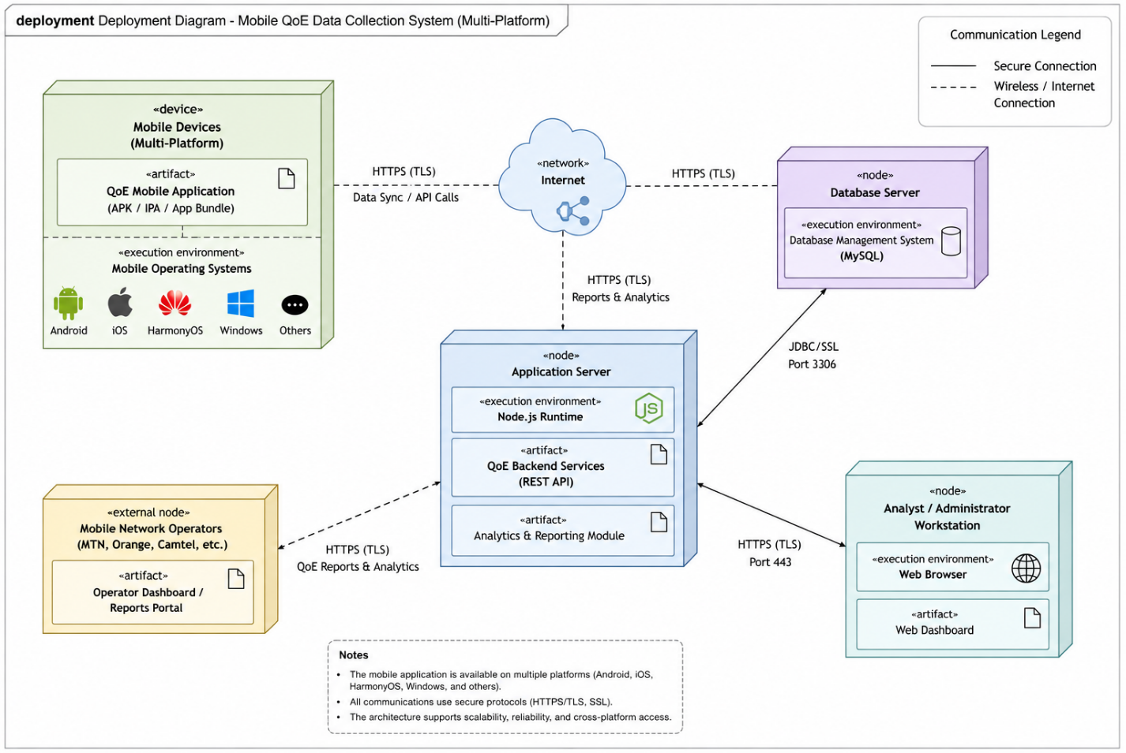

6.4. Description of Deployment Nodes

6.4.1. Mobile Devices (Multi-Platform)
The Mobile Devices node represents all supported client devices on which the QoE mobile application can be installed and executed.

6.4.1.1. Supported Mobile Operating Systems
- Android
- iOS
- HarmonyOS
- Windows Mobile platforms
- Other compatible mobile operating systems

6.4.1.2. Execution Environment
Mobile Operating Systems
Deployed Artifact
QoE Mobile Application
- APK (Android Package)
- IPA (iOS Application Package)
- App Bundles for other platforms
Responsibilities
The QoE mobile application performs the following tasks:
- Collecting network metrics such as:
  - Signal strength
  - Download speed
  - Upload speed
  - Latency
  - Packet loss
  - Jitter
- Collecting GPS location and timestamp information
- Monitoring network performance continuously in the background
- Gathering user satisfaction ratings and feedback
- Synchronizing collected data with the backend server through secure APIs

The multi-platform architecture increases system availability and ensures that users from different mobile ecosystems can participate in QoE data collection.

6.4.2. Internet Network
The Internet node represents the communication infrastructure connecting all distributed components of the system.
Functions
- Enables communication between mobile devices and backend services
- Supports synchronization of QoE data
- Allows remote access to reports and dashboards
- Facilitates secure API communication

Communication Protocol
HTTPS with TLS encryption

The use of encrypted communication channels ensures confidentiality and integrity of transmitted data.

6.4.3. Application Server
The Application Server hosts the backend services responsible for processing application requests and managing system logic.
Execution Environment
Node.js Runtime Environment
Deployed Artifacts
- QoE Backend Services (REST API)
- Analytics and Reporting Module

Responsibilities
The application server is responsible for:
- Receiving synchronized QoE data from mobile devices
- Processing network performance information
- Managing user authentication and authorization
- Generating reports and analytics dashboards
- Providing APIs for mobile and web applications
- Supporting communication between the database and external dashboards

The application server acts as the central processing unit of the system architecture.

6.4.4. Database Server
The Database Server stores and manages all persistent system data.
Execution Environment
Database Management System (MySQL)
Responsibilities
The database server stores:
- User account information
- Network performance metrics
- GPS and timestamp data
- User feedback and ratings
- Generated reports and analytics data

Communication
Communication between the application server and database server is performed using:
- JDBC/SSL connection
- Port 3306

Secure database communication improves system reliability and protects sensitive information.

6.4.5. Analyst and Administrator Workstation
This node represents computers used by analysts and administrators to monitor and manage the system.
Execution Environment:
Web Browser
Deployed Artifact:
Web Dashboard
Responsibilities
Analysts and administrators use the system to:
- Monitor QoE analytics and reports
- Analyze network performance trends
- Manage users and configurations
- Support maintenance and troubleshooting activities
- Assist decision-making for network optimization

Communication with the application server occurs through secure HTTPS connections.

6.4.6. Mobile Network Operators
Mobile Network Operators such as MTN Cameroon, Orange Cameroon, and Camtel are external stakeholders connected to the system.
Deployed Artifact:
Operator Dashboard / Reports Portal
Responsibilities:
Network operators use the generated QoE analytics to:
- Evaluate service quality
- Detect network coverage issues
- Improve network reliability and performance
- Support strategic planning and optimization

Operators access summarized reports and analytics dashboards generated by the backend system.

6.5. Communication Between Nodes
The deployment diagram illustrates secure communication links between all major nodes in the system architecture.

Key Communication Paths
Source Node | Destination Node | Communication Protocol
Mobile Devices | Application Server | HTTPS (TLS)
Application Server | Database Server | JDBC/SSL
Analyst Workstation | Application Server | HTTPS
Mobile Network Operators | Application Server | HTTPS

These communication channels ensure secure, reliable, and efficient exchange of information across the distributed system.

6.6. Cross-Platform Architecture Considerations
The updated deployment architecture introduces support for multiple mobile operating systems. This improvement offers several advantages:
- Increased Accessibility:
Users can install and use the application regardless of their mobile operating system.
- Wider Data Collection Coverage:
Supporting multiple platforms increases the number of potential participants and improves the diversity of collected QoE data.
- Improved Scalability:
The architecture can accommodate future mobile technologies and operating systems.
- Better User Adoption:
Cross-platform compatibility enhances usability and encourages broader acceptance of the application.

6.7. Security Considerations
Security remains an important aspect of the deployment architecture. The system incorporates several security mechanisms, including:
- HTTPS communication with TLS encryption
- Secure REST API communication
- SSL-secured database connections
- User authentication and authorization
- Restricted access to dashboards and reports
- Confidential handling of user information

These mechanisms help protect system resources and maintain the privacy of collected data.

6.8. Advantages of the Deployment Architecture
The proposed deployment architecture provides several benefits:
- Scalability:
The centralized backend infrastructure can support large numbers of users and devices.
- Reliability:
Distributed deployment reduces the impact of system failures.
- Security:
Encrypted communication channels protect sensitive information.
- Maintainability:
Backend services and databases can be updated independently without affecting mobile clients.
- Cross-Platform Support:
The application supports multiple mobile operating systems, increasing accessibility and usability.
- Accessibility:
Analysts, administrators, and network operators can remotely access dashboards and reports through web interfaces.

6.9. Conclusion
The deployment diagram provides a comprehensive representation of the physical architecture of the Mobile QoE Data Collection System. It demonstrates how multi-platform mobile devices, backend servers, databases, analysts, and network operators interact within a distributed and secure environment to support real-time QoE monitoring and analytics.
The updated architecture extends support beyond Android devices to include multiple mobile operating systems, thereby improving accessibility, scalability, and user participation. The deployment model ensures secure communication, centralized data processing, and efficient management of network performance information.
This deployment architecture provides a strong technical foundation for the successful implementation, operation, and future expansion of the proposed QoE monitoring system.

7.CONCLUSION
The system modeling and design phase provides a comprehensive representation of the Mobile QoE Data Collection System. Each diagram contributes a unique perspective: the Context Diagram defines boundaries, the Use Case Diagram highlights functionalities, the Sequence Diagrams capture dynamic interactions, the Class Diagram structures the system, and the Deployment Diagram illustrates the physical architecture. Together, they form a cohesive blueprint that ensures clarity, feasibility, and alignment with project objectives.
This modeling process lays a strong foundation for implementation, testing, and deployment, ultimately supporting mobile operators in improving network performance and enhancing user satisfaction.

