> air <- read.csv('P:/ST1050/airline.csv', stringsAsFactors = FALSE)

> print(air)

Year Month DayofMonth DayOfWeek DepTime CRSDepTime

1 2005 1 1 6 1211 1216

2 2005 1 2 7 1209 1216

3 2005 1 3 1 1213 1216

4 2005 1 4 2 NA 1216

> air

Year Month DayofMonth DayOfWeek DepTime CRSDepTime

1 2005 1 1 6 1211 1216

2 2005 1 2 7 1209 1216

3 2005 1 3 1 1213 1216

4 2005 1 4 2 NA 1216

> air[,1:5]

Year Month DayofMonth DayOfWeek DepTime

1 2005 1 1 6 1211

2 2005 1 2 7 1209

3 2005 1 3 1 1213

4 2005 1 4 2 NA

> air[1:50,]

Year Month DayofMonth DayOfWeek DepTime CRSDepTime ArrTime

1 2005 1 1 6 1211 1216 1451

2 2005 1 2 7 1209 1216 1447

3 2005 1 3 1 1213 1216 1454

4 2005 1 4 2 NA 1216 NA

> air[1:50,1:8]

Year Month DayofMonth DayOfWeek DepTime CRSDepTime ArrTime

1 2005 1 1 6 1211 1216 1451

2 2005 1 2 7 1209 1216 1447

3 2005 1 3 1 1213 1216 1454

4 2005 1 4 2 NA 1216 NA

> delay<-air$DepDelay

> delayChange<-air$DepDelay-air$ArrDelay

> delayChange

[1] 6 8 5 NA -7 -2 0 15 13 18 12 15 18 17

[15] 11 12 9 9 5 3 4 4 11 -1 9 -6 4 -15

[29] 1 1 8 6 -3 8 1 -6 -5 3 2 2 1 6

[43] 7 0 8 8 5 10 11 0 9 0 -10 8 15 9

> crazymakers<-delay[delay>300]

> crazymakers[1:10]

[1] NA NA NA NA NA NA NA NA NA NA

> crazymakers<-crazymakers[!is.na(crazymakers)]

> crazymakers[1:10]

[1] 303 315 323 369 488 304 397 308 302 301

> median

function (x, na.rm = FALSE, ...)

UseMethod("median")

<bytecode: 0x0000000009c70c98>

<environment: namespace:stats>

> class(median)

[1] "function"

> median(delay)

[1] NA

> median(delay, na.rm=TRUE)

[1] -1

> hist(rnorm(1000))

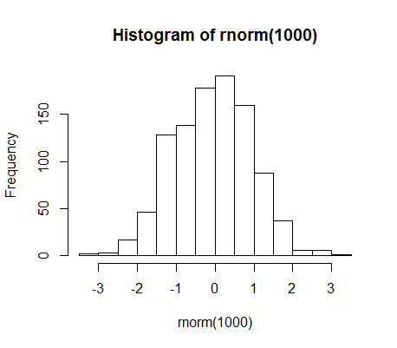

> ?rnorm