**27/11/2018**

**Name:** Maxim Chopivskyy

**ID Number:** 118364841

# ST1050 Practical 20

## Q1a

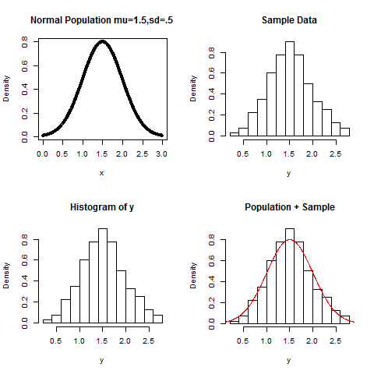

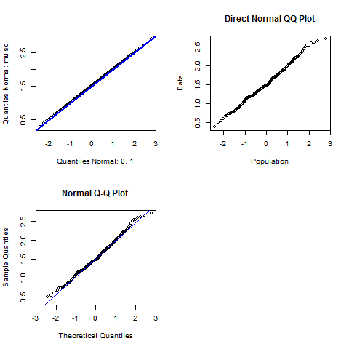

## Q1b

It’s plotting the normal population

## Q1c

We are checking for the Quantile-Quantile plot for a sample from the standard normal distribution.

## Q1d

The blue line is to provide a reference when comparing the sets of sample quantiles and theoretical quantiles. The closer the two sets align with it, the less distributed the sets are.

## Q1e

We are trying to demonstrate that our population data sample has a normal distribution.

## Q1f

> pdf("Rplots.pdf")

> par(mfrow=c(2,2))

> set.seed(1)

>

> mu=2 ; sd = 1

> u =seq(-3,3,.01) ; x=mu+sd*u ; fx = dnorm(x,mu,sd)

> plot(x,fx,main="Normal Population mu=2,sd=1",xlab="x", ylab="Density")

>

> n=200

>

> y = rnorm(n,mu,sd)

> hist(y,freq=FALSE,main="Sample Data")

>

> o=hist(y,freq=F)

> hist(y,freq=FALSE,main=" Population + Sample",ylim=range(fx,o$density))

> lines(x,fx,col=2)

>

> squant = sort(y)

> ps = ((1:n)+.5)/(n+1)

> pquant=qnorm(ps,mu,sd) ; pquant01=qnorm(ps,0,1)

>

> plot(pquant01,pquant,ylab="Quantiles Normal: mu,sd ",

+ xlab="Quantiles Normal: 0, 1"); abline(a=mu,b=sd,col=4,lwd=2)

>

> plot(pquant01,squant,xlab="Population",ylab="Data",main="Direct Normal QQ Plot")

>

> qqnorm(y); abline(lm(squant~pquant01)$coef,col=4)

## Q2b