Azure – Virtual Network

Question: Why to deploy multiple VNets?

Answer:

1. Provides network isolation and segmentation
2. Name resolution
3. Traffic filtering

Question: When multiple Vnets make sense?

Answer:

1. Saving money
2. Segmenting workloads
3. Securing traffic

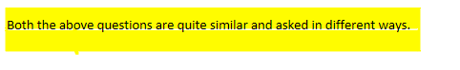

DDoS - Distributed Denial of Service

NSG - Network Security Group is a virtual firewall.

NIC - Network Interface Card associate your machine address to IP address

NIC is only applicable in terms of Virtual Machines

CIDR - Classless Inter-Domain Routing

