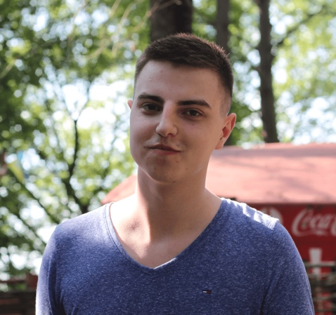Maxim Lysenko

*Front-end Developer*

28 Dec 1994; Lutsk/Kyiv, Ukraine;

phone: +38(063)-596-55-76,

mail: maxim.lysenko94@gmail.com,

skype: max123281

OBJECTIVE

I’m looking for an opportunity to grow as a Front-end/JavaScript Developer.

SKILLS

* HTML5, CSS3, JavaScript (ECMAScript 2015);
* TypeScript;
* Twitter Bootstrap, Less/SASS;
* jQuery, AngularJS 1.x;
* Grunt/Gulp;
* Git;
* Adobe Photoshop (PSD to HTML);
* Understanding and using OOP principles, MVC pattern and SPA approach;
* Strong Upper-intermediate English.

EDUCATION

National Aviation University, Institute of Computer Information Technologies

Bachelor in Computer Science: 2012 - 2016

Front-end Development, Brain Academy

November 2015 – March 2016

160 hours

LANGUAGES

* Ukrainian (mother tongue);
* Russian (fluent);
* English (upper-intermediate);
* German (basic).

ADDITIONAL INFORMATION

Please visit my portfolio [web-site](http://maximlysenko.github.io/) to learn more about me.

Some code examples You can find [here](https://github.com/tetp1c).