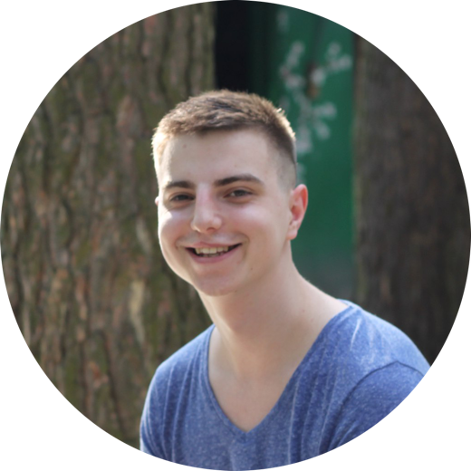Maxim Lysenko

Front-end Developer (AngularJS)

From $400

Birth date: 28 Dec 1994

Location: Kyiv, Ukraine

Phone: +38(063)-596-55-76

Email: [maxim.lysenko94@gmail.com](mailto:maxim.lysenko94@gmail.com)

Skype: max123281

SUMMARY

Hi! I’m young ambitious person, looking for an opportunity to grow as a Front-end / JavaScript Developer. I have good knowledge of Front-end techniques and keep study on it every day to increase my proficiency in Web technologies. My objective for now is to become Full Stack JavaScript Developer using MEAN Stack.

SKILLS

|  |  |
| --- | --- |
| * HTML5; * CSS3; * Twitter Bootstrap; * Less/Sass; * Native JavaScript; * jQuery; | * AngularJS 1.x; * MVC Pattern; * SPA Approach; * Adobe Photoshop (PSD to HTML) * Git / Git Flow; * Gulp. |

Languages: English (Upper-Intermediate), Ukrainian (Mother tongue), Russian (Fluent), German (Basics).

EXPERIENCE

**Junior Front-end Developer (AngularJS) -** May 2016 – Aug 2016

Bumeen Group

EDUCATION

**National Aviation University, Institute of Computer Information Technologies.**

Bachelor in Computer Science – 2012 – 2016.

ADDITION INFO

Feel free to visit my [portfolio](http://maximlysenko.github.io/) website for detailed information and code examples.