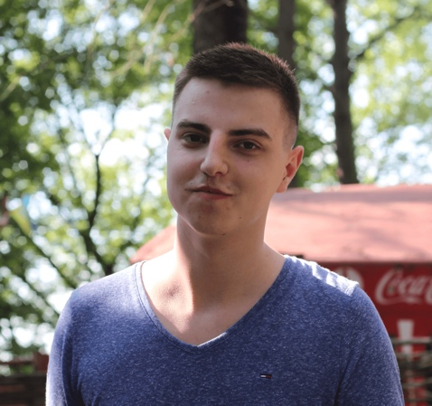Maxim Lysenko

*Front-end Developer*

28 Dec 1994, Kyiv, Ukraine;

phone: +38(063)-596-55-76,

mail: maxim.lysenko94@gmail.com,

skype: max123281

OBJECTIVE

I’m looking for an opportunity to grow as a Front-end/JavaScript Developer.

SKILLS

* HTML5, CSS3, JavaScript (ECMAScript 2015);
* TypeScript;
* Twitter Bootstrap, Less/SASS;
* jQuery, AngularJS 1.x;
* Grunt/Gulp;
* Git;
* Adobe Photoshop (PSD to HTML);
* Understanding and using OOP principles;
* Understanding MVC pattern and SPA approach;

EDUCATION

National Aviation University, Institute of Computer Information Technologies

Bachelor in Computer Science: 2012 - 2016

Front-end Development, Brain Academy

November 2015 – March 2016

160 hours

LANGUAGES

* Ukrainian (mother tongue);
* Russian (fluent);
* English (upper-intermediate);
* German (basic).

ADDITIONAL INFORMATION

I’m young ambitious person looking for some work experience in IT. It’s very important for me to improve my skill level, learn new technologies and grow as a web developer.

Some code examples You can find here: https://github.com/tetp1c/Final-Project

or here: https://github.com/tetp1c/simple-todoList-on-JS