Configuration
The following configuration steps only need to be run once. You must be logged in as a member of the domain RTCCUniversalServerAdmins group and a member of the local administrator group. Do not run these steps on subsequent installations of the Security Authorization Filter on this server. These requirements only need to be run once.
The Security Authorization Filter must be installed on a server joined to your internal Active Directory Directory Services where your Skype for Business Server infrastructure is deployed. Use the Skype for Business Server 2015 – Deployment Wizard to install the Local Configuration Store and assign a certificate to this server where the Security Authorization Filter will be deployed.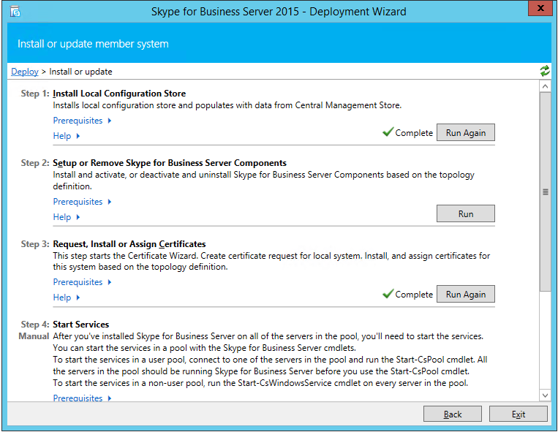
Next, you must run the PowerShell script, configure.ps1, after you complete this installation. This PowerShell script is located in %programFiles%\MB\Security Authorization Filter to configure the Security Authorization Filter as a Skype for Business trusted application server.
Finally, configure any firewalls to allow TCP access over SQL port 1433 (default port) between the Security Authorization Filter and the Security Filter Manager, and TCP access over SIP port 6666 between the Security Authorization Filter and your Skype for Business Server pools.

