Project Resolution process

Hello! I’m Max! How are you doing up there in Chicago? Let me introduce you to this document where I will to briefly describe how I developed the project, what I assumed to do so and how to run it, along with its unit test. Let’s get to it!

**Technologies, tools and Work organization**

* Frameworks:
  + ASP.NET Core 2.2
  + Entity Framework Core 2.2
* Database:
  + Microsoft SQL 2017.
* IDEs:
  + Microsoft Visual Studio
  + Visual Studio Code
* Version Control:
  + Git
  + Host: Github
* Endpoint testing: Postman.

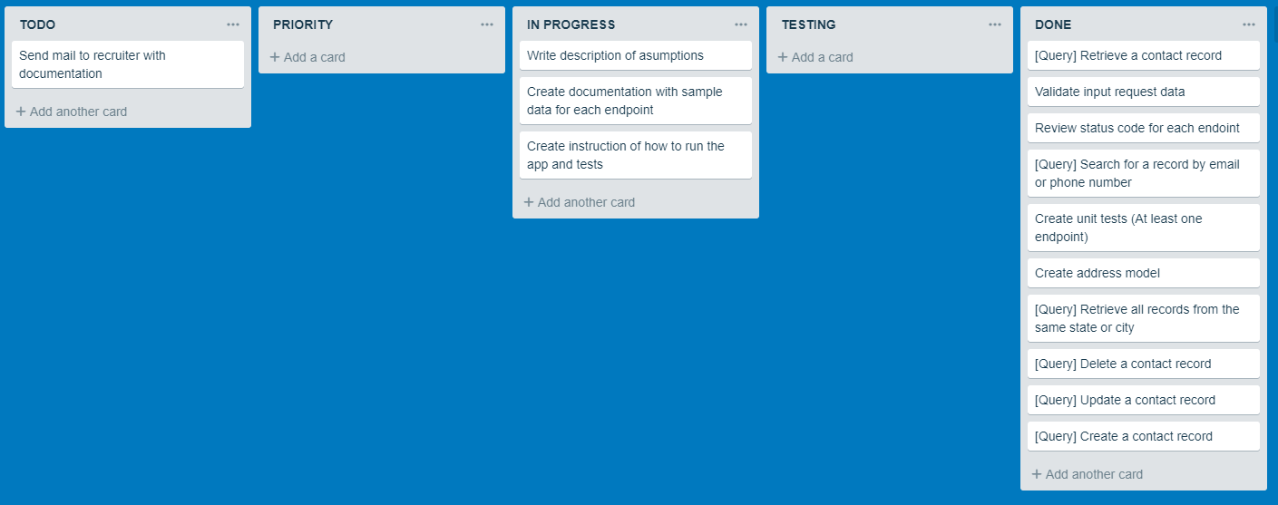To organize myself I created a *Trello* board, followed the workflow and got to it!

As for version control, I used **Github** and worked with two main Branches: *master* and *dev.* In the last one I commited and pushed developed and tested code, and after a final test of the entire application, merge into *master*.

**Assumptions**

Keeping in mind the main **entity<Contact>**, I’ve assumed this app is developing to save and store people related to the user, Contact also has two object properties, each one with a 1:1 class relations: <**Address>** and <**ContactPhone>**.

* **Contact fields.**

|  |  |  |  |
| --- | --- | --- | --- |
| Field Name | Required | Format | Validation |
| Id | **Yes**.  Auto generated Unique identifier, Key | long |  |
| Name | Yes | String | Max length (40) |
| Company | No | String | Max length (40) |
| Profile Image | No | String, receiving a imageURL or a base64 string | - |
| Email | Yes.  AlternateKey | String | In ContactValidator |
| Birthday | Yes | DateTime |  |
| ContactPhone | **Yes**. | ContactPhone class |  |
| Address | Yes | Address class |  |

* **Address fields**

|  |  |  |  |
| --- | --- | --- | --- |
| Field Name | Required | Format | Validation |
| Id | **Yes**.  Auto generated Unique identifier, Key | long | - |
| AddressLine1 | Yes | String | Max length (60) |
| AddressLine2 | No | String | Max length (40) |
| City | No | String | Max length (40) |
| State | Yes | String | Max length (40) |
| Contact (owner) | Yes | Contact class |  |

* **ContactPhone fields**

|  |  |  |  |
| --- | --- | --- | --- |
| Field Name | Required | Format | Validation |
| ContactPhoneid | **Yes**.  Auto generated Unique identifier, Key | String | - |
| PersonalPhone | Yes, American phone number. | String | In ContactValidator |
| WorkPhone | No, American phone number. | String | In ContactValidator |
| Contact (owner) | yes | String, receiving a imageURL or a base64 string | Max length (40) |

**Setup**

[Download .NET Core 2.2 SDK](https://dotnet.microsoft.com/download/dotnet-core/2.2) (Or just the runtime)

To **build and run** the project using the command line:

1. Open the Command Prompt
2. Download the project repository with the following command: **“git clone** <https://github.com/maximojgonzalezc/SCodeChallengeWebAPI.git>**”**
3. Step into the solution directory folder **“cd SCodeChallengeWebAPI”**
4. Restore nuget packages with **“dotnet restore”**
5. Step into the project src **“cd SCodeChallengeWebAPI”**
6. Create the database **“dotnet ef migrations add FirstMigration”**
7. Apply the migration to the database to create the schema **“dotnet ef database update”**
8. Run the project **“dotnet run in the src directory.”**

Point your browser to [**http://localhost:5000**](http://localhost:5000/)

*Of course, you can also run it from either Visual Studio 2017 or Visual Studio Code with the IDE handling most of the steps above.*

To run the **unit tests** follow all steps until 4, followed by:

1. Step into the project src **“cd SCodeChallengeWebAPITest”**
2. Run “dotnet test”

**API Endpoints documentation:**

[**https://documenter.getpostman.com/view/6990804/S17tQ7i7**](https://documenter.getpostman.com/view/6990804/S17tQ7i7)