**Project “A System For Comparing Product**

**Characteristics”**

**Pavliuc Maxim, IS31Z**

**2024**

**PPW2 USARB 2025**

**Summary:**

***1.*** ***Short Description:*** 3

***2.*** ***ToR*** 4

***3.*** ***Requirements*** 7

***4.*** ***Web-site structure*** 8

**Schematic structure of the site:** 8

***5.*** ***Project duration and timelines*** 14

# ***Short Description:***

SpecSavers - Your Ultimate Guide to Product Comparisons

Welcome to SpecSavers, the premier platform dedicated to helping you make informed decisions about products. Our system is unlike any other, as we delve into the intricacies of product specifications and features. Join us for an unforgettable journey into the heart of product comparisons, where you'll find the perfect match for your needs.

System Overview:

SpecSavers is a one-of-a-kind platform that brings together experts, enthusiasts, and consumers from around the world to discuss product specifications, features, and the broader implications of informed decision-making. Whether you're a tech enthusiast, a savvy shopper, or simply curious about the best products on the market, this platform is the ultimate destination for you.

Platform Highlights:

Cutting-Edge Comparisons: Dive deep into the world of product specifications with hands-on comparisons led by renowned experts. Learn about key features, performance metrics, and pricing.

# ***ToR***

**SpecSavers Website Design Project Outline**

1. **Project Overview:**

This TOR outlines the requirements and objectives for the website design project.

The project aims to create a user-friendly and visually appealing website for SpecSavers.

1. **Objectives:**

- To craft an engaging, responsive website that delivers a seamless user experience across various devices, with special emphasis on mobile and tablet compatibility to cater to on-the-go visitors.

- To enrich the user journey with intuitive navigation and user-friendly interfaces, boosting engagement and encouraging participation in adoption, donation, and educational initiatives.

- To elevate "SpecSavers'" stature in the digital landscape, augmenting the organization's visibility and establishing its reputation as a leader in animal welfare and rescue services.

1. **Scope of Work:**

- Development of a custom web architecture that includes a variety of pages tailored to showcase adoptable pets, educational resources, and ways to help, determined during the requirements analysis phase.

- Design of compelling graphics and multimedia elements to captivate users' interest and accurately convey the compassionate ethos of the "SpecSavers" brand.

- Implementation of a Content Management System (CMS)

1. **Deliverables:**

- Fully functional website with all specified features and pages.

- High-resolution images and graphics used in the design.

- Documentation for using the CMS (if applicable).

1. **Timeline:**

A comprehensive project timeline will be shared at the start of the project.

Regular progress updates and milestones will be established throughout the project.

1. **Budget:**

The budget for this project is 30$.

Any additional costs beyond the agreed budget must be approved in advance.

1. **Team Responsibilities:**

SpecSavers will provide content, branding guidelines, and any necessary information.

The design and development team will execute the website creation according to the specifications outlined in this TOR.

1. **Approval Process:**

- The project will adhere to a structured approval process, encompassing requirement analysis, system design, development stages, to testing (including unit, integration, system, and security testing).

- Standards compliance will be observed to guarantee product quality, reliability, and security.

1. **Contact Information:**

- Complete contact details for the project coordinator and key organizational contacts will be provided, including phone numbers, emails, and office locations.

1. **Confidentiality:**

All project-related information and materials are considered confidential and should not be disclosed without proper authorization.

1. **Terms and Conditions:**

This TOR serves as a binding agreement between SpecSavers and the design and development team.

1. **Amendments:**

- Modifications to this TOR must be formally documented and approved in writing by both parties.

1. **Acceptance:**

- Authorized representatives from "SpecSavers" and the development team will sign this document to signify their agreement and commitment to the project's terms.

Client's Signature: ______________________________ Date: ________________

Project Manager's Signature: ______________________ Date: ________________

# ***Requirements***

* UI/UX Colors

Main Colors:

* Green
* Black
* White
* Blue

⦁Browsers and supported devices.

Browsers:

⦁ Opera;

⦁ Google chrome;

Devices:

⦁ PC;

⦁ Mobiles devices;

Resolutions:

* PC
  + From full HD to 8K
* Mobile devices
  + Width from 300 to 600

# ***Web-site structure***

## ***Schematic structure of the site:***

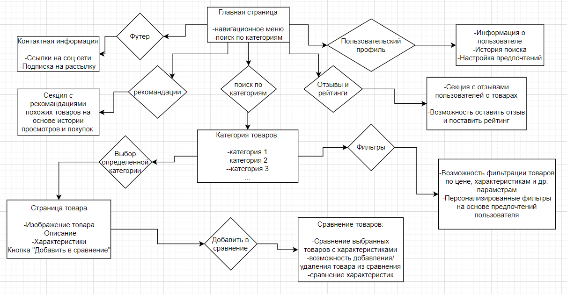

* 1. ***MainPage***

- Mission statement and vision of " SpecSavers "

- Latest news and upcoming events.

- Navigation to key site sections like categories, comparison, information about us and other features.

The homepage will be designed as a **Landing Page** , serving as an introduction to the company and providing essential information for users. Here’s how it will be structured:

* 1. **Overview of the Company**:
  + The homepage will feature a clear, engaging overview of the company, highlighting its mission, values, and key services or products.
  + This section will provide users with a snapshot of what the company does, helping them quickly understand its purpose and offerings.

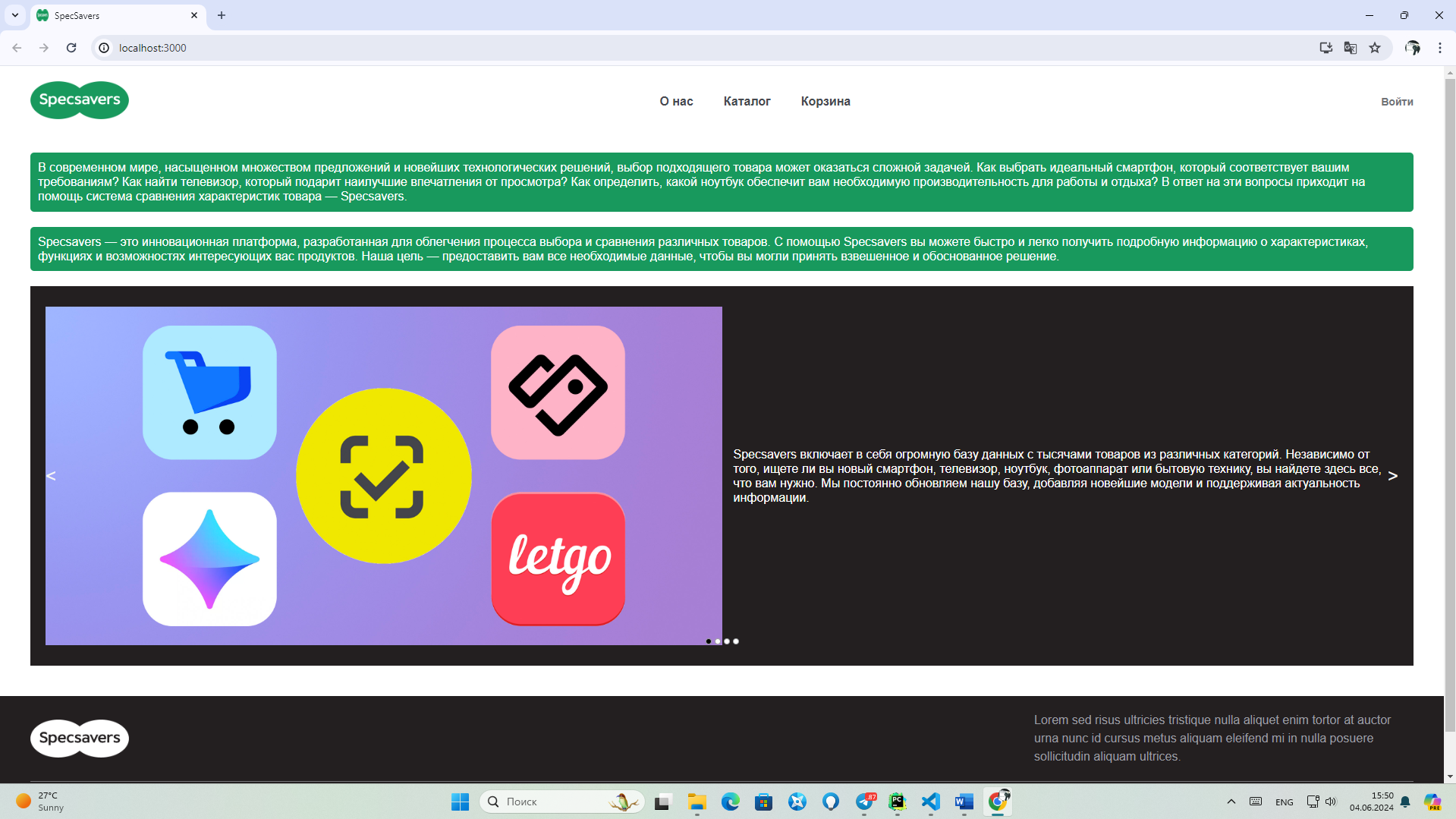

Each section will be visually distinct, making it easy for users to navigate the page and find the information they need. The landing page will serve as a central hub, ensuring visitors have a comprehensive understanding of the company and can access essential services and contacts quickly.

* 1. ***Navigation Bar***

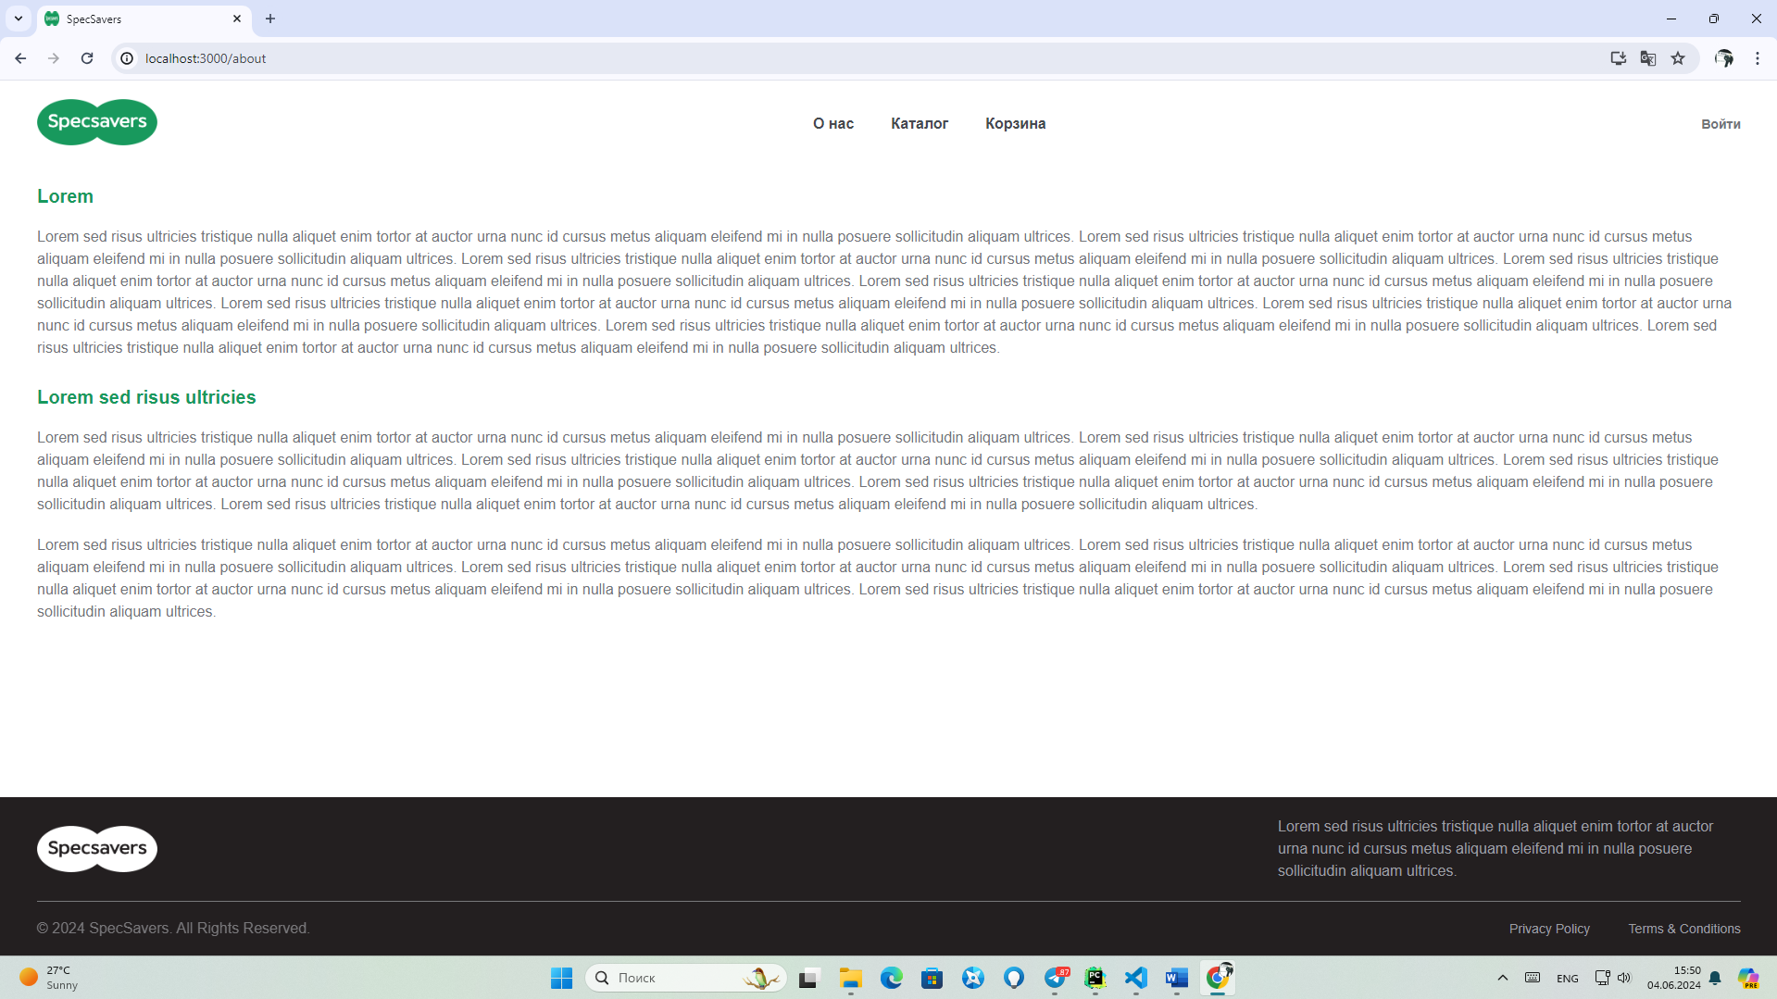

**Structure**: The navbar should consist of the following elements, displayed horizontally:

* **Logo**: Placeholder for the company's logo or banner. Clicking this element should navigate to the homepage.
* **About Us**: Link that redirects to the "About Us" page, providing information about the company or organization.
* **Catalog**: A link leading to the "Products" page where users can all products.
* **Corzina**
* **Login**: Link that redirects to the "Login/Rgistration" page.
  1. ***About Us***

- Detailed history of "SpecSavers" including its story and milestones.

- Our mission, values, and the impact we aim to make our service better.

- Introduction to our dedicated team.

- Information on partnerships with local communities



* 1. ***Categories of Products***

- Categories of products.

- Search filters for easy navigation

- Adoption inquiry form and guidelines on how to help or foster.

The section should display multiple products (in this example, four) arranged horizontally in a grid format. Each product card contains the following elements:

* **Product Photo**: A placeholder for an image of the product, centrally located at the top of each product card. This should showcase the product visually and may include a hover effect (optional) to enlarge or zoom in on the image.
* **Product Specifications**:
* **CPU**: The type and model of the CPU.
* **GPU**: The type and model of the GPU.
* **RAM**: The amount of memory (RAM).
* These specifications should be displayed in a simple, minimalistic format under the product photo, providing essential details for comparison between products.
* **Buy Button**: A "Buy" button at the bottom of each product card that users can click to purchase the product or view additional details (this can redirect to the product’s detailed page or directly add it to the shopping cart).

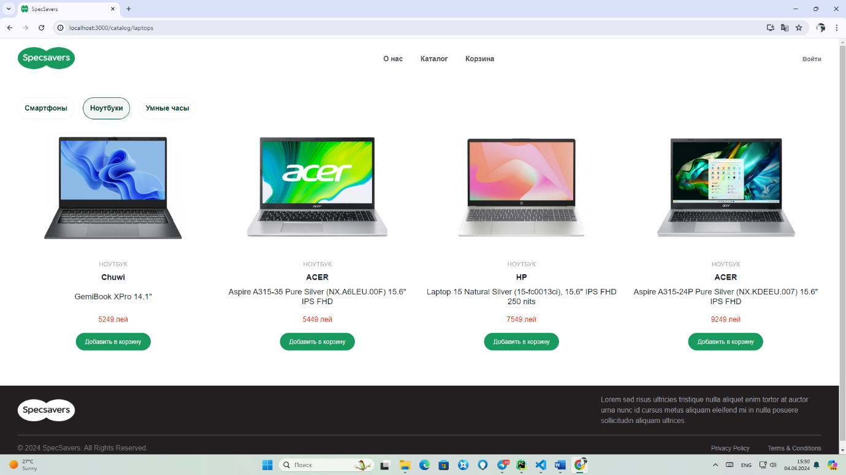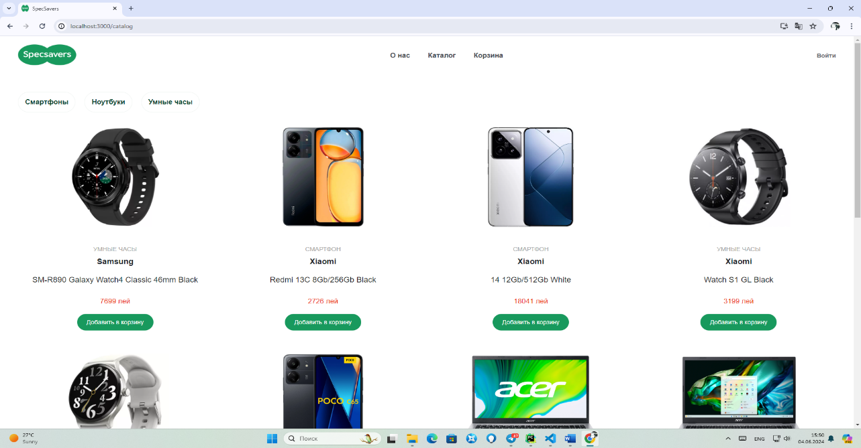

* 1. ***Personal account and registration***

- Detailed personal information, including phone numbers, email, and physical address.

**Authorization and Registration:**

For those new to our platform or yet to establish an account, the authentication process conveniently offers links for authorization and registration. Selecting "Authorization" directs users to a page where they can authenticate their identity using existing accounts, including the option to use social media profiles for verification. Alternatively, first-time users can access the "Registration" link, guiding them to a page where they can create a new account. This registration process allows users to input their relevant details and preferences, initiating their journey within our platform.

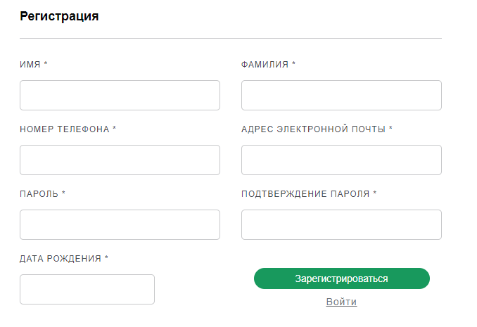

This authentication mechanism is pivotal in safeguarding user accounts, ensuring the protection of sensitive information and interactions. Below is a detailed breakdown of how this authentication process operates:

* **User Identification:**

The initial step in the authentication process involves user identification. Users will encounter fields requesting specific identification details, such as a username, email address, or mobile number, depending on the method used during account registration.

* **Password Entry:**

To fortify account security, the authentication process necessitates the input of a secure and confidential password. The password field is designed to shield user data from unauthorized access. Users are strongly encouraged to choose a robust and unique password. In the event of password forgetfulness, we offer a straightforward "Forgot Password?" link. This link provides users with a secure path to resetting their password, with instructions delivered via a secure email or SMS to facilitate a safe account recovery process.

* 1. ***Product Cart Page***

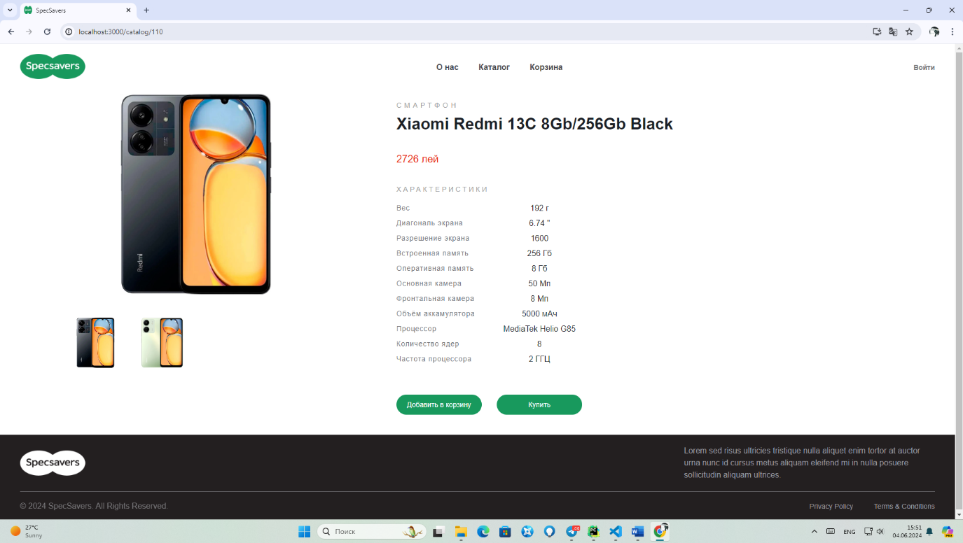

* **Product Name:** Immediately following the identifier is the product's name, providing a clear and concise label for the item.
* **Product Description:** A detailed product description follows, offering comprehensive information about the item. This description encompasses essential product specifications, features, and any pertinent details, allowing for a thorough understanding.

***4.7* *Comparison***

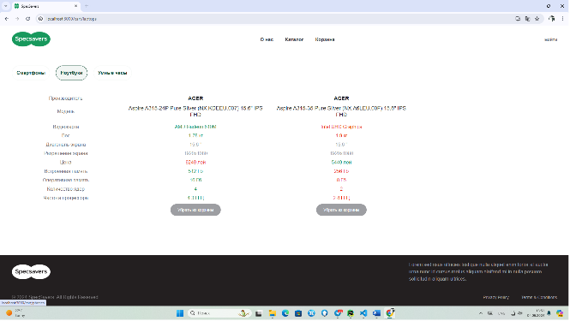

***5. Database Structure***

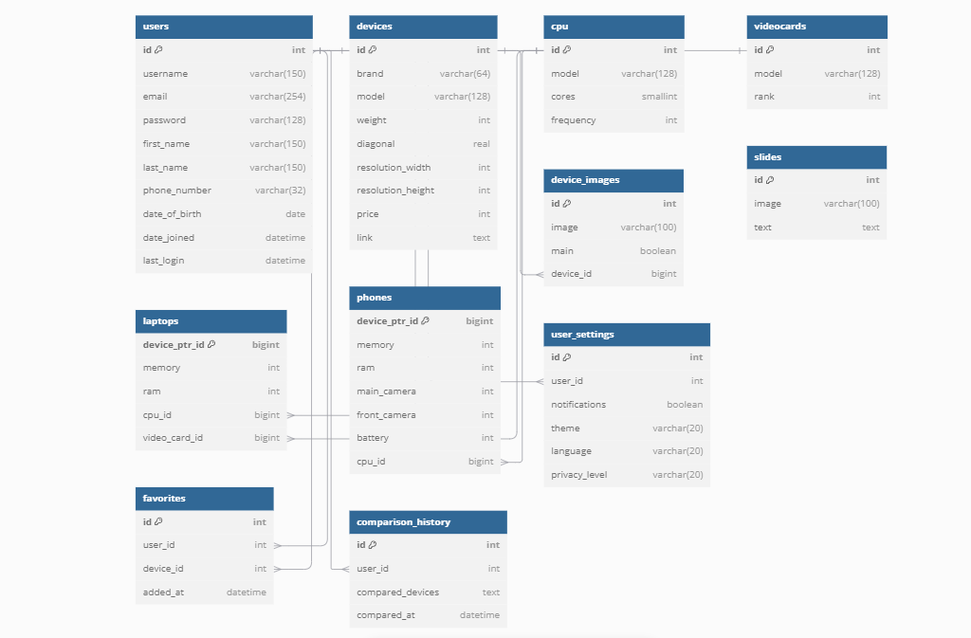

Here’s a detailed breakdown of each table in the schema:

**1. users (Authentication User Table)**

This table stores information about users.

* id (int): Unique identifier for each user (primary key, auto-incremented).
* username (varchar(150)): Username for the user (unique).
* email (varchar(250)): Email address for the user (unique).
* password (varchar(100)): Encrypted password for the user.
* first_name (varchar(150)): User's first name.
* last_name (varchar(150)): User's last name.
* phone_number (varchar(30)): Phone number of the user.
* date_of_birth (date): User's date of birth.
* date_joined (datetime): Date and time when the user joined the platform.
* last_login (datetime): The last time the user logged in.

**What it does:**

Stores information about registered users, including their personal data, contact information, and login activity.

**What it provides:**

Enables user authentication and authorization (using fields like username, email, and password).

Supports profile management features, such as updating name, phone number, and date of birth.

Tracks user activity through last_login, providing insight into the last time the user logged in.

**2. devices (Main Device Table)**

This table stores general information about devices.

* id (int): Unique identifier for each device (primary key, auto-incremented).
* brand (varchar(70)): Brand name of the device.
* model (varchar(130)): Model name of the device.
* weight (int): Weight of the device (in grams).
* diagonal (real): Screen diagonal size (in inches).
* resolution_width (int): Screen width resolution (in pixels).
* resolution_height (int): Screen height resolution (in pixels).
* price (int): Price of the device.
* link (text): URL or reference link to the product page or relevant information.

**What it does:**

Stores general information about all devices, such as brand, model, screen size, resolution, and price.

**What it provides:**

Serves as the foundation for searching and filtering devices by various attributes (e.g., brand, price, screen resolution).

Provides information for displaying devices on a website or mobile application.

Facilitates connections with specific device types like laptops or phones.

**3. cpu (Central Processing Unit Table)**

This table stores details about CPUs used in devices.

* id (int): Unique identifier for each CPU (primary key, auto-incremented).
* model (varchar(128)): Model name of the CPU.
* cores (smallint): Number of CPU cores.
* frequency (int): Frequency of the CPU (in GHz or MHz).

**What it does:**

Stores details about CPUs used in devices, including model, number of cores, and frequency.

**What it provides:**

Provides information for comparing processor characteristics across devices.

Links with laptops and phones using CPUs from this table.

Supports filtering and sorting of devices by CPU performance.

**4. videocards (Main Video Card Table)**

This table stores information about video cards (graphics processing units) in devices.

* id (int): Unique identifier for each video card (primary key, auto-incremented).
* model (varchar(130)): Model name of the video card.
* rank (int): Ranking or tier of the video card (used for performance comparison).

**What it does:**

Stores details about video cards (graphics processing units), including model and ranking.

**What it provides:**

Allows for linking video cards to laptops, providing information on graphical performance.

Enables users to compare video cards by rank to choose a device with optimal graphics power.

**5. laptops (Main Laptop Table)**

This table stores specific laptop-related information. It references the devices, cpu, and videocards tables.

* device_ptr_id (bigint): Unique identifier for each laptop (primary key, references devices.id).
* device_id (int): Reference to the devices.id (foreign key).
* memory (int): Total memory (storage) of the laptop (in GB).
* ram (int): RAM size of the laptop (in GB).
* cpu_id (bigint): Reference to the cpu.id (foreign key).
* video_card_id (bigint): Reference to the videocards.id (foreign key).

**What it does:**

Stores laptop-specific information, including memory, RAM, CPU, and video card.

**What it provides:**

Offers detailed specifications for laptops, helping users make informed decisions when purchasing.

Provides filtering and sorting options for laptops based on specific criteria like memory size or video card type.

**6. phones (Main Phone Table)**

This table stores specific information about phones. It references the devices and cpu tables.

* device_ptr_id (bigint): Unique identifier for each phone (primary key, references devices.id).
* memory (int): Total memory (storage) of the phone (in GB).
* ram (int): RAM size of the phone (in GB).
* main_camera (int): Main camera resolution (in megapixels).
* front_camera (int): Front-facing camera resolution (in megapixels).
* battery (int): Battery capacity (in mAh).
* cpu_id (bigint): Reference to the cpu.id (foreign key).

**What it does:**

Stores phone-specific information, such as memory, RAM, cameras, and battery capacity.

**What it provides:**

Offers detailed specifications for phones, allowing users to search for phones with certain attributes, such as camera quality or battery life.

Provides filtering options for phones based on their specifications to meet users' needs.

**7. device_images (Main Device Image Table)**

This table stores image data related to devices.

* id (int): Unique identifier for each image (primary key, auto-incremented).
* image (varchar(100)): Image URL or file path for the device.
* main (boolean): Indicates whether the image is the main or primary image for the device.
* device_id (bigint): Reference to the devices.id (foreign key).

**What it does:**

Stores image data related to devices, including image URLs and whether an image is the main image.

**What it provides:**

Displays device images on websites or mobile applications, allowing users to view visual representations of products.

Supports multiple images per device, including the main image for product listings.

**8. favorites (User Favorites Table)**

This table stores information about user-favorite devices.

* id (int): Unique identifier for each favorite (primary key, auto-incremented).
* user_id (int): Reference to the users.id (foreign key).
* device_id (int): Reference to the devices.id (foreign key).
* added_at (datetime): Date and time when the device was added to favorites.

**What it does:**

Stores information about devices that users have added to their favorites list.

**What it provides:**

Allows users to save devices to their favorites for future reference.

Helps users organize and quickly find devices they are considering purchasing.

**9. comparison_history (User Device Comparison History Table)**

This table stores the history of device comparisons by users.

* id (int): Unique identifier for each comparison (primary key, auto-incremented).
* user_id (int): Reference to the users.id (foreign key).
* compared_devices (text): A text field storing details about the compared devices.
* compared_at (datetime): Date and time when the comparison was made.

**What it does:**

Stores information about devices that users have compared in the past.

**What it provides:**

Allows users to view which devices they have compared previously.

Enables further comparisons and helps users make better-informed decisions when selecting a device.

**10. user_settings (User Settings Table)**

This table stores the settings of each user, such as notification preferences and theme settings.

* id (int): Unique identifier for each settings entry (primary key, auto-incremented).
* user_id (int): Reference to the users.id (foreign key).
* notifications (boolean): Whether notifications are enabled or disabled for the user.
* theme (varchar(20)): The theme chosen by the user (e.g., dark, light).
* language (varchar(20)): The language preference for the user (e.g., "en", "fr").
* privacy_level (varchar(20)): Privacy setting level for the user (e.g., "high", "medium", "low").

**What it does:**

Stores user-specific settings such as notification preferences, theme settings, language, and privacy level.

**What it provides:**

Personalizes the user experience by allowing users to manage notifications, choose a theme (e.g., dark or light mode), and select their preferred language.

Provides options for managing privacy settings, improving user control over how their data is handled and presented.

These tables form the core of a database that handles users, devices, and device-related information, such as laptops, phones, and their respective components.

# ***Project duration and timelines***

The successful execution of the "Specsavers" online comparative system project requires a well-defined timeline to ensure that all tasks are completed efficiently and within the established timeframe. The project duration and timelines are outlined as follows:

**Project Start Date:**

 The project is scheduled to commence in September 2024. This marks the initiation of the project planning and requirement analysis phase.

**Project Duration:**

 The total project duration is estimated to be approximately 16 weeks, encompassing all project phases from inception to deployment.

**Phase Breakdown:**

The project will be divided into distinct phases, each with its own set of tasks and milestones. The key phases include:

**a. Planning and Requirement Analysis Phase:**

This phase is expected to take approximately 2 weeks  and will involve defining project objectives, scope, and requirements.

**b. Design and Development Phase:**

The design and development phase is anticipated to span 10 weeks. During this phase, the website's design, front-end and back-end development, and database integration will take place.

**c. Testing and Quality Assurance Phase:**

Approximately 2 weeks will be allocated for thorough testing, quality assurance, and bug fixing to ensure a reliable and error-free website.

**d. Deployment and Launch Phase:**

The final phase, which includes website deployment and launch preparations, is expected to take  2 weeks.

**Post-Launch Support:**

Following the website's successful launch, a post-launch support period of  2 months will be provided to address any immediate issues, perform updates, and provide assistance as needed.

**Project Completion Date:**

The project is scheduled to be completed by 24 December 2024 , marking the official launch of the "Specsavers" comparing system.

Timelines and milestones will be continuously monitored throughout the project to ensure that it remains on schedule. Any deviations from the project plan will be addressed promptly to mitigate potential delays and ensure a timely delivery.