**Project “A System For Comparing Product**

**Characteristics”**

**Pavliuc Maxim, IS21Z**

**2024**

**Summary:**

**1.** **Description:** 3

**2.** **ToR** 5

**3.** **Requirements** 7

**4.** **Web-site structure** 8

**Schematic structure of the site:** 8

**5.** **Project duration and timelines** 13

# **Description:**

SpecSavy - Your Ultimate Guide to Product Comparisons

Welcome to SpecSavy, the premier platform dedicated to helping you make informed decisions about products. Our system is unlike any other, as we delve into the intricacies of product specifications and features. Join us for an unforgettable journey into the heart of product comparisons, where you'll find the perfect match for your needs.

System Overview:

SpecSavy is a one-of-a-kind platform that brings together experts, enthusiasts, and consumers from around the world to discuss product specifications, features, and the broader implications of informed decision-making. Whether you're a tech enthusiast, a savvy shopper, or simply curious about the best products on the market, this platform is the ultimate destination for you.

Platform Highlights:

Cutting-Edge Comparisons: Dive deep into the world of product specifications with hands-on comparisons led by renowned experts. Learn about key features, performance metrics, and pricing.

In-Depth Reviews:

Our lineup of reviewers includes tech experts, industry professionals, and consumer advocates. Gain insights into the latest products, trends, and innovations.

Consumer Advocacy:

Explore the ethical and practical aspects of product comparisons and informed decision-making. Discuss the impact of informed choices on consumer rights and satisfaction.

Networking Opportunities:

Connect with like-minded individuals, share experiences, and collaborate on projects that promote informed decision-making and consumer empowerment.

Consumer Rights and Responsibilities:

Hear from advocates and experts who have used informed decision-making to navigate the market. Learn how to make the most of your purchasing power.

Digital Commerce and Culture:

Explore the economic and cultural aspects of product comparisons, from online shopping trends to consumer behavior.

SpecSavy is not just a platform; it's an opportunity to expand your knowledge, make meaningful connections, and become a part of a global community dedicated to informed decision-making and consumer empowerment.

Join us on this extraordinary journey into the world of product comparisons at SpecSavy. Together, we'll unravel the mysteries of the market and empower ourselves with the knowledge to make the best choices for our needs and preferences.

# **ToR**

SpecSavy Website Design Project Outline

1. **Project Overview:**

This TOR outlines the requirements and objectives for the website design project.

The project aims to create a user-friendly and visually appealing website for SpecSavy.

1. **Objectives:**

- To craft an engaging, responsive website that delivers a seamless user experience across various devices, with special emphasis on mobile and tablet compatibility to cater to on-the-go visitors.

- To enrich the user journey with intuitive navigation and user-friendly interfaces, boosting engagement and encouraging participation in adoption, donation, and educational initiatives.

- To elevate "SpecSavy'" stature in the digital landscape, augmenting the organization's visibility and establishing its reputation as a leader in animal welfare and rescue services.

1. **Scope of Work:**

- Development of a custom web architecture that includes a variety of pages tailored to showcase adoptable pets, educational resources, and ways to help, determined during the requirements analysis phase.

- Design of compelling graphics and multimedia elements to captivate users' interest and accurately convey the compassionate ethos of the "SpecSavy" brand.

- Implementation of a Content Management System (CMS)

1. **Deliverables:**

- Fully functional website with all specified features and pages.

- High-resolution images and graphics used in the design.

- Documentation for using the CMS (if applicable).

1. **Timeline:**

A comprehensive project timeline will be shared at the start of the project.

Regular progress updates and milestones will be established throughout the project.

1. **Budget:**

The budget for this project is 10$.

Any additional costs beyond the agreed budget must be approved in advance.

1. **Team Responsibilities:**

SpecSavy will provide content, branding guidelines, and any necessary information.

The design and development team will execute the website creation according to the specifications outlined in this TOR.

1. **Approval Process:**

- The project will adhere to a structured approval process, encompassing requirement analysis, system design, development stages, to testing (including unit, integration, system, and security testing).

- Standards compliance will be observed to guarantee product quality, reliability, and security.

1. **Contact Information:**

- Complete contact details for the project coordinator and key organizational contacts will be provided, including phone numbers, emails, and office locations.

1. **Confidentiality:**

All project-related information and materials are considered confidential and should not be disclosed without proper authorization.

1. **Terms and Conditions:**

This TOR serves as a binding agreement between SpecSavy and the design and development team.

1. **Amendments:**

- Modifications to this TOR must be formally documented and approved in writing by both parties.

1. **Acceptance:**

- Authorized representatives from "SpecSavy" and the development team will sign this document to signify their agreement and commitment to the project's terms.

# **Requirements**

⦁Browsers and supported devices.

Browsers:

⦁ Opera;

⦁ Google chrome;

Devices:

⦁ PC;

⦁ Mobiles devices;

Resolutions:

* PC
  + From full HD to 8K
* Mobile devices
  + Width from 300 to 600

# **Web-site structure**

## **Schematic structure of the site:**

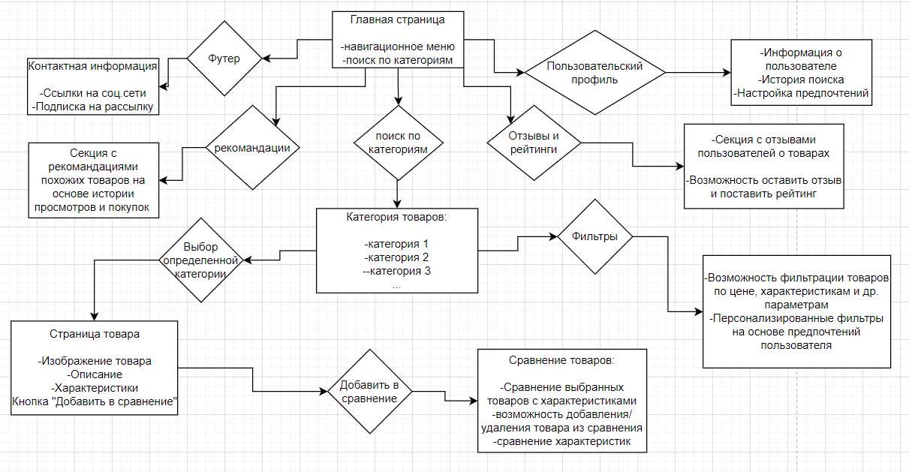

1. **Navbar**

- Mission statement and vision of " SpecSavy "

- Latest news and upcoming events.

- Navigation to key site sections like categories, comparison, information about us and other features.

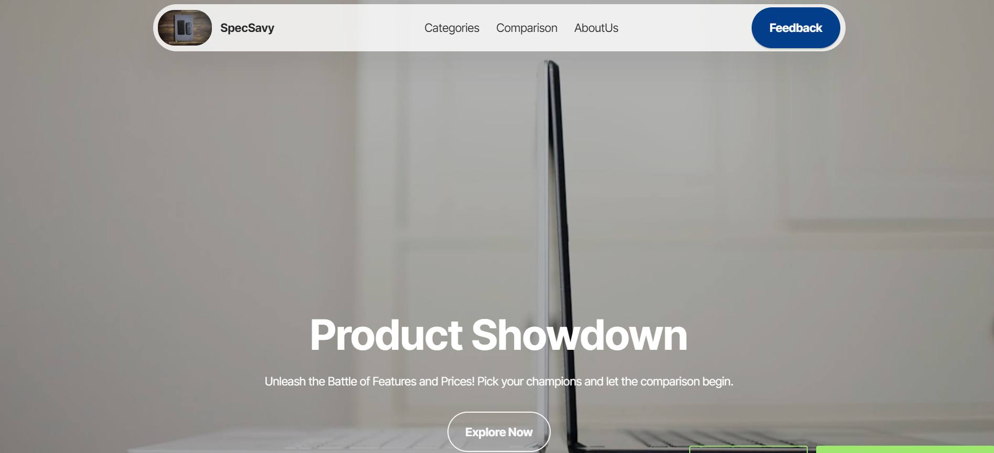

1. **About Us**

- Detailed history of "SpecSavy" including its story and milestones.

- Our mission, values, and the impact we aim to make our service better.

- Introduction to our dedicated team.

- Information on partnerships with local communities

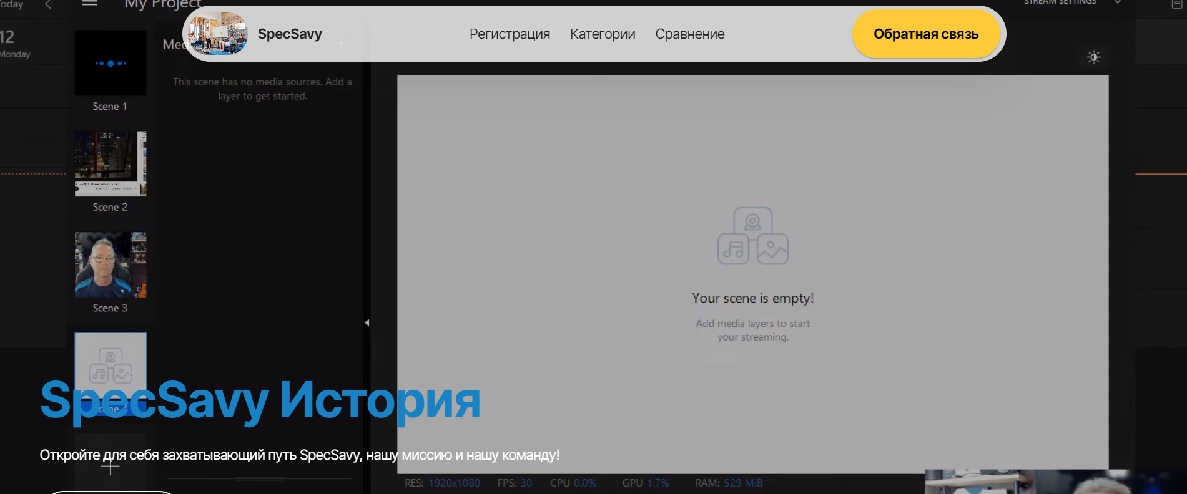

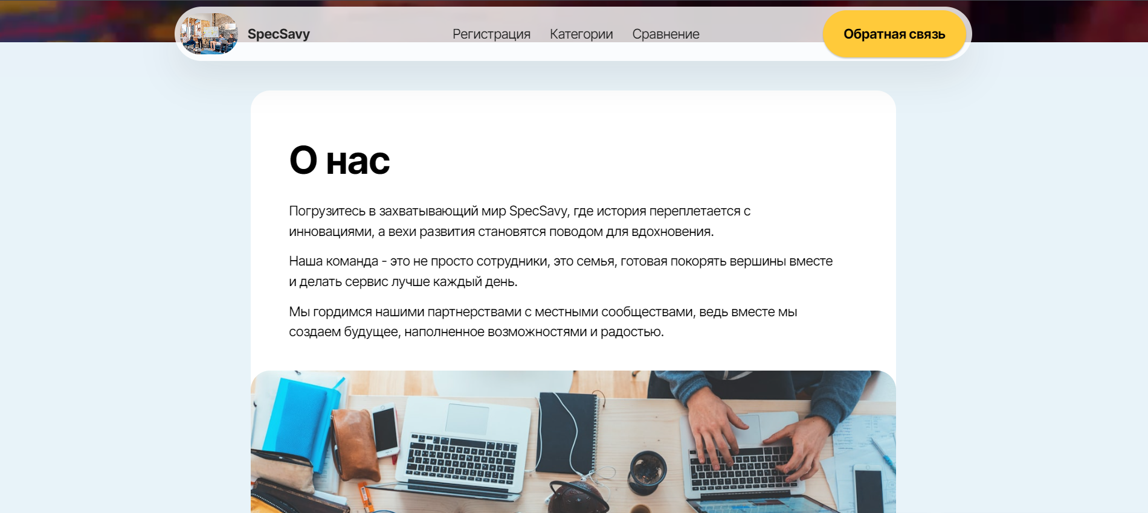

1. **Categories of Products**

- Categories of products.

- Search filters for easy navigation

- Adoption inquiry form and guidelines on how to help or foster.

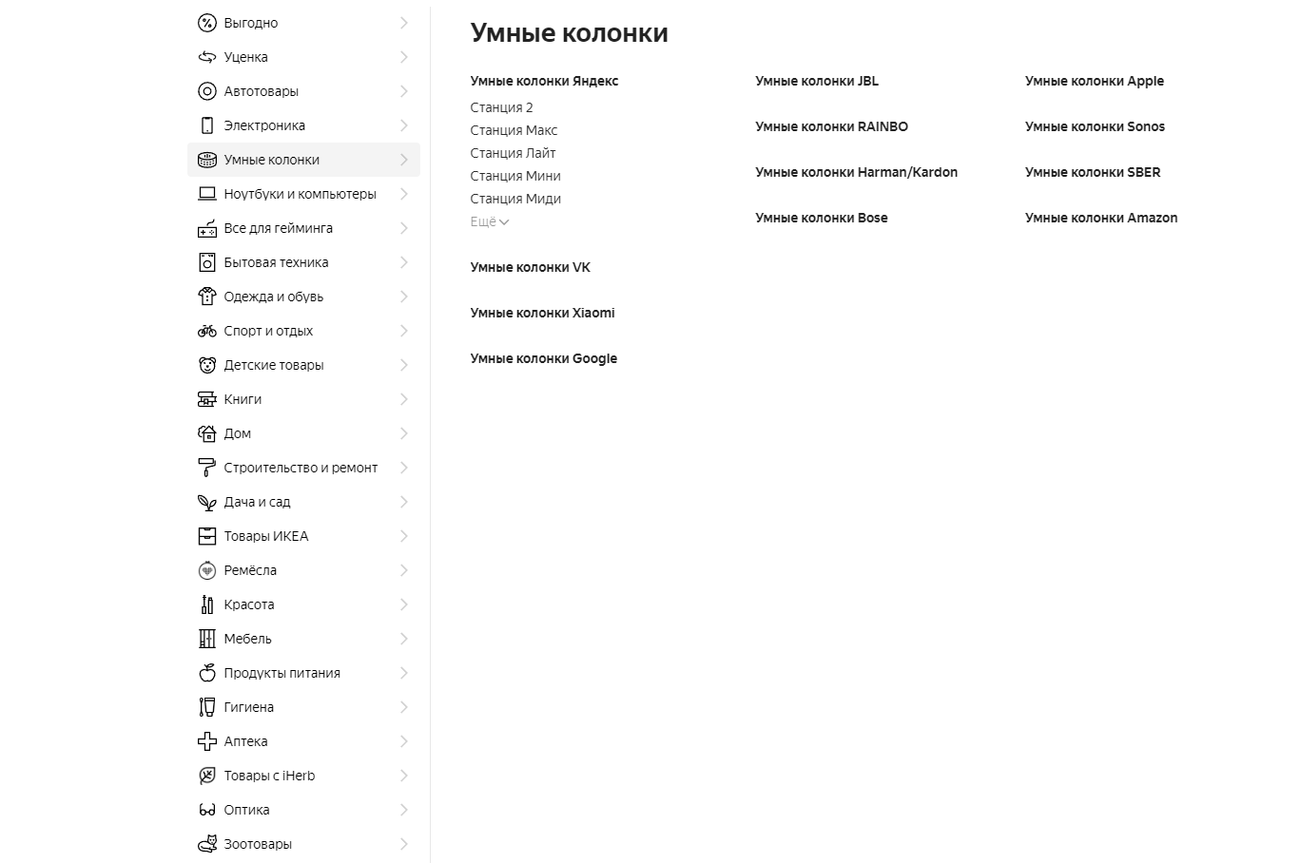

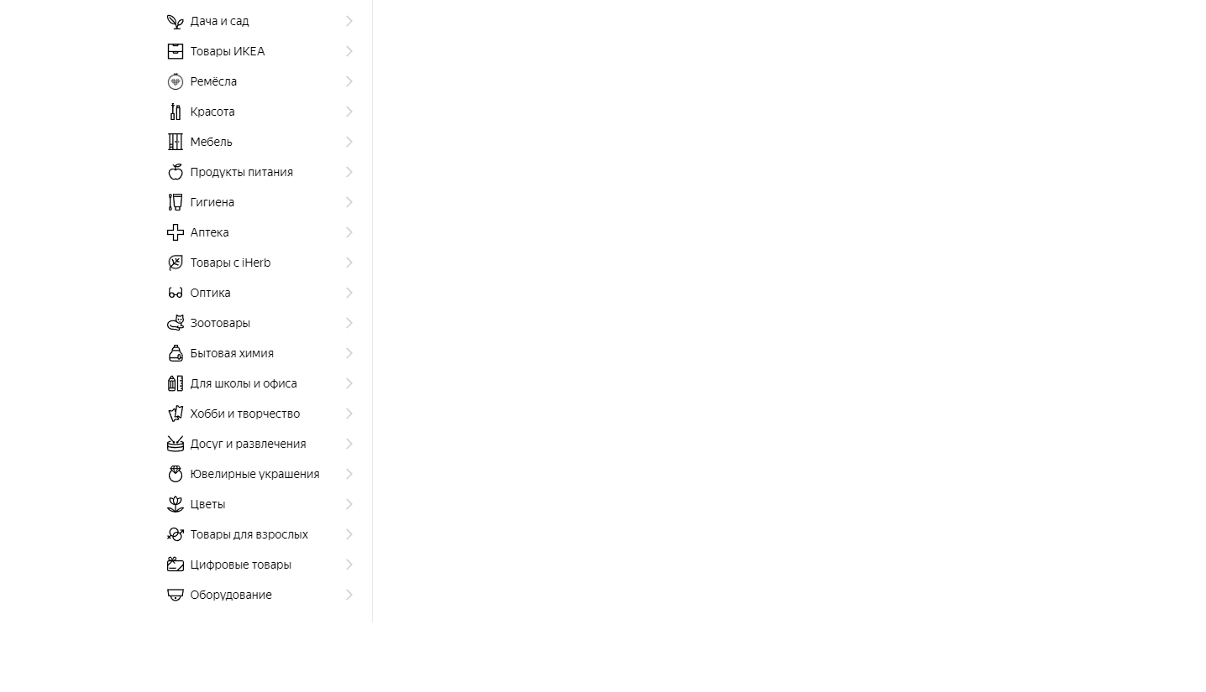

1. **Contact & Location**

- Detailed contact information, including phone numbers, email, and physical address.

- Interactive map showing " SpecSavy '" location and service areas.

- Links to " SpecSavy '" social media profiles and online contact form.

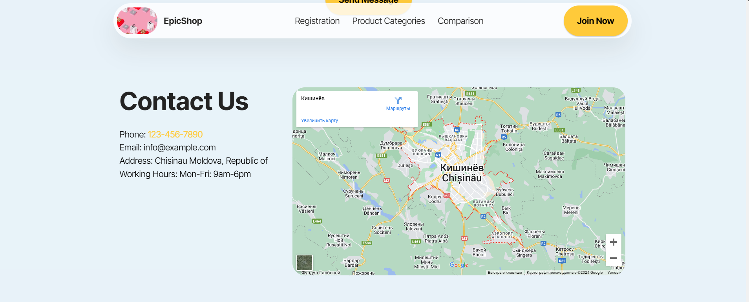

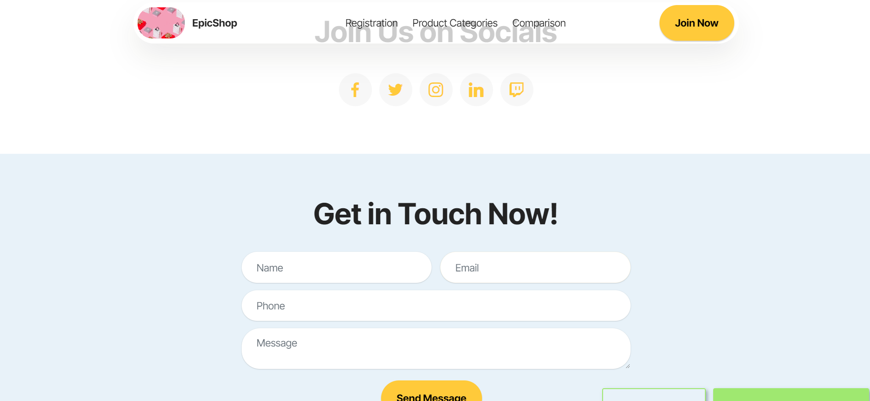

1. **Comparision**

- Displaying entries on the site page.

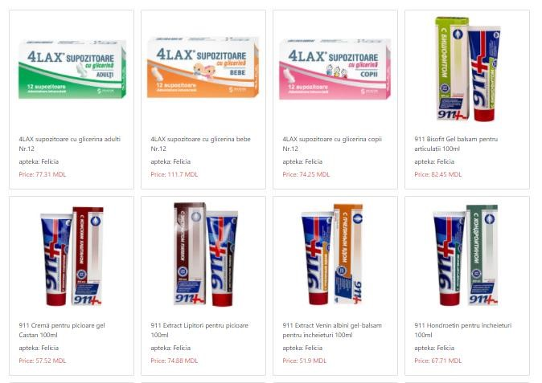

*Displaying entries on the site*

For example, let’s enter “Citramon” in the search field on the main page of the site and see what it gives us.

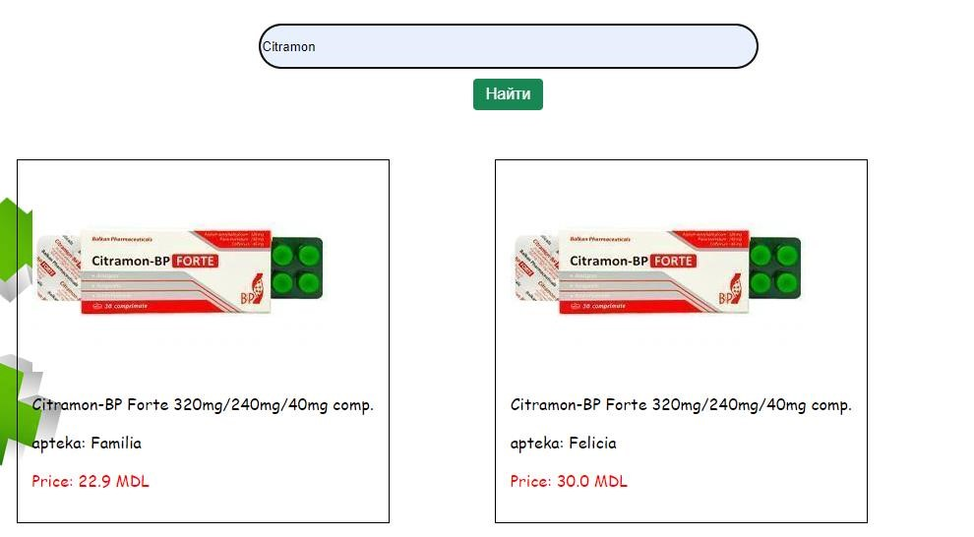

*Search results*

Let's apply the filter "Price by age" and the data should be sorted in the following order.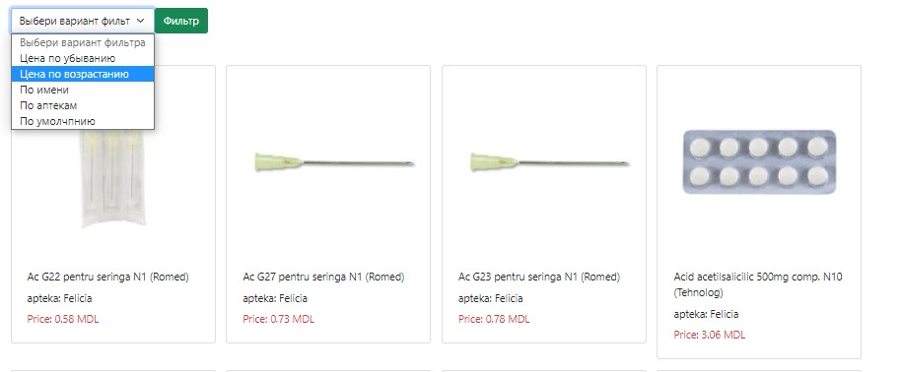

*Filter result Prices ascending*

Let's apply the filter "Price in descending order" and the data should be sorted in the following order. (See Figure 1.12)

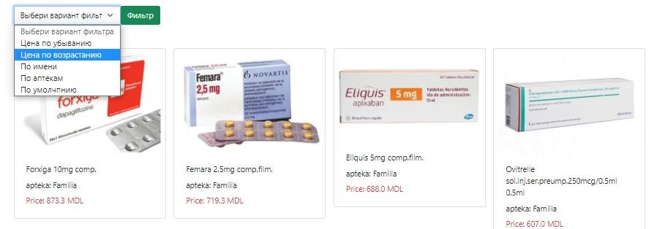

*Filter result Prices descending*

# **Project duration and timelines**

Project Initiation: The project will commence on the 5th of February, 2024, This phase involves preparatory work, including finalizing the project team.

Design Phase (30.02.2024 - 31.05.2024): During this period, our focus will be on crafting a modern, responsive website design that aligns with "SpecSavy'" mission and user expectations. This involves:

- User Experience Design: Enhancing the website's usability to ensure that visitors can easily navigate and find the information or actions they seek. This includes organizing content logically, optimizing page layouts, and ensuring accessibility standards are met.

- Responsive Design: Ensuring the website is fully functional and visually appealing on a variety of devices and screen sizes, from desktops to smartphones. This will involve using flexible layouts, images, and cascading style sheet (CSS) media queries.

Main Page and Content Management (30.02.2024 - 15.05.2024):

- Main Page Development: The first step will be developing the homepage, which sets the tone for the entire website. The main page will feature a welcoming and informative overview of “SpecSavy" .