Notes:
Missing values: LotFrontage (259), Alley(1352)
Non-variant feature: Street, Alley, Utilities

1. MSSubClass:
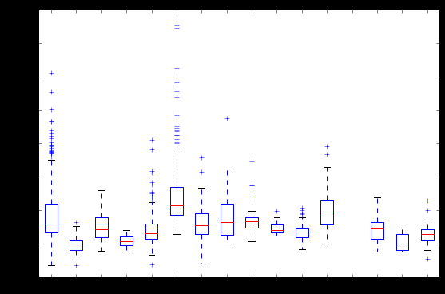
do not have missing values. show some variations, but not significant. can be used

2. MSZoning
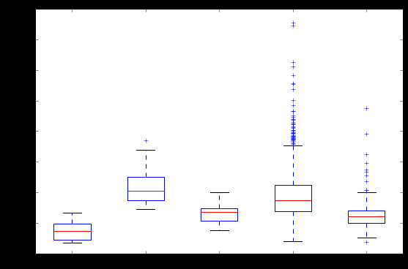
do not have missing values. show some variations, but not significant. can be used
RL 0.788356
RM 0.149315
FV 0.044521
RH 0.010959
C (all) 0.006849
Most of the houses are RL(Residential Low Density)

3. LotFrontage
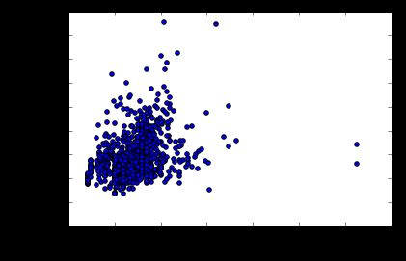
corrleation with Price: 0.351799

Pretty low.
259 missing values.

According to my experience, the relationship between house price and distance to street is not linear. House too far away from street is not convenient. And house too close to street is noisy.
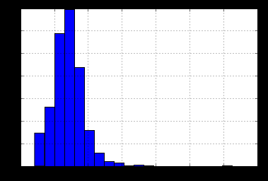
So the highest house price is belong to a house which has median distance to street.

4. LotArea
LotArea SalePrice
LotArea 1.000000 0.263843
SalePrice 0.263843 1.000000
Different from my expectation, I thought the bigger the dearer. But… So the price depends on suburbs. In one subsurb, the bigger the dearer.

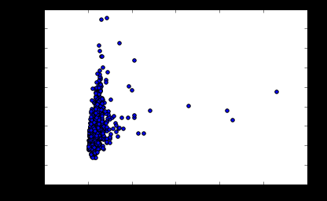

5. Street:
Pave 0.99589
Grvl 0.00411

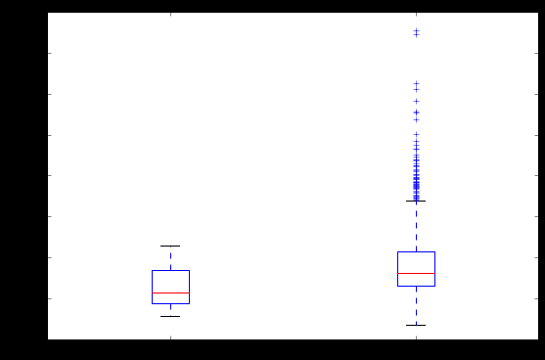
only 6 houses have Grvl road.
Let’s ignore this feature.

6. Alley:
Too many missing value and non-variant.

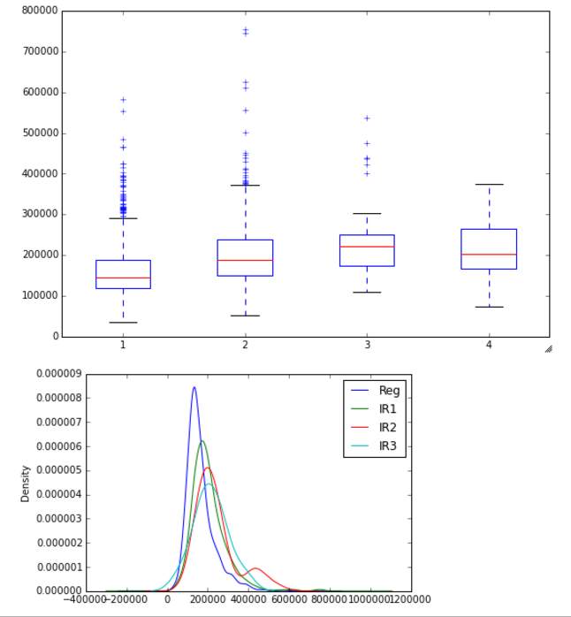
7. LotShape:
Not too much difference between different shapes.

8. LandContour:
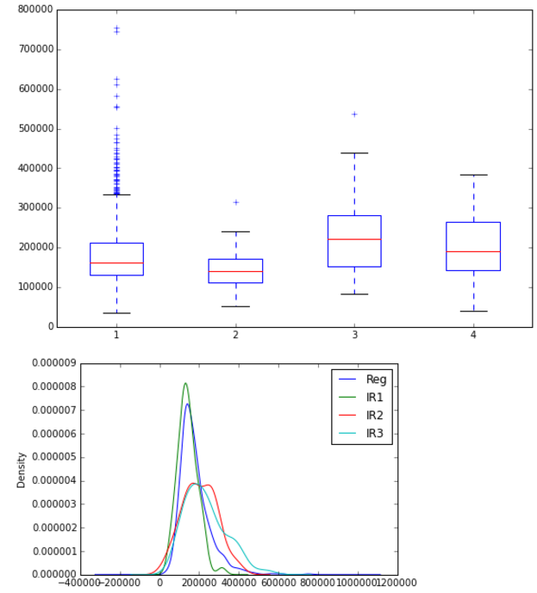
slight different distribution. Let’s go and see

9. Utilities: remove it!

10. LotConfig:
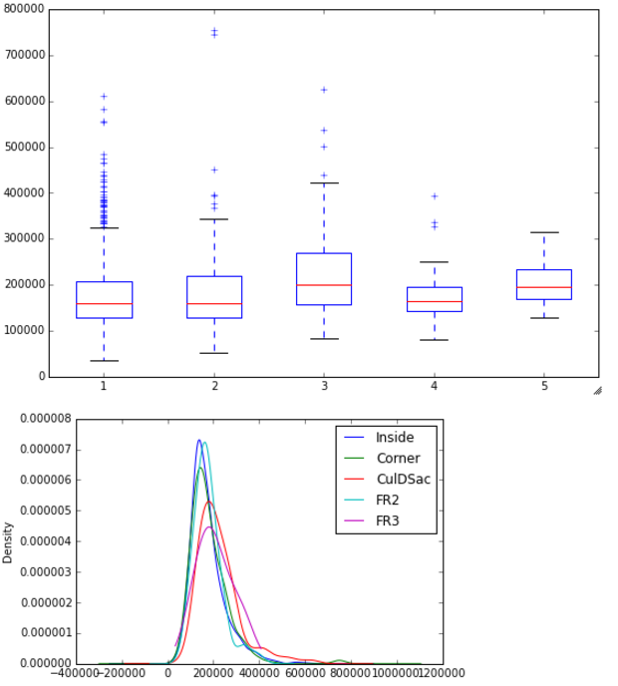

11. LandSlope: low variant, can be ignore.
Gtl 1396
Mod 60
Sev 3
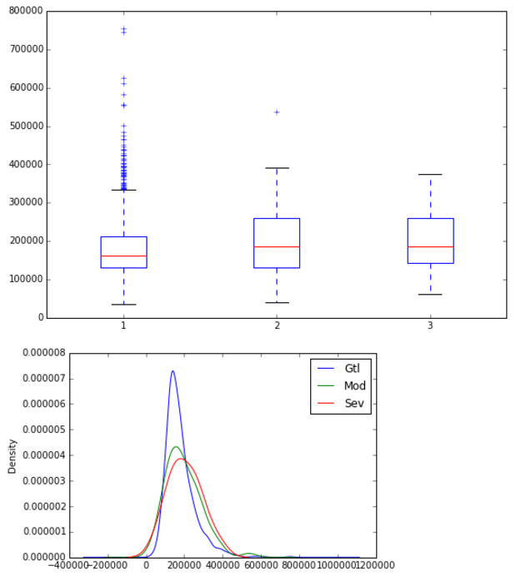

12:
Neighborhood: good feature, can be combined with LotArea.
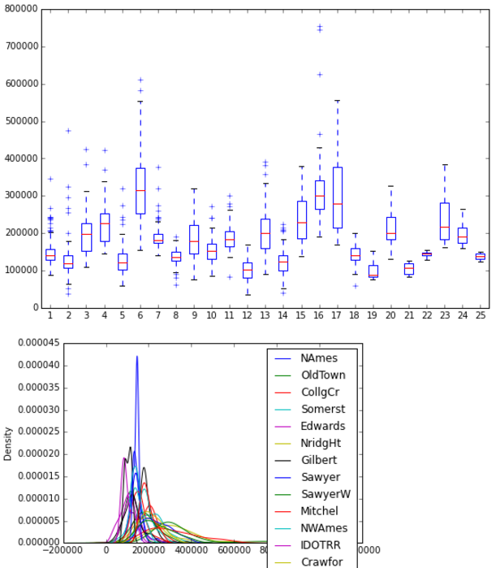
13. Condition1:
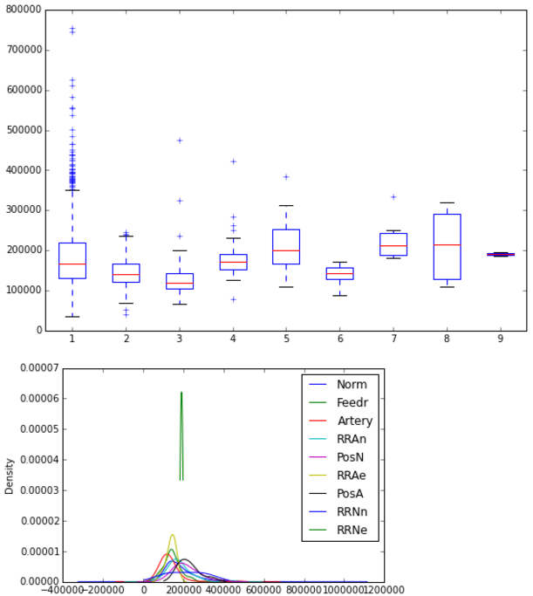
14. Condition2:
Is there a way to combine condition1 and 2? low-variant

15. BldgType:
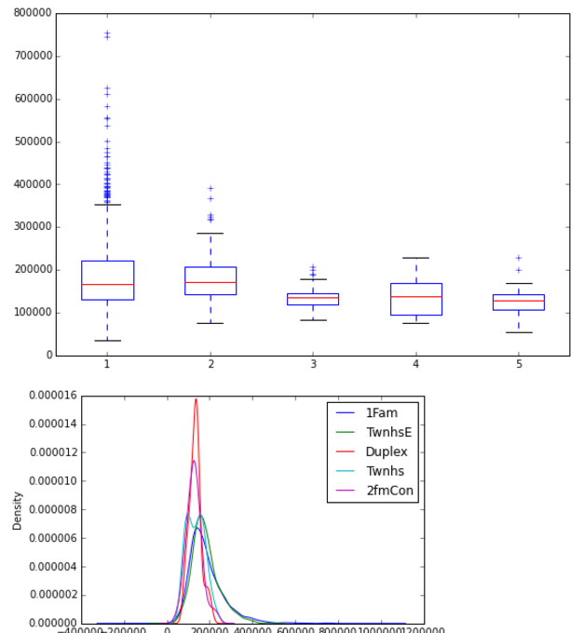

16. HouseStyle:

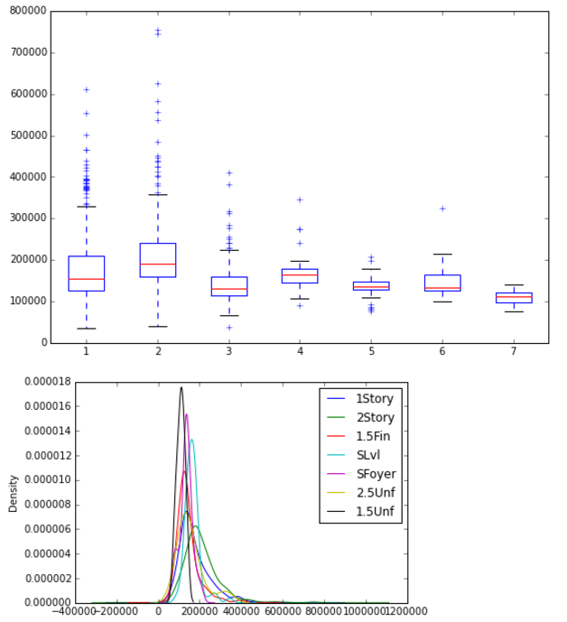
17. OverallQuality: Very significant feature!
5 428
6 357
7 281
8 174
4 110
9 64
3 20
10 13
2 10
1 2
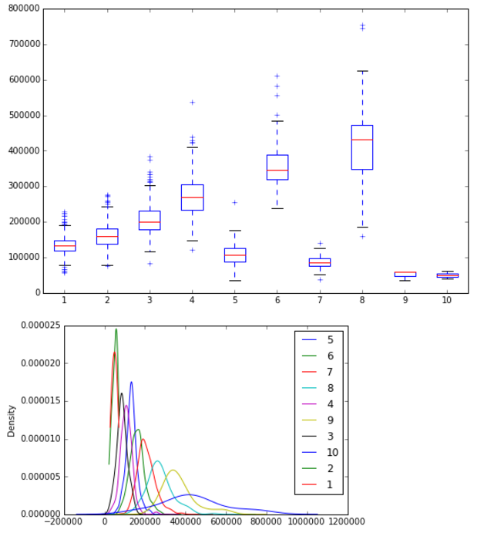

18. OverallCond:

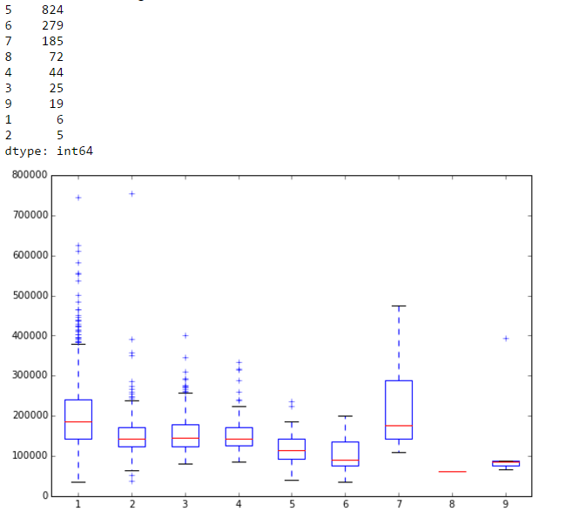

19. YearBuilt: when year increases, price increases. Several outliers need to be excluded. 或者分两段，1940之后还是蛮correlated的

