YearRemodAdd:

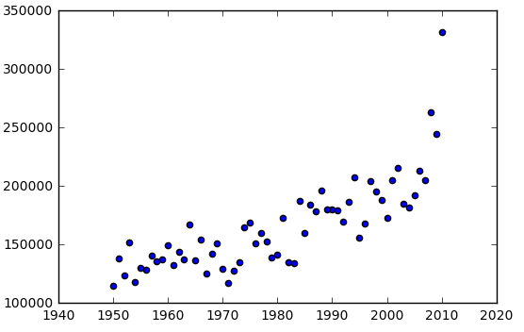

price

strong correlation with price

RoofStyle: show some variants but mainly 'Gable'.

RoofMatl: CompShg 1442

Tar&Grv 12

WdShake 4

WdShngl 1

can be ingnored. mainy 'RootMatl'

Exterior1st: good variants VinylSd 510

MetalSd 230

HdBoard 220

Wd Sdng 205

Plywood 113

CemntBd 65

BrkFace 37

WdShing 30

AsbShng 24

Stucco 18

BrkComm 4

AsphShn 1

CBlock 1

Exterior2nd, MasVnrType, MasVnrType, ExterCond, BsmtExposure(38 missing ), BsmtFinType1(38), BsmtFinSF1, BsmtFinType2(no much difference, ) BsmtFinSF2:, BsmtUnfSF(bad), Heating(delete), LowQualFinSF(bad), BsmtFullBath(not much different, BsmtHalfBath(bad), KitchenAbvGr(bad), Functional:(no difference), GarageCond:(bad), WoodDeckSF:, OpenPorchSF|EnclosedPorch|3SsnPorch|ScreenPorch: (very bad) , PoolQC(too much missing, ignore at first. but pool usually indicates a higher price), Fence(too many missing values and no difference), MiscFeature(1406 missing ):, MiscVal(bad), MoSold(no much difference), YrSold(no difference):

ExterQual, Foundation, BsmtQual(37 missing), BsmtCond(37 missing no basement), TotalBsmtSF, HeatingQC, CentralAir, 1stFlrSF, 2ndFlrSF, GrLivArea, FullBath, HalfBath, BedroomAbvGr, KitchenQual, TotRmsAbvGrd, Fireplaces(ok), FireplaceQu(some variant), GarageType, GarageYrBlt(81 missing), GarageFinish(81 missing), GarageCars, GarageArea, GarageQual(ok), PavedDrive:, SaleType:(ok), SaleCondition(ok)::: very good